**Software Development Life Cycle (SDLC):**

The **Software Development Life Cycle (SDLC)** is a systematic process for developing software, which includes planning, designing, building, testing, and deploying software applications. The goal of SDLC is to ensure that the software meets the business requirements, is of high quality, and is delivered on time and within budget.

**Phases of the SDLC:**

1. **Planning and Requirement Analysis**
2. **System Design**
3. **Implementation (Coding)**
4. **Testing**
5. **Deployment**
6. **Maintenance**

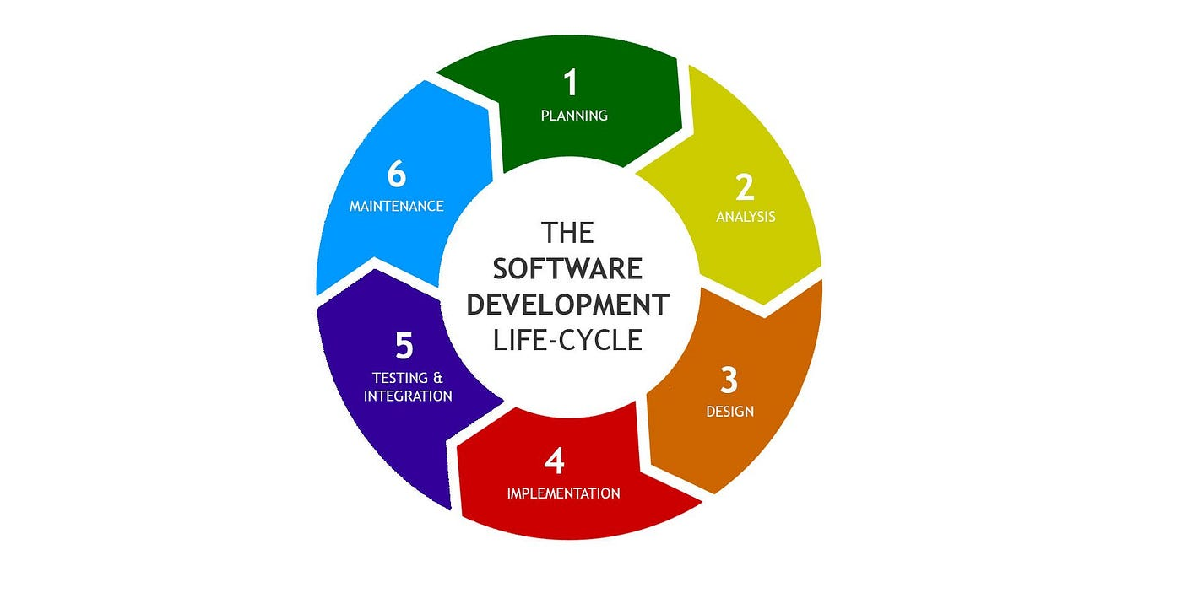

Let’s dive into each phase with an example and understand the roles and responsibilities of a **DevOps Engineer** at each step.

* **Planning and Requirements Analysis:**

In this phase, the project's scope, requirements, and objectives are defined. Stakeholders, including customers, managers, and developers, discuss the requirements, and feasibility studies are conducted.

* **Example:** For an **e-commerce application**, requirements may include:
* User registration and authentication
* Product Catalog
* Shopping cart and checkout process
* Payment gateway integration
* **Role of a DevOps Engineer:**
* **Infrastructure Planning:** Understand the project requirements and plan the infrastructure accordingly (cloud services, servers, databases, etc.).
* **Tool Selection:** Identify the tools required for CI/CD, version control, monitoring, and configuration management.
* **Automation Strategy:** Plan automation for builds, deployments, and testing to streamline development workflows.
* **Security Consideration:** Integrate security practices into the SDLC by planning tools for vulnerability scanning and compliance checks.
* **System Design:**

This phase involves creating architectural diagrams, data flow diagrams, database designs, and defining the technical stack. It specifies how the system should function and the components it will use.

* **Example:** For an **e-commerce application**, the design might include:
* **Frontend Components:** React.js for the user interface.
* **Backend Services:** Microservices using Python and Flask.
* **Databases:** PostgreSQL for product and user data, Redis for caching.
* **Role of a DevOps Engineer:**
* **Design CI/CD Pipelines:** Create pipelines to automate code testing, building, and deployment.
* **Infrastructure as Code (IaC):** Use tools like Terraform or CloudFormation to define and provision infrastructure.
* **Containerization Strategy:** Plan to containerize services using Docker, and design Kubernetes clusters for orchestration.
* **Configuration Management:** Define configuration management practices using tools like Ansible or Puppet to manage system configurations.
* **Implementation (Coding):**

The coding phase involves actual development based on the requirements and design. Developers write the code, unit tests, and follow coding standards.

* **Example:** For an **e-commerce application**, developers implement:
* User registration API
* Product listing and search functionality
* Shopping cart feature
* **Role of a DevOps Engineer:**
* **Version Control and Management:** Set up and manage repositories in tools like GitHub or GitLab.
* **Automated Builds:** Configure Jenkins or GitHub Actions to trigger automated builds upon code check-ins.
* **Code Review Automation:** Integrate tools like SonarQube for static code analysis and to enforce code quality standards.
* **Environment Management:** Automate the creation of development and testing environments using scripts or cloud templates.
* **Testing:**

In this phase, the software is tested for defects. Different testing methods such as unit testing, integration testing, system testing, and user acceptance testing are performed.

* **Example:** For an **e-commerce application**, testing may include:
* Unit tests for individual functionalities (e.g., adding items to the cart).
* Integration tests to check interaction between services (e.g., cart and payment services).
* End-to-end tests simulating user actions like placing an order.
* **Role of a DevOps Engineer:**
* **Automated Testing Integration:** Configure automated tests in the **CI/CD** pipeline, using tools like Selenium or JUnit.
* **Test Environment Management:** Provision isolated environments for different types of testing (QA, UAT).
* **Continuous Testing:** Implement continuous testing frameworks to run tests on each build.
* **Monitoring Test Results:** Set up dashboards in tools like **Grafana** to monitor test results and detect issues early.
* **Deployment:**

In this phase, the software is deployed to the production environment. It may involve multiple stages such as staging, canary releases, blue-green deployments, or rolling updates.

* **Example:** For an **e-commerce application**, deployment strategies may include:
* **Staging Environment:** First deploy to a staging environment for final testing.
* **Blue-Green Deployment:** Two identical production environments are used, where one is live (blue) and the other is idle (green). The new release is deployed to the idle environment, and if it works well, traffic is switched to it.
* **Role of a DevOps Engineer:**
* **Deployment Automation:** Use tools like Jenkins, GitHub Actions, or GitLab CI/CD for automated deployment.
* **Container Orchestration:** Deploy Microservices using Kubernetes, implementing strategies like rolling updates or canary deployments.
* **Rollback Strategies:** Plan rollbacks in case of deployment failures to ensure service continuity.
* **Post-Deployment Monitoring:** Set up application monitoring and log aggregation using Prometheus and Grafana to track application performance.
* **Maintenance:**

After deployment, the software requires regular maintenance to fix bugs, optimize performance, or implement minor feature enhancements.

* **Example:** For an **e-commerce application**, maintenance tasks may include:
* Patching vulnerabilities.
* Scaling up the infrastructure during sales or promotional events.
* Monitoring and optimizing database performance.
* **Role of a DevOps Engineer:**
* **Monitoring and Alerts:** Configure monitoring systems like Prometheus for real-time metrics and alerts.
* **Log Management:** Use tools like ELK Stack or Grafana Loki to manage logs and troubleshoot issues.
* **Scaling:** Implement auto-scaling policies to handle increased load.
* **Security Management:** Regularly update dependencies and apply security patches to the infrastructure.

**Importance of SDLC from a DevOps Perspective:**

1. **Automation: DevOps** focuses on automating each phase of the **SDLC** to improve speed and reduce manual intervention.
2. **Collaboration:** Promotes better collaboration between development, operations, and quality assurance teams.
3. **Continuous Integration/Delivery (CI/CD):** Integrates **CI/CD** practices into the **SDLC** for rapid and reliable software delivery.
4. **Quality Assurance:** Ensures quality through continuous testing and monitoring.
5. **Feedback Loops:** Shortens feedback loops to quickly address issues and iterate over improvements.

**Example of Building a ChatBot Application:**

Building a comprehensive ChatBot application involves distinct roles for AI/ML Engineers and DevOps Engineers, each contributing unique skills to the project's development and deployment:

* **Roles and Responsibilities as an AI/ML Engineer:**

1. **Data Collection and Preparation:**

* Gather and preprocess data from various sources to train the Chabot’s Natural Language Processing (**NLP**) models.
* Perform data cleaning, normalization, tokenization, and augmentation to ensure high-quality input for the models.

1. **Model Development:**

* Design, develop, and fine-tune machine learning and deep learning models for tasks like intent recognition, entity extraction, and language generation.
* Use NLP libraries (e.g., **SpaCy**, **NLTK**, **Hugging Face**) and machine learning frameworks (e.g., **TensorFlow**, **PyTorch**).

1. **Training and Evaluation:**

* Train the models using labeled datasets and continuously improve their performance through iterative fine-tuning.
* Evaluate models using metrics like **accuracy**, **precision**, **recall**, **F1-score**, and **BLEU** score for language generation.

1. **Algorithm Optimization:**

* Optimize models to achieve faster inference times and reduced memory usage.
* Implement techniques such as pruning, quantization, and knowledge distillation for model optimization.

1. **Feature Development:**

* Implement specific features like sentiment analysis, multi-turn conversation handling, context retention, or topic-switching capabilities.

1. **Model Deployment and Integration:**

* Package the trained models into a deployable format (e.g., **Docker** **containers**) and expose them as APIs.
* Work closely with DevOps engineers to ensure the model is integrated seamlessly with the rest of the chatbot system.

1. **Monitoring and Maintenance:**

* Continuously monitor the Chabot’s performance, gather feedback, and retrain models as needed.
* Analyze logs and user interactions to improve the model’s accuracy over time.
* **Roles and Responsibilities as an DevOps Engineer:**

1. **Infrastructure Setup & Management:**

* Design and provision the underlying infrastructure using tools like **AWS**, **GCP**, or **Azure**.
* Set up and manage servers, storage, networking, and cloud services needed for the chatbot application.

1. **Containerization:**

* Create Docker containers for each service, including the Chabot’s API, model servers, and other backend components.
* Use Docker Compose or Kubernetes for orchestrating the services.

1. **Continuous Integration/Continuous Deployment (CI/CD):**

* Set up Jenkins, GitHub Actions, or GitLab **CI/CD** pipelines to automate the building, testing, and deployment processes.
* Implement multiple jobs for tasks like unit testing, integration testing, model versioning, and code analysis.

1. **Monitoring & Logging:**

* Integrate monitoring tools like **Prometheus** and **Grafana** to track the system’s performance, response times, and resource utilization.
* Set up logging solutions like ELK Stack or **Loki** for centralized log management and error tracking.

1. **Scalability and Load Balancing:**

* Implement auto-scaling policies to ensure the application can handle increased traffic.
* Use load balancers to distribute incoming requests across multiple instances.

1. **Security and Compliance:**

* Ensure secure access to services using **Role-Based Access Control** (**RBAC**) and secrets management.
* Implement data encryption, network security policies, and compliance requirements.

1. **Backup and Disaster Recovery:**

* Set up automated backups for data and configurations.
* Create disaster recovery strategies to minimize downtime and ensure business continuity.
* **Example Workflow:**
* **AI/ML Engineer:** Develops and tests a new sentiment analysis model, pushes the code to a feature branch in GitHub.
* **DevOps Engineer:** Jenkins detects the code change, triggers a pipeline to build and test the new model in a Docker container, and deploys it to a staging environment for further evaluation.