* Microservice
* Collection of inter connected services
* Fine Grained
* Light Weight
* Advantages
* Low Coupling
* Improved Modularity
* Promotes Parallel Development
* Promote Scalability
* Disadvantages
* Infra cost is higher
* Integration testing complexity
* Service Management and deployment
* Nano service Anti pattern
* Reason to fail
* Lack of
* Planning
* Knowledge
* Skills
* Time
* Prevention from failure
* Determine applicability
* Prioritize Automation
* Have a clear plan
* Avoid common pitfalls
* Microservice Template
* Reduce setup time
* Similar code for each setup
* In monolithic one but in MS 10s or more may be there
* Cross cutting components like
* Logging
* Metrics
* Connection to DB
* Sample with C#
* <https://github.com/AdrienTorris/aspnet-core-simple-microservices-sample>
* <https://github.com/3pillarlabs/core-microservices-template>
* Mono vs Discrete (multi) Repo
* Microservice Decomposition
* Loosely coupled
* High cohesion – Strongly related to each other
* Common Closure Principle – Things that change together, should be packaged together
* Microservice Communication
* Remote Procedure Invocation

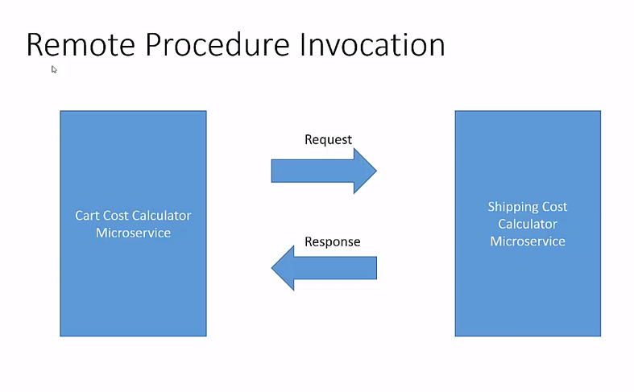

* Async Msg Based Communication

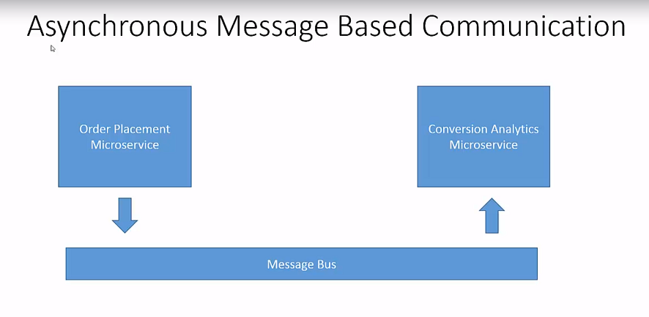

* Custom or domain communication protocol
* Microservice Registry

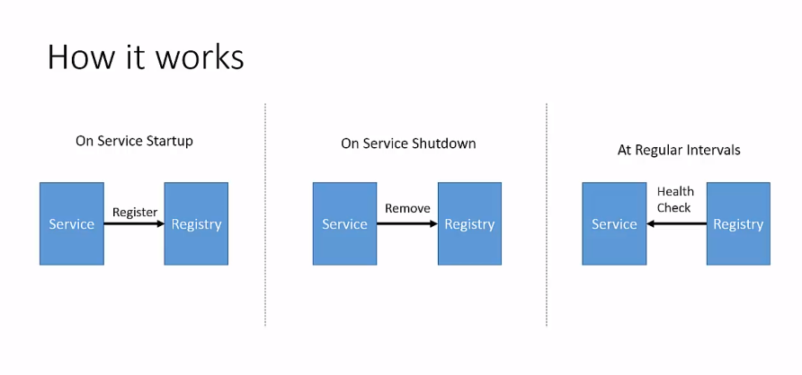

* Microservice Discovery
* Client Side Discovery

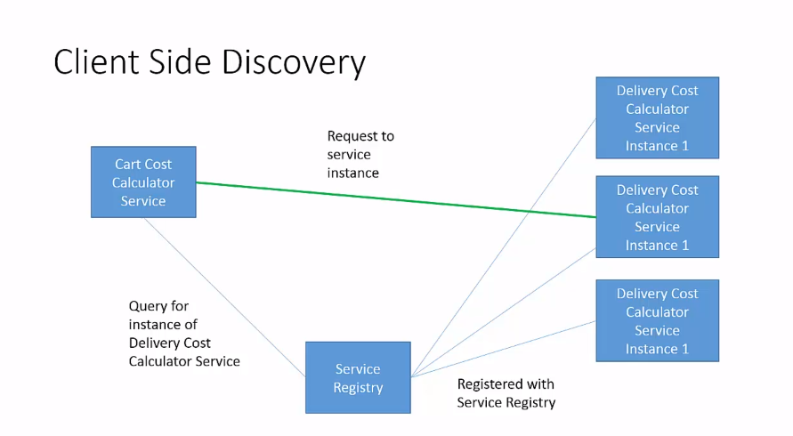

* Server side discovery

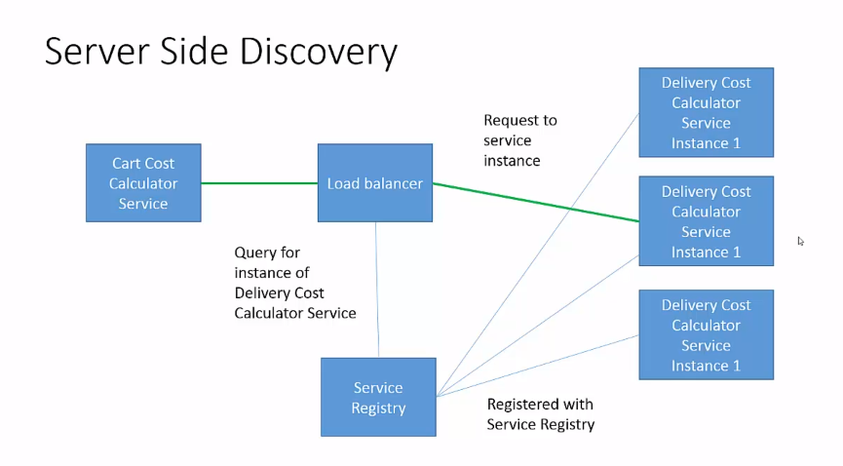

<https://www.consul.io/>

<https://github.com/Netflix/eureka>

<https://zookeeper.apache.org/>

* Microservices Data
* Databases
* Shared DB

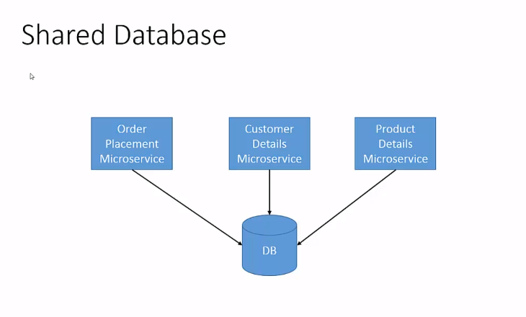

* DB Per Service

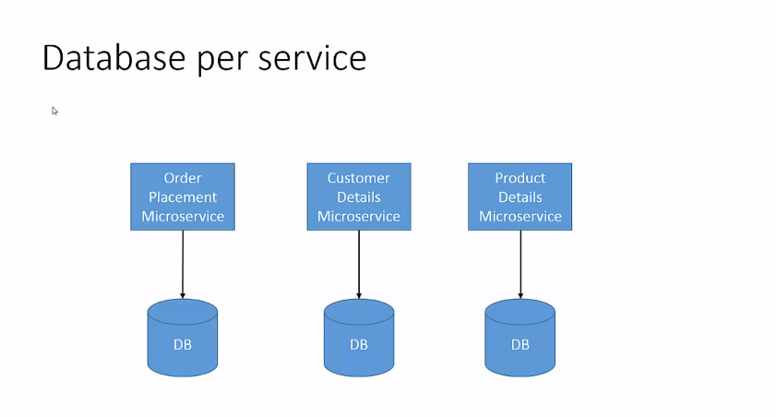

* API Composition

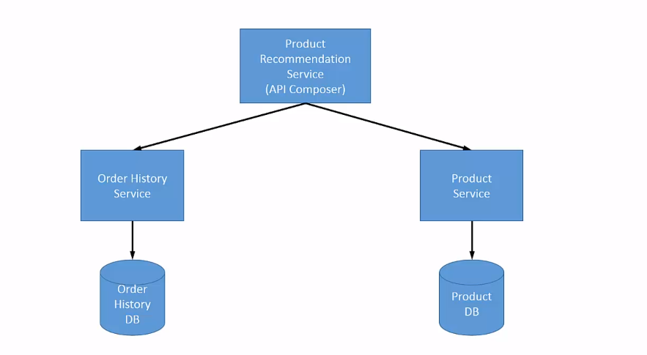

* Event Sourcing

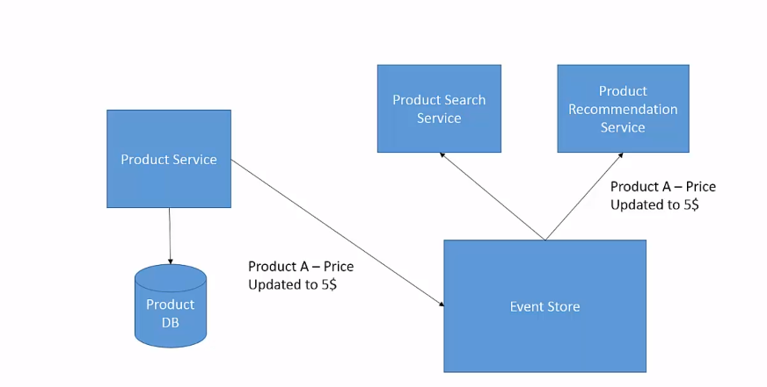

<https://axoniq.io/>

<https://eventstore.com/>

<https://github.com/NEventStore/NEventStore>

<https://github.com/EduardoPires/EquinoxProject>

* Two phase commit

Choregraphy 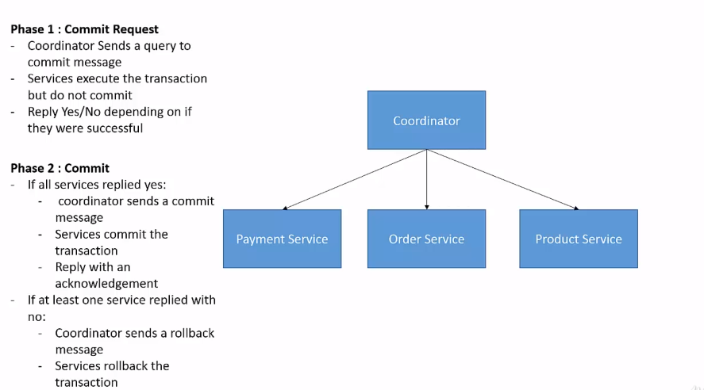

* SAGA
* Choreography based SAGA

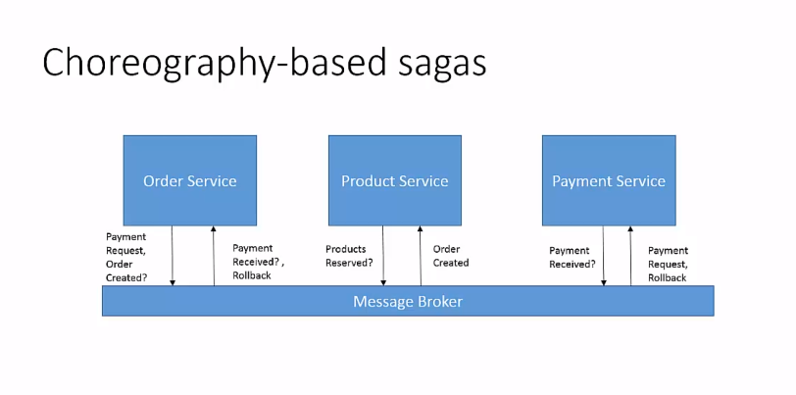

* Orchestrator based SAGA

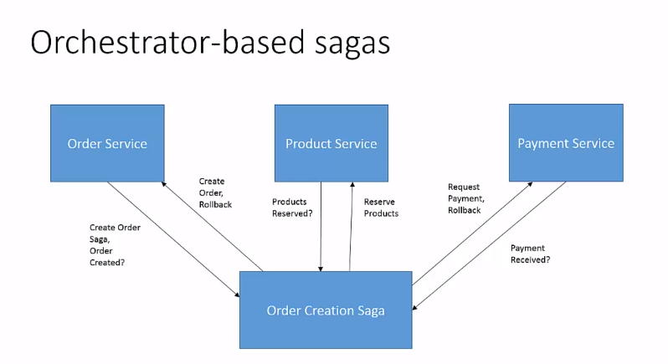

* Fault tolerance
* Failover Mechanism
* Circuit breaker

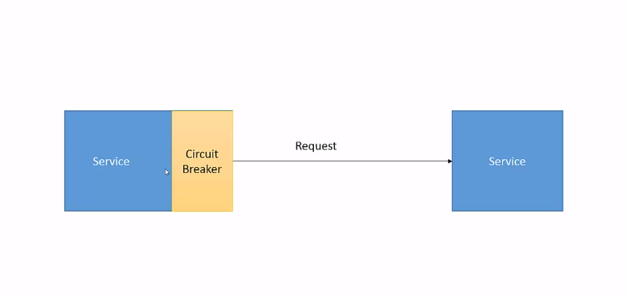

<https://github.com/Netflix/Hystrix>

<https://github.com/App-vNext/Polly>

* Health Check API

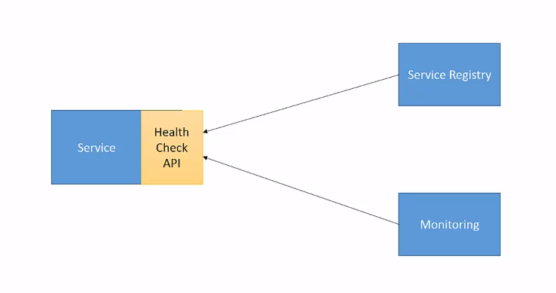

* Logging

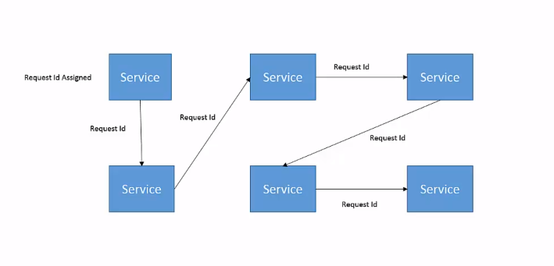

From

<https://cognizant.udemy.com/course/microservices-software-architecture-patterns-and-techniques/learn/practice/1038070?start=start-page#overview>