THE HINDU SENIOR SECONDARY SCHOOL, INDIRA NAGAR

Title of the Case Study - **Partnership with Community—Journey of Learning**

Theme/Area of Reporting Innovation/Best Practice - **International School Award—Collaboration with schools across the globe on educational topics**

Name and Address of the School - **The Hindu Senior Secondary School, No 1, 2nd Main Road, Indira Nagar, Chennai-600020**

Name of the Principal - **Smt. Padmini Sriraman**

Name(s) of the contributing teacher(s) or student(s), if any and qualification-

Ms Chandra Chandrashekaran

Ms Hema Venkateswaran

Ms Kala Senthil

Ms Rajalakshmi

Contact Details (preferably email)- hemavenkateswaran.hsss@gmail.com

**Table of Contents**

|  |  |  |
| --- | --- | --- |
| Serial no. | Contents | Page Number |
| 1 | Abstract | 3 |
| 2 | Introduction | 3 |
| 3 | Challenging situations | 4 |
| 4 | Analysis of the problem | 4 |
| 5 | Objectives | 4 & 5 |
| 6 | Planning | 5 |
| 7 | Success Criteria & alternatives | 5 |
| 8 | Implementation & Challenges faced | 5& 6 |
| 9 | Resources involved | 6 |
| 10 | Evidences of Success | 6-9 |
| 11 | Beneficiary Satisfaction | 10 |
| 12 | Concluding Remarks | 10 |
| 13 | Keywords | 10 |
| 14 | References | 10 |
| 15 | Certificates of originality by Principal/author & NOC | 11 & 12 |

**Executive Summary/Abstract:**

Journey of Learning…

Education today is evolving towards a borderless culture and its prime responsibility is to create Global Citizens. The traditional ways of teaching cannot adequately prepare young people for the future. The need for today’s education is to shift focus and emphasize on partnering with community to make the learning more meaningful and relevant to the present world. This would also include with the value-oriented teaching with the aim of not only understanding the values of different sections of people across the world but also to reflect them in their attitudes and behavior, and contribute to society through good citizenship and ethics.

Internationalism is the order of the day and hence calls for students to have a global understanding in order to face the challenges and knowing about the world outside. The ISA approach helped in encouraging students to reach out to each other to solve problems and share knowledge thereby leading to a deeper learning and understanding. The ability to think critically is important in today’s scenario and as we know that world is getting more complex, knowledgeable and technical than before, children of today needs to understand and learn new concepts critically and differently. Thus collaborating with schools across the globe has paved way in exchange of new ideas and sharing of knowledge that can mediate student learning and enhance critical thinking as they work through in different collaborative learning environment.

**Introduction**

**Context/Background for the case study**-

Our school actively participated in the International School Award instituted by the British Council. The teachers and students worked together with a single goal of taking learning beyond the confines of the classrooms to the outside world. As a part of this we undertook projects on seven different topics for classes I to XII involving more than 2000 children. Some of the topics chosen for research were My Nation My Pride, Houses around us, Natural Disasters, World Food Programme and so on.

This initiative helped nurturing global citizenship in the young minds and helped in boosting the confidence and enhancing the core skills.

Collaborative work with partner school has helped in building a strong workforce for the future and enhances the organizations image by providing a valued community service.

**Case Presentation**

**Identification of the problem/challenging situation/issue to be resolved**—

The current scenario in the field of education witnesses lot of global challenges. Students are now exposed to variety of global practices and innovations as never before. The larger goal of this initiative is to help the children identify their uniqueness and strength, understand their weaknesses, build their character, imbibe values, develop leadership qualities and spirit of enterprise so that they will grow as global citizens. It is equally important to raise them as citizens who are sensitive to the rising environmental threats, care for the mother earth and feel responsible to contribute to the world’s peace and harmony.

**Analysis of the problem**

We, at the Hindu Senior Secondary School, believe strongly in giving ample opportunities to our students to explore beyond classrooms and text books. The International School Award instituted by the British Council has paved way in involving the entire school to have a holistic learning experience well integrated into the curriculum.

As social human beings, we need to have a sense of belonging which needs to be nurtured right from the early hood stages. It is here that community plays an important role. Without communities, we would live an isolated livelihood.

Partnership with communities allows us to support one another, interact and share experience and helps to tackle modern life challenges. Having such community interactions in place will definitely influence our thinking and make us to achieve our goals.

**Objectives-**

To expose students to the outside world

To help children to discover himself/herself

To foster team building

To develop leadership qualities

To instill a multi cultural understanding

To develop proficiency in ICT and communication skills

To equip with necessary skills to emerge as responsible global citizens

To explore beyond classrooms and text books and thoroughly enjoy the whole process of learning

To broaden their exposure

To develop empathy

To sensitise children on the chosen topics

To analyse problems from the grass root level and come up with solutions

**Planning done-**

Identifying topics for international community development and better understanding of global issues.

Listing out the topics which would give opportunities to the students to identify and find solutions for community development and understanding.

Identifying schools across the world which would like to work on similar topics in resolving issues relating to community development

Getting in touch with the students in different countries through networking technology to gain first hand information

Collectively working on the relevant topics and coming out with solutions

Planning activities as per the topics chosen such as poster making , painting, chart work, model making, collage work, networking and so on

**Success Criteria and possible alternatives decided**-

The education and knowledge know no boundaries and the world has in fact become a global village. Hence the main criteria were to get in touch with more communities across the globe and to work on collective objectives, thereby achieving global citizenship

**Implementation-**

Various projects were carried out spanning for the entire academic year

This included students researching on the global topics and then preparing a comparative study between India and the countries chosen for the project.

After gaining thorough knowledge students were able to compare and contrast the similarities and dissimilarities of the different countries.

Students were able to find partnerships to carry out the collaborative projects through portals such as schools online, creating blogs, skype sessions, correspondence through mails and through personal communication (post card writing, epals etc)

**Challenges faced in implementation-**

Sticking to the fixed time frame

Getting partner schools from across the world and getting them to work on topics listed by us

**Resources involved(both Human and Material)-**

Teachers, Students, Parents, Research personnel, Literary sources, Computers

**Evidences of Success**-

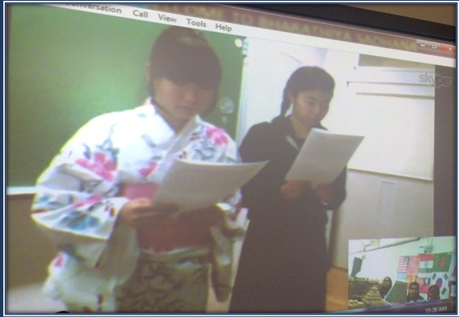

Skype calls with the school in Japan on combating with natural disasters

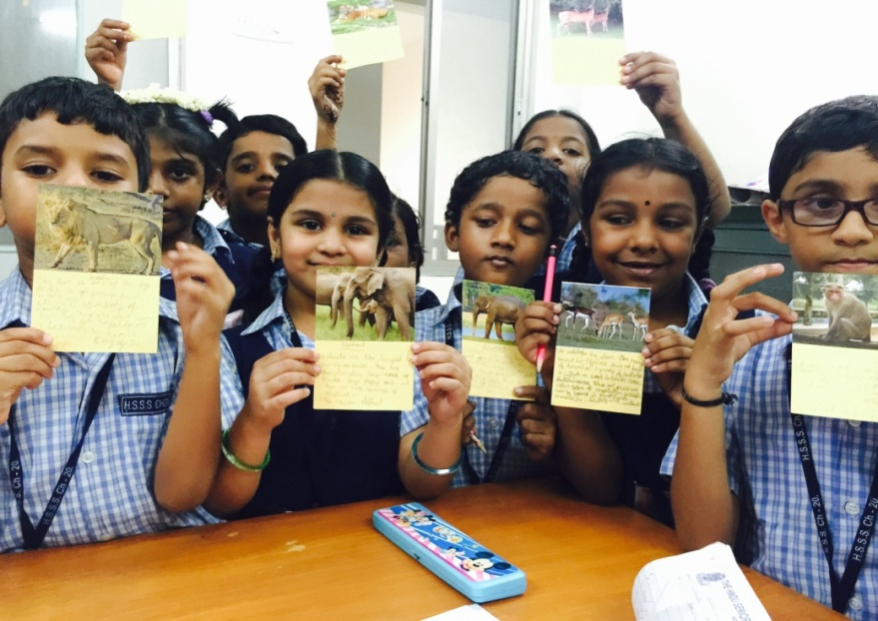

Exchange of post cards thereby sharing information

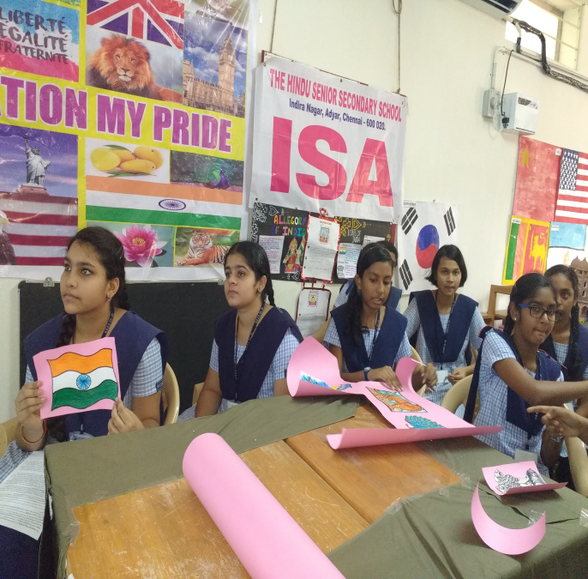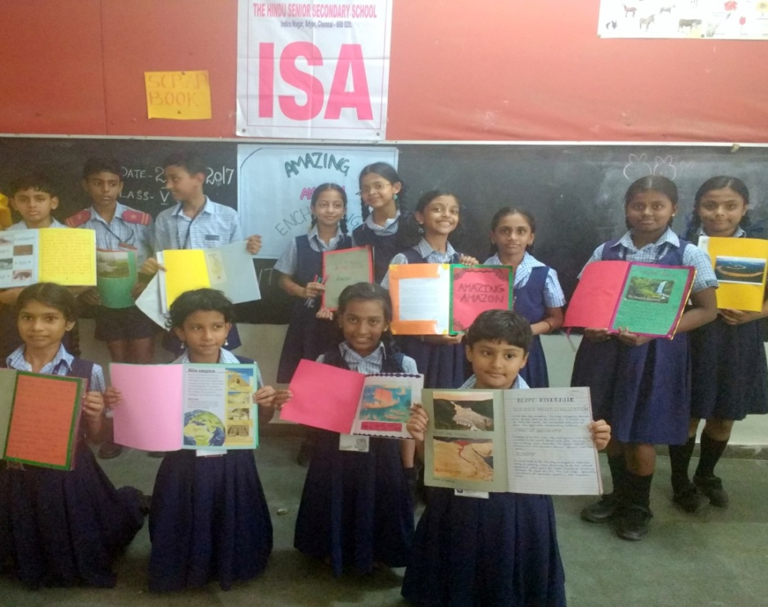

Enrichment of knowledge on rivers across the globe

Sharing of knowledge about our nation with the partner school in Nepal.

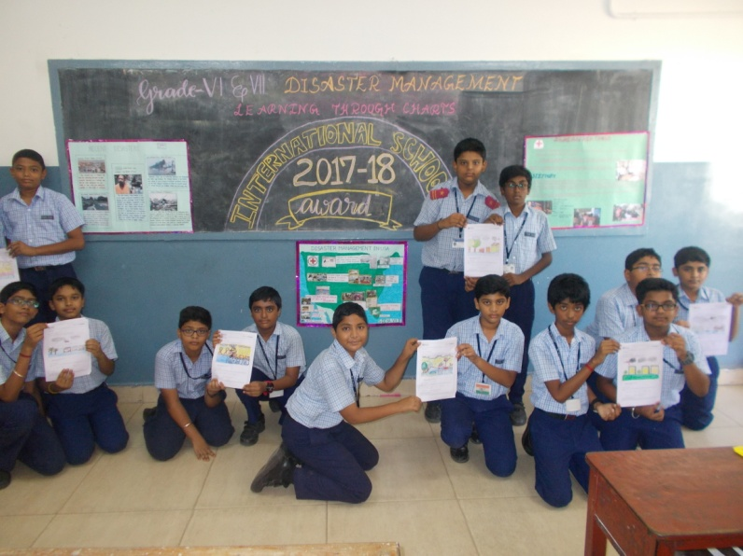

Students showcasing the charts prepared by them on Disaster management in India and Japan

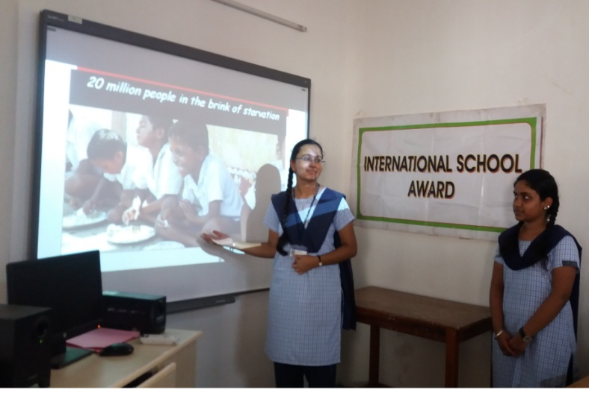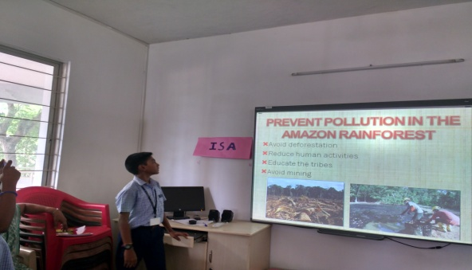 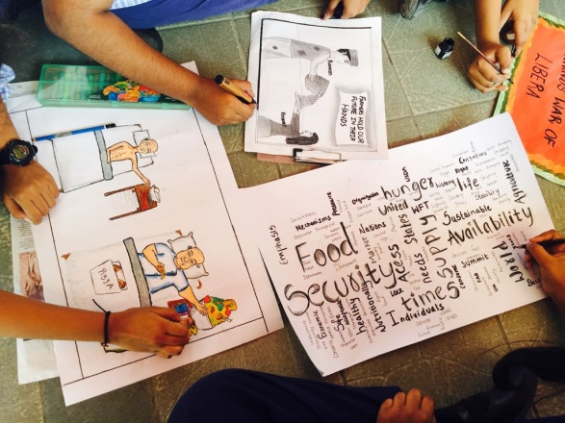

Poster Designing - Bringing awareness on food shortage prevailing in different parts of the world.

Students of class 11 presenting a video on food security.

Sharing of the knowledge on prevention of pollution in the Amazon rain forest

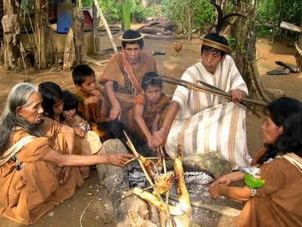

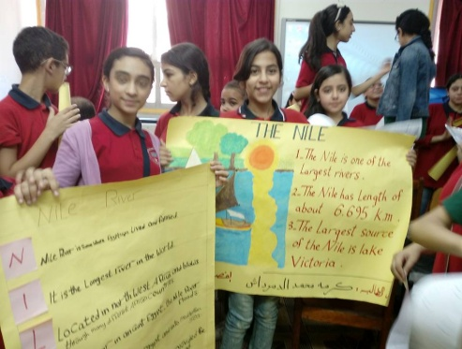

Partner schools from Colombia and Egypt providing information on the Rivers of their country –The Amazon & the Nile through pictures.

**Table showing collaboration with schools**

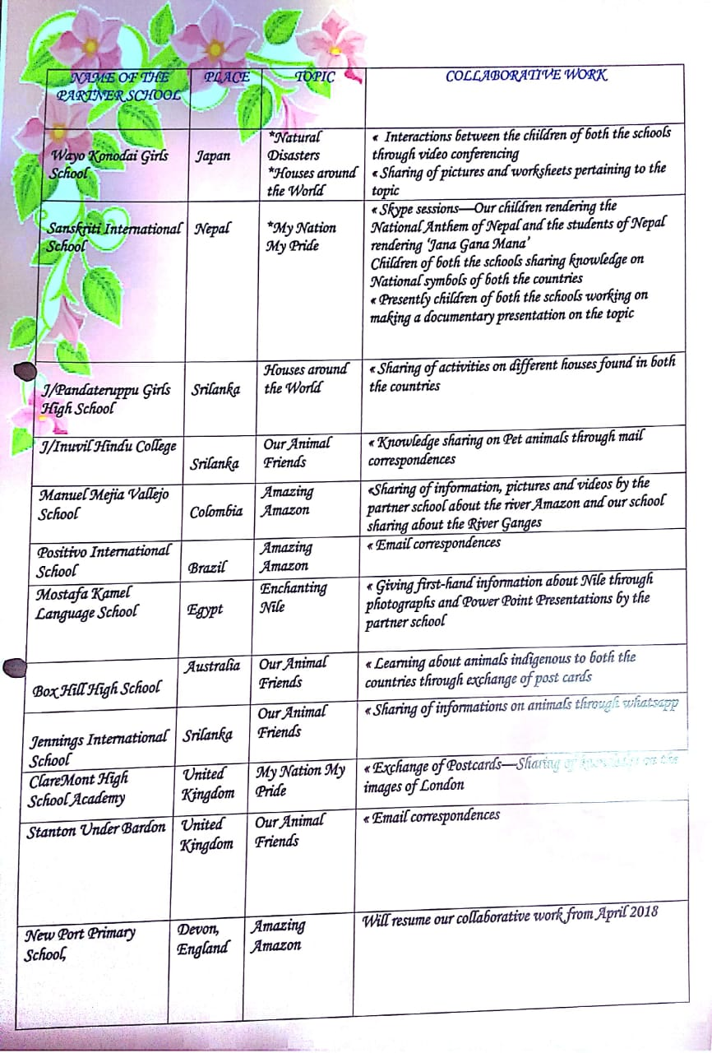

**Beneficiary Satisfaction-**

Partnerships with schools across the globe have served to strengthen, support and even transform ideas resulting in improved quality of learning. In due course, this has also led to the development of creativity and innovations.

Such collaborations with schools has helped in reinforcing the concepts taught in the school without merely replicating it. Such collaborative works has fostered in bringing out the innate talent of children in various facets.

**Concluding remarks**:

Boundaries across the world are shrinking and both students and teachers are coming closer to the global community more rapidly than before. We at The Hindu Senior Secondary School will continue in our endeavors to impart universal education and bring internationalism into the classrooms, thereby making our students ready to face the challenges globally. We are also working towards incorporating international best practices and sharing knowledge with our partner school with the aim of developing learning and communication with global dimension.

The journey of learning was truly an enriching experience for both the teaching faculty and the student community. This also has played a pivotal role in grooming the younger generation into confident leaders who are ready to work for the cause of community development.

**Key words:**

Internationalism Universal education

Collaboration Global community

Partnerships Environmental threats

Community learning Net working

Creativity and Innovation Value oriented teaching/learning

**References:**

Periodicals, Books, Encyclopedias’, Websites, etc..

