**/\***

**\* Brett Huffman**

**\* CMPSCI 4250**

**\* Jul 7, 2021**

**\* Project 3**

**Question 2**

**\*/**

/* Base Case */

getmax([], 0).

/* Recursive Cases */

getmax([Head|Tail], Max) :- getmax(Tail, Value), Head > Value, Max is Head.

getmax([Head|Tail], Max) :- getmax(Tail, Value), Head =< Value, Max is Value.

trace, getmax([12, 4], NumMax)

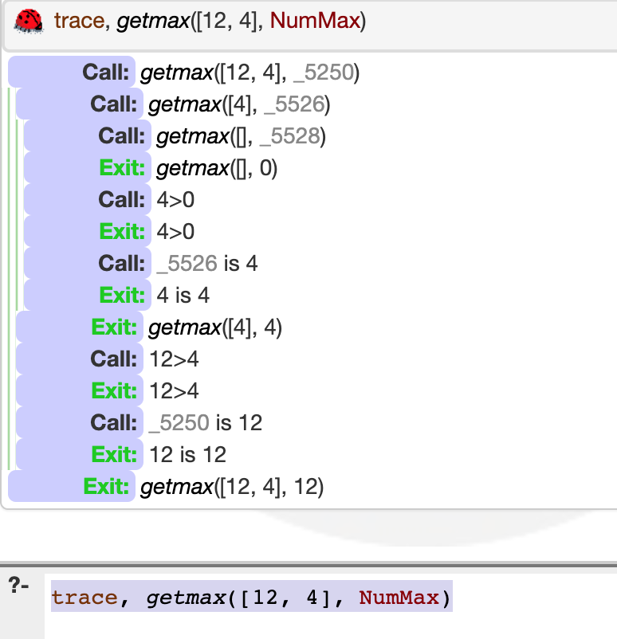

getmax([12, 4, 6, 54, 22, 43, 20, 5], NumMax)

**NumMax** = 54