# Phase 2 – Research

## 1st

Model: "model"

_________________________________________________________________

Layer (type) Output Shape Param #

=================================================================

input_1 (InputLayer) [(None, 150, 150, 3)] 0

sequential (Sequential) (None, 150, 150, 3) 0

conv2d (Conv2D) (None, 148, 148, 32) 896

max_pooling2d (MaxPooling2D (None, 74, 74, 32) 0

)

conv2d_1 (Conv2D) (None, 72, 72, 64) 18496

max_pooling2d_1 (MaxPooling (None, 36, 36, 64) 0

2D)

conv2d_2 (Conv2D) (None, 34, 34, 128) 73856

flatten (Flatten) (None, 147968) 0

dense (Dense) (None, 5) 739845

=================================================================

Total params: 833,093

Trainable params: 833,093

Non-trainable params: 0

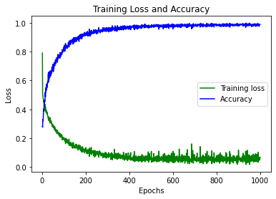

## 2nd

Model: "model"

_________________________________________________________________

Layer (type) Output Shape Param #

=================================================================

input_1 (InputLayer) [(None, 150, 150, 3)] 0

sequential (Sequential) (None, 150, 150, 3) 0

conv2d (Conv2D) (None, 148, 148, 32) 896

max_pooling2d (MaxPooling2D (None, 74, 74, 32) 0

)

conv2d_1 (Conv2D) (None, 72, 72, 64) 18496

max_pooling2d_1 (MaxPooling (None, 36, 36, 64) 0

2D)

conv2d_2 (Conv2D) (None, 34, 34, 128) 73856

flatten (Flatten) (None, 147968) 0

dense (Dense) (None, 5) 739845

=================================================================

Total params: 833,093

Trainable params: 833,093

Non-trainable params: 0

_________________________________________________________________

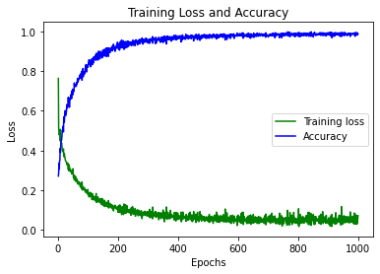

Phase 3

32, 16 => Did not grow as fast or reach as high of accuracy

Model: "model_1"

_________________________________________________________________

Layer (type) Output Shape Param #

=================================================================

input_2 (InputLayer) [(None, 150, 150, 3)] 0

sequential_1 (Sequential) (None, 150, 150, 3) 0

conv2d_3 (Conv2D) (None, 148, 148, 32) 896

max_pooling2d_2 (MaxPooling (None, 37, 37, 32) 0

2D)

conv2d_4 (Conv2D) (None, 35, 35, 16) 4624

flatten_1 (Flatten) (None, 19600) 0

dense_1 (Dense) (None, 10) 196010

dense_2 (Dense) (None, 5) 55

=================================================================

Total params: 201,585

Trainable params: 201,585

Non-trainable params: 0

_________________________________________________________________

Model 4

Add another Conv layer to 3; 64, 32, 16, 8

Model Made with Input as Output

Model: "model_5"

_________________________________________________________________

Layer (type) Output Shape Param #

=================================================================

input_7 (InputLayer) [(None, 150, 150, 4)] 0

conv2d_11 (Conv2D) (None, 148, 148, 32) 1184

flatten_5 (Flatten) (None, 700928) 0

dense_9 (Dense) (None, 5) 3504645

=================================================================

Total params: 3,505,829

Trainable params: 3,505,829

Non-trainable params: 0

_________________________________________________________________

