Session Four
Implementation and Testing
MerkleForge Project Report
Prepared as implementation, testing, performance, and user-operation evidence for the MerkleForge Rust workspace.

Session Four: Implementation and Testing

4.1 System Development

Overview Of The Overall System Development
MerkleForge was developed as a high-performance Rust toolkit for building and testing Merkle-based verification systems. The system addresses the need for a single, reusable library that supports multiple authenticated data structures instead of forcing developers to combine separate libraries for binary Merkle trees, sparse Merkle trees, and Ethereum-compatible Patricia tries.
The development process followed an incremental phase-based approach:
Phase | Development Focus | Outcome
Phase 1 | Core infrastructure | Shared traits, proof types, errors, serialization, hash adapters, CI setup
Phase 2 | Binary Merkle Tree | Flat-array binary tree, insertion/removal, proof generation, proof verification, property tests, benchmarks
Phase 3 | Sparse Merkle Tree | 256-bit sparse tree, empty-hash cache, key-addressed updates, membership/non-membership proofs, shortcut nodes, batching, batch updates
Phase 4 | Merkle Patricia Trie | Ethereum-compatible nibble paths, RLP/HP encoding, node hashing, insert/get/remove, proof generation, Ethereum test vectors
Phase 5 | Benchmarking and evaluation | Criterion benchmark suite, comparative benchmarks, energy-aware benchmark notes, public benchmark documentation
Phase 6 | Documentation and publication | Crate READMEs, website, live demo, release automation, user-facing documentation

The system was designed around four main goals:
- Provide a unified MerkleTree<H> interface for different tree variants.
- Allow hash functions to be changed through Rust generics without rewriting
tree logic.
- Support stateless proof verification for light clients.
- Provide measurable benchmark evidence for speed, proof size, and efficiency.

System Development Architecture
The workspace is divided into focused crates so each part has a clear responsibility:
MerkleForge/
├── merkle-core/ # Shared traits, errors, proof types, metadata
├── merkle-hash/ # SHA-256, Keccak-256, and BLAKE3 hash adapters
├── merkle-variants/ # Binary, sparse, and Patricia tree implementations
├── merkle-bench/ # Criterion benchmark suite and comparison benchmarks
├── website/ # React + TypeScript documentation and demo website
├── benchmarks/ # Energy benchmark documentation
├── profiling/ # Flamegraph and profiling documentation
└── .github/workflows/ # CI, release, website, and benchmark publishing flows
The diagram below summarizes the logical flow of the system.
flowchart LR
User["Developer or light client"] --> API["MerkleForge public API"]
API --> Core["merkle-core traits and proof types"]
API --> Hash["merkleforge-hash adapters"]
API --> Variants["merkle-variants tree implementations"]
Variants --> Binary["BinaryMerkleTree"]
Variants --> Sparse["SparseMerkleTree"]
Variants --> Patricia["MerklePatriciaTrie"]
Variants --> Proofs["Proof generation"]
Proofs --> Verify["Stateless verification"]
Hash --> Bench["merkle-bench Criterion suite"]
Variants --> Bench
Bench --> Website["GitHub Pages benchmark dashboard"]

4.2 System Implementation

How The System Was Built
The system was implemented in Rust using a workspace layout. Rust was selected because it provides strong memory safety, deterministic performance, zero-cost abstractions, and good support for cryptographic and systems-level code.
At the implementation level, MerkleForge is composed of the following modules.

1. merkle-core: Shared Foundation
The merkle-core crate contains the shared interfaces and types used across the whole project. It does not implement any concrete tree. Instead, it defines the contracts that all tree variants follow.
Main responsibilities:
- HashFunction trait for pluggable cryptographic algorithms.
- MerkleTree trait for shared tree operations.
- ProofVerifier trait for stateless proof verification.
- Serializable trait for proof and metadata encoding.
- MerkleError for consistent error reporting.
- LeafIndex, NodeIndex, MerkleProof, ProofNode, ProofSide, and
TreeMetadata types.
Important codebase screenshots to include:
Figure | Codebase Area | File
Figure 4.1 | Shared Merkle tree trait | `merkle-core/src/traits/merkle_tree.rs`
Figure 4.2 | Hash function contract | `merkle-core/src/traits/hash_function.rs`
Figure 4.3 | Common proof types | `merkle-core/src/types/common.rs`

2. merkleforge-hash: Hash Adapter Layer
The merkleforge-hash crate implements three hash adapters:
Adapter | Algorithm | Main Use
`Sha256` | SHA-256 | General-purpose binary and sparse trees
`Keccak256` | Keccak-256 | Ethereum-compatible Patricia trie roots
`Blake3` | BLAKE3 | High-throughput non-Ethereum workloads

All adapters implement the same HashFunction trait. This means developers can switch algorithms by changing only the tree type parameter:
use merkle_variants::BinaryMerkleTree;
use merkleforge_hash::{Blake3, Sha256};
let sha_tree = BinaryMerkleTree::<Sha256>::new();
let blake_tree = BinaryMerkleTree::<Blake3>::new();
The hash layer also applies domain separation. Leaf hashes and internal node hashes are kept separate so an attacker cannot substitute an internal node as a leaf value.

3. merkle-variants: Tree Implementations
The merkle-variants crate contains the concrete data structures.

Binary Merkle Tree
BinaryMerkleTree<H> is optimized for ordered datasets such as transaction batches, logs, and file chunks. It uses flat array storage and computes parent nodes bottom-up. It supports:
- Leaf insertion.
- Leaf removal.
- Root computation.
- Inclusion proof generation.
- Stateless proof verification.
- Generic MerkleTree<H> implementation.

Sparse Merkle Tree
SparseMerkleTree<H> is designed for very large key spaces where most entries are empty. It supports a fixed 256-bit key space and avoids storing empty branches.
Implemented sparse tree optimizations:
- Precomputed empty-hash cache with 257 entries.
- Key-addressed insert, remove, and get operations.
- Membership and non-membership proofs.
- Shortcut nodes for sparse subtrees containing only one leaf.
- Batched terminal subtrees for reduced storage overhead.
- Batch insert and batch remove APIs for rollup-style workloads.

Merkle Patricia Trie
MerklePatriciaTrie<H> implements an Ethereum-compatible trie. It uses 4-bit nibble paths and supports the four standard MPT node types:
- Empty node.
- Leaf node.
- Extension node.
- Branch node.
Implemented Patricia trie functionality:
- Nibble path extraction from byte keys.
- Hex-prefix path encoding.
- Recursive Length Prefix node encoding and decoding.
- Ethereum-style node references, where small nodes are inlined and large nodes
are hashed.
- Insert, get, and remove operations.
- Canonical node collapsing after removal.
- EIP-1186-style proof generation.
- Verification against official Ethereum trie test vectors.

4. merkle-bench: Benchmarking Layer
The benchmark crate isolates performance testing from the runtime crates. It contains Criterion benchmarks for:
- Hash throughput.
- Baseline leaf and node hashing.
- Binary tree construction and proof verification.
- Sparse tree inserts, proofs, non-membership proofs, and batch updates.
- Patricia trie inserts, gets, proofs, verification, and state roots.
- Comparative benchmarks against rs-merkle and merkle_light.
- Energy-aware construction timing.
The results are summarized in BENCHMARKS.md and published through the website benchmark dashboard.

5. Website And Live Demo
The website was implemented with React, TypeScript, and Vite. It provides:
- A landing page explaining the project.
- A beginner-friendly documentation page.
- Examples with copyable code blocks.
- Benchmark results for developers and non-expert readers.
- A live light-client verification demo where users can edit transactions and
verify proofs directly in the browser.

Screenshots Of UI And System Workflows
The following screenshots were captured from the local website build.
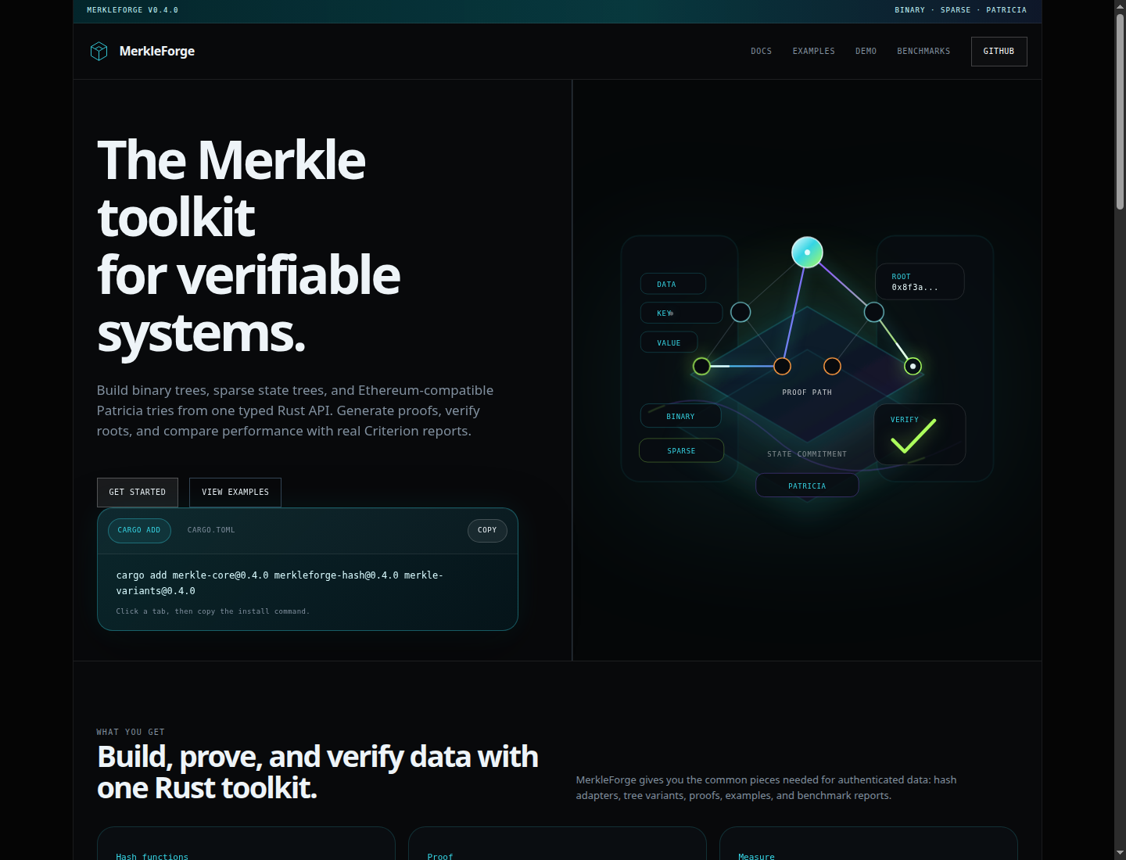
Figure 4.4: MerkleForge website landing page

Figure 4.5: Documentation page explaining installation and proof generation
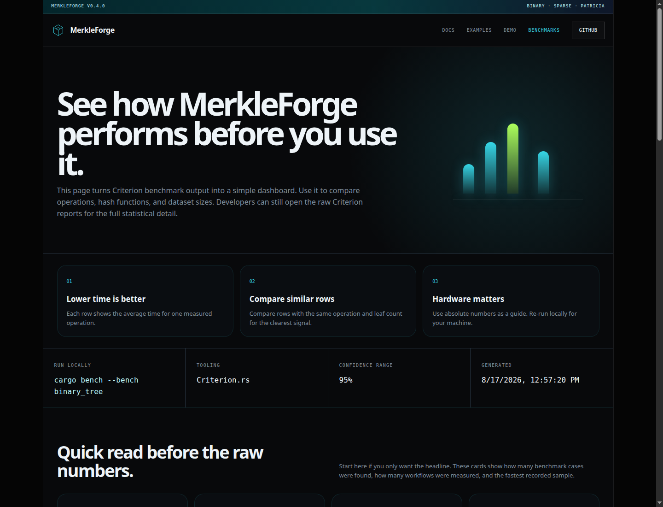
Figure 4.6: Benchmark dashboard showing measured performance data
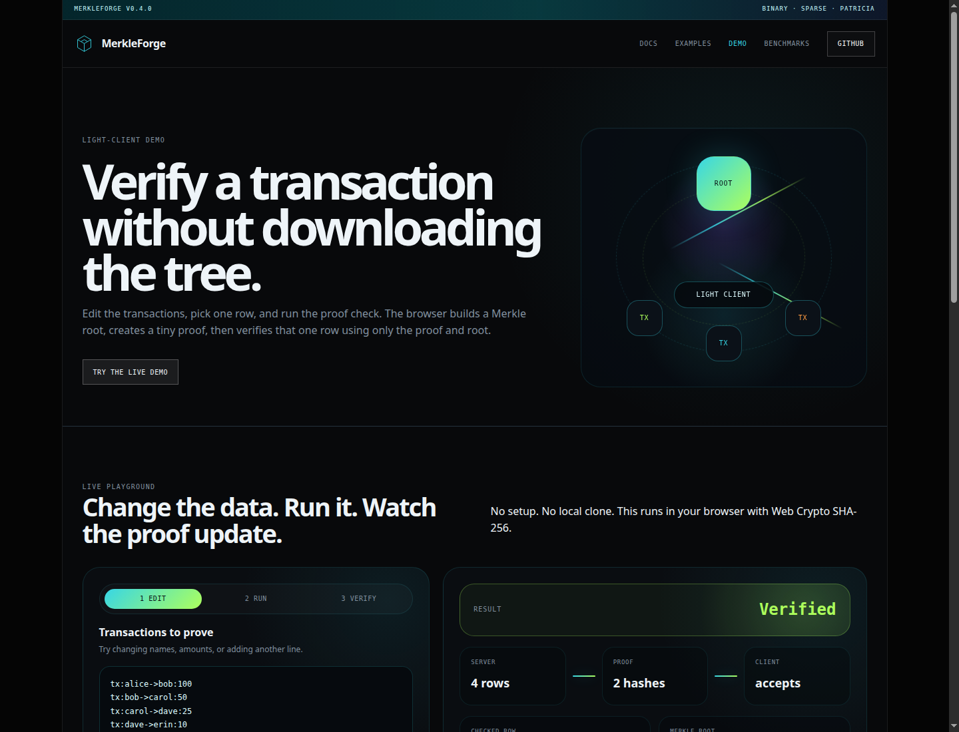
Figure 4.7: Live stateless light-client verification demo

Codebase Screenshots
The following screenshots show selected parts of the implementation and CI configuration used during system development.
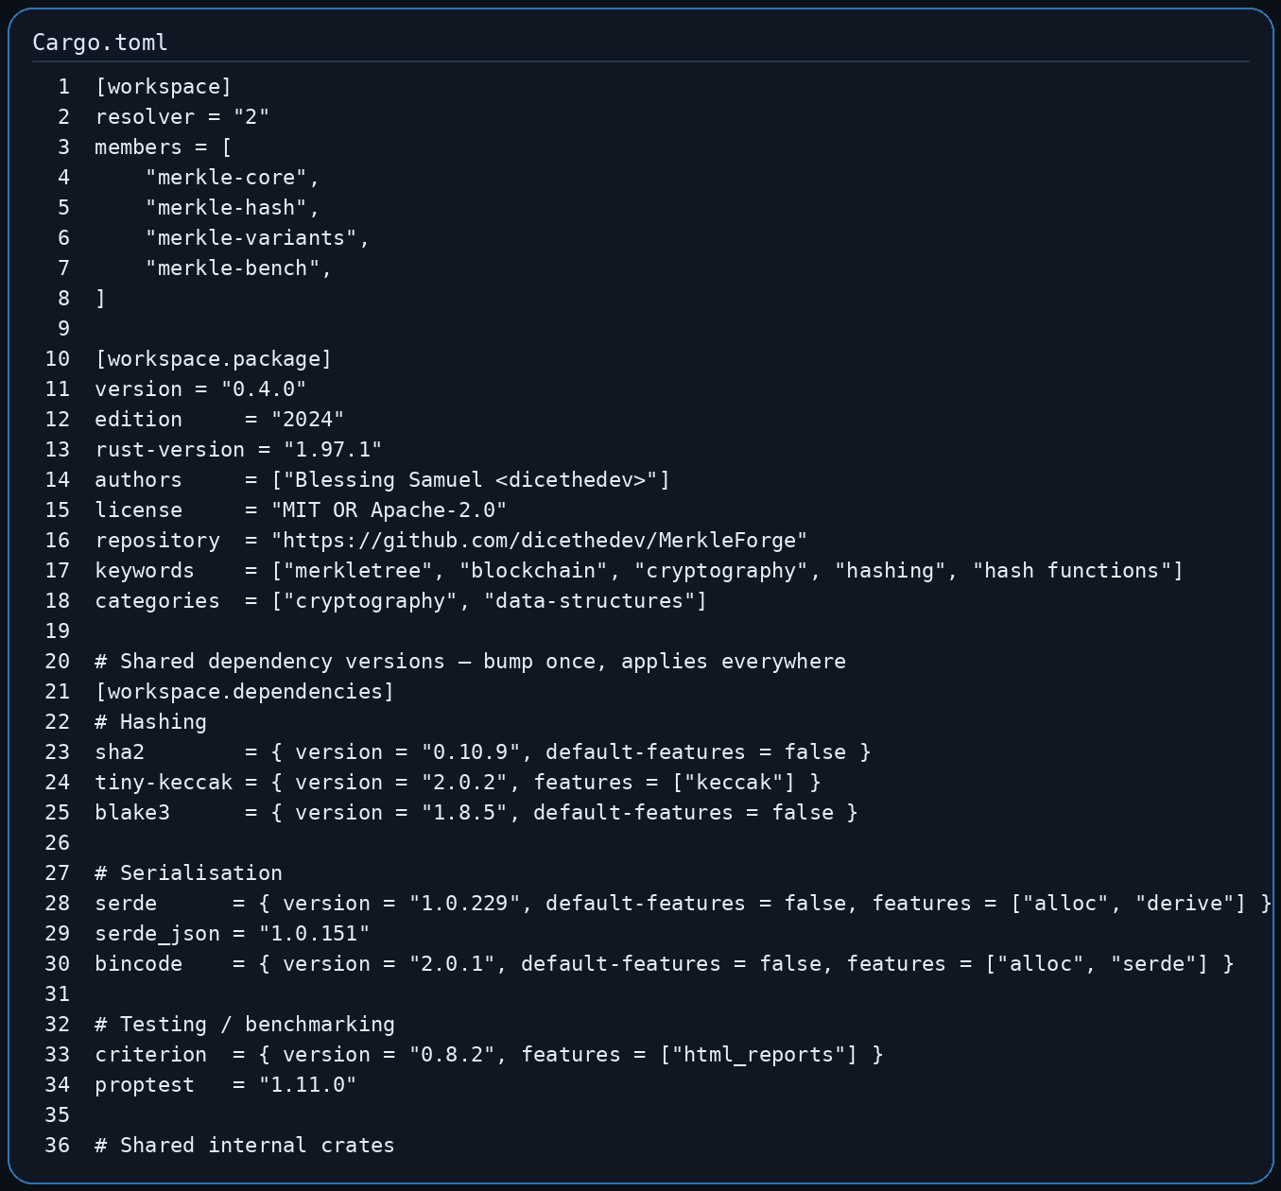
Figure 4.8: Workspace manifest and shared dependency versions
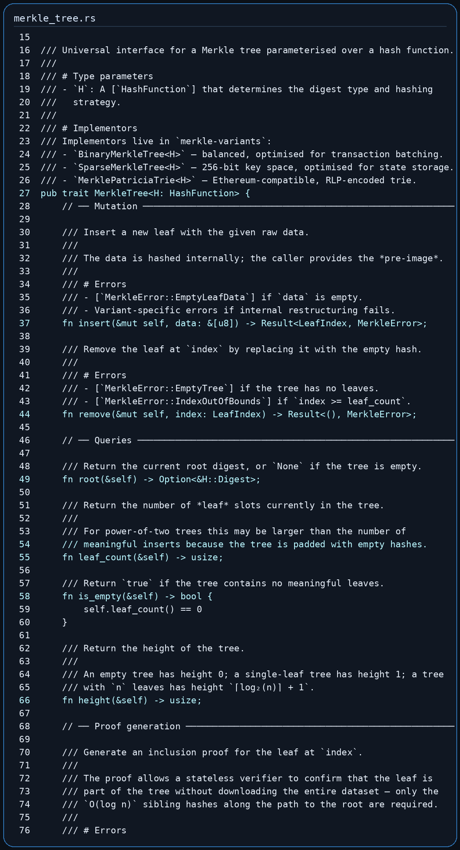
Figure 4.9: Shared MerkleTree and ProofVerifier trait contract
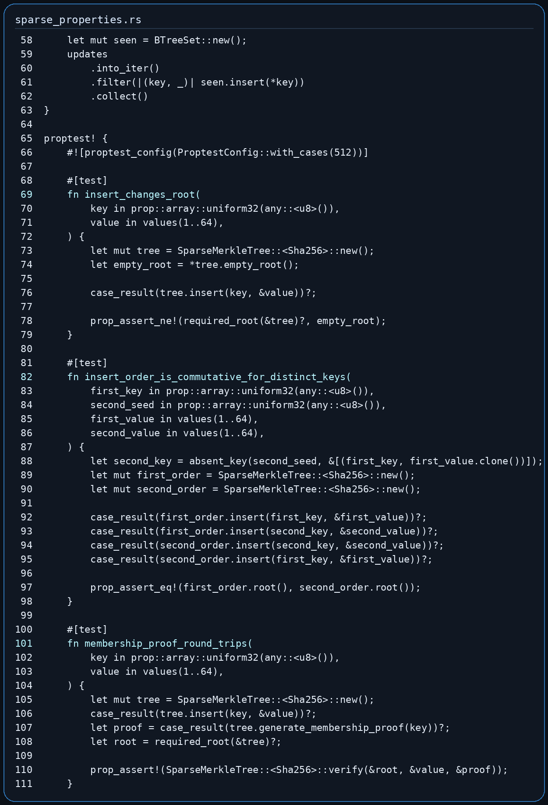
Figure 4.10: Sparse tree property-based tests
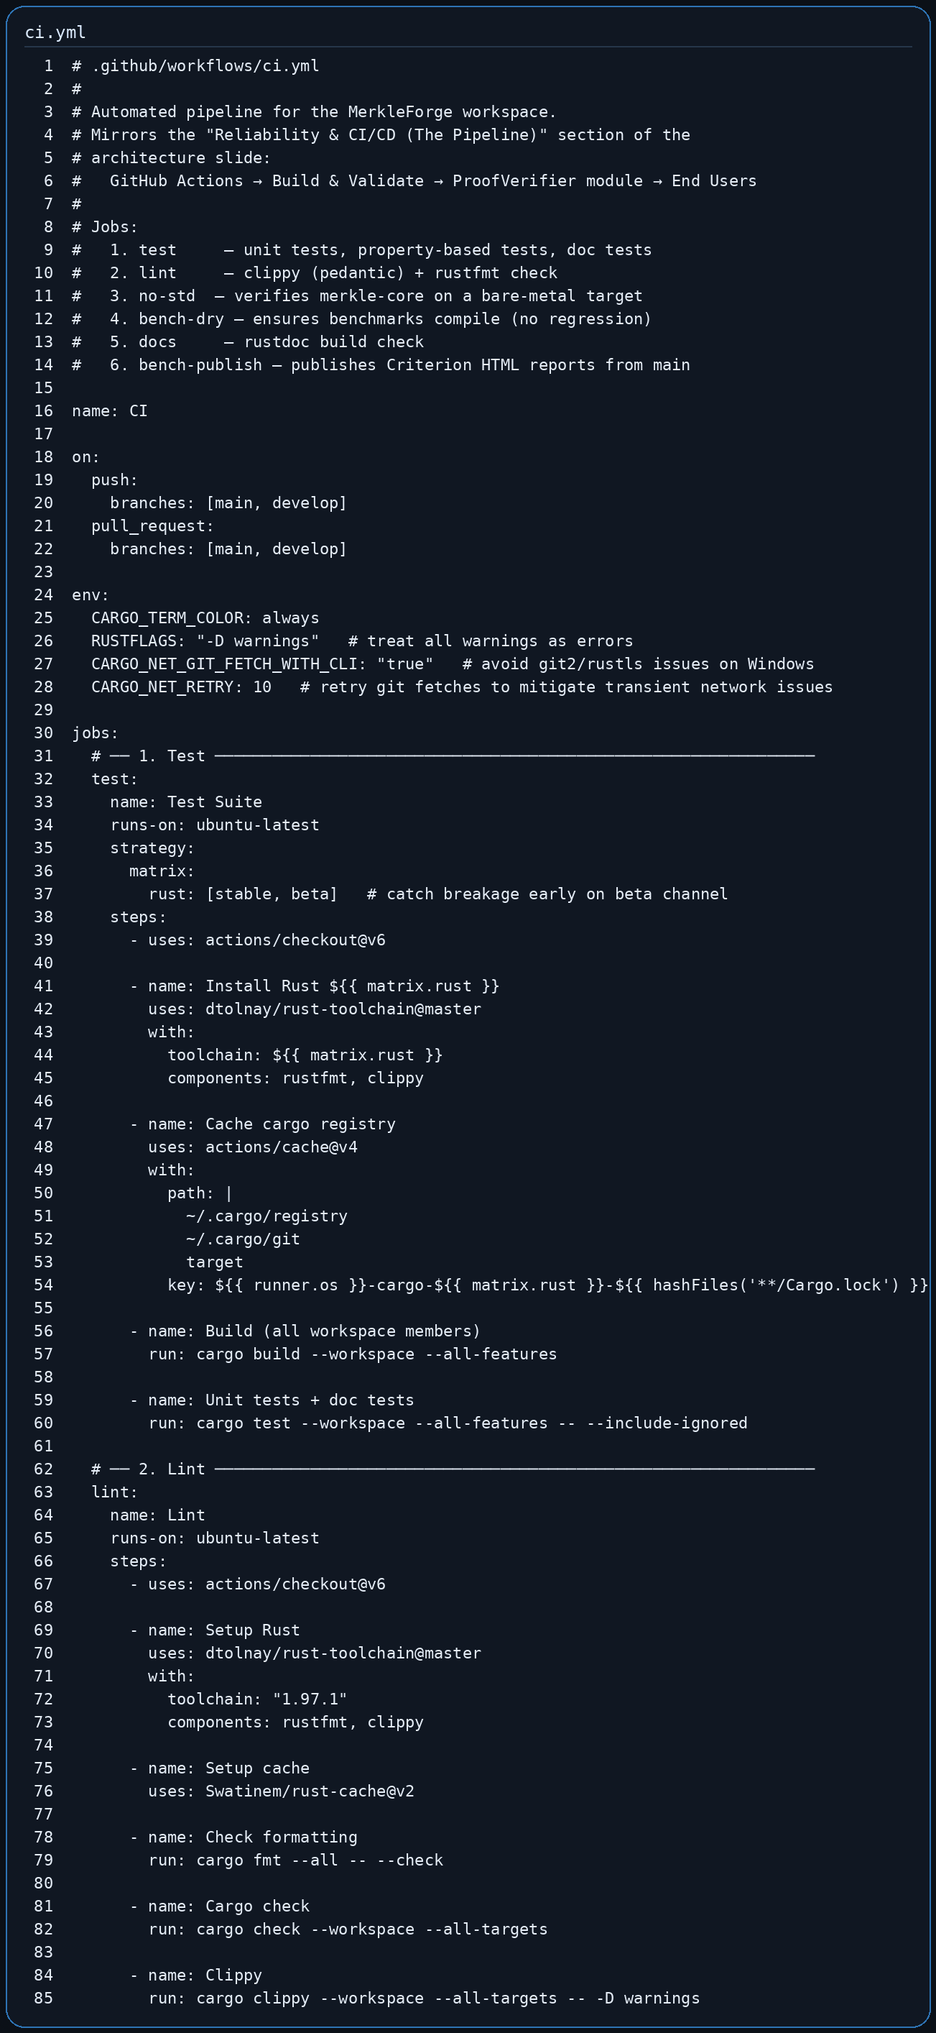
Figure 4.11: GitHub Actions CI workflow
Recommended codebase screenshots to include in the final report:
Figure | Screenshot Content | Suggested File
Figure 4.8 | Workspace manifest and shared dependency versions | `Cargo.toml`
Figure 4.9 | `MerkleTree` and `ProofVerifier` trait definitions | `merkle-core/src/traits/merkle_tree.rs`
Figure 4.10 | Binary tree proof generation implementation | `merkle-variants/src/binary.rs`
Figure 4.11 | Sparse tree membership/non-membership proof tests | `merkle-variants/tests/sparse_properties.rs`
Figure 4.12 | Patricia trie Ethereum vector test | `merkle-variants/tests/patricia_ethereum_vectors.rs`
Figure 4.13 | CI workflow for test, lint, docs, no_std, and benchmark checks | `.github/workflows/ci.yml`

4.3 Testing Strategies
Testing was performed at several levels to ensure that the system works correctly both as individual modules and as an integrated workspace.

Unit Testing
Unit tests were used to test individual functions, data structures, and error conditions. These tests are located mainly inside the Rust source files under merkle-core, merkle-hash, and merkle-variants.
Examples of unit-tested behavior:
- Empty tree initialization.
- Empty leaf rejection.
- Root generation after insert.
- Proof verification success and failure.
- Hash determinism.
- Domain separation between leaf and internal node hashing.
- RLP encoding and decoding for Patricia trie nodes.
- Empty trie root matching the Ethereum known hash.
Local result:
cargo test --workspace
merkle-core: 15 passed
merkleforge-hash: 21 passed
merkle-variants unit tests: 105 passed

Integration Testing
Integration tests verify combined modules working together. These tests are stored under merkle-variants/tests/.
Integration coverage includes:
- binary_trait_contract.rs: verifies that binary trees satisfy the shared
MerkleTree<H> contract across SHA-256, Keccak-256, and BLAKE3.
- binary_properties.rs: verifies binary tree root sensitivity, proof
correctness, tamper detection, and serialization.
- sparse_properties.rs: verifies sparse tree insert/remove behavior,
membership proofs, non-membership proofs, batch-vs-sequential equivalence, and proof serialization.
- patricia_properties.rs: verifies Patricia trie insertion, removal,
canonical root behavior, proof verification, and RLP round-trips.
- patricia_ethereum_vectors.rs: validates Patricia trie root output against
official Ethereum trie test vectors.
Local integration result:
binary_properties: 6 passed
binary_trait_contract: 3 passed
patricia_ethereum_vectors: 3 passed
patricia_properties: 9 passed
sparse_properties: 7 passed
doc tests: 2 passed, 5 ignored

Property-Based Testing
Property-based tests were implemented with Proptest. Instead of testing only a few fixed examples, Proptest generates many random inputs and checks that the system invariants always hold.
Important properties tested:
- Any leaf mutation changes the binary tree root.
- Generated proofs verify immediately after insertion.
- Tampered proof siblings fail verification.
- Removing a leaf invalidates stale proofs.
- Sparse insert order is commutative for distinct keys.
- Sparse non-membership proofs verify for absent keys.
- Sparse batch insert equals sequential insert.
- Patricia insert followed by get returns the inserted value.
- Patricia insert order is canonical for the same key set.
- Patricia RLP encode/decode round-trips generated nodes.

User Acceptance Testing
User Acceptance Testing focused on whether the project could be used by a developer or evaluator without needing to understand the entire internal codebase.
UAT activities:
User Task | Acceptance Observation
Install the crates from the README | Dependency block is copyable and uses published `0.4` versions
Generate a binary tree proof | Quick-start example compiles and shows proof verification
View project documentation | Website documentation page explains installation, proofs, variants, recipes, and safety notes
Run a live proof demo | Website demo allows editing transactions and verifying a selected row in the browser
Inspect benchmark results | Benchmark page and `BENCHMARKS.md` explain latency, throughput, proof size, and comparison data
Verify CI quality | GitHub Actions runs test, lint, docs, no_std check, and benchmark compile checks

4.4 Test Cases And Results
Test Case ID | Test Case | Expected Result | Actual Result | Status
TC-01 | Create a new `BinaryMerkleTree<Sha256>` | Tree is empty and root is `None` | New tree reports empty | Pass
TC-02 | Insert non-empty leaf into binary tree | Leaf count increases and root is created | Root generated successfully | Pass
TC-03 | Insert empty leaf data | Operation returns `MerkleError::EmptyLeafData` | Error returned without mutation | Pass
TC-04 | Generate proof for valid binary leaf | Proof verifies against root and leaf data | Proof verified successfully | Pass
TC-05 | Tamper proof sibling hash | Verification returns `false` | Tampered proof failed verification | Pass
TC-06 | Remove leaf from binary tree | Leaf is removed and root updates | Removal succeeded and stale proof failed | Pass
TC-07 | Create new sparse tree | Root equals precomputed empty sparse root | Empty root cache used | Pass
TC-08 | Sparse insert by 256-bit key | Root changes and leaf count increments | Root changed and leaf stored | Pass
TC-09 | Sparse non-membership proof for absent key | Proof verifies absence against root | Non-membership proof verified | Pass
TC-10 | Sparse batch insert vs sequential insert | Both methods produce same root | Roots matched | Pass
TC-11 | Sparse proof serialization round-trip | Serialized/deserialized proof verifies identically | Round-trip proof remained valid | Pass
TC-12 | Create new Patricia trie | Trie is empty and root is `None` | Empty trie initialized correctly | Pass
TC-13 | Patricia insert then get | Retrieved value equals inserted value | Value retrieved successfully | Pass
TC-14 | Patricia remove then get | Removed key returns `None` | Key removed successfully | Pass
TC-15 | Patricia RLP round-trip | `rlp_decode(rlp_encode(node)) == node` | Round-trip succeeded | Pass
TC-16 | Empty Patricia root | Root equals Ethereum empty trie hash | Matched known Ethereum root | Pass
TC-17 | Official Ethereum trie vectors | Computed roots match expected roots | All vector cases passed | Pass
TC-18 | Hash adapter determinism | Same input produces same digest | Deterministic output confirmed | Pass
TC-19 | Cross-hash trait contract | Tree works with SHA-256, Keccak-256, and BLAKE3 | Contract tests passed | Pass
TC-20 | Website build | React/TypeScript site builds successfully | `npm --prefix website run build` passed | Pass
TC-21 | Workspace test suite | All non-ignored tests pass | `cargo test --workspace` passed | Pass

4.5 Performance Evaluation
Performance was evaluated using Criterion benchmarks. Criterion was selected because it performs statistical measurement and reports confidence intervals, which reduces noise compared to simple stopwatch timing.

Benchmark Environment
Item | Value
CPU | 11th Gen Intel(R) Core(TM) i7-1185G7 @ 3.00GHz
CPU layout | 4 cores / 8 threads, x86_64
RAM | 15 GiB
OS | Linux 7.0.0-28-generic x86_64 GNU/Linux
Rust | rustc 1.97.1
Date | 2026-08-17

Hash Function Performance
Algorithm | 32B latency | 64B latency | 1MB throughput
SHA-256 | 109.60 ns | 177.40 ns | 1.28 GiB/s
Keccak-256 | 1.23 us | 660.99 ns | 291.12 MiB/s
BLAKE3 | 230.70 ns | 247.83 ns | 5.99 GiB/s

Interpretation:
- SHA-256 is strong for small inputs and is widely supported.
- Keccak-256 is required for Ethereum-compatible Patricia trie roots.
- BLAKE3 provides the highest throughput for large data and is useful for
non-Ethereum workloads where maximum software speed is important.

Binary Merkle Tree Performance
Leaves | Construction (SHA-256) | Construction (BLAKE3) | Proof gen | Proof verify
100 | 147.19 us | 140.96 us | 45.22 ns | 1.09 us
1,000 | 1.80 ms | 1.83 ms | 57.21 ns | 1.87 us
10,000 | 30.53 ms | 39.07 ms | 74.18 ns | 2.06 us
100,000 | 268.23 ms | 274.93 ms | 78.69 ns | 2.95 us

Interpretation:
- Construction time grows as the number of leaves increases.
- Proof generation and verification remain very fast because proof paths grow
logarithmically.
- This makes the binary tree suitable for transaction batches and file chunk
verification.

Sparse Merkle Tree Performance
Existing keys | Insert (SHA-256) | Proof gen (SHA-256) | Proof verify (SHA-256) | Non-membership proof
10 | 189.85 us | 244.18 us | 91.43 us | 268.20 us
100 | 2.11 ms | 2.25 ms | 75.74 us | 2.32 ms
1,000 | 20.24 ms | 20.32 ms | 81.58 us | 20.12 ms
10,000 | 181.05 ms | 198.84 ms | 63.00 us | 203.49 ms

Sparse batch updates showed significant improvement compared with repeated sequential insertion:
Batch size | Batch insert | Sequential insert | Speedup
10 | 288.97 us | 1.53 ms | 5.30x
100 | 2.08 ms | 88.12 ms | 42.46x
1,000 | 20.33 ms | 8.69 s | 427.72x

Interpretation:
- Sparse trees are useful for huge state maps where most slots are empty.
- Non-membership proofs are important because they prove that a key does not
exist.
- Batch updates are especially useful for rollup workloads because shared path
segments are recomputed once instead of repeatedly.

Comparative Benchmark Results
Metric | MerkleForge | `rs-merkle` | `merkle_light`
10K leaf construction | 22.77 ms | 3.69 ms | 2.29 ms
Proof size, 10K tree | 469 bytes | 448 bytes | 512 bytes
Proof verification | 1.84 us | 6.39 us | 1.78 us

Interpretation:
- MerkleForge is competitive in proof size and proof verification.
- rs-merkle and merkle_light are faster in the current 10K construction
baseline.
- MerkleForge provides broader functionality because it includes binary, sparse,
and Patricia variants under one API.

Energy-Aware Benchmark
Algorithm | 100K construction time | CPU cycles | Energy package joules
SHA-256 | 463.52 ms | not captured | not captured
Keccak-256 | 1.49 s | not captured | not captured
BLAKE3 | 261.02 ms | not captured | not captured

The current energy-aware benchmark records wall-clock construction time. CPU cycles and package joules require Linux perf or another power measurement tool on supported hardware. These fields should be regenerated on the final benchmark machine before the final paper submission.

4.6 Application Manual

Steps For User Operations

A. Install MerkleForge Crates
Add the crates to a Rust project's Cargo.toml:
[dependencies]
merkle-core = "0.4"
merkleforge-hash = "0.4"
merkle-variants = "0.4"

B. Create A Binary Merkle Tree
use merkle_core::prelude::*;
use merkle_variants::BinaryMerkleTree;
use merkleforge_hash::Sha256;
fn main() -> Result<(), MerkleError> {
let mut tree = BinaryMerkleTree::<Sha256>::new();
tree.insert(b"alice:100")?;
tree.insert(b"bob:250")?;
let root = tree.root().expect("tree is not empty");
println!("root: {:?}", root);
Ok(())
}

C. Generate And Verify A Proof
let proof = tree.generate_proof(LeafIndex(0))?;
let valid = BinaryMerkleTree::<Sha256>::verify(root, b"alice:100", &proof);
assert!(valid);

D. Run The Stateless Light-Client Demo
cargo run -p merkle-variants --example light_client
Expected output:
server: built tree and exported root + proof
client: tree dropped before verification
Stateless verification: true

E. Run Tests
cargo test --workspace
For the release-style test command:
make test

F. Run Linting And Formatting
make fmt
make lint

G. Run Benchmarks
cargo bench --bench hash_throughput
cargo bench --bench binary_tree
cargo bench --bench sparse_tree
cargo bench --bench patricia_trie
cargo bench --bench comparison
cargo bench --bench bench_energy
Criterion reports are generated under:
target/criterion/

H. Run The Website Locally
npm --prefix website ci
VITE_BASE_PATH=/ npm --prefix website run build
VITE_BASE_PATH=/ npm --prefix website run preview
Then open:
http://127.0.0.1:4173/

Changeover Procedures
The changeover procedure explains how to move from manual local development to the deployed project state.

1. Development Changeover
- Create or update a feature branch from develop.
- Implement the change in the correct crate or website module.
- Run formatting, linting, tests, and any relevant benchmark compile checks.
- Commit the change with a clear conventional commit message.
- Push the branch and open a pull request into develop.
- Review CI results and resolve all failures.
- Merge into develop after review.

2. Release Changeover
- Merge develop into main through a pull request.
- Ensure CI passes on main.
- Run the manual release workflow with the target version.
- Confirm that crates are published to crates.io.
- Confirm that the GitHub release tag exists.
- Confirm that documentation and website pages point to the correct version.

3. Benchmark Publishing Changeover
- Push benchmark-ready code to main.
- The benchmark publishing workflow runs Criterion benchmarks.
- Generated reports are copied into the GitHub Pages artifact.
- The website dashboard links users to the latest benchmark reports.
- BENCHMARKS.md should be updated when new final benchmark numbers are
collected.

4. User Changeover
For users moving from another Merkle library:
- Install merkle-core, merkleforge-hash, and merkle-variants.
- Replace library-specific tree construction with a MerkleForge tree variant.
- Choose the hash adapter required by the application.
- Generate a root and proof using the MerkleForge API.
- Verify proofs statelessly using only the root, proof, and target data.
- Use benchmarks to decide whether binary, sparse, or Patricia storage best
fits the workload.

Summary
Session Four produced a complete implementation and testing record for MerkleForge. The system now includes reusable Rust crates, multiple Merkle tree variants, stateless proof verification, Ethereum-compatible Patricia trie support, property-based tests, official Ethereum vector validation, benchmark evidence, and a React documentation website with a live proof demo.
The local verification run confirmed that the workspace test suite passed:
cargo test --workspace
Result: passed
The remaining performance documentation work is to capture final RSS memory usage and complete any benchmark rows currently marked not captured in BENCHMARKS.md on the final evaluation machine.

