Some title

Some title
And a small subtitle
- This is part one
  - heading one in /main.md
- This is part two
  - To do
  - heading level 2 in the .md
    - heading level 3 in the .md
  - Heading level 1 (should become 2) in content/a_outerfolder/main.md
  - Heading level 1 (should become 2) in content/b_outerfolder/main.md
  - Heading level 1 (should become 2) in content/c_outerfolder/main.md
    - hello from behe
    - hullow from b_boho
  - hellobd
- another top level heading

This is part one

heading one in /main.md
Edit made on new os.
paragraph in /main.md
note the things in parts must be directories which contain a main.md. That main.md file may also have a parts section for including further files, etc.
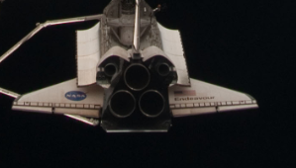
alt text

This is part two

To do
- Closely match the appearance of my latex documents from a year ago
  - same border spacing
  - same structure, e.g. have an abstract/terminology/progress sections, bibliography/appendix etc
  - make top level headings as ‘parts’, e.g. part 1, part 2,
well let’s consider this algorithm
def mainko(bozo):
return "hungry"
as well as this
int mainko(int bozo){
return ERROR_UNDEF;
}

heading level 2 in the .md
aaa

heading level 3 in the .md
bbb
todo - make the key:value thing in parts be section parts to filenames, e.g. for abstract, progress, etc?

Heading level 1 (should become 2) in content/a_outerfolder/main.md
Content below that heading in the markdown file
xxx change
let’s see if this mermaid filter works. Should look like the example from https://github.com/raghur/mermaid-filter

Now let’s try another, this one from here: https://stackoverflow.com/questions/68561397/mermaid-syntax-error-on-trying-render-a-diagram-on-github-md-file

This is a link to demo doc 2, clicking this link should open the file, which should be copied to the output folder.

Heading level 1 (should become 2) in content/b_outerfolder/main.md
Content below that heading in the markdown file. A nested list test follows.
- This is one element
- Another
  - And a nested element
    - with a nested dot
    - another
  - More element
- Outer end of list
Note that there are two more subfolders here, however they are not referenced in this markdown file, and hence are not integrated into the final document.
This is a link to demo doc 3, clicking this link should open the file, which should be copied to the output folder.

Heading level 1 (should become 2) in content/c_outerfolder/main.md
ffbc

hello from behe
hohoe

jfdksllkjfdslkjfds
bo how bew stant
now let’s add an image
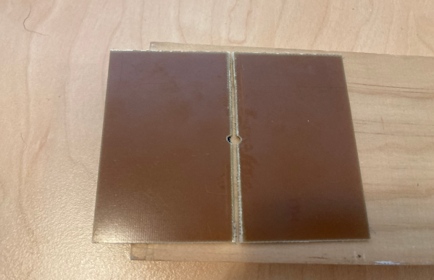
Here’s me doing some PCB stuff

hullow from b_boho
as a paragraph
alt text

as a second level heading
huahua
another end line… helps?

hellobd
ffbd

another top level heading
here’s a copy-pasted thing of the parts - does it work?
This is a link to demo doc 1, clicking this link should open the file, which should be copied to the output folder.
Lets make an external link which is this to a file outside/above this project.

