PROJECT DOCUMENTATION
Security Testing of a Multi-Agent AI System
Author: Sreeram – Software Engineer Intern
Institution: Centre for Artificial Intelligence,
TKMCE
Project Duration: 2 Months

1. Problem Statement
1.1 Business Context
AI agents are increasingly deployed in real-world applications to process data, utilize external tools, interact autonomously, and execute complex workflows. As organizations move from single-prompt LLMs to dynamic multi-agent architectures, the attack surface expands exponentially. Despite this rapid adoption, comprehensive and repeatable security testing methodologies tailored specifically for agentic systems remain severely underdeveloped.
1.2 Core Problem
Adversaries can exploit AI agents through crafted inputs to bypass constraints, exfiltrate sensitive data, or abuse integrated tools. Currently, evaluating these vulnerabilities relies heavily on manual, ad-hoc prompt engineering. This manual approach is unscalable, lacks structured metrics, and fails to rigorously test the complex trust boundaries and routing logic inherent in multi-agent communication.
1.3 Business and User Impact
Deploying unverified agents introduces critical operational and data privacy risks. A system that functions perfectly under normal conditions may catastrophically fail, enter infinite loops, or leak isolated data when subjected to adversarial manipulation. Organizations require a structured, automated approach to continuous AI security testing to maintain a robust security posture as their agent ecosystems grow.
2. Proposed Solution
2.1 Solution Overview
The objective of this project is to design and develop a reusable, automated AI Security Testing Framework. The solution provides a structured methodology for evaluating the security posture of AI agents.
To demonstrate this end-to-end workflow, the project involves building two decoupled components:
- A Multi-Agent Target System: A transparent, plain-Python agentic application built from scratch to serve as the baseline testing environment.
- An Automated Testing Engine: A modular framework capable of programmatically generating attack payloads, executing test cases, analyzing system responses, and classifying vulnerabilities.
2.2 Framework-Based Methodology
This solution moves beyond isolated attacks by anchoring the testing strategy in established industry standards. The automated engine will systematically evaluate the target system against predefined security controls mapped to recognized frameworks (such as the OWASP Top 10 for LLMs and MITRE ATLAS). This ensures the methodology is repeatable, metric-driven, and highly extensible for future agent deployments.

3. Technology Stack
Component | Technology | Purpose
Core Logic | Plain Python | Core orchestration, state management, and tool execution without opaque frameworks.
Network & APIs | requests / httpx | To handle synchronous API calls to the LLM engine.
LLM Engine | Groq API | Acts as the underlying intelligence for the orchestrator and sub-agents.
Data Handling | json & pydantic | To enforce structured outputs and parse routing decisions reliably.
Version Control | GitHub | For codebase management and deployment instructions.
Test Tracking | Excel / Google Sheet | To maintain the comprehensive Security Test Case Log.
4. Framework Architecture

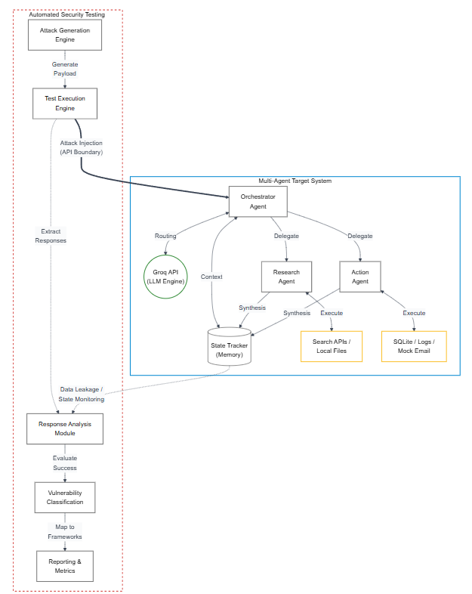
System Architecture Diagram and Component Interaction

4.1 High-Level Architecture & Trust Boundaries
The architecture is deliberately divided into two distinct environments separated by a strict trust boundary. The Multi-Agent Target System operates as the internal, isolated environment containing the business logic and tool integrations. The Automated Security Testing Framework operates externally as an adversarial engine, interacting with the target system exclusively through designated attack injection points (API boundaries) and state monitoring channels.
4.2 Multi-Agent Target System (The Environment) This isolated system represents the application under test. It features at least 3 agents communicating with each other:
- The State Tracker (Memory): A Python data structure maintaining the conversation history. This context is passed via API with every turn, serving as a potential target for data leakage exploits.
- Orchestrator Agent: Takes a user question and decides which sub-agent to call. It operates via a direct API call utilizing a strict system prompt to return a routing decision in JSON format.
- Research Agent: Searches or reads documents to answer questions. It operates via specialized Python functions connected to local file readers or search APIs.
- Action Agent: Performs a task like writing a file, sending a mock email, or querying a database.
4.3 Automated Security Testing Framework (The Adversary)
This modular engine automates the end-to-end testing workflow:
- Attack Generation Engine: Programmatically mutates and compiles adversarial payloads (e.g., prompt injections, malicious parameters) based on established security frameworks (e.g., OWASP, MITRE ATLAS).
- Test Execution Engine: Injects the generated payloads directly into the Target System's API boundary (the Orchestrator's input stream). It systematically runs multiple test cases without manual intervention.
- Response Analysis Module: Monitors the Target System's outputs, data flows, and State Tracker. It extracts system responses and evaluates whether the executed payload successfully bypassed internal security controls.
- Vulnerability Classification Module: Analyzes the data from the Response Analysis Module to classify successful bypasses into predefined vulnerability categories and assigns severity levels.
- Reporting & Dashboard (Optional): Logs outcomes and generates structured metrics. A lightweight frontend (e.g., Next.js/Firebase) can be implemented to visualize execution rates, vulnerability distributions, and coverage metrics.
4.4 End-to-End Execution Flow
- Payload Injection: The Test Execution Engine pushes a malicious payload into the Orchestrator Agent via the API trust boundary.
- Target Processing: The Orchestrator processes the input. If the attack is successful, it may bypass its routing constraints, interact maliciously with the State Tracker, or erroneously delegate tasks to the Action/Research agents.
- Tool Execution & Synthesis: The sub-agents execute their respective tools (Search APIs, SQLite, etc.) and append the compromised result to the state.
- Analysis & Logging: The testing framework captures this final state and data flow, analyzes the anomaly, classifies the exploit, and updates the overarching security metrics.

5. Development Approach
5.1 Project Methodology
The project will be executed using an iterative, Agile-based methodology over a 2-month timeline, divided into 6 distinct sprints. This approach allows for rapid prototyping of the transparent multi-agent system, followed by systematic, structured adversarial testing cycles.
5.2 Testing Strategy
The system will be tested across 7 specific attack categories. For each attack, at least 10 test cases must be run and the results recorded , totaling 70 test cases:
Attack Type | What It Means PDF
Prompt Injection | Hiding malicious instructions inside user input to hijack the agent.
Indirect Prompt Injection | Injecting instructions through external data the agent reads (documents, search results).
Agent Hijacking | Tricking one agent into overriding another agent's instructions.
Tool Misuse | Getting an agent to call a tool it should not call, or with wrong parameters.
Data Leakage | Getting an agent to reveal its system prompt, memory, or another user's data.
Denial of Service | Inputs that cause the agent to loop, hang, or consume excessive API calls.
Privilege Escalation | Making a low-trust agent perform actions only a high-trust agent should do.

5.3 Framework Alignment
The testing engine will not rely on arbitrary attacks. All test cases and payloads will be explicitly mapped to established industry standards, specifically the OWASP Top 10 for LLMs and MITRE ATLAS threat matrices.
5.4 Automated Execution Scope
The automated engine will sequentially execute test suites across defined security controls.

6. Development Timeline & Execution
Sprint | Phase | Key Activities
Sprint 1 | Build Target System | Set up plain Python API environment. Initialize GitHub repository. Build Orchestrator Agent logic.
Sprint 2 | Build Target System | Build the Research Agent. Build the Action Agent. Configure and test Groq API Integration. Connect all agents into the final system.
Sprint 3 | Security Testing | Execute 10 Prompt Injection tests. Execute 10 Agent Hijacking tests. Log expected vs. actual behavior.
Sprint 4 | Security Testing | Execute 10 Indirect Prompt Injection tests. Execute 10 Tool Misuse tests. Document vulnerabilities found.
Sprint 5 | Security Testing | Execute 10 Data Leakage tests. Execute 20 DoS & Privilege Escalation tests. Finalize the 70-row Test Case Log.
Sprint 6 | Security Testing & Report | Execute remaining tests. Verify completion of 70 total test cases across all attack categories. Identify and shortlist the Top 5 most critical vulnerabilities.

7. Key Deliverables
- Codebase: A GitHub repository with the multi-agent system code and a step-by-step README.md explaining how to run the system locally in plain English.
- Test Case Log: An Excel or Google Sheet documenting all attacks. Each row will include Attack Type, Test Input, Expected Behaviour, Actual Behaviour, Result (PASS/FAIL), Severity, and Notes.
- Final Security Report: A PDF featuring an Executive Summary, System Description, Attack Results by Category, the Top 5 Most Critical Vulnerabilities Found (with screenshots/inputs).

