Graduate Institute of Communication Engineering
College of Electrical Engineering and Computer Science
National Taiwan University
Term Paper

An Implementation for
JPEG Decoder

Student Name: Ying-Wun Huang
Student ID: R00942033
Student Name: Yi-Fan Chang
Student ID: R00942127

Advisor: Jian-Jiun Ding, Ph.D.

June, 2012

CONTENTS

CONTENTS i
LIST OF FIGURES ii
LIST OF TABLES iii
Chapter 1 Introduction 1
Chapter 2 The JPEG Decoder 3
2.1 Read Header 3
2.1.1 Read Quantization Table 4
2.1.2 Read Frame Header 7
2.1.3 Read Huffman Table 8
2.2 Cluster for Huffman Table 14
2.2.1 Introduction 14
2.2.2 Proposed Method 15
2.2.3 Jumping Over the Clusters 15
2.2.4 Example of Decoding a Codeword 16
2.3 Read Bitstream of Huffman coding 18
Chapter 3 Experimental Results and Conclusion 20
3.1 How to Run This Program 20
3.2 Decoded Result 24
3.3 Conclusion 24
REFERENCE 25

LIST OF FIGURES

Fig. 1.1 Flow chart of JPEG encoder and decoder. (a) Encoder, (b) Decoder. 1
Fig. 2.1 lena.jpg 3
Fig. 2.2 JFIF and quantization table in JPEG file. 4
Fig. 2.3 Zigzag-scanning for 8x8 block. 5
Fig. 2.4 Frame header and Huffman table in JPEG file. 6
Fig. 2.5 4:2:0 8
Fig. 2.6 Single-side growing Huffman tree (SGH-tree). [1] (a) 5 level, (b) 13 level. 14
Fig. 2.7 Change the 13-level SGH-tree into the super tree (S-tree). [1] 15
Fig. 2.8 Example for jumping over the clusters. [1] 18
Fig. 2.9 Bitstream of Huffman code in JPEG file. 19
Fig. 3.1 JPEGDecoderDemo.exe in command window. 20
Fig. 3.2 Parts of lena.jpg in Parser.txt. 21
Fig. 3.3 Parts of lena.jpg in Parser.txt. 22
Fig. 3.4 Details of decoding steps in command window. 23
Fig. 3.5 The decoded result. (a) lena.jpg, (b) lena.bmp 24

LIST OF TABLES

Table. 2.1 Some markers of the JPEG header 4
Table. 2.2 Quantization table for luminance 5
Table. 2.3 Quantization table for chrominance. 6
Table. 2.4 Number of codeword v.s. codelength for Huffman table for luminance DC. 9
Table. 2.5 Huffman table for luminance DC. 10
Table. 2.6 Number of codeword v.s. codelength for Huffman table for luminance AC. 10
Table. 2.7 Part of Huffman table for luminance AC. 11
Table. 2.8 Number of codeword v.s. codelength for Huffman table for chrominance DC. 12
Table. 2.9 Huffman table for chrominance DC 12
Table. 2.10 Number of codeword v.s. codelength 13
Table. 2.11 Part of Huffman table for chrominance AC. 13
Table. 2.12 SGH table. [1] 16

Introduction

Generally speaking, the JPEG decoder is the inverse of JPEG encoder as shown in Fig. 1.1.
(a)
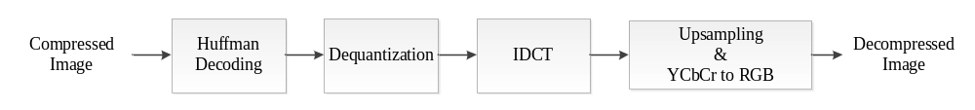
(b)
Fig. 1.1 Flow chart of JPEG encoder and decoder. (a) Encoder, (b) Decoder.

A brief description of the JPEG encoder:
- Reading the pixel value of the original image in RGB color space.
- Transfer the RGB color space to YCbCr space since the human eyes are sensitive to luminance than chrominance which can be downsampled (ex. 4:2:0) to save the storage.
- Transfer the YCbCr space from space domain to frequency domain by discrete cosine transform (DCT) since the human eyes are sensitive to low frequency than high frequency which can be hardly quantized to save the storage.
- Using quantization to decrease the DCT coefficient values required to recode.
- Encode the bitstream by Huffman coding due to the probability distribution of symbols. Symbols with high probability will have shorter codelength, which is a good property to decrease the memory usage.
A brief description of the JPEG decoder:
- Reading the bitstream and decode by Huffman decoding.
- Dequantize the quantized DCT coefficient values.
- Do the inverse DCT (IDCT) to transfer the YCbCr space from frequency domain to space domain.
- Reconstruct the chrominance by upsampling and transfer the YCbCr space to RGB color space.
- Save the pixel value to the bitmap in RGB space and output the decompressed image.
In the following chapters, we will discuss the JPEG decoder in details and show the experimental results.

The JPEG Decoder

In this chapter, we will introduce the JPEG decoder step by step. Here we give an example of decoding a JPEG image “lena.jpg” compressed by Paint on Windows 7.
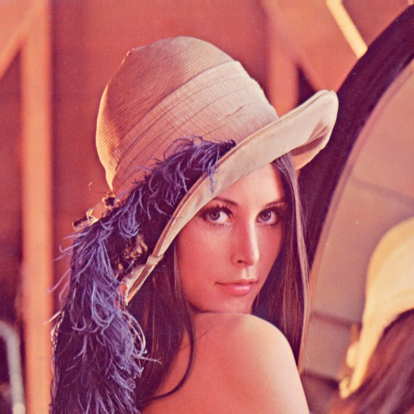
Fig. 2.2 lena.jpg

Read Header
For the purpose of discussing the content of a JPEG file, we show the file in hexadecimal with PSPad which is a text editor (available at http://www.pspad.com/en/download.php).
From Fig. 2.3, we can find that it comes with “FF DB” in the beginning, which is the marker “SOI”. The meaning of the marker can be found in Table. 2.1. “FF E0” comes after “FF D8”, which is the beginning of the JFIF header (information about JFIF can be found at http://en.wikipedia.org/wiki/JPEG_File_Interchange_Format).
After the JFIF header, we will start to recode 6 important tables which are quantization table for luminance, quantization table for chrominance, Huffman table for luminance DC, Huffman table for luminance AC, Huffman table for chrominance DC and Huffman table for chrominance AC.
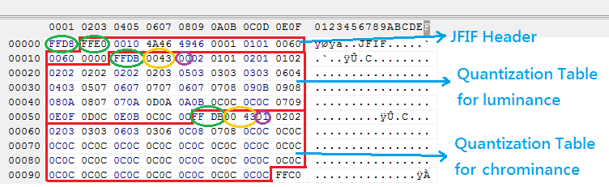
Fig. 2.3 JFIF and quantization table in JPEG file.

Table. 2.1 Some markers of the JPEG header
Name | Code (HEX) | Description
SOI | FFD8 | Start Of Image
EOI | FFD9 | End Of Image
SOF | FFC0 | Start Of Frame
SOS | FFDA | Start Of Scan
DHT | FFC4 | Define Huffman Table
DQT | FFDB | Define Quantization Table
 | FFE0 | JFIF marker

Read Quantization Table
From Fig. 2.3 and Table. 2.1, the quantization tables are start from “FF DB”.
For the quantization table – luminance:
- “00 43”: The length of quantization table is 43-2(“00 43”)-1(“00”) =40(Hex) =64(Dec).
- “00”: The marker of quantization table for luminance.
- “02 01”~”0C 0C”: The content of quantization table for luminance, which should be record in zigzag form (Fig. 2.4) as shown in Table. 2.2.
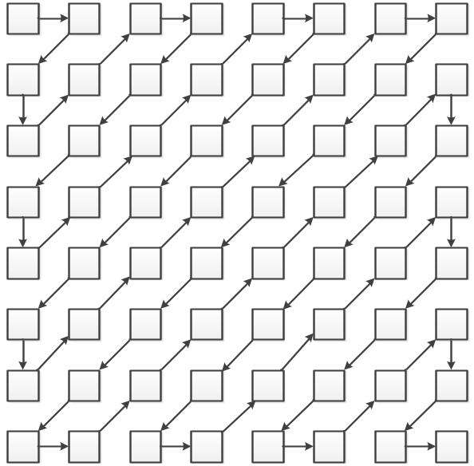
Fig. 2.4 Zigzag-scanning for 8x8 block.

Table. 2.2 Quantization table for luminance
2 | 1 | 1 | 2 | 3 | 5 | 6 | 7
1 | 1 | 2 | 2 | 3 | 7 | 7 | 7
2 | 2 | 2 | 3 | 5 | 7 | 8 | 7
2 | 2 | 3 | 3 | 6 | 10 | 10 | 7
2 | 3 | 4 | 7 | 8 | 13 | 12 | 9
3 | 4 | 7 | 8 | 10 | 12 | 14 | 11
6 | 8 | 9 | 10 | 12 | 15 | 14 | 12
9 | 11 | 11 | 12 | 13 | 12 | 12 | 12

For the quantization table –chrominance:
- “00 43”: The length of quantization table is 43-2(“00 43”)-1(“00”) =40(Hex) =64(Dec).
- “01”: The marker of quantization table for chrominance.
- “02 02”~”0C 0C”: The content of quantization table for chrominance, which should be record in zigzag form (Fig. 2.4) as shown in Table. 2.3.

Table. 2.3 Quantization table for chrominance.
2 | 2 | 3 | 6 | 12 | 12 | 12 | 12
2 | 3 | 3 | 8 | 12 | 12 | 12 | 12
3 | 3 | 7 | 12 | 12 | 12 | 12 | 12
6 | 8 | 12 | 12 | 12 | 12 | 12 | 12
12 | 12 | 12 | 12 | 12 | 12 | 12 | 12
12 | 12 | 12 | 12 | 12 | 12 | 12 | 12
12 | 12 | 12 | 12 | 12 | 12 | 12 | 12
12 | 12 | 12 | 12 | 12 | 12 | 12 | 12

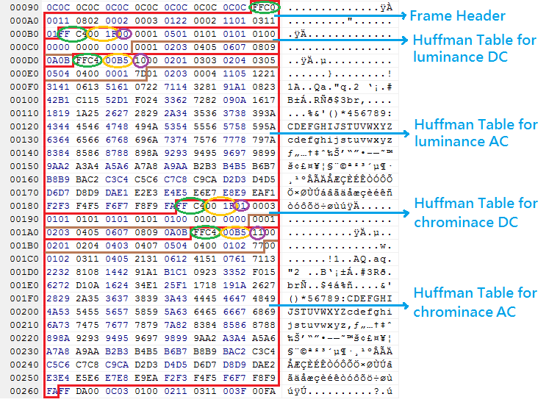
Fig. 2.5 Frame header and Huffman table in JPEG file.

Read Frame Header
“FF C0” means start of the frame header which contains the information about the frame such as frame height, frame width, subsampling mode, etc. The following are the details of frame header in Fig. 2.5:
- “00 11”: The length of the frame header is 11(Hex) = 17(Dec).
- “08”: Range of pixel value is 0~255(8 bit).
- “02 00”: The height of the frame is 200(Hex) = 512(Dec).
- “02 00”: The width of the frame is 200(Hex) = 512(Dec).
- “03”: Number of components is 3 (Y, Cb, Cr).
- “01”: ID of Y.
- “22”: The horizontal sampling factor of Y is H_{Y}=2, and the vertical sampling factor of Y is V_{Y}=2.
- “00”: Quantization table number of Y.
- “02”: ID of Cb.
- “11”: The horizontal sampling factor of Cb is H_{Cb}=1, and the vertical sampling factor of Cb is V_{Cb}=1.
- “01”: Quantization table number of Cb.
- “03”: ID of Cr.
- “11”: The horizontal sampling factor of Cr is H_{Cr}=1, and the vertical sampling factor of Cr is V_{Cr}=1.
- ”01”: Quantization table number of Cr.

The frame sizes of each component can be calculated from frame height, frame width, and sampling factors. In this case, the maximum horizontal sampling factor is H_{max}=2 and maximum vertical sampling factor is V_{max}=2.
Thus, the frame sizes of each component are:
- Frame width of Y: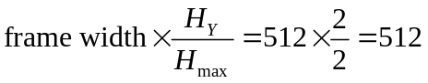
- Frame height of Y: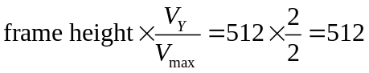
- Frame width of Cb: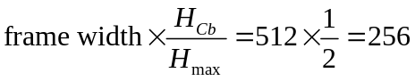
- Frame height of Cb: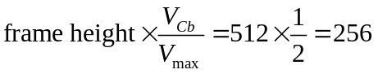
- Frame width of Cr: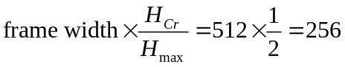
- Frame height of Cr: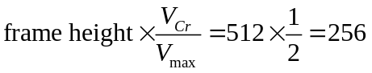

From the sampling factors, it can be found that Cb and Cr are downsampled in every 2 pixels in both vertical and horizontal direction. Therefore, the subsampling mode in this case is 4:2:0 as shown in Fig. 2.6.

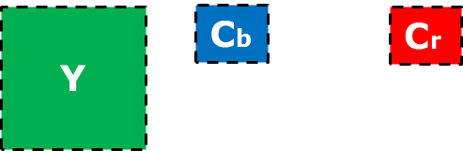
Fig. 2.6 4:2:0

Read Huffman Table
In this section, we will read the Huffman table in the JPEG file first, and then cluster the Huffman table by the method in section 2.2.
The following are the details of Huffman table for luminance DC in Fig. 2.5:
- “FF C4”: Define Huffman table which is the start marker.
- “00 1F”: The number of category is 1F - 2(“00 1F”) - 1(“00”) – 10(“00 01~00 00”) =D(Hex)=12(Dec).
- “00”: Huffman Table for luminance DC.
- “00 01”~”00 00”: Numbers of codeword with codelength equal to 1~16. The detail of this case is shown in Table. 2.4.
- “00 01”~”0A 0B”: Category of Huffman table for luminance DC.
Now we can generate the Huffman table for luminance DC with Table. 2.4 and algorithm 1. The result is shown in Table. 2.5.

Table. 2.4 Number of codeword v.s. codelength for Huffman table for luminance DC.
Codelength | 1 | 2 | 3 | 4 | 5 | 6 | 7 | 8 | 9 | 10 | 11 | 12 | 13 | 14 | 15 | 16
Number of  Codeword | 0 | 1 | 5 | 1 | 1 | 1 | 1 | 1 | 1 | 0 | 0 | 0 | 0 | 0 | 0 | 0

Algorithm 1: Generate Huffman table
i = 0, codevalue = 0;
for(k = 1; k <= 16; k++)
{
for(j = 1; j <= number_of_codeword[k]; j++)
{
codeword[i] = codevalue;
codelength[i] = k;
codevalue++;
i++;
}
codevalue *= 2;
}

Table. 2.5 Huffman table for luminance DC.
Category | Codelength | Codeword
00 | 2 | 00
01 | 3 | 10
02 | 3 | 11
03 | 3 | 100
04 | 3 | 101
05 | 3 | 110
06 | 4 | 1110
07 | 5 | 11110
08 | 6 | 111110
09 | 7 | 1111110
0A | 8 | 11111110
0B | 9 | 111111110

The following are the details of Huffman table for luminance AC in Fig. 2.5:
- “FF C4”: Define Huffman table which is the start marker.
- “00 B5”: The number of category is B5 - 2(“00 B5”) - 1(“00”) – 10(“00 02~00 7D”) =A2(Hex)=162(Dec).
- “10”: Huffman Table for luminance AC.
- “00 02”~”00 7D”: Numbers of codeword with codelength equal to 1~16. The detail of this case is shown in Table. 2.6.
- “01 02”~”F9 FA”: Category of Huffman table for luminance AC.
Now we can generate the Huffman table for luminance AC with Table. 2.6 and algorithm 1. The result is shown in Table. 2.7.

Table. 2.6 Number of codeword v.s. codelength for Huffman table for luminance AC.
Codelength | 1 | 2 | 3 | 4 | 5 | 6 | 7 | 8 | 9 | 10 | 11 | 12 | 13 | 14 | 15 | 16
Number of  codeword | 0 | 2 | 1 | 3 | 3 | 2 | 4 | 3 | 5 | 5 | 4 | 4 | 0 | 0 | 1 | 125

Table. 2.7 Part of Huffman table for luminance AC.
Category | Codelength | Codeword
01 | 2 | 00
02 | 2 | 01
03 | 3 | 100
00 | 4 | 1010
04 | 4 | 1011
11 | 4 | 1100
05 | 5 | 11010
12 | 5 | 11011
21 | 5 | 11100
31 | 6 | 111010
41 | 6 | 111011
… | … | …
EA | 16 | 1111111111110100
F1 | 16 | 1111111111110101
F2 | 16 | 1111111111110110
F3 | 16 | 1111111111110111
F4 | 16 | 1111111111111000
F5 | 16 | 1111111111111001
F6 | 16 | 1111111111111010
F7 | 16 | 1111111111111011
F8 | 16 | 1111111111111100
F9 | 16 | 1111111111111101
FA | 16 | 1111111111111110

The following are the details of Huffman table for chrominance DC in Fig. 2.5:
- “FF C4”: Define Huffman table which is the start marker.
- “00 1F”: The number of category is 1F - 2(“00 1F”) - 1(“00”) – 10(“00 01~00 00”) =D(Hex)=12(Dec).
- “01”: Huffman Table for chrominance DC.
- “00 03”~”00 00”: Numbers of codeword with codelength equal to 1~16. The detail of this case is shown in Table. 2.8.
- “00 01”~”0A 0B”: Category of Huffman table for chrominance DC.
Now we can generate the Huffman table for chrominance DC with Table. 2.8 and algorithm 1. The result is shown in Table. 2.9.

Table. 2.8 Number of codeword v.s. codelength for Huffman table for chrominance DC.
Codelength | 1 | 2 | 3 | 4 | 5 | 6 | 7 | 8 | 9 | 10 | 11 | 12 | 13 | 14 | 15 | 16
Number of  codeword | 0 | 3 | 1 | 1 | 1 | 1 | 1 | 1 | 1 | 1 | 1 | 0 | 0 | 0 | 0 | 0

Table. 2.9 Huffman table for chrominance DC
Category | Codelength | Codeword
00 | 2 | 00
01 | 2 | 01
02 | 2 | 10
03 | 3 | 110
04 | 4 | 1110
05 | 5 | 11110
06 | 6 | 111110
07 | 7 | 1111110
08 | 8 | 11111110
09 | 9 | 111111110
0A | 10 | 1111111110
0B | 11 | 11111111110

The following are the details of Huffman table for chrominance AC in Fig. 2.5:
- “FF C4”: Define Huffman table which is the start marker.
- “00 B5”: The number of category is B5 - 2(“00 B5”) - 1(“00”) – 10(“00 02~00 7D”) =A2(Hex)=162(Dec).
- “11”: Huffman Table for chrominance AC.
- “00 02”~”02 77”: Numbers of codeword with codelength equal to 1~16. The detail of this case is shown in Table. 2.10.
- “00 01”~”F9 FA”: Category of Huffman table for chrominance AC.
Now we can generate the Huffman table for chrominance AC with Table. 2.10 and algorithm 1. The result is shown in Table. 2.11.

Table. 2.10 Number of codeword v.s. codelength
for Huffman table for chrominance AC.
Codelength | 1 | 2 | 3 | 4 | 5 | 6 | 7 | 8 | 9 | 10 | 11 | 12 | 13 | 14 | 15 | 16
Number of  codeword | 0 | 2 | 1 | 2 | 4 | 4 | 3 | 4 | 7 | 5 | 4 | 4 | 0 | 1 | 2 | 119

Table. 2.11 Part of Huffman table for chrominance AC.
Category | Codelength | Codeword
00 | 2 | 00
01 | 2 | 01
02 | 3 | 100
03 | 4 | 1010
11 | 4 | 1011
04 | 5 | 11000
05 | 5 | 11001
21 | 5 | 11010
31 | 5 | 11011
06 | 6 | 111000
12 | 6 | 111001
… | … | …
E9 | 16 | 1111111111110100
EA | 16 | 1111111111110101
F2 | 16 | 1111111111110110
F3 | 16 | 1111111111110111
F4 | 16 | 1111111111111000
F5 | 16 | 1111111111111001
F6 | 16 | 1111111111111010
F7 | 16 | 1111111111111011
F8 | 16 | 1111111111111100
F9 | 16 | 1111111111111101
FA | 16 | 1111111111111110

Cluster for Huffman Table
In this section, we will cluster the Huffman table by method for the purpose of memory efficiency and high-speed search Huffman coding.

Introduction
For the traditional Huffman coding algorithm, 2^{k} words in the memory for k-bit Huffman code wastes lots of memory and takes a long time when decoding (Fig. 2.7(a)), which will be terrible when k is 13 or higher (Fig. 2.7(b)).

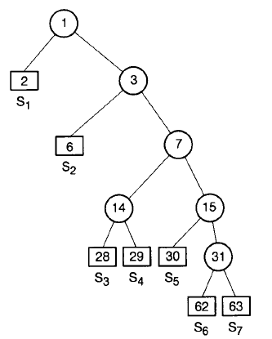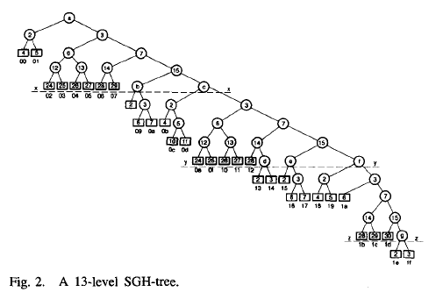
(a) (b)
Fig. 2.7 Single-side growing Huffman tree (SGH-tree). (a) 5 level, (b) 13 level.

This paper proposed a tree clustering algorithm based on an ordering and clustering to speed up for searching a symbol in a Huffman tree and reduce the memory usage. We will discuss the details in the next section.

Proposed Method
For the codeword with short length, it costs less searching time due to high probability symbol, but how about the codeword with long length? This paper proposes a method to speed up the searching time by jumping over the clusters (Fig. 2.8).

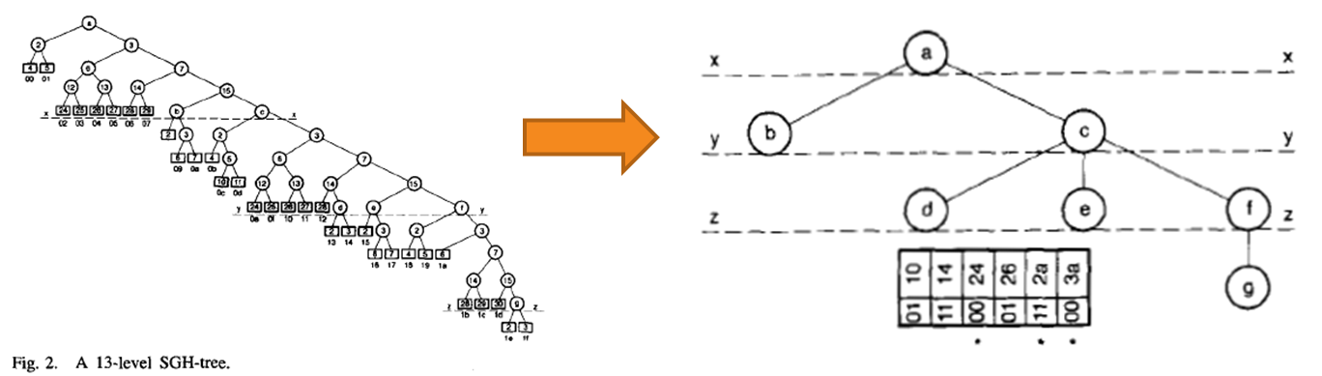
Fig. 2.8 Change the 13-level SGH-tree into the super tree (S-tree).

Jumping Over the Clusters
Suppose we have a Huffman table as shown in Table. 2.12, and jumping over the clusters by the codelength of 4. Therefore, the Huffman table will divided into 4 sections by dashed line x, y and z.
In section 1, we imagine that there are four imaginary bits in front of the Huffman codes and each of the four imaginary bits are the same. Thus, the Huffman codes “00” to “1101” are grouped into the same cluster “a”.
In section 2, since there are two kinds of the first four bits “1110” and “1111”, it can be divided into two clusters “b” and “c”. The Huffman codes “11100” to “111011” are grouped into cluster “b”, and “111100” to “11111100” are grouped into cluster “c”.
In section 3, since there are three kinds of the second four bits “1101”, “1110” and “1111”, it can be divided into three clusters “d”, “e” and “f”. For the same reason, we can group the Huffman codes into cluster “g” in section 4.
Table. 2.12 SGH table.
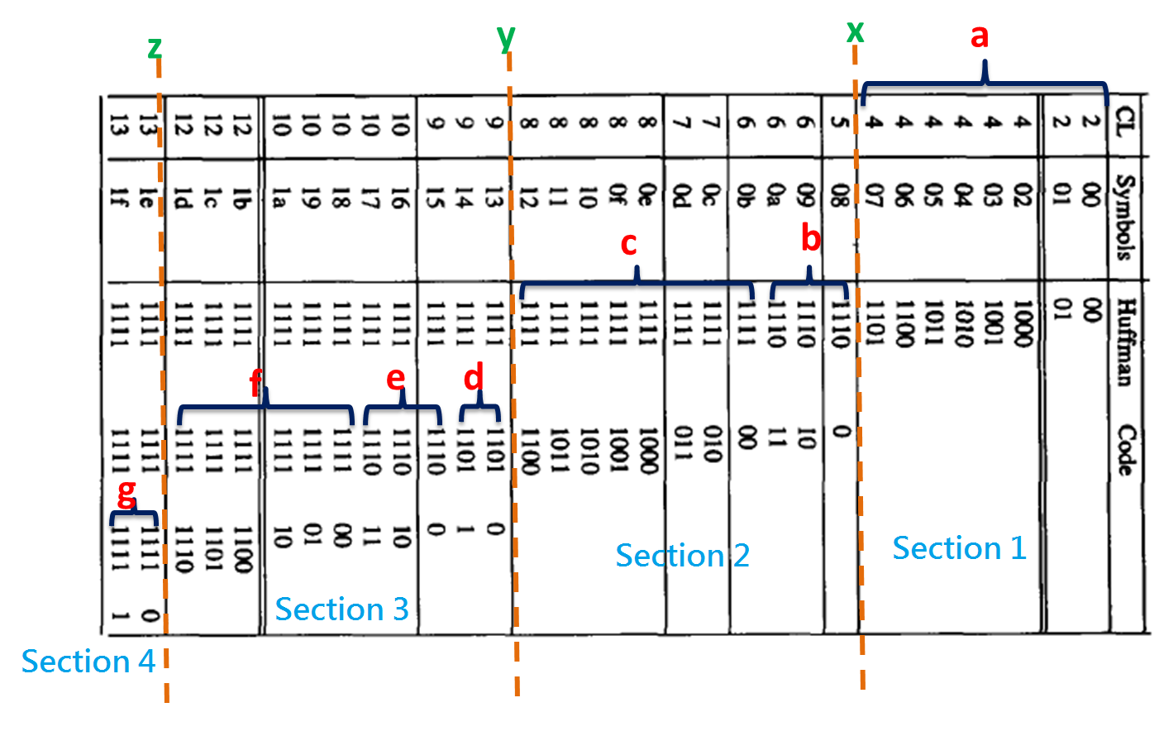

Example of Decoding a Codeword
Here we give an example to show how to decode a codeword by jumping over the clusters. Assume there is a bitstream “1111111111110…” need to decode, and following are the decoding steps as shown in Fig. 2.9:
- Since the cluster length of cluster “a” is 11+1=100(Bin)=4(Dec), thus we read the first four bits “1111” into the buffer, and “1111(Bin)=15(Dec)” means the 15th position which is 1 2 in the cluster table (a).
- 1 means that we need to look up the super table to see what cluster we should jump to.
- 2 means the 2nd position in super table which is 11 14.
- 11 means the cluster length of cluster “c” is 11+1=100(Bin)=4(Dec).
- 14 is the start position of cluster “c” in the memory.
- Since the cluster length of cluster “c” is 4, thus we read the next four bits “1111” into the buffer, and “1111(Bin)=15(Dec)” means the 15th position which is 1 5 in the cluster table (c).
- 1 means that we need to look up the super table to see what cluster we should jump to.
- 5 means the 5th position in super table which is 11 2a.
- 11 means the cluster length of cluster “f” is 11+1=100(Bin)=4(Dec).
- 2a is the start position of cluster “f” in the memory.
- Since the cluster length of cluster “f” is 4, thus we read the next four bits “1111” into the buffer, and “1111(Bin)=15(Dec)” means the 15th position which is 1 6 in the cluster table (f).
- 1 means that we need to look up the super table to see what cluster we should jump to.
- 6 means the 6th position in super table which is 00 3a.
- 00 means the cluster length of cluster “g” is 00+1=01(Bin)=1(Dec).
- 3a is the start position of cluster “g” in the memory.
- Since the cluster length of cluster “g” is 1, thus we read the one bit “0” into the buffer, and “0(Bin)=0(Dec)” means the 0th position which is 0 2 in the cluster table (g).
- 0 means that the codeword is in the current cluster.
- 2 is “10(Bin)”, so the most significant one bit (MS1B) is at the location 1, that is, the codelength is one. The right of MS1B is “0” which means the location is 3a+0=3a(Hex) in the memory.
- Therefore, the overall codeword is “1111111111110”, and the decoded symbol is “1e”.
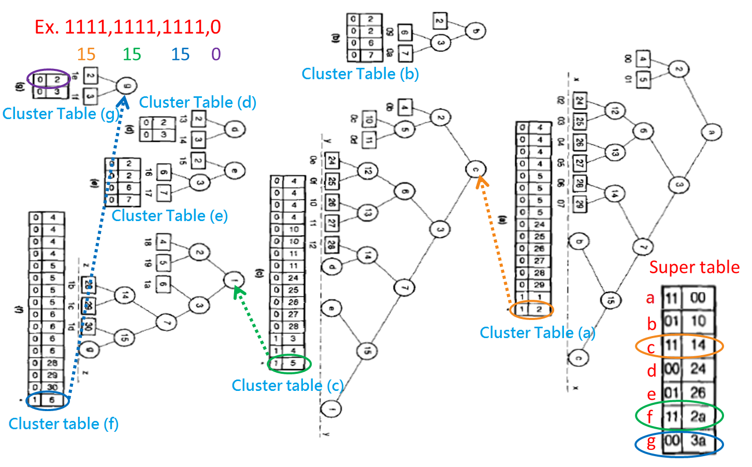
Fig. 2.9 Example for jumping over the clusters.

Read Bitstream of Huffman coding
“FF DA” means start of scan which is the start marker of the bitstream of Huffman code, and FF D9“ is the end marker of the bitstream, which means “end of image”. The remains between “FF DA” and “FF D9”are the Huffman codes that we need to decode.

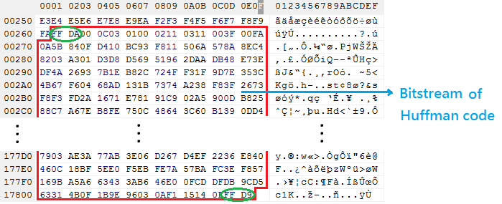
Fig. 2.10 Bitstream of Huffman code in JPEG file.

Experimental Results and Conclusion

In this chapter, we will show our experimental results. The following are the demo steps of our program, compiled on Windows 7 64bit with Visual Studio 2010.
JPEGDecoderDemo.exe is under the folder: JPEGDecoderDemo\JPEGDecoder Demo\Release\.

How to Run This Program
Be sure that “JPEGDecoderDemo.exe” and JPEG file in the same folder, then double click “JPEGDecoderDemo.exe” and enter the input JPEG filename and output bmp filename.

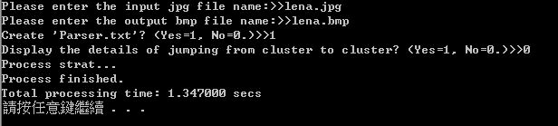
Fig. 3.11 JPEGDecoderDemo.exe in command window.

If choosing “Yes” for the question “Creat 'Parser.txt'?”, it will create “Parser.txt” in the same folder, which shows the information such as quantization tables, Huffman tables, and decoded blocks YCbCr as shown in Fig. 3.12 and Fig. 3.13.
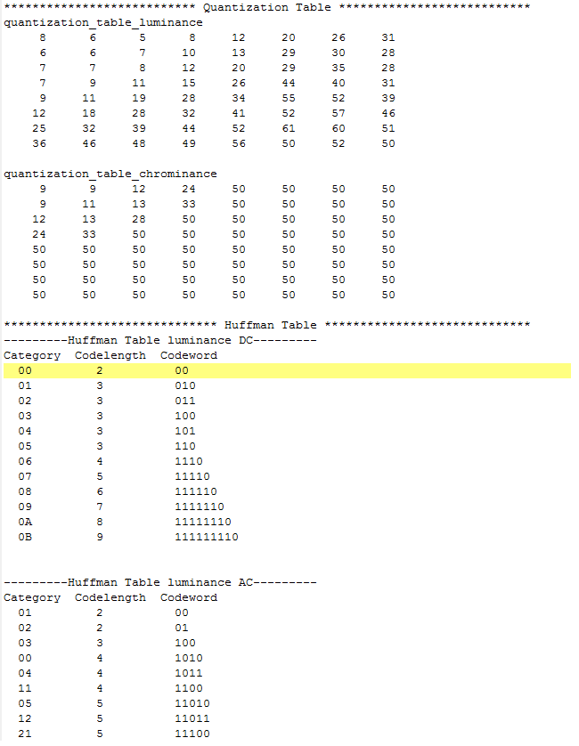
Fig. 3.12 Parts of lena.jpg in Parser.txt.
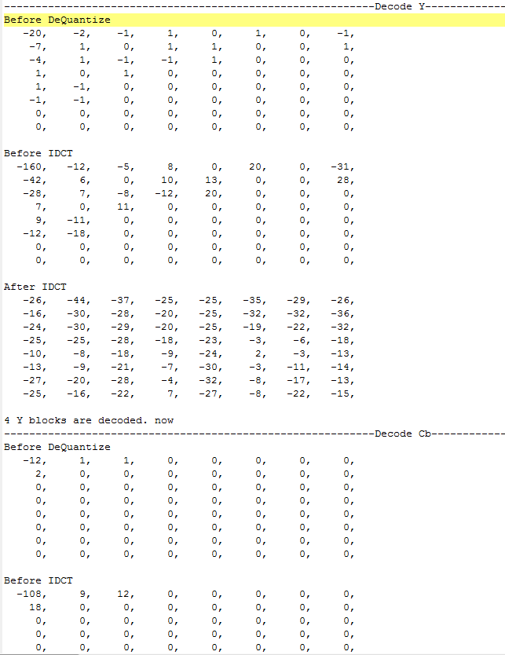
Fig. 3.13 Parts of lena.jpg in Parser.txt.

If choosing “Yes” for the question “Display the details of jumping from cluster to cluster?”, then it will display the details of decoding (bitstream in buffer, cluster, decoded symbols, decoded DC terms and AC terms, etc.) step by step in command window as show in Fig. 3.14.

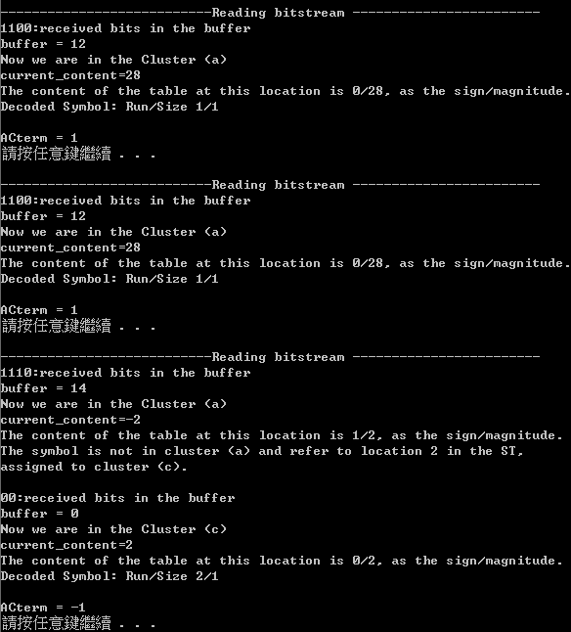
Fig. 3.14 Details of decoding steps in command window.

Decoded Result
The following are the compressed image (lena.jpg) and the decompressed image (lena.bmp).
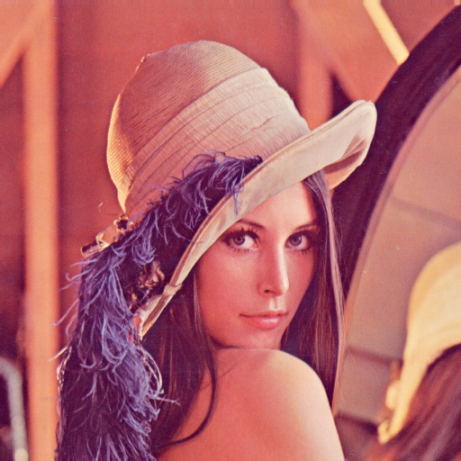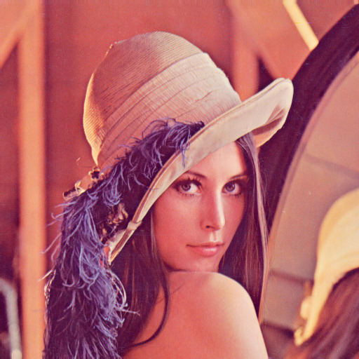
- (b)
Fig. 3.15 The decoded result. (a) lena.jpg, (b) lena.bmp

Conclusion
We have implemented a JPEG decoder with the Huffman decoding method proposed by which claims high efficiency in memory space and high-speed searching for Huffman decoding. Our impression is that it is difficult to deal with the bitstream in the buffer.

REFERENCE

- R. Hashemian, "Memory Efficient and High Speed Search Huffman Coding”, IEEE Transactions on Communications, Vol. 43, No. 10, pp. 2576-2581, October, 1995.
- JPEG Standard, “Information Technology- Digital Compression and Coding of Continuous-Tone Still Images Requirements and Guidelines,” Recommendation T.81, ITU, September, 1992
- 酒井善則、吉田俊之 共著，白執善 編譯，“影像壓縮技術”，全華，2004.

