Lab 04 – Writing functions

COMP130 - Introduction to Computing
Dickinson College
Instructor: John MacCormick

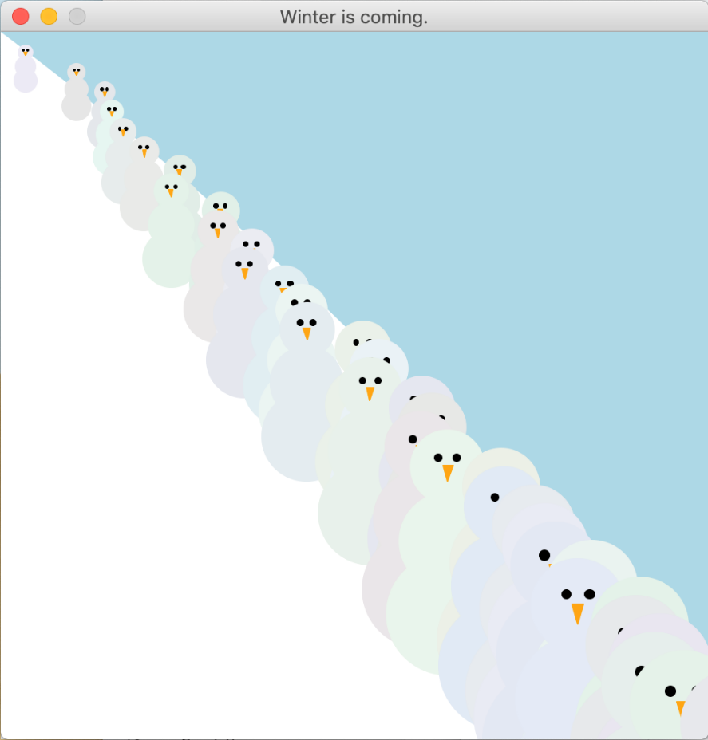
Your task for this lab is to write a complete program that uses the graphics.py module to create a picture similar to the one shown here. This is a picture of some snowthem wandering down a hillside. (The word “snowthem” seems to be a gender-neutral word for “snowman” or “snowmen”.)

Your program should be written in a single file called snowthem.py. This is the only file submitted to Moodle for this lab. It is possible to receive a high grade without completing the whole picture. At a minimum, aim to complete a function that draws a single snowthem at a given $x,y$-position on the picture (this will score at least 85% if working correctly). Don’t comment out earlier attempts or questions as labs 1 and 2. Submit just the final working version of the code.

Guidelines
1. Use functions to encapsulate each piece of this task. For example, you may have a draw_a_snowthem function which calls several other functions such as draw_body, draw_eyes, and draw_nose. Each of these would have parameters to specify the location and perhaps also the size of the item being drawn.
2. Use incremental development. That is, divide your task into meaningful subtasks that are as small as possible. Implement and test each subtask before moving on. For example, it may be easiest to start with draw_nose or draw_body.
3. Use the standard layout of a Python program: imports at the top, then all the function definitions, then a small amount of “top-level” code at the bottom. For our purposes, top-level code is any code that is not inside a function definition. If you have more than a few lines of top-level code, move it into a function and invoke the function in the top-level code instead.

[continues on next page]

Recommended approach
There is no single correct way to complete this assignment. Many different approaches could be used. The following suggestions represent one possible way to proceed.

1. draw_nose
Write a function draw_nose(win, x, y, width, height). This draws the orange triangular nose of a snowthem in the graphics window win, with the given width and height, and with the top middle of the nose positioned at coordinates x, y.

2. draw_circle
Write a function draw_circle(win, x, y, r, color). This draws a circle in the graphics window win, with center x,y, radius r, and color color.

3. draw_eyes
Write a function draw_eyes(win, x, y, r, x_sep). This draws both black eyes of a snowthem. The radius of each eye is r. The point x,y is halfway between the two eyes, and the centers of the eyes are separated by x_sep.
Very important: employ code reuse. This function needs to draw two circles. Do this by calling the function draw_circle twice. Thus, you reuse the draw_circle function.

4. draw_face
The function draw_face should draw the eyes and nose of a snowthem with a specified location and size. Try to figure out which parameters the function should have on your own, and ask for help if you need it. When writing the function, make sure to reuse code. You will be reusing both draw_eyes and draw_nose.

5. draw_head
This function will draw a circle for the snowthem’s head in a given color, at a given location and with a given size. It will then draw the face on the circle. So it will reuse draw_circle and draw_face.

6. draw_snowthem
This function will draw a snowthem at a given location, in a given color and with a given size.

Note: as mentioned above, successful completion of the lab to this point will score at least 85%. If you are satisfied with that score, then the rest of the lab is optional.

7. complete the picture
Try to design the remaining functions on your own, but don’t hesitate to ask for help if you need it.

Acknowledgment. This lab was originally authored by Lev Fruchter. It was adapted and edited by John MacCormick.

