**Score: _____**

**NA2 – Physical and Data Link Layers**

**Activities**

COMP256 – Computing Abstractions

Dickinson College

Spring 2023

Prof. Grant Braught

**Name:**

**Introduction:**

In today’s class we discussed the physical and data link layers.

**The Physical Layer:**

🔑 1. Data can be transmitted serially (one bit at a time) or in parallel (multiple bits simultaneously). Use human transportation as an analogy to explain the difference between serial and parallel data transmission.

🔑 2. When transmitting data serially over a physical medium the 0’s and 1’s in the data must be encoded into signals on the medium. For example, in class we saw the Nonreturn To Zero (NRZ) and Manchester encodings for transmitting 0’s and 1’s over a wire. There are many others as well.

a. Give the string of bits that are encoded in the signal below assuming that it is using NRZ encoding.



b. Give the string of bits that are encoded in the signal below assuming that it is using Manchester encoding.

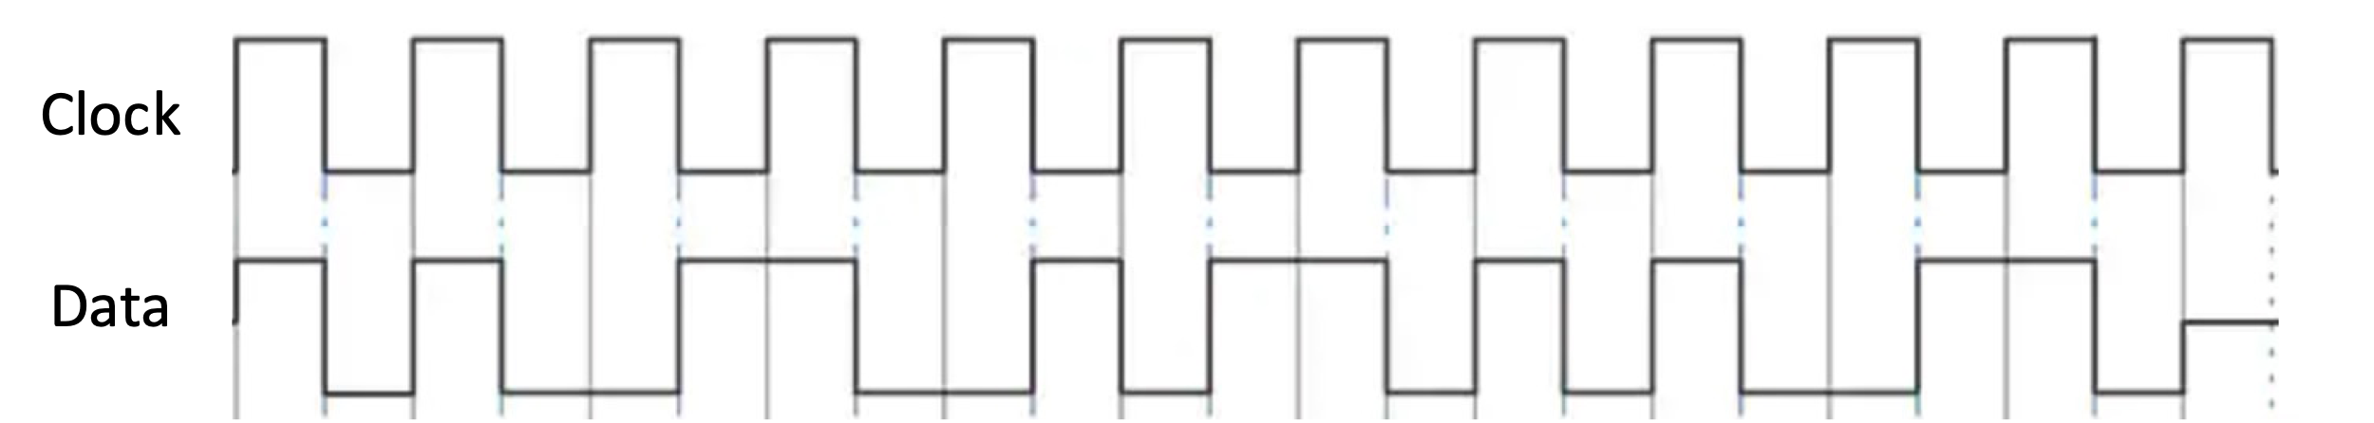

🏆 c. There are many other encodings in addition to NRZ and Manchester. Watch the following video that describes the NRZ-I encoding:

* <https://www.youtube.com/watch?v=Kxndom8GaUQ> (1:24)

Draw in the Data signal in the figure below so that it encodes the same bits of data as the NRZ signal from part a.

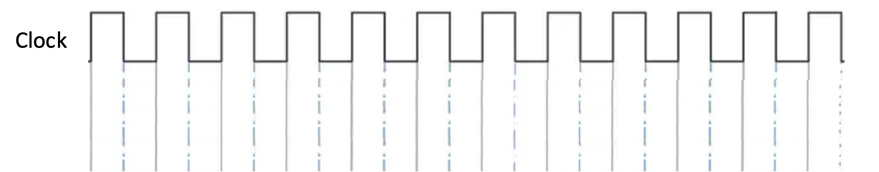

🏆 3. The Manchester encoding is clearly more complicated than the NRZ encoding. However, there is an advantage is gained with this complexity. This question explores that advantage. Refer to the Data traces for the NRZ and Manchester encodings in parts a and b above to help in answering the following questions.

a. Will an NRZ encoding of a long string of 0’s or a long string of 1’s contain transitions from low to high voltage or vice versa?

b. Will a Manchester encoding of a long string of 0’s or a long string of 1’s contain transitions from low to high voltage or vice versa?

c. Explain briefly explain how the fact that a Manchester encoding ensures that there are frequent transitions that are coordinated with the clock could be useful for physical layer data transmissions.

While encodings are a physical layer concern, the data link layer and physical layers are often closely coupled. This is because many of the data link layer operations are performed by the network interface card (e.g. the Ethernet interface card) that connects the node to the physical network. The specification for Ethernet indicates that the transmitted bits are to be encoded using Manchester Encoding

**Ethernet in the Data Link Layer:**

🔑 4. Ethernet use Carrier Sense Multi-Access with Collision Detection (CSMA/CD) over a broadcast media when transmitting data.

a. All Ethernet frames are broadcast to every node connected to the local area network (LAN). How does the frame being sent get processed by its intended recipient and not by the other nodes?

b. What does an Ethernet device do before it begins transmitting a frame? Why does it do that?

c. When two Ethernet devices begin the process of transmitting a frame at almost exactly the same time, they may both decide that it is okay to transmit. Explain at a high level, what happens when they both begin to transmit their frames.

d. What is the purpose of transmitting the preamble with each Ethernet frame?

5. When two or more Ethernet devices detect a collision, they each wait a random amount of time before trying to retransmit their frame. Why do they wait a random amount of time?

6. The random amount of time that an Ethernet device waits before attempting to retransmit a frame after a collision is determined using an exponential backoff algorithm. This question explores that algorithm.

a. How long (in clock ticks) an Ethernet device wait on average the first time it detects a collision when trying to transmit a frame?

b. How many collisions in a row would have to occur before the maximum time an Ethernet device would wait to try to send a frame again exceeded 16,000 clock ticks?

🏆 c. What is the longest time (in seconds) that a 100Mbs Ethernet device would wait after a collision, due to its exponential backoff, before trying to resend a frame?

7. The exponential backoff algorithm is so named because the range of possible times that an Ethernet device will wait after a collision grows exponentially with successive collisions (up to 10 collisions). This question explores why.

a. If

🏆 8. Using what we know about the ethernet frame format (i.e. don’t try to look up an answer to this question, you will not find the correct answer). If the *bandwidth* of the communication link being used at the physical layer were 1Mbs, what would the maximum data rate for Ethernet transmissions over this physical link? Hint: Find the amount of useful data that would be transmitted assuming the entire payload (data part) of the frame is useful.

**Error Detection and Correction:**

🔑 9. A parity bit can be used for detecting transmission errors (e.g. a 0 being flipped to a 1, or vice versa).

a. Complete the following table by indicating the value of the parity bit for each given byte using odd or even parity as indicated.

|  |  |  |  |  |  |
| --- | --- | --- | --- | --- | --- |
|  | |  |  |  |  |
|  | **Parity Type** | | **Byte** | **Parity Bit** |  |
|  | Odd | | 1010 0011 |  |  |
|  | Odd | | 0010 0101 |  |  |
|  | Even | | 0101 0111 |  |  |
|  | Even | | 1100 0110 |  |  |
|  | |  |  |  |  |

b. Each of the following data values has been received by a device after having been transmitted using either even or odd parity as indicated. Fill in the “Error Detected” column with either “Yes” or “No” to indicate if an error can be detected in the transmitted Data.

|  |  |  |  |  |  |
| --- | --- | --- | --- | --- | --- |
|  | |  |  |  |  |
|  | **Parity**  **Type** | | **Data** | **Error Detected** |  |
|  | Odd | | 010111011 |  |  |
|  | Odd | | 101101010 |  |  |
|  | Even | | 001000000 |  |  |
|  | Even | | 111100111 |  |  |
|  | |  |  |  |  |

10. Imagine that the byte 0110 0011 were transmitted from node A to B with an even parity bit added.

a. Give a byte plus a parity bit that might be received by B if exactly two transmission errors occurred.

b. Would B detect that that these transmission errors have occurred?

c. Give an example showing that

11.

Error Correction with 2D Parity

Can correct 1 bit.

Can detect two bits, give example..

Optional: To help me improve and scope these activities for future semesters please consider providing the following feedback.

a. Approximately how much time did you spend on this activity outside of class time?

b. Please comment on any particular challenges you faced in completing this activity.