**Score: _____**

**NA3 – Network Layer**

**Activities**

COMP256 – Computing Abstractions

Dickinson College

Spring 2023

Prof. Grant Braught

**Name:**

**Introduction:**

In this set of material, we looked at the Network Layer Service and how it is responsible for routing messages between two end-systems by directing them through a series of routers. We saw that this is a distributed process where each router works independently using its routing tables to make decisions about where to send the message next (i.e. its next hop). We learned about Internet Protocol (IP) addresses and subnets, how they used in IP routing tables and how hierarchical routing helps manage some of the complexity of the Internet. We then gained some insight into how routing tables can be automatically constructed and maintained by having routers exchange information between themselves. Finally, there was an example of that brough the Network and Data Link layers together. This example illustrated how an IP datagram would move between layers of the network stack layers (Network, Data Link and Physical) using both IP addresses and MAC addresses as it is routed across the network.

**IP Addresses:**

IP addresses and subnet masks are usually written using “dotted octet” form. E.g. 127.232.19.44. However, that is just a convenient representation of the underlying binary values. In binary, each part of the IP address is 8-bits long (thus “octet”). The base 10 values we typically see are found by interpreting those 8-bits as a base 10 value using unsigned binary representation. These questions will have you work with the binary forms of IP addresses and

🔑 1. Give the binary form of the following IP addresses: 127.232.19.44

🔑 2. Give the “dotted octet” subnet address for the IP from question #1 if:

a. The subnet mask for the machine is: 255.255.0.0.

b. The subnet mask for the machine is: 255.255.240.0

3. Use the system configuration information on your computer to find the IP address and subnet mask for your computer.

a. Give the “dotted octet” and binary representation of the IP address of your computer.

b. What is “dotted octet” and binary representation of the subnet mask of your computer?

c. Show that your computer is on the subnet that is indicated by your subnet mask.

🏆 4. The subnet mask determines how many nodes may be attached to the associated network.

a. How many nodes could a subnet have if the subnet mask is 255.255.255.0?

b. How many nodes can be on the same subnet as your machine (use #3 part b)?

🔑 5. Consider the network diagram below:

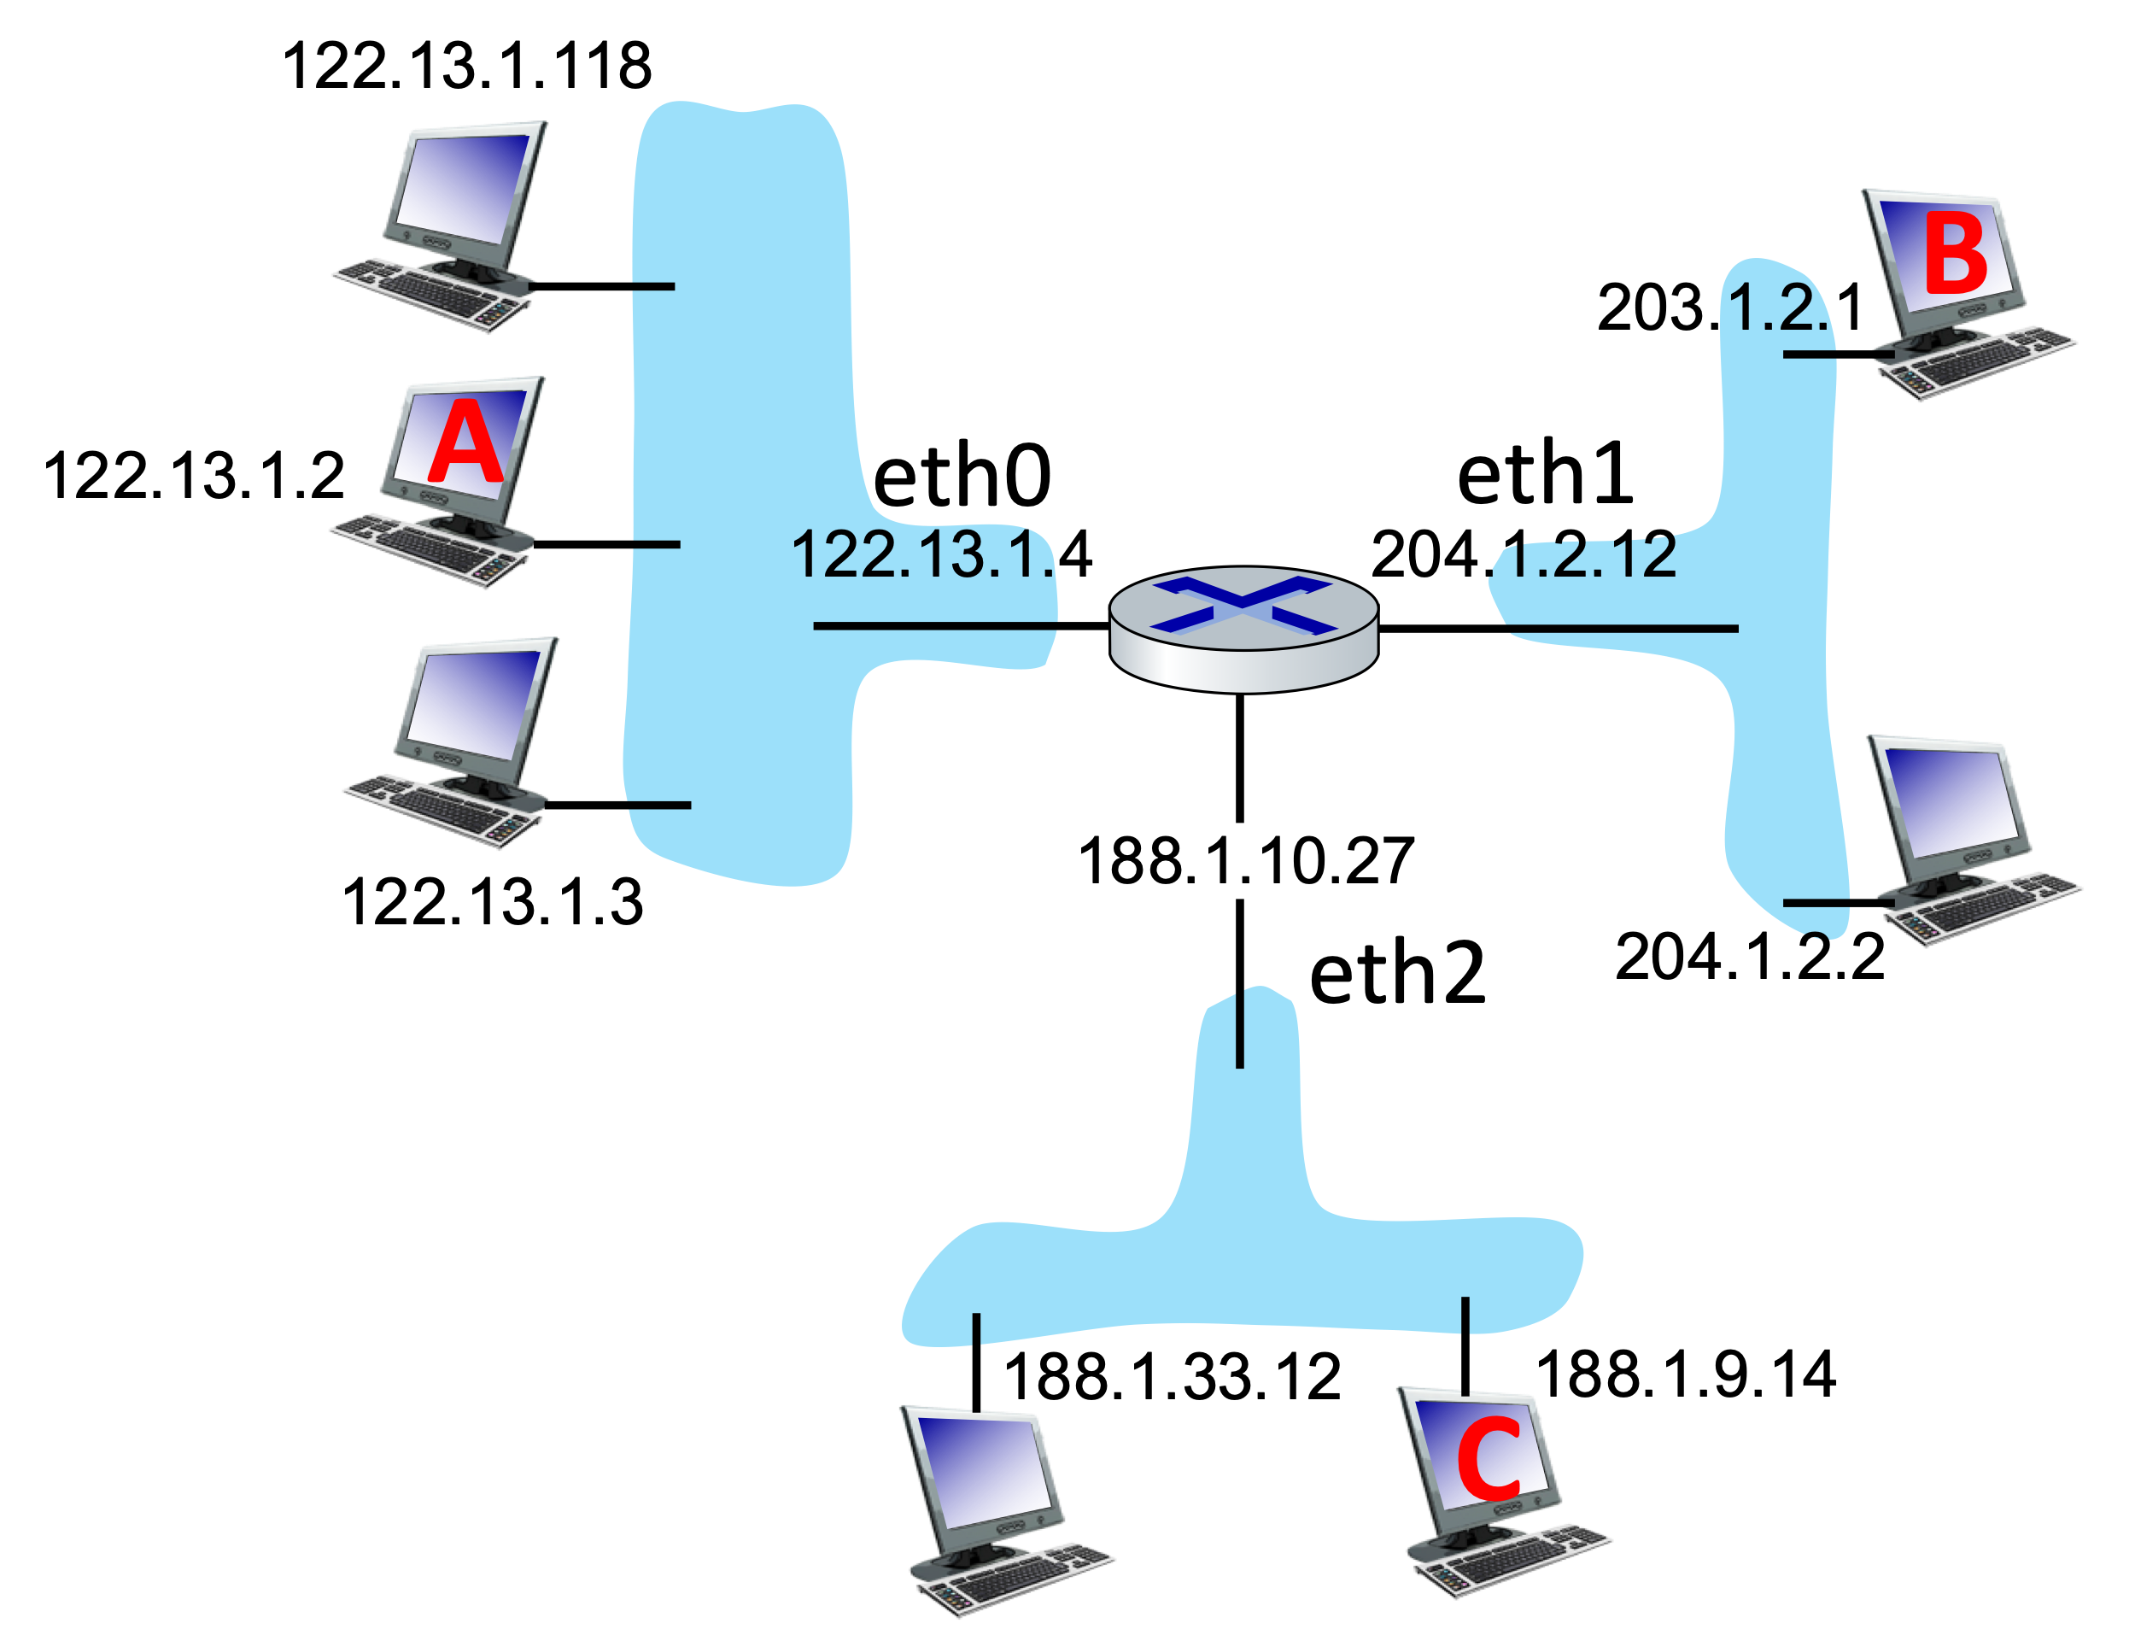

a. Give a subnet mask and the IP address of the default (first-hop) router for the machine A?

|  |  |  |  |
| --- | --- | --- | --- |
|  |  |  |  |
|  | Subnet Mask: |  |  |
|  | Router: |  |  |
|  |  |  |  |

b. Give a subnet mask and the IP address of the default (i.e. first-hop) router for the machine C?

|  |  |  |  |
| --- | --- | --- | --- |
|  |  |  |  |
|  | Subnet Mask: |  |  |
|  | Router: |  |  |
|  |  |  |  |

**IP Routing:**

🔑 6. The network given above in question #5, contains one router that directs datagrams between three subnets. Fill in the table below showing what the routing table for that router would look like.

|  |  |  |  |  |
| --- | --- | --- | --- | --- |
|  |  |  |  |  |
|  | **Dest. Net** | **Interface** | **Next Hop** |  |
|  |  |  |  |  |
|  |  |  |  |  |
|  |  |  |  |  |
|  |  |  |  |  |

🔑 7. Consider the network shown below that uses the same simplified addresses scheme (e.g. A.7) as the “Decentralized Routing Activity” from class. As in class the network interfaces for the routers are named using their compass directions. Note that router R2 now has a SW interface and router R4 has a NE interface to the network X.



Below are routing tables for the routers in the above network.

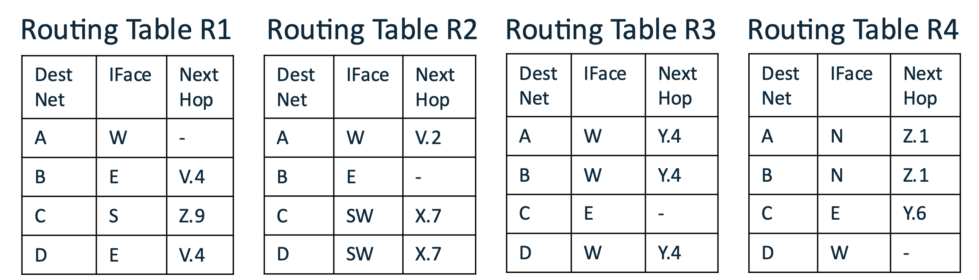

The following questions ask for the route that is taken by messages from different sources to destinations. Use the following notation to express a route: A1 -> R1 -> R2 -> B2 to show a route from the source A1 through R1 and then through R2 and then to B2.

|  |  |  |  |  |
| --- | --- | --- | --- | --- |
|  |  |  |  |  |
|  | **Source** | **Destination** | **Route** |  |
|  | B.3 | A.7 |  |  |
|  | D.1 | D.3 |  |  |
|  | A.2 | C.9 |  |  |
|  | C.3 | A.1 |  |  |
|  | A.2 | D.2 |  |  |
|  |  |  |  |  |

**Building Routing Tables:**

🔑 8. Consider the following network similar to the one from the class slides that were used to illustrate the ideas behind the Routing Information Protocol (RIP) :



The next several questions will ask you to fill in these tables using an approximation of RIP. As with the class examples, we will use the compass directions as the names of the interface for simplicity.

|  |  |  |  |  |  |  |  |  |  |  |  |  |  |  |  |
| --- | --- | --- | --- | --- | --- | --- | --- | --- | --- | --- | --- | --- | --- | --- | --- |
|  |  |  |  |  |  |  |  |  |  |  |  |  |  |  |  |
|  | **Routing Table R1** | | | |  | **Routing Table R2** | | | |  | **Routing Table R3** | | | |  |
|  | Dest  Net | IFace | Next  Hop | Num  Hops |  | Dest  Net | IFace | Next  Hop | Num  Hops |  | Dest  Net | IFace | Next  Hop | Num  Hops |  |
|  | V | W | - | 1 |  |  |  |  |  |  |  |  |  |  |  |
|  | X | E | - | 1 |  |  |  |  |  |  |  |  |  |  |  |
|  |  |  |  |  |  |  |  |  |  |  |  |  |  |  |  |
|  |  |  |  |  |  |  |  |  |  |  |  |  |  |  |  |
|  |  |  |  |  |  |  |  |  |  |  |  |  |  |  |  |
|  |  |  |  |  |  |  |  |  |  |  |  |  |  |  |  |
|  | **Routing Table R4** | | | |  | **Routing Table R5** | | | |  |  |  |  |  |  |
|  | Dest  Net | IFace | Next  Hop | Num  Hops |  | Dest  Net | IFace | Next  Hop | Num  Hops |  |  |  |  |  |  |
|  |  |  |  |  |  |  |  |  |  |  |  |  |  |  |  |
|  |  |  |  |  |  |  |  |  |  |  |  |  |  |  |  |
|  |  |  |  |  |  |  |  |  |  |  |  |  |  |  |  |
|  |  |  |  |  |  |  |  |  |  |  |  |  |  |  |  |
|  |  |  |  |  |  |  |  |  |  |  |  |  |  |  |  |
|  |  |  |  |  |  |  |  |  |  |  |  |  |  |  |  |

a. In the first step, each router fills in rows for the networks to which it is directly connected. Using a **red text**, fill in each routing table with the information for the networks to which it is directly connected. The Routing Table R1 has been filled in as an example.

b. Each router then shares its routing information with its neighbors (e.g. R1 shares with R2 and R4, R3 shares with R2 and R5). If the shared information received by a router provides a route to a new network then that router will add it to its table. Use **purple text** to update each table using the information that will have been shared by its neighbors.

c. This process of sharing continues such that every time a router updates its table it shares its information with its neighbors again. As before, if the shared information received by a router provides a route to a new network then the router will add it to its table. It is also possible that a router will receive information about a shorter route to a network that it already has a route for. When this happens the router updates its table so that it will use the shorter route.

Use **Burnt Yellow** text to fill in the information that is added in each routing table with the next share. Use underlining to indicate any of the Red or Purple information that is updated with the next share. If any information is both added and updated (i.e. 2 different updates come in at the same time) use Underlined Burnt Yellow text.

d. After the shares in parts a, b, and c, every router should have a route to every network. Thus, any datagram sent from one network to another can be delivered. Will every datagram be sent along the shortest route? If not give an example of a source and destination that will result in a route that is longer than necessary.

e. Now imagine there is a change in the network such that the connection between R2 and R3 is reduced to 1-hop and that R2 is able to detect this change and update its routing information. What routes in R3 would be updated the next time R2 shares its routing information with R3?

🏆 9. In question 8 you carried three steps of our approximation of the Routing Information Protocol (RIP).

a. You may have noticed that not every node needs to share all of its information at every step. In fact, it would be quite inefficient to do so since all of that sharing would be using network bandwidth that then is unavailable for transmitting other data.

Write a rule that describes what data a router should share during a step. Hint: Think about when the shared data will actually be useful to the neighbor.

b. If the rule you identified in part a is followed, what happens once all of the shortest routes have been identified?

Optional: To help me improve and scope these activities for future semesters please consider providing the following feedback.

a. Approximately how much time did you spend on this activity outside of class time?

b. Please comment on any particular challenges you faced in completing this activity.