SWMM5 Graphics Diagram Suite — Design Specification
Project: SWMM5-UI (https://swmm-ui-engine.replit.app) — a React-based web clone of the EPA SWMM 5.2.4 desktop GUI with a WASM simulation engine Reference model: Greenville_SI.inp (bundled sample model) Audience: SWMM5-UI front-end / visualization developer Status: Design-proven. All 16 diagrams are implemented and rendered in an interactive prototype (see Appendix); this document is the engineering specification for porting them into the application.
This specification documents a suite of sixteen graphics diagrams (D1–D16) that extend the visualization coverage of SWMM5-UI. Every diagram has been designed, prototyped, and rendered against real model data; each entry below defines its purpose, exact data mapping, visual encoding, interaction behavior, and intended integration point in the application. All prototype values are extracted from the bundled Greenville_SI.inp model input file and from a full EPA SWMM 5.2.4 simulation executed with pyswmm, so the encodings specified here are known to work against real data at production scale (172 nodes, 235 links, 30 subcatchments).

1. Current State of SWMM5-UI Graphics
SWMM5-UI already reproduces the core output-side graphics of the EPA SWMM 5.2.4 desktop GUI:
- Thematic map legends — classed symbology for subcatchment % Imperviousness, node Depth, and link Flow on the network map.
- Time Series Plot — multi-variable time series for any selected object.
- Profile Plot — longitudinal water-surface profile along a node path.
- Scatter Plot — pairwise variable scatter for an object.
- Frequency Plot — frequency/exceedance analysis of a variable.
- Continuity display — runoff and routing continuity errors from the status report.
- 3D view, plus Report / Stats / Table tabular views.
Gap assessment. Two areas are under-served relative to the desktop product and to what the data supports:
- Input-side schematics. Cross-sections, pump/storage/rating curves, design storms, LID controls, subcatchment idealization, and DWF patterns are currently editable only through tables and forms. None of the visual, self-checking representations that make the desktop GUI effective (curve plots, layer diagrams, hyetographs) exist yet. Group A (D1–D8) fills this gap.
- Richer output diagnostics. The app plots variables but offers no composite diagnostic views: no combined system hydrograph, no HGL-snapshot profile, no flow-duration or depth–flow diagnostic, no continuity gauges or mass-balance view, no surcharge heatmap, no storage utilization summary. Group B (D9–D16) fills this gap.
All sixteen diagrams are designed to consume data the app already has (the INP object model and the binary .out results), so none require engine changes.

2. Design System
All diagrams in the suite share one visual language, chosen to sit naturally inside SWMM5-UI’s light engineering aesthetic.

2.1 Theme and palette
- Light engineering theme: off-white page background (#fafaf8), white cards (#ffffff), hairline borders (#e4e1da), dark ink text (#2f3439), muted secondary text (#757a80).
- Low-saturation categorical palette (muted, print-safe, distinguishable in grayscale order): slate blue #46677f, teal #4d8577, amber #c07f2e, brick red #b04a41, neutral slate #66727d. Extended 8-color series order: blue, teal, amber, red, mauve #7a6a8a, olive #8a7a4d, cyan-slate #4d7a85, tan #96684d.
- Sequential/diverging ramp for capacity-type quantities: blue → amber → red across 0–1 (blue #2e5a82 at 0, amber #d6a450 at 0.5, red #b04a41 at 1), matching the severity semantics of the app’s surcharge legend.
- Grids and axes: light grid lines (#e7e4de), darker axis frame (#b9b4aa), 10–10.5 px tick labels, italic unit labels. Axes always framed, never floating.

2.2 Labeling conventions
- Units are always labeled on every axis, in the model’s own units (LPS flow, m length/depth, m² area, m³ volume, ha subcatchment area, in/hr rainfall intensity where the INP is written in inches). No unit-less axes.
- Source tags: every diagram carries monospaced tags naming its data provenance, e.g. [XSECTIONS], [CURVES] PUMP3, [.OUT link:flow]. Input-side diagrams cite INP sections; output-side diagrams cite .out report blocks or time-series variables.
- Key numbers annotated in-plot: peaks, thresholds, and totals are written directly on the figure (e.g. “peak runoff 568 LPS @ 12.3 hr”) rather than left to a caption.

2.3 Card anatomy
Every diagram is delivered as a card with a fixed anatomy, mirroring the prototype:
- Header — diagram ID chip (D1–D16; blue for Group A inputs, teal for Group B outputs), title, and source tags.
- Figure — SVG or canvas render with framed axes, legend, and tooltips.
- Design-spec block — data mapping, visual encoding, interaction idea (the content expanded in Sections 3–4).
- Note line — one-line factual takeaway computed from the live data (e.g. “no conduit approaches surcharge in this run”).

2.4 Legend classes matching the app
Where a diagram overlaps an existing app legend, it reuses the app’s class breaks exactly:
- % Imperviousness: 5 classes — 0–20, 20–40, 40–60, 60–80, >80 % on a green ramp (#e3ebdd → #4f7042).
- Link MaxQ: 4 severity classes on grey → blue → amber → red with increasing stroke width; sub-threshold links in neutral grey.
- Capacity (d/D): 0 → ≥1 blue→red ramp, where ≥1 denotes surcharge.
- Node glyphs: junction = circle, outfall = triangle, storage = square, divider = diamond — identical to the app map.

3. Diagram Catalog — Group A: Model Input Diagrams
Group A diagrams visualize the input deck: the physical and hydrologic definition of the model. Their purpose is error detection and comprehension before a run — the equivalents of the desktop GUI’s property editors, rendered visually.

3.1 D1 — Cross-Section Shape Gallery
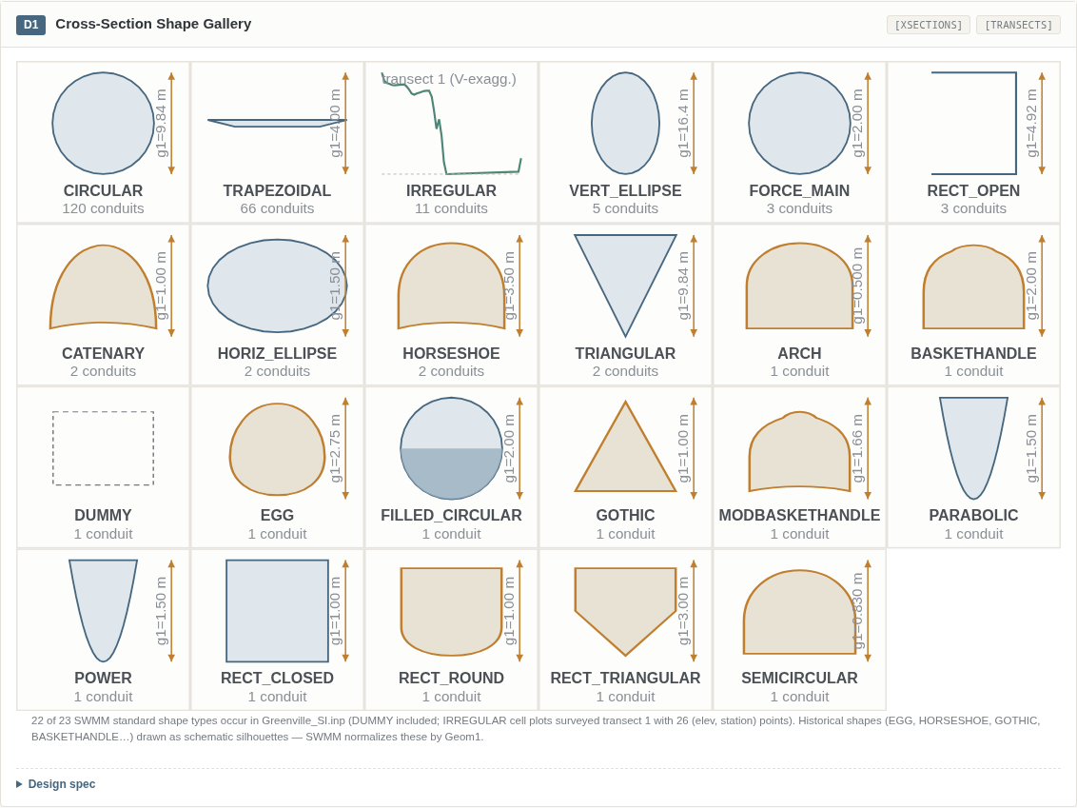
D1 — Cross-Section Shape Gallery
Purpose. A one-screen gallery of every conduit cross-section shape used in the model, drawn to scale with its governing dimension. It turns the abstract [XSECTIONS] table into an immediately scannable catalog and exposes shape-type diversity (Greenville uses 22 of the 23 standard SWMM shapes) that is invisible in tabular form.
Data mapping
Element | Source
Shape type, Geom1–Geom4 per conduit | [XSECTIONS] section of INP
Per-shape conduit counts | aggregated over [XSECTIONS]
IRREGULAR cell geometry | real [TRANSECTS] (elevation, station) survey points
Visual encoding. Each shape is drawn parametrically in a normalized 120×110 cell at uniform scale and true aspect. A vertical amber dimension arrow marks Geom1 (max depth/diameter). A chip under each cell shows the conduit count for that shape. Shapes with closed-form geometry (CIRCULAR, FORCE_MAIN, FILLED_CIRCULAR, ellipses, TRAPEZOIDAL, TRIANGULAR, RECT_OPEN/CLOSED, PARABOLIC, POWER) are computed from Geom1–Geom4; FILLED_CIRCULAR renders the Geom2 sediment segment; historical/special shapes (EGG, HORSESHOE, GOTHIC, BASKETHANDLE, MODBASKETHANDLE, SEMICIRCULAR, ARCH, CATENARY) are drawn as schematic silhouettes because SWMM normalizes them by Geom1; IRREGULAR cells plot the surveyed transect polyline with vertical exaggeration.
Interaction recommendation. Clicking a cell filters the map to conduits of that shape and opens the cross-section editor pre-set to that type.
Integration point in SWMM5-UI. Map view (filter-by-shape) + cross-section property editor. Candidate home: a “Gallery” tab in the conduit editor.

3.2 D2 — Pump Characteristic Curves
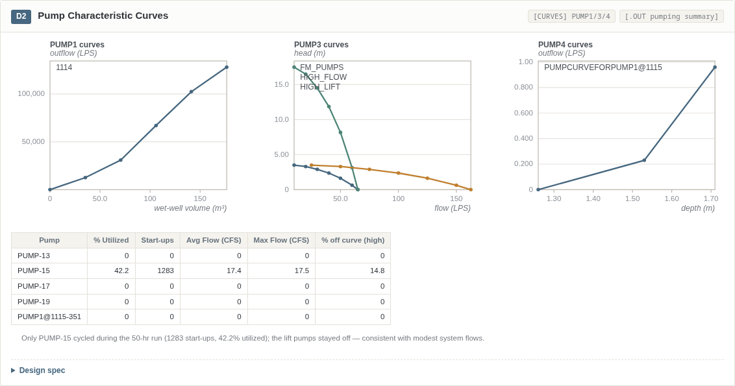
D2 — Pump Characteristic Curves
Purpose. Plots all pump curves by family (PUMP1/3/4) alongside the pumping summary from the run, so a reviewer can confirm at a glance that each pump’s duty point behavior matches its curve and see which pumps actually cycled.
Data mapping
Element | Source
PUMP1 curve (outflow vs wet-well volume) | [CURVES] curve 1114
PUMP3 curves (head vs flow) | [CURVES] FM_PUMPS, HIGH_FLOW, HIGH_LIFT
PUMP4 curve (outflow vs depth) | [CURVES] PUMPCURVEFORPUMP1@1115
% utilized, start-ups, avg/max flow, % off-curve | .out pumping summary report
Visual encoding. Three panels, one per pump-curve family, each with per-curve hue from the categorical series and labeled axes in the family-appropriate variables (volume/depth/flow on x per PUMP1–PUMP4 semantics). Curve vertices drawn as markers. A companion table lists % utilized, start-ups, average and maximum flow, and % time off the pump curve per pump.
Interaction recommendation. Hovering a curve spotlights the corresponding pump node on the map; table rows link to the pump property editor.
Integration point in SWMM5-UI. Graph view (curve panel) + pump property editor; summary table reuses the Stats view table component. In the reference run only PUMP-15 cycled (the lift pumps stayed off, consistent with modest system flows) — exactly the kind of finding this diagram surfaces.

3.3 D3 — Storage Curves (Depth–Area)
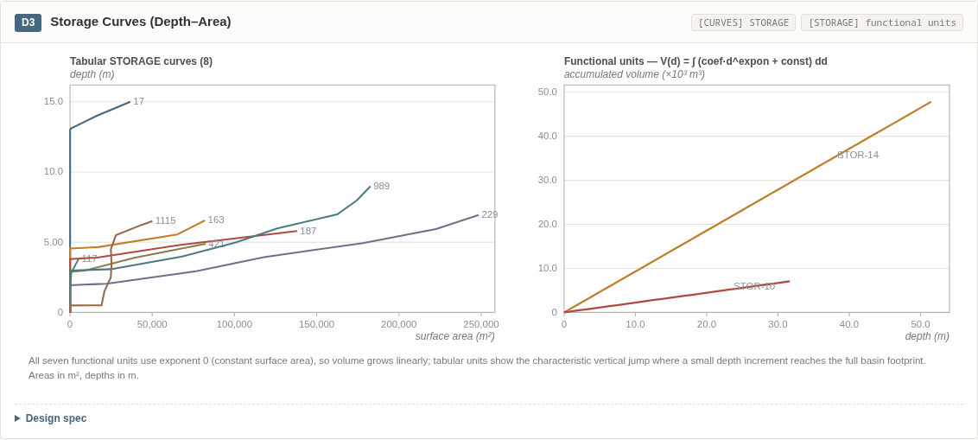
D3 — Storage Curves
Purpose. Visualizes how each storage unit’s surface area varies with depth — both the eight tabular storage curves and the functional (A·d^E + C) units — and integrates area into accumulated volume so unit capacities can be compared directly.
Data mapping
Element | Source
Tabular depth–area curves (8) | [CURVES] entries of type STORAGE
Functional units (209, 260, 261, STOR-10/12/14/16) | [STORAGE] coefficient / exponent / constant
Accumulated volume V(d) = ∫A dd | computed from coef/expon/const
Visual encoding. Left panel: tabular curves with x = surface area (m²), y = depth (m), one hue per curve, name labeled at the curve endpoint. Right panel: accumulated volume vs depth for the two largest functional units. All seven functional units in Greenville use exponent 0 (constant surface area), so their volume curves are linear; tabular units show the characteristic vertical jump where a small depth increment reaches the full basin footprint.
Interaction recommendation. Dragging a curve vertex live-recomputes unit volume and updates the storage summary estimate — the chart doubles as the curve editor preview.
Integration point in SWMM5-UI. Graph view + storage-unit property editor (curve tab).

3.4 D4 — Design-Storm Hyetographs
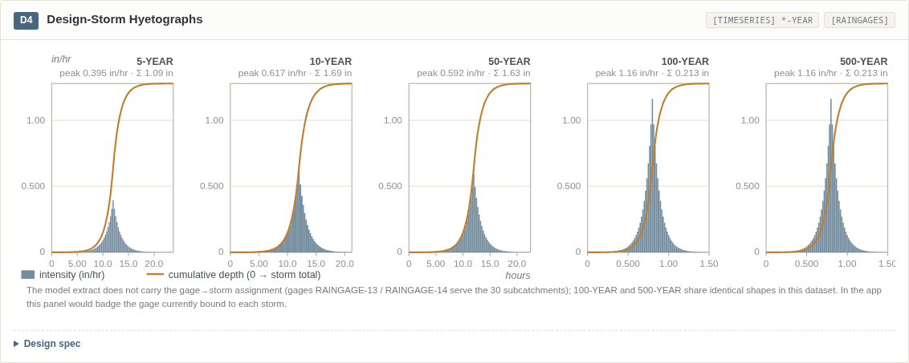
D4 — Design-Storm Hyetographs
Purpose. Small-multiple hyetographs of the five design storms (5/10/50/100/500-YEAR) on a shared intensity scale, so storm severity and shape are directly comparable across return periods.
Data mapping
Element | Source
Storm intensity vs time (in/hr) | [TIMESERIES] 5-YEAR … 500-YEAR
Cumulative mass curve | trapezoidal integral of intensity
Gage binding (target) | [RAINGAGES] (see caveats — not explicit in extract)
Visual encoding. One panel per storm, shared y-scale across all panels; bars = intensity (slate blue), amber line = cumulative depth normalized to storm total; the peak-hour bar is ticked and each panel is annotated with peak intensity and storm total depth. A historical storm time series (July 17, 1996) is also present in the dataset and can be added as a sixth panel.
Interaction recommendation. A storm picker assigns the selected time series to a rain gage; hovering a bar shows intensity and cumulative depth; each panel badges the gage currently bound to that storm.
Integration point in SWMM5-UI. Graph view (rain gage object) + rain gage property editor. Note: the 100-YEAR and 500-YEAR storms are identical in this file (see Section 6) — the shared scale makes this duplication visually obvious, which is the point.

3.5 D5 — Boundary & Rating Curves
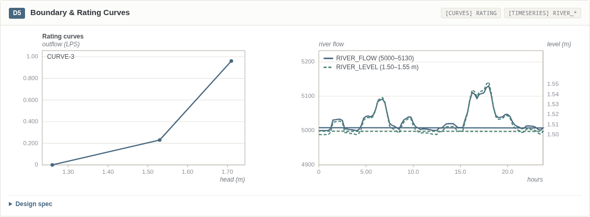
D5 — Boundary & Rating Curves
Purpose. Combines the outfall rating curve (head → outflow) with the river boundary hydrographs (flow and level), giving a complete picture of the model’s downstream boundary conditions on one card.
Data mapping
Element | Source
Rating curve (head vs outflow) | [CURVES] CURVE-3, type RATING
River boundary hydrographs (0–24 hr) | [TIMESERIES] RIVER_FLOW, RIVER_LEVEL
Visual encoding. Left panel: rating curve as a line with vertex markers, head (m) on x, outflow (LPS) on y. Right panel: dual-axis time plot sharing the hour axis — river flow (slate blue, left axis) and river level (teal dashed, right axis), with min–max ranges in the legend.
Interaction recommendation. Clicking an outfall boundary toggles between its FREE / NORMAL / TIMESERIES boundary editor with this chart as a live preview of the selected boundary type.
Integration point in SWMM5-UI. Outfall property editor (boundary tab) + Graph view.

3.6 D6 — LID Control Layer-Cakes
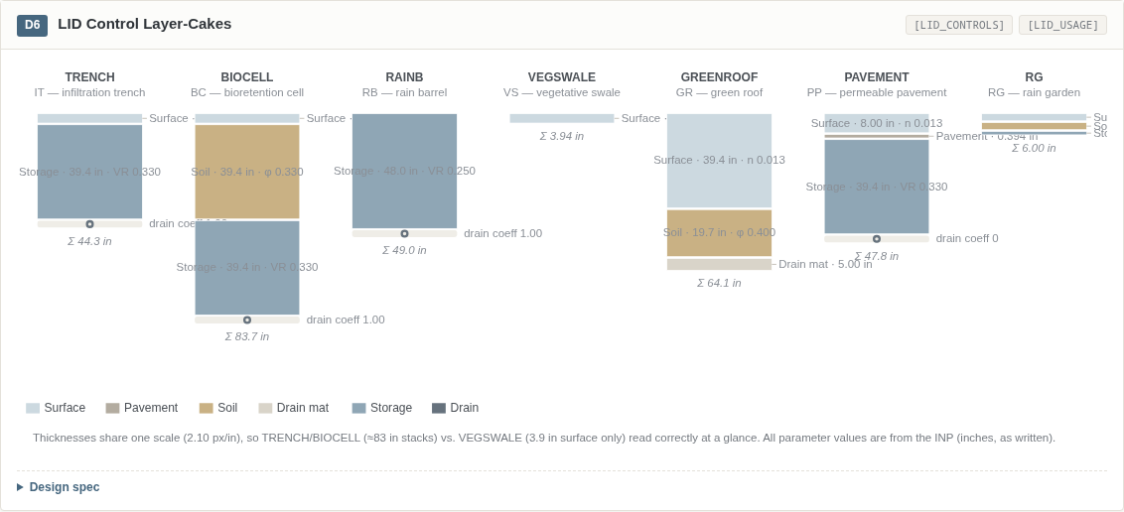
D6 — LID Control Layer-Cakes
Purpose. A cross-section “layer-cake” for each of the seven LID controls, showing the vertical stack of engineered layers (surface, pavement, soil, drain mat, storage, underdrain) at true relative thickness. This is the fastest way to sanity-check LID designs — e.g. infiltration trenches with ≈83 in stacks versus a vegetative swale that is surface-only.
Data mapping
Element | Source
Layer parameter vectors per control | [LID_CONTROLS] — SURFACE, PAVEMENT, SOIL, DRAINMAT, STORAGE, DRAIN (first element = layer thickness, in)
Deployment of controls to subcatchments | [LID_USAGE] (for editor context)
Visual encoding. One column per LID control; strata drawn top→bottom with thickness on a single shared linear scale (px per inch), a distinct muted fill per layer class, and a control-type chip (IT/BC/RB/PP/RG/VS/GR) on top. Callouts give thickness plus the key hydraulic parameter per layer (soil porosity φ, storage void ratio, surface roughness n); the underdrain renders as a pipe symbol with its drain coefficient; each column is totaled (Σ in).
Interaction recommendation. In the LID editor, clicking a stratum opens that layer’s parameter form; a ruler on the left shows cumulative inches.
Integration point in SWMM5-UI. LID control editor (new visual panel replacing the bare parameter grid).

3.7 D7 — Subcatchment Idealization (C10)
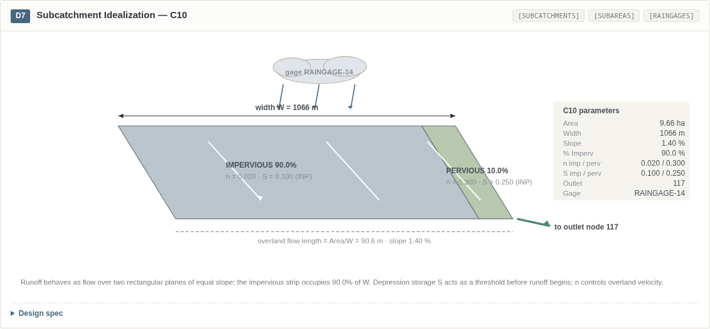
D7 — Subcatchment Idealization
Purpose. The classic SWMM idealized-plane schematic for a representative subcatchment (C10): runoff as flow over two rectangular planes — impervious and pervious — of equal slope, draining to the outlet node. It makes the lumped-parameter abstraction concrete and editable.
Data mapping
Element | Source
Area 9.6579 ha, width 1066.4 m, slope 1.4 %, % imperv 90 | [SUBCATCHMENTS] C10
Manning n (0.02 imperv / 0.3 perv), depression storage (0.10 / 0.25) | [SUBAREAS]
Outlet node 117, gage RAINGAGE-14 | [SUBCATCHMENTS], [RAINGAGES]
Visual encoding. An oblique-projected parallelogram split by % imperviousness into an impervious (slate) and pervious (green) strip; width dimension arrow across the back edge; overland flow length (= Area/W) and slope annotated on the front edge; white flow-direction arrows down-slope; rainfall arrows from a labeled gage cloud; teal gutter arrow to the outlet node. A side parameter panel lists all eight governing values as written in the INP.
Interaction recommendation. The schematic is the subcatchment editor: dragging the impervious/pervious divider updates % Imperv and recomputes the strip widths live.
Integration point in SWMM5-UI. Subcatchment property editor (visual tab) linked from the Map view.

3.8 D8 — DWF & Pattern Library
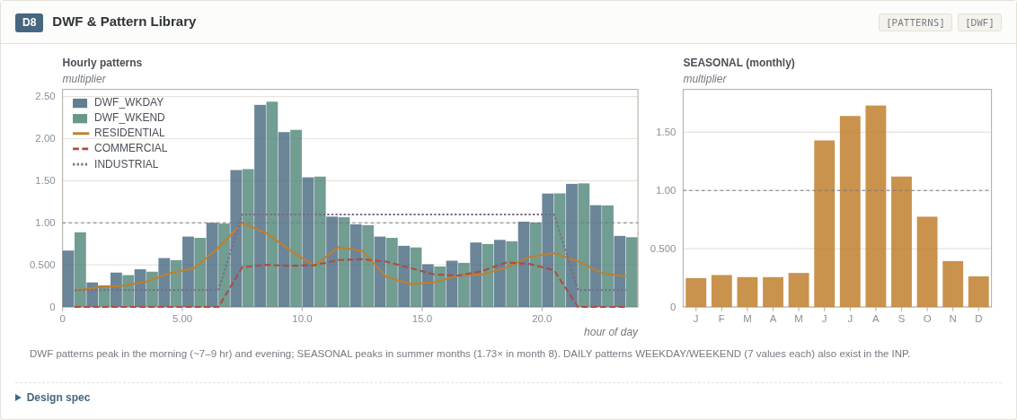
D8 — DWF & Pattern Library
Purpose. Plots the model’s full pattern library — weekday/weekend dry-weather-flow multipliers, the three land-use patterns, and the seasonal (monthly) pattern — so temporal loading assumptions are reviewable in one place.
Data mapping
Element | Source
Hourly multipliers (bars) | [PATTERNS] DWF_WKDAY (HOURLY), DWF_WKEND (WEEKEND)
Land-use overlays (lines) | [PATTERNS] RESIDENTIAL, COMMERCIAL, INDUSTRIAL
Monthly multipliers (bars) | [PATTERNS] SEASONAL (MONTHLY, 12 values)
Application of patterns to nodes | [DWF] (editor context; DAILY WEEKDAY/WEEKEND patterns also exist in the INP)
Visual encoding. Left panel: grouped bars (weekday slate, weekend teal) on a shared 0–24 hr multiplier axis with three land-use patterns overlaid as distinct line styles, and a dashed reference at multiplier 1.0. Right panel: monthly bars in amber with the same 1.0 reference. DWF patterns peak in the morning (~7–9 hr) and evening; SEASONAL peaks in summer.
Interaction recommendation. The pattern editor edits multipliers in a spreadsheet grid while this chart live-updates; pattern usage per node is listed alongside.
Integration point in SWMM5-UI. Graph view (pattern object) + pattern editor dialog.

4. Diagram Catalog — Group B: Simulation Output Diagrams
Group B diagrams visualize the results deck: composite diagnostics built from the binary .out file. Reference run: 50 hr (1997-01-01 00:00 → 1997-01-03 02:00), DYNWAVE routing, 5-min report series (600 steps).

4.1 D9 — System Hydrograph
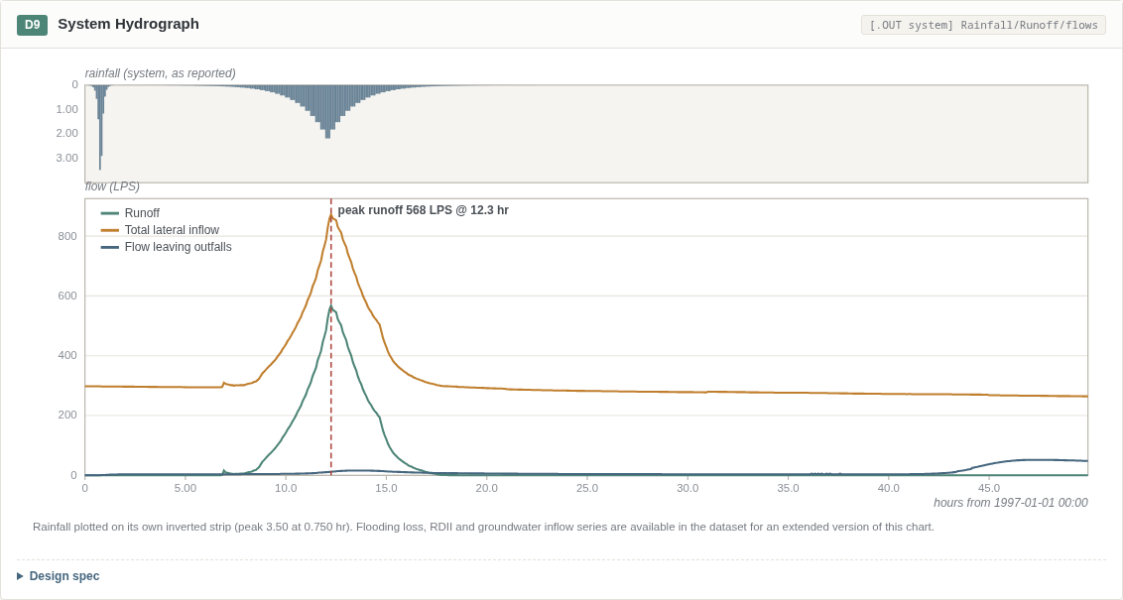
D9 — System Hydrograph
Purpose. The SWMM classic: rainfall above, system response below, on one time axis. It is the single most informative whole-run summary and the natural landing view after a simulation completes.
Data mapping
Element | Source
Rainfall, Runoff, Total lateral inflow, Flow leaving outfalls (LPS) | .out system time series, 600 steps @ 5 min
(Extended version) Flooding loss, RDII, groundwater inflow | also available in the dataset
Visual encoding. Inverted rainfall bars hang from a framed top strip (own scale, peak annotated); three flow lines below share the LPS axis in teal (runoff), amber (lateral inflow), and slate blue (outfall flow); a dashed red vertical marker flags peak runoff — 568 LPS at 12.3 hr in the reference run.
Interaction recommendation. A time-brush under the chart scrubs the map animation and cross-links to the profile plot’s HGL snapshot (D10).
Integration point in SWMM5-UI. Graph view (Time Series, system object) — promoted to a default “Run summary” chart.

4.2 D10 — Longitudinal Profile with HGL Snapshots
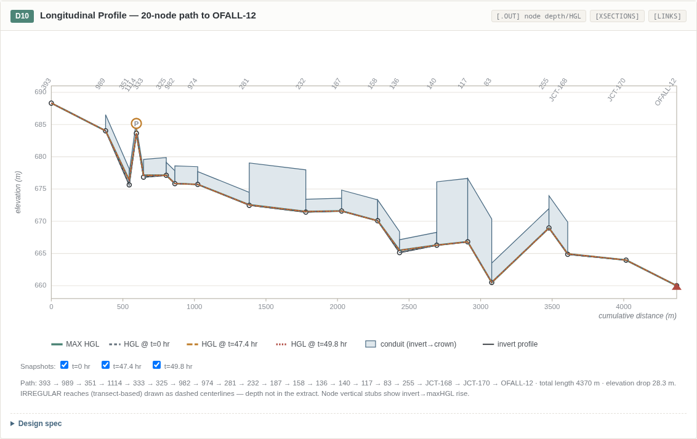
D10 — Longitudinal Profile
Purpose. Extends the existing profile plot into a full hydraulic diagnostic: conduit geometry, max HGL, and selectable instantaneous HGL snapshots along a 20-node trunk path (node 393 → outfall OFALL-12; 4370 m, 28.3 m drop), with the pump station and outfall flagged.
Data mapping
Element | Source
Node invert (m), max HGL (m), time of max | .out node summary / depth series
Conduit shape, Geom1 (crown height), length (m), MaxQ | [XSECTIONS], [LINKS], .out link summary
HGL snapshots at t = 0, 47.4, 49.8 hr | .out report time series
Visual encoding. Distance–elevation plot: conduits as filled bands from invert to crown (dashed centerline where IRREGULAR transect depth is n/a in the extract — see Section 6), node inverts as ticked circles with vertical stubs showing invert→maxHGL rise, MAX HGL as a bold teal polyline, three toggleable snapshot HGL lines in distinct dashes, pump station 1114 flagged with an amber “P”, outfall marked with a red triangle. Rotated node labels along the top; horizontal legend below.
Interaction recommendation. A time slider replays HGL along the path (snapshots become animation frames); clicking a conduit band opens its cross-section (D1); clicking a node opens its result graph.
Integration point in SWMM5-UI. Profile view — this is a feature upgrade to the existing Profile Plot.

4.3 D11 — Flow-Duration (Exceedance) Curve — link 140OF
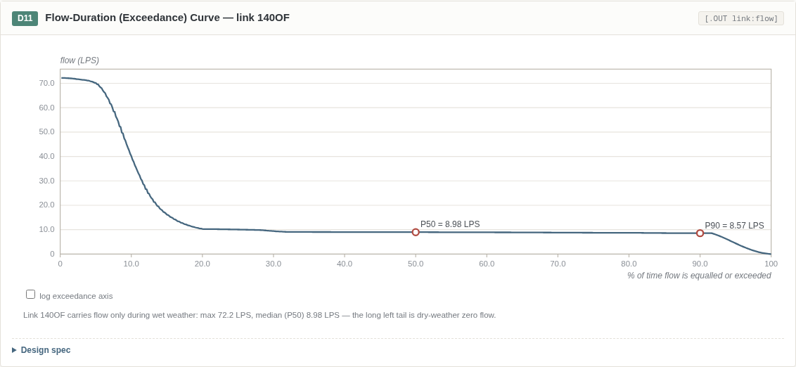
D11 — Flow-Duration Curve
Purpose. Ranks the full flow record of a link to show what fraction of time any flow is equaled or exceeded — the standard tool for distinguishing dry-weather-dominated links from wet-weather conveyance.
Data mapping
Element | Source
600 report steps (5-min) of absolute flow (LPS), link 140OF | .out link:flow series
Exceedance p = rank/N × 100 | computed
Visual encoding. Rank-order curve on a % exceedance x-axis; a checkbox switches the axis to log scale to spread the low-exceedance tail; P50 and P90 reference dots annotated with their flow values. For 140OF the long left tail is dry-weather zero flow (median ≈ 0), confirming it carries flow only during wet weather.
Interaction recommendation. Hovering reads off “flow Q is exceeded p % of the time”; a link picker swaps the series.
Integration point in SWMM5-UI. Stats view (frequency analysis) — a per-link companion to the existing Frequency Plot.

4.4 D12 — Depth-vs-Flow Scatter — link 140OF
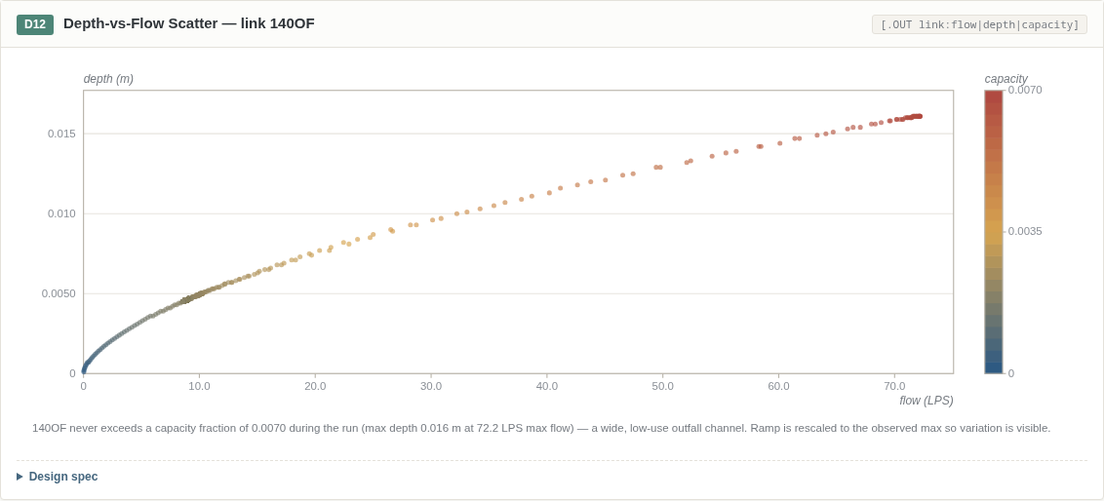
D12 — Depth-vs-Flow Scatter
Purpose. A hydraulic diagnostic scatter — depth against flow with points colored by capacity fraction — that reveals regime behavior (normal flow vs backwater vs surcharge approach) for a single conduit.
Data mapping
Element | Source
600 report steps: | flow
Visual encoding. x = flow, y = depth; point hue = capacity fraction on the shared blue→amber→red ramp scaled 0 → observed max, with a stepped colorbar and labeled ticks. For 140OF the ramp is rescaled to the observed max (a wide, low-use outfall channel), making the within-regime variation visible; the colorbar annotation makes the rescaling explicit.
Interaction recommendation. Lasso-selecting a cluster filters the time series everywhere else (linked brushing) to isolate the event that produced it.
Integration point in SWMM5-UI. Graph view (Scatter) — extends the existing Scatter Plot with capacity encoding and linked brushing.

4.5 D13 — Continuity & Mass Balance
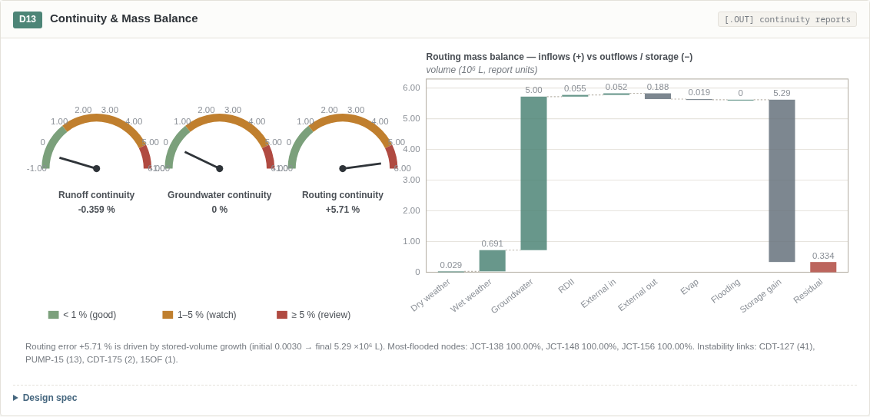
D13 — Continuity & Mass Balance
Purpose. Turns the run’s continuity reports into an at-a-glance health check: three gauges for the headline continuity errors plus a mass-balance waterfall that explains where the routing error comes from.
Data mapping
Element | Source
Runoff / Groundwater / Flow Routing continuity error (%) | .out continuity reports (reference run: −0.359 % / 0.0 % / +5.706 %)
Routing block volumes (10⁶ L, report units) | .out flow routing continuity block
Most-flooded nodes, instability links | .out report tables
Visual encoding. Three dial gauges with green (<1 %), amber (1–5 %), and red (≥5 %) zones and a needle at the true signed value (range −1…6 %). The waterfall accumulates inflows (dry weather, wet weather, groundwater, RDII, external), then subtracts outflows (external outflow, evaporation, flooding) and net storage gain, leaving the continuity residual as a red terminal bar; bars in teal (gains) and slate (losses) with running-total connectors. In the reference run the routing error is driven by stored-volume growth over the 50-hr run.
Interaction recommendation. The gauges sit on the run-status panel and turn red live during long simulations; clicking the residual bar lists the top instability links.
Integration point in SWMM5-UI. Health / run-status panel (new), upgrading the current text-only continuity display.

4.6 D14 — Conduit Capacity Heatmap — 16 links
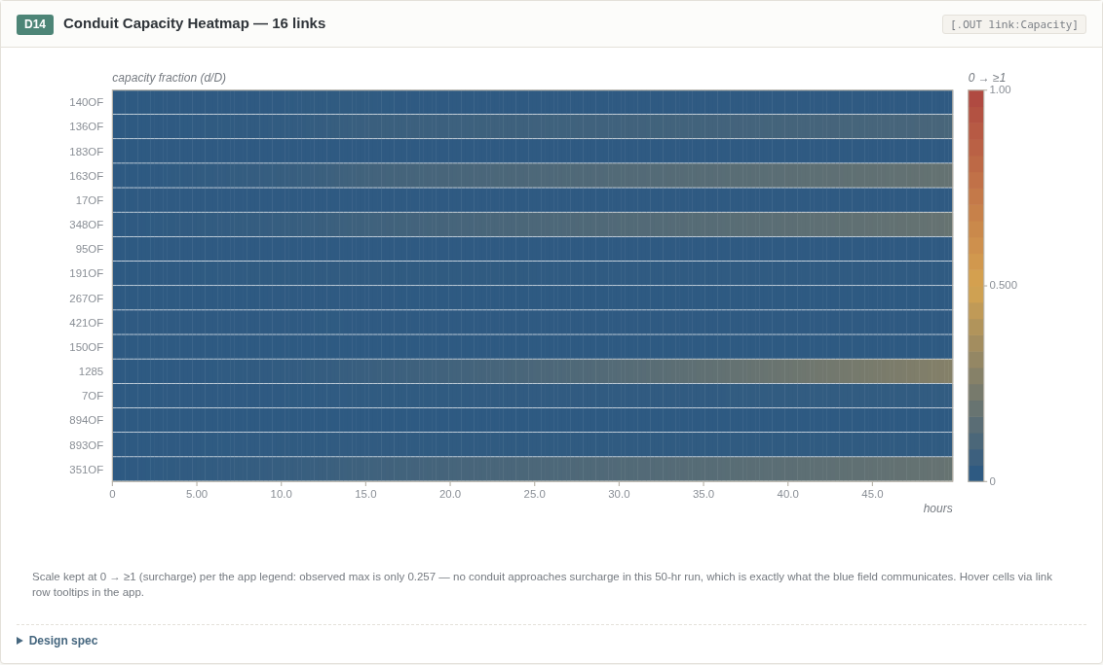
D14 — Conduit Capacity Heatmap
Purpose. A system-wide surcharge surveillance view: capacity (d/D) for the 16 highest-flow links over the entire run as a time matrix, so incipient surcharge is visible as a pattern, not a number in a table.
Data mapping
Element | Source
Capacity (d/D) fraction, 16 highest-flow links | .out link:Capacity, 200 columns @ 15-min (0–49.75 hr)
Row order | link-flow summary ranking
Visual encoding. Matrix: rows = links (sorted by flow ranking), columns = time; cell hue = capacity on the shared 0 → ≥1 blue→red ramp with a vertical legend bar. The scale is deliberately kept at 0 → ≥1 (surcharge) per the app legend: the observed max in the reference run is only 0.257 — no conduit approaches surcharge, which is exactly what the uniform blue field communicates.
Interaction recommendation. Hovering a cell reads link/time/capacity; clicking a row opens the link time-series plot; a threshold toggle highlights cells at surcharge (≥1).
Integration point in SWMM5-UI. Stats view (new matrix chart) with row drill-through to the Graph view.

4.7 D15 — Storage Unit Performance
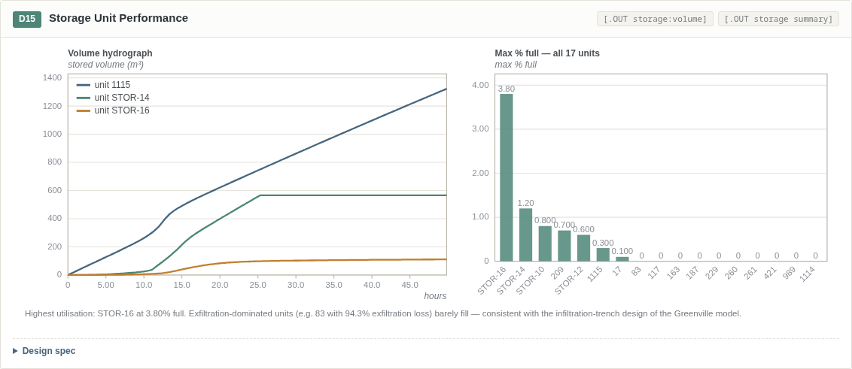
D15 — Storage Unit Performance
Purpose. Combines volume hydrographs for the active storage units with a utilization ranking of all 17 units, answering “which storage worked, and how hard?”
Data mapping
Element | Source
Stored volume (m³), units 1115, STOR-14, STOR-16 | .out storage:volume, 300 steps @ 10 min
MaxPctFull, MaxVolume, MaxOutflow — all 17 units | .out storage summary
Visual encoding. Left: multi-line volume hydrograph (categorical hues, per-unit max annotated in tooltip). Right: bars sorted descending by max % full, hue ramping teal (<50 %) → amber (≥50 %) → red (≥100 %), unit labels rotated beneath. Exfiltration-dominated units (e.g. unit 83, with 94.3 % exfiltration loss) barely fill — consistent with the infiltration-trench design of the Greenville model.
Interaction recommendation. Clicking a bar selects the unit and overlays its inflow/outflow on the line chart.
Integration point in SWMM5-UI. Stats view (storage summary) + Graph view (storage time series).

4.8 D16 — Network Thematic Mini-Map
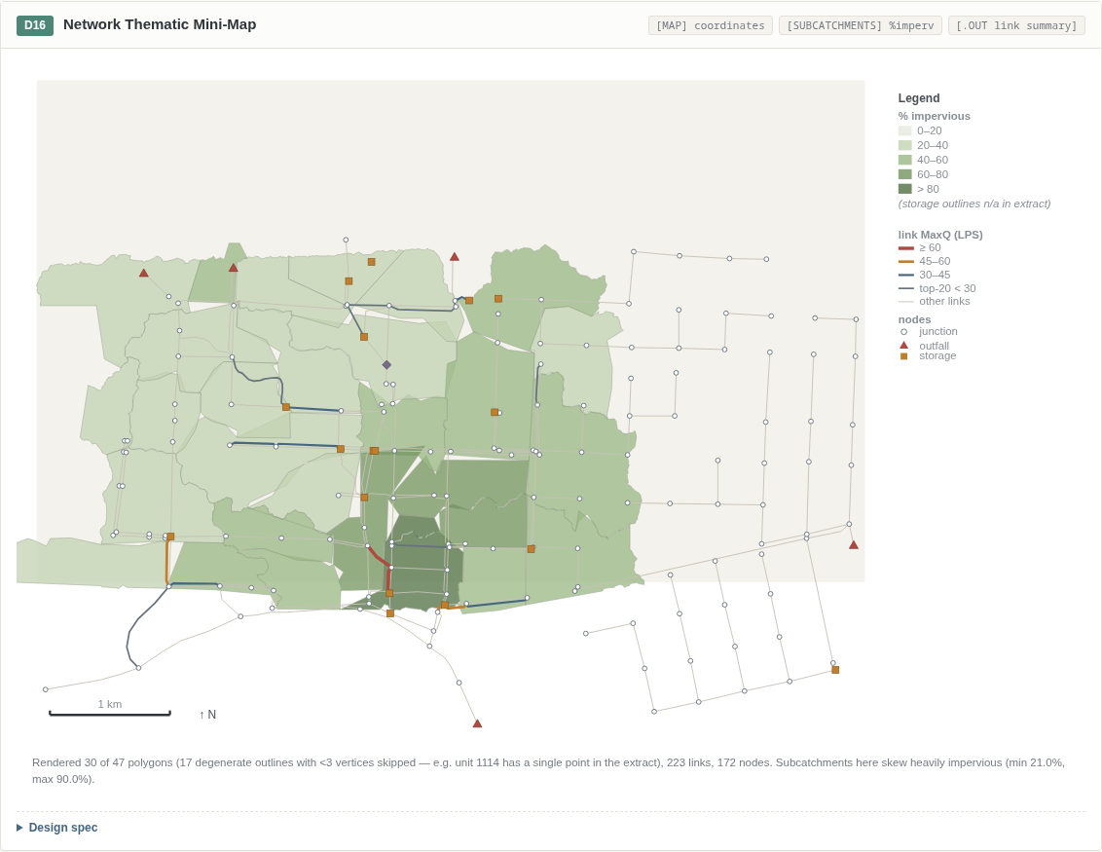
D16 — Network Thematic Mini-Map
Purpose. A static, spec-fidelity reference of the app’s thematic renderer: the whole network symbolized by input (% imperviousness) and output (MaxQ) theme classes simultaneously, validating that the class-break engine matches the desktop GUI’s look.
Data mapping
Element | Source
Node/link/subcatchment coordinates | [MAP] coordinate sections
Subcatchment % imperviousness | [SUBCATCHMENTS]
Link MaxQ class (top 20 links) | .out link-flow summary
Visual encoding. Subcatchment polygons colored by the app’s 5-class imperviousness green ramp; conduit width and color by the 4-class MaxQ severity ramp (grey → blue → amber → red, increasing width; other links neutral); node glyphs by type (junction circle, outfall triangle, storage square, divider diamond); storage-unit outlines in tan; legend box, 1 km scale bar, and north arrow. Rendering is robust to degenerate polygons (outlines with <3 vertices are skipped — see Section 6).
Interaction recommendation. In the app this is the thematic engine itself: a class-break editor re-colors the live map; clicking any feature opens its property/result panel.
Integration point in SWMM5-UI. Map view (thematic legend/class-break editor).

5. Implementation Priorities
Ranking combines user impact against implementation effort. All diagrams consume data the app already holds (INP object model + .out results), so effort is dominated by rendering and interaction work. Quick wins first:
Rank | Diagram | Impact | Effort | Rationale
1 | D13 Continuity & Mass Balance | High | Low | Report blocks already parsed; small SVG gauges + bars; upgrades an existing text display
2 | D9 System Hydrograph | High | Low | System series already plotted piecemeal; this is layout + peak annotation
3 | D11 Flow-Duration Curve | Medium | Low | Pure client-side ranking of an existing series; reuses Frequency Plot plumbing
4 | D16 Thematic Mini-Map classes | High | Low–Med | Legend classes already exist; adds the class-break editor + output theme
5 | D4 Design-Storm Hyetographs | High | Low | Time series already loaded; small-multiple layout is mechanical
6 | D8 DWF & Pattern Library | Medium | Low | Bar/line panels over existing pattern data
7 | D3 Storage Curves | Medium | Low–Med | Curve plotting + simple analytic volume integration
8 | D2 Pump Curves + summary | Medium | Low–Med | Curve panels are simple; pumping summary table needs report parsing
9 | D12 Depth-Flow Scatter | Medium | Low–Med | Existing Scatter Plot + color ramp; linked brushing is the only new infra
10 | D15 Storage Performance | Medium | Low–Med | Two standard panels; storage summary parsing needed
11 | D14 Surcharge Heatmap | High | Med | Matrix renderer + per-link capacity extraction at 15-min steps
12 | D10 Profile HGL Snapshots | High | Med–High | Upgrade of existing Profile Plot; needs HGL series per path node + band geometry
13 | D5 Boundary & Rating Curves | Medium | Med | Dual-axis panel + boundary editor wiring
14 | D1 Cross-Section Gallery | Medium | Med–High | 23 parametric shape renderers + transect plotting; high polish value
15 | D6 LID Layer-Cakes | Medium | Med | Custom stacked renderer + editor integration
16 | D7 Subcatchment Idealization | Medium | Med | One-off schematic; drag interaction on the divider
Recommended sequencing: ship ranks 1–4 as a “run health + theming” milestone, ranks 5–10 as an “input graphics” milestone, and ranks 11–16 as a “diagnostics” milestone.

6. Data Pipeline & Caveats

6.1 Pipeline
- Parse — Greenville_SI.inp parsed with swmmio (all INP sections into structured records).
- Execute — model run with pyswmm (EPA SWMM 5.2.4 engine), producing the binary .out file; the run completed with 209 warnings.
- Extract — binary .out decoded with swmmtoolbox into system/node/link/storage time series and summary report tables.
- Bundle — everything serialized into a single JS data module (data.js, 268 KB, const SWMM = {...}) with 19 top-level keys: meta, system, profile, profileHGL, scatter, heatmap, subSeries, storageSeries, xsections, transects, curves, timeseries, patterns, storageUnits, subcatchments, lid, map, continuity, summaries.
In SWMM5-UI the equivalent sources are the in-browser INP object model and the WASM engine’s .out buffer; no server-side extraction is needed at runtime.

6.2 Reference model facts
- 172 nodes (149 junctions, 5 outfalls, 1 divider, 17 storage units), 235 links (223 conduits, 5 pumps, 2 orifices, 4 weirs, 1 outlet), 30 subcatchments.
- 229 cross-sections spanning 23 distinct shape types; 11 transects; 17 curves (5 pump, 8 storage, plus rating, diversion, control, shape).
- 7 LID controls; 8 DWF/seasonal patterns; 5 design storms (5/10/50/100/500-YEAR) plus the 1996 historical storm; river boundary time series.
- Units LPS / SI; infiltration GREEN_AMPT; routing DYNWAVE; run period 1997-01-01 00:00 → 1997-01-03 02:00 (50 hr).
- Key results: continuity errors runoff −0.359 %, groundwater 0.0 %, routing +5.706 %; peak system runoff 568 LPS at 12.3 hr; profile path 20 nodes (393 → OFALL-12), 4370 m, 28.3 m drop; max observed link capacity 0.257.

6.3 Data caveats
These are properties of the extracted dataset, documented here so implementations handle them deliberately rather than discovering them as bugs:
- 100-YR and 500-YR storms are identical in the file (same intensity series). Do not treat this as an extraction bug; badge it in the UI (D4 shared scale makes it visible).
- 17 storage-unit map polygons are degenerate (<3 vertices in the extract; e.g. unit 1114 has a single point). Polygon renderers must skip or point-symbolize these (D16 skips them and reports the count).
- IRREGULAR conduits carry null Geom1 (their depth comes from transects, which the extract does not join back to conduits). Profile bands (D10) must fall back to a dashed centerline for these reaches.
- Gage→storm binding is not explicit in the extract: gages RAINGAGE-13/RAINGAGE-14 serve the 30 subcatchments, but which design storm each gage uses is not recorded. D4 should present storms as a library with the binding badge filled in from the live INP model in the app.

Appendix: Prototype
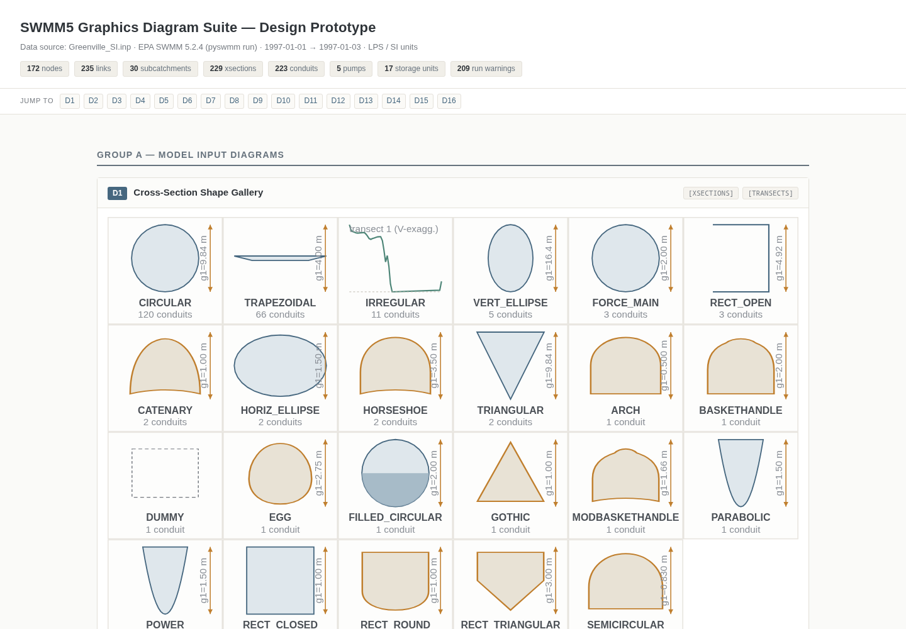
Prototype gallery — header and diagram cards
An interactive prototype of the complete suite accompanies this specification: a single-page gallery (index.html + data.js, no external libraries, vanilla JS + inline SVG) rendering all sixteen cards D1–D16 exactly as specified above, including the working snapshot toggles (D10), log-axis switch (D11), and tooltips throughout. Each card carries its Design-spec block (data mapping / visual encoding / interaction), which this document reuses and expands. The prototype runs against the real Greenville_SI.inp extract described in Section 6, so every figure in this document is reproduced from live model data rather than mock data.

