Install R and RStudio

Panafrican DIMA R training team

## Install R

To install R on **Windows**, we need to go to this page: <http://cran.r-project.org/bin/windows/base/> and follow the first link to download the installation program (**Download R 4.1.2 for Windows**).

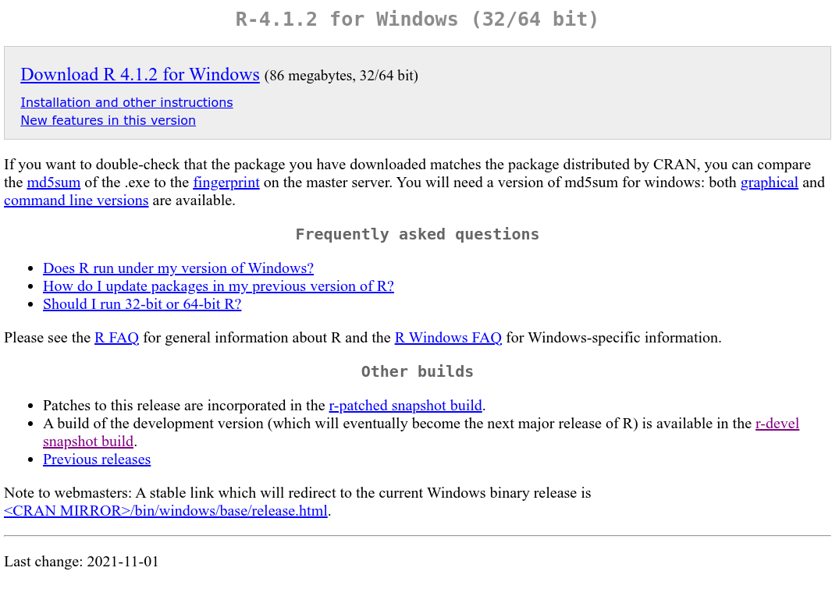

Once the installation program is launched, you just have to install **R** with all the default options.

For **Mac OS X**, the installation files are available at <http://cran.r-project.org/bin/macosx/>.

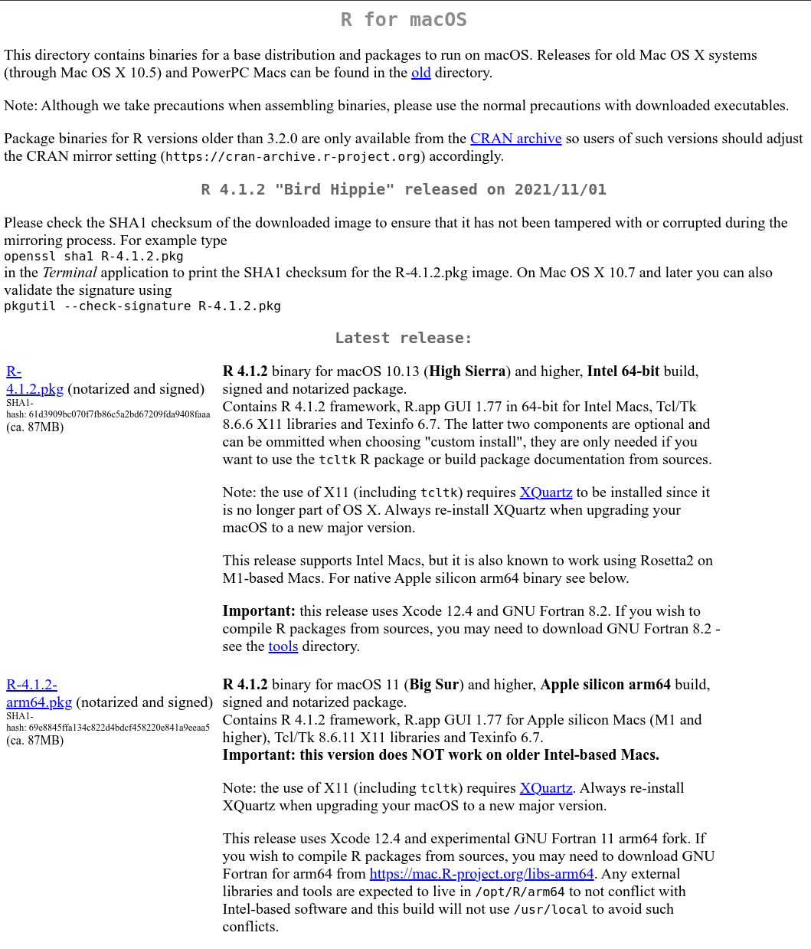

## Install RStudio

Rstudio need to be installed after R and to do that, you need to follow this url <http://www.rstudio.com/products/rstudio/download/>.

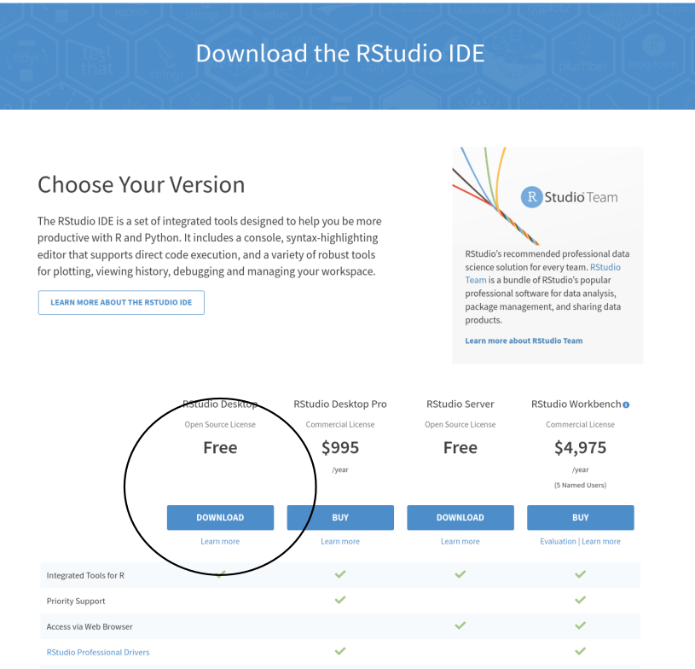

And then you select the installer corresponding to your operating system.

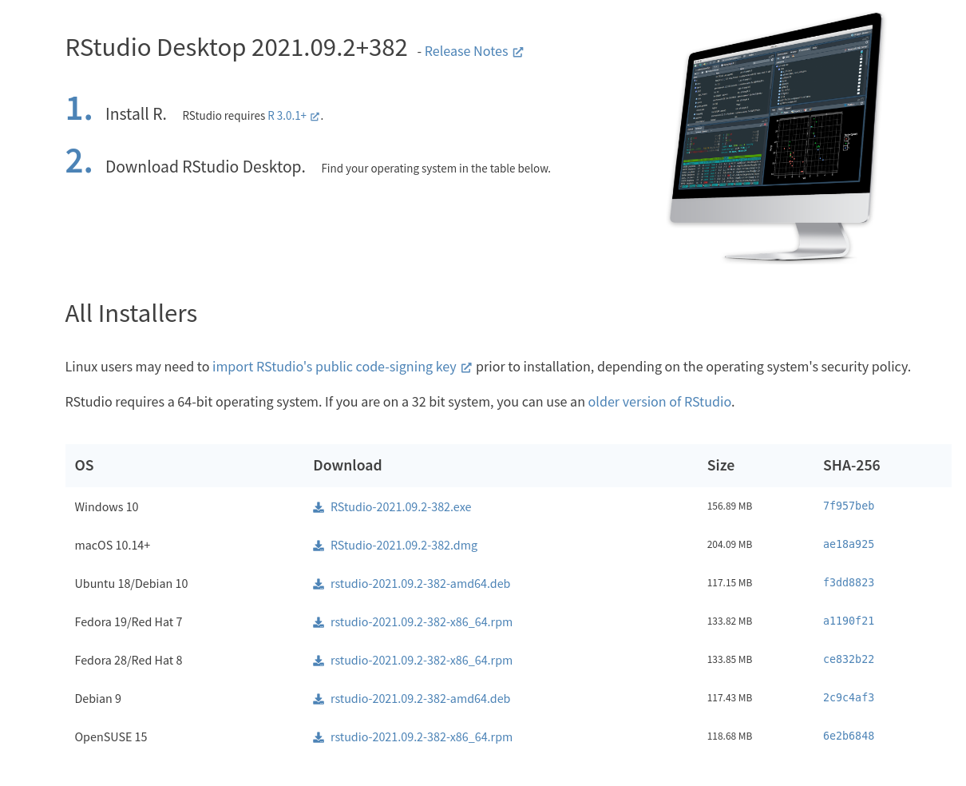

## Install the R package tidyverse

tidyverse is a metapackage we will use during this training. You can do it from the command line, if you are familiar with R using the following code:

install.packages("tidyverse", repos = "https://cloud.r-project.org/")

You can also use directly RStudio and its menu. You will need to go through the **Package** tab, then the **Install** tab and in the dialog box you have to type **tidyverse** in the text area.

