Population Statistics 2019

Pan-Africa DIMA Units

17 February 2022

# Methodology

Let’s say we are drafting a report that will be updated every quarter. The methodology section will not change substantially. We can leave the text as it is, but adding dynamic parts. For example: this report analyzes data on UNHCR’s population of concern in the year **2019**. This number will be updated whenever we filter a different year in the object above.

## Basic commands

In this subsection, we will introduce some basic commands for reports in markdown.

### Style of text

We can customize the style of the text. **Bold text** *Italic text* ***Bold and italic text***

### Quotes

“It is further proof that refugee movements and the broader issue of migration of populations … is a global challenge that cannot be confined to a few countries.”

**Filippo Grandi**

Footnotes are also included and will be added automatically to the bottom of the page like the following ones. This is a footnote[1], it can include anything and can also be stylize UNHCR[2]

### Lists

Lists also are automatic but they will need extra manual tweaking if you want to apply a more adapted paragraph style with less spacing. This apply for both ordered and unordered lists.

* item 1
* item 2
* item 3

## Tables

Tables will come with a default style. More advanced layout can be achieved using the [flextable](https://ardata-fr.github.io/flextable-book/index.html) package. Like the lists there is a built-in paragraph style if you want to improve the look and feel of your tables.

**Table** : Population of Concern by Country of Asylum

| asylum_name | total_sum |
| --- | --- |
| Dem. Rep. of the Congo | 7699312 |
| Ethiopia | 3772672 |
| Uganda | 3685628 |
| Sudan | 2962570 |
| Somalia | 2712388 |

# Plots

Creating plots in R is an exciting universe in itself. Let’s analyze the code below and reverse-engineer the main elements to consider when creating a graph with R.

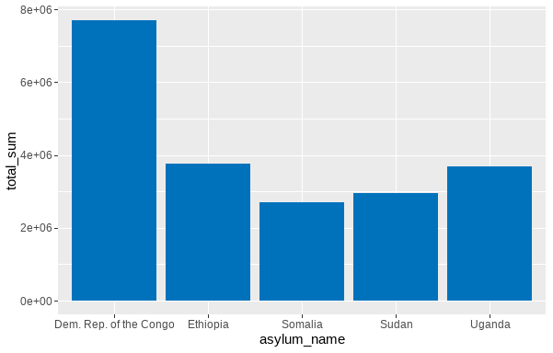

1. Text of the footnote
2. The **United Nations** High Commissioner for Refugees <https://www.unhcr.org/>