**Dataset #1**

Category (general): Travel

Thread Category (based sa nacreate na category): Philippines Destinations

Thread:

1. Title: "Hidden Gems: Unexplored Paradises in the Philippines"

- Content: Share your favorite undiscovered places and hidden gems in the Philippines. Let's uncover the beauty beyond the popular tourist spots!

2. Title: "Island Hopping Extravaganza: Best Islands to Visit in the Philippines"

- Content: Discuss your island-hopping experiences and recommend must-visit islands in the Philippines. Share tips, itineraries, and breathtaking photos!

3. Title: "Cultural Marvels: Exploring Heritage Sites in the Philippines"

- Content: Dive into the rich cultural history of the Philippines. Share your experiences visiting historical sites, UNESCO World Heritage sites, and cultural festivals.

Channel Name: PinoyWanderlust

Channel Description:

Explore the diverse beauty of the Philippines with PinoyWanderlust! From pristine beaches and lush mountains to vibrant cities and cultural treasures, join our community to share travel stories, tips, and recommendations.

Channel Thumbnail:

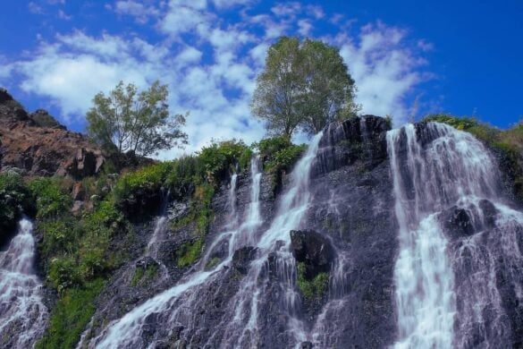

Channel Category: Travel & Adventure

**Dataset #2 (From Mark)**

Category (general): Folklores

Thread Category: Mythical Creatures in the Philippines

Thread:

1. Title: "Legends Unveiled: Tales of Mythical Creatures in Filipino Folklore"

Content: Share intriguing stories and legends about mythical creatures from Filipino folklore. Discuss their origins, characteristics, and significance in local culture. Let's explore the enchanting world of Aswangs, Tikbalangs, Kapres, and more!

2. Title: "Encounters with Enigmatic Beings: Personal Experiences with Mythical Creatures" Content: Have you ever encountered or heard firsthand accounts of encounters with mythical creatures in the Philippines? Share your own experiences or stories passed down through generations. Let's delve into the mystique surrounding these elusive beings.

3. Title: "Mythical Marvels: Art and Depictions of Filipino Mythical Creatures" Content: Explore the artistic representations of mythical creatures in Filipino culture. Share paintings, sculptures, or digital art depicting Aswangs, Nuno sa Punso, Diwatas, or other legendary beings. Discuss the symbolism and interpretations behind these artistic creations.

Channel Name: MythicalMystique

Channel Description: Explore the realms of mythical creatures, legends, and folklore from around the world. Uncover the mysteries, tales, and cultural significance of these enchanting beings through discussions, stories, and historical connections.

Channel Thumbnail:

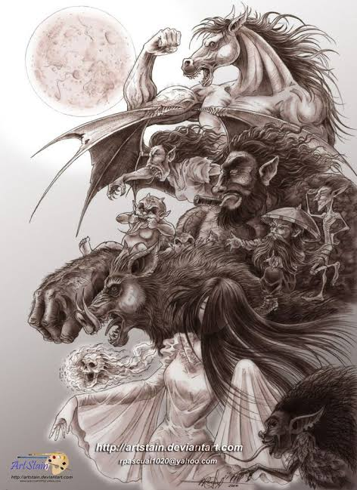

Channel Category: Cultural Events

**Dataset #3 (From Mark)**

Category (general): Foods

Thread Category: Exotic Foods in the Philippines

Thread:

1. Title: "Taste Adventures: Exotic Delicacies of the Philippines"

Content: Share your culinary escapades exploring unique and lesser-known Filipino dishes! From balut to tamilok, let's discuss exotic delicacies, traditional recipes, and your tasting experiences.

1. Title: "Street Food Safari: Uncovering Exotic Flavors in Filipino Streets"

Content: Dive into the bustling streets of the Philippines and share your encounters with exotic street food. From isaw to betamax, let's exchange recommendations, street food maps, and mouthwatering snapshots!

3.Title: "Culinary Journeys: Exotic Fusion Cuisine in the Philippines"

Content: Explore the fusion of flavors in Filipino cuisine! Discuss unique blends, uncommon ingredients, and exotic food pairings that showcase the diversity and creativity of Filipino culinary artistry. Share your favorite fusion food discoveries and recipes.

Channel Name: ExoticaEats

Channel Description: Embark on a gastronomic journey filled with exotic and unique flavors! ExoticaEats celebrates the diversity of global cuisines, inviting you to discover, discuss, and savor the most unusual and tantalizing foods from various cultures and traditions.

Channel Thumbnail:

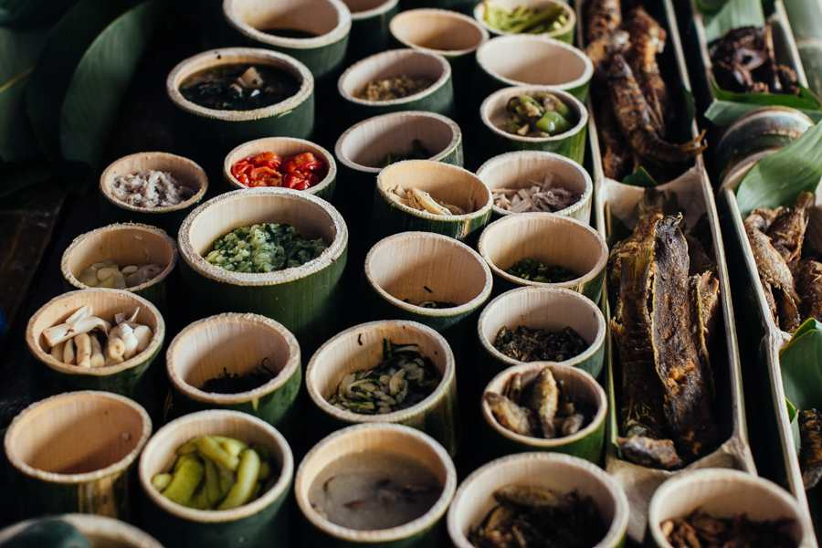

Channel Category: Philippine Foods

Channel 1: TechTalkPH

Channel Name: TechTalkPH

Channel Description: Explore the dynamic landscape of the tech industry in the Philippines with TechTalkPH! Join us for insightful discussions on emerging technologies, startups, and the impact of innovation on the country's economy.

Channel Thumbnail:



Channel Thread 1:

Channel Thread Title: "Rising Stars: Filipino Tech Startups to Watch" Channel Thread Content: Discuss and share your insights on promising tech startups in the Philippines. Whether it's fintech, health tech, or AI-driven innovations, let's spotlight the rising stars shaping the future of the Philippine tech industry.

Channel Thread 2:

Channel Thread Title: "Challenges and Opportunities: Navigating the Tech Scene in PH" Channel Thread Content: Engage in a conversation about the current challenges and opportunities in the Philippine tech industry. Share your experiences, opinions, and predictions for the future. How can we collectively overcome hurdles and foster growth?

Channel 2: FiestaFiestaPH

Channel Name: FiestaFiestaPH

Channel Description: Immerse yourself in the vibrant and colorful world of Philippine fiestas with FiestaFiestaPH! Join us as we celebrate the rich cultural tapestry of the country through lively discussions about traditional festivals, local delicacies, and community spirit.

Channel Thumbnail:

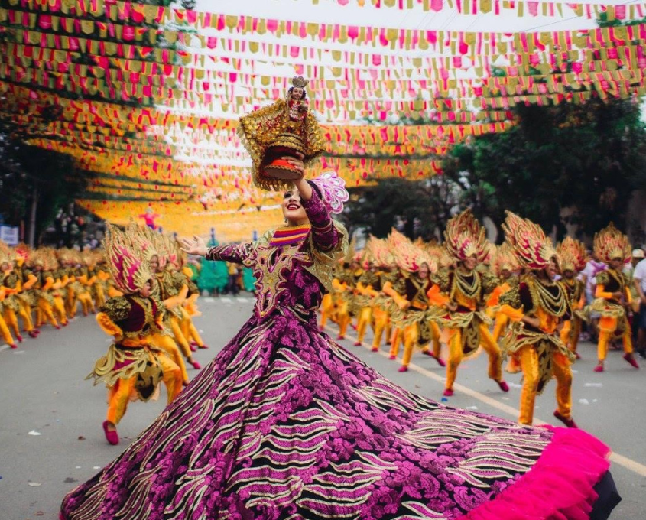

Channel Thread 1:

Channel Thread Title: "Fiesta Feast: Your Ultimate Guide to Philippine Festival Foods" Channel Thread Content: Indulge in a virtual feast! Share your favorite foods and delicacies from Philippine fiestas. From traditional dishes to street food delights, let's compile a gastronomic guide to the culinary treasures of these festive celebrations.

Channel Thread 2:

Channel Thread Title: "Dance, Music, and Merriment: Best Moments from Philippine Fiestas" Channel Thread Content: Relive the joyous moments! Share your experiences of the vibrant dance performances, lively music, and overall merriment at Philippine fiestas. Discuss your favorite celebrations and the unique cultural expressions that make each fiesta special.