GHANA COMMUNICATION TECHNOLOGY UNIVERSITY

FACULTY OF COMPUTING AND INFORMATION SYSTEMS
DEPARTMENT OF INFORMATION TECHNOLOGY

PROJECT TITLE
DESIGN AND DEVELOPMENT OF HOSPITAL MANAGEMENT SYSTEM

BY
NYAMEKYE ISAAC ANTWI | 4211231074
EMMANUEL MANFUL | 4211231099
BERNARD CONRAD HESSE | 4211231234

A PROJECT SUBMITTED TO THE DEPARTMENT OF INFORMATION TECHNOLOGY OF GHANA COMMUNICATION TECHNOLOGY UNIVERSITY IN PARTIAL FULFILMENT OF REQUIREMENTS FOR AWARD OF BACHELOR OF SCIENCE IN INFORMATION TECHNOLOGY

KORMI KORTO
(SUPERVISOR)
MAY, 2026

DECLARATION
We hereby declare that this project is the result of our original research conducted under the supervision of our appointed supervisor. To the best of our knowledge, this work has not been submitted, either in whole or in part, for any academic award at this University or at any other institution.
Nyamekye Isaac Antwi  (ID: 4211231074) | Signature: ________________________  Date: ____________________________
Emmanuel Manful  (ID: 4211231099) | Signature: ________________________  Date: ____________________________
Bernard Conrad Hesse  (ID: 4211231234) | Signature: ________________________  Date: ____________________________

CERTIFICATION
I certify that this project was supervised in accordance with the academic guidance of procedures by the Ghana Communication Technology University.
Kormi Korto  (Supervisor) | Signature: ________________________  Date: ____________________________

DEDICATION
This project is dedicated to all healthcare professionals, hospital administrators, and medical staff who work tirelessly to provide quality healthcare services and improve the well-being of patients every day. To hospitals and healthcare institutions striving to enhance efficiency, accuracy, and patient care through modern technological solutions. To software developers and technology innovators whose contributions continue to transform the healthcare industry through digital systems and automation. Above all, this project is dedicated to patients and future healthcare users who deserve accessible, reliable, secure, and efficient healthcare management services. The “Design and Development of Hospital Management System” represents the integration of healthcare and technology in promoting effective hospital operations, improved patient record management, and better healthcare delivery.

ABSTRACT
The healthcare sector has experienced significant technological advancement aimed at improving the quality and efficiency of medical services. However, many hospitals still rely on manual methods for managing patient records, appointments, billing, and other administrative activities. These traditional systems are often slow, prone to errors, difficult to maintain, and vulnerable to loss of important information. The need for a reliable computerized system has therefore become essential in modern healthcare institutions. This project titled “Design and Development of Hospital Management System” was developed to address these challenges by providing an efficient digital platform for managing hospital operations. The system is intended to improve record keeping, reduce paperwork, and enhance communication within hospital departments.
The Hospital Management System was designed to automate major hospital activities such as patient registration, appointment scheduling, doctor management, medical record management, billing, and report generation. The development of the system followed a structured methodology involving system analysis, system design, implementation, testing, and evaluation. Various programming tools, database technologies, and web development frameworks were used to ensure that the system is secure, user-friendly, and reliable. The system allows authorized users to access and manage patient information quickly and accurately. In addition, it minimizes duplication of records and improves the speed of healthcare service delivery. The implementation process also focused on ensuring data integrity, confidentiality, and ease of use for healthcare personnel.
The developed system was tested under different conditions to evaluate its performance, functionality, and reliability in handling hospital operations. The results obtained showed that the system effectively improves operational efficiency, reduces administrative workload, and enhances the management of patient information within healthcare facilities. It also supports faster decision-making by providing quick access to accurate hospital data and reports. The project demonstrates the importance of integrating information technology into healthcare systems to improve service delivery and organizational performance. In conclusion, the Hospital Management System provides a practical and effective solution for modern hospital management challenges. The system can contribute significantly to improving healthcare administration, patient care, and overall hospital efficiency.

TABLE OF CONTENT

DECLARATION i
CERTIFICATION ii
DEDICATION iii
ABSTRACT iv
TABLE OF CONTENT v
LIST OF FIGURES vii
LIST OF TABLES viii
LIST OF ABBREVIATIONS ix
ACKNOWLEDGEMENT x
CHAPTER 1 1
1.0 INTRODUCTION 1
1.1 Background of Study 2
1.2 Problem Statement 3
1.3 Aim and Objectives of Study 4
1.3.1 Aim of Study 4
1.3.2 Objectives of Study 4
1.4 Significance of Study 4
1.4.1 Organization 5
1.4.2 Academia 5
1.4.3 Government 6
1.5 Scope and Limitations of Study 6
1.5.1 Scope of Study 6
1.5.2 Limitations of Study 7
1.6 Organization of Study 8
CHAPTER 2 9
LITERATURE REVIEW 9
2.1 Inefficiency of Manual and Paper-Based Hospital Record Systems 9
2.2 Lack of Integration and Coordination Among Hospital Departments 11
2.2.1 Poor Communication and Information Sharing 12
2.2.2 Duplication of Records and Delays in Service Delivery 13
2.3 Data Security and Confidentiality Challenges in Hospital Information Management 13
2.4 Design of a Secure and User-Friendly Hospital Management System 15
2.4.1 User Interface and System Usability 16
2.5 Development of a Centralized Database System for Managing Hospital Records 17
2.6 Implementation of Modules for Patient Registration, Appointment Scheduling, Billing, and Medical Record Management 18
2.6.1 Patient Registration and Appointment Scheduling 19
2.6.2 Billing and Medical Record Management 20
2.7 Electronic Health Record (EHR) System 21
2.7.1 Limitations of Electronic Health Record (EHR) Systems 22
2.8 OpenMRS 23
2.8.1 Limitations of OpenMRS 24
2.9 MediTracker 25
2.9.1 Limitations of MediTracker 26
2.10 DHIS2 27
2.10.1 Limitations of DHIS2 28
CHAPTER 3 29
METHODOLOGY, SYSTEM SPECIFICATION AND DESIGN 29
3.1 Overview 29
3.1.1 Methodology 29
3.1.2 Justification for Chosen Methodology 31
3.2 System Requirement Specification 35
3.2.1 Functional Requirements 37
3.2.2 Non-Functional Requirements 39
3.2.3 Software Requirements 41
3.3 System Design 42
3.3.1 Use Case Diagram 43
3.3.2 Sequence Diagram 44
3.3.3 Entity Relationship Diagram 45
3.3.4 Flow Chart Diagram 46
3.3.5 Data Flow Diagram (DFD) 47
3.4 System Architecture 49
3.4.1 Context Diagram 50
REFERENCES 52

LIST OF FIGURES
Figure 3. 1 Iterative Model Diagram 33
Figure 3. 2 Application to the Proposed System 34
Figure 3. 3 UML Class Diagram 36
Figure 3. 4 use case diagram 43
Figure 3. 5 Sequence Diagram 44
Figure 3. 6 Entity Relationship Diagram 45
Figure 3. 7 Flowchart Diagram 46
Figure 3. 8 Level 0 Data Flow Diagram 47
Figure 3. 9 Level 1 Data Flow Diagram 48
Figure 3. 10 System Architecture Teir 3 50
Figure 3. 11 Context Diagram 51

LIST OF TABLES

LIST OF ABBREVIATIONS
DFD | Data Flow Diagram
EHR | Electronic Health Record

ACKNOWLEDGEMENT
It is our great privilege to have had the opportunity to carry out this thesis under the supervision of Kormi Korto of the Faculty of Computing and Information Systems at Ghana Communication Technology University (GCTU), Accra Tesano. We express our sincere appreciation and deepest gratitude to our supervisor for his constant support, invaluable guidance, and unwavering encouragement throughout the course of this research. We also extend our gratitude to the Head of the Faculty of Information Technology and the authorities of Ghana Communication Technology University for providing the necessary infrastructural facilities and an enabling environment for this research work. Special thanks go to all faculty members and staff of the Department of Information Technology Studies at GCTU for their cooperation, assistance, and support in making this work a success.

CHAPTER 1

INTRODUCTION
The healthcare industry plays a vital role in every society by ensuring the well-being and survival of individuals through the provision of medical services. Over the years, hospitals have relied on manual systems for managing patient records, appointments, billing, and administrative tasks. These traditional methods often involve the use of paper files and physical registers, which are time-consuming, prone to human error, and difficult to manage as patient data increases. With the advancement of information technology, there has been a growing need to automate hospital processes to improve efficiency, accuracy, and service delivery. The Design and Development of Hospital Management System is therefore aimed at addressing these challenges by introducing a computerized system that enhances hospital operations and improves healthcare management.
Historically, hospital management systems were entirely manual, with records stored in physical files and documentation handled by administrative staff. This approach often led to challenges such as misplaced records, duplication of patient data, delays in retrieving information, and inefficiencies in communication between departments. As technology evolved, hospitals began adopting simple digital systems such as standalone databases and basic software applications to manage patient information. However, these early systems were limited in functionality and lacked integration across different hospital departments. In recent years, modern Hospital Management Systems have evolved into fully integrated platforms that support real-time data access, cloud storage, automation, and interoperability between healthcare units, significantly improving the quality of healthcare delivery.
The trend in healthcare technology is now focused on digital transformation, where hospitals are increasingly adopting advanced systems that incorporate web-based applications, mobile accessibility, artificial intelligence, and data analytics. These innovations help healthcare providers make faster and more informed decisions while improving patient experience and reducing operational costs. In developing countries, including Ghana, there is a growing interest in adopting such systems to replace inefficient manual processes and improve healthcare delivery standards.

Background of Study
The management of hospital operations has become increasingly complex due to the rising number of patients, expansion of healthcare services, and the demand for accurate and timely medical information. Traditionally, hospitals relied on manual record-keeping systems in which patient details, appointments, prescriptions, and billing information were stored in paper-based files. While this approach served healthcare institutions for many years, it is associated with several limitations such as data redundancy, difficulty in retrieving patient records, loss or damage of files, and inefficiencies in communication between departments. According to (Thant and Tin, 2023), manual systems are often error-prone and do not scale effectively in environments where large volumes of data must be processed efficiently.
With the advancement of information and communication technology, many healthcare institutions have adopted Hospital Management Systems (HMS) to automate and integrate their operations. These systems combine multiple hospital functions such as patient registration, electronic health records, laboratory management, pharmacy services, and billing into a centralized digital platform. (Laudon, Laudon and Traver, 2023)emphasize that information systems improve organizational efficiency by enhancing data processing, accuracy, and decision-making capabilities. In the same vein, studies by (Mulukuntla and Pamulaparthyvenkata, 2020)indicate that digital health systems significantly reduce administrative workload and improve patient care outcomes by minimizing delays in accessing critical information. Despite these advantages, many systems in developing regions are still underutilized due to challenges such as high implementation costs, lack of infrastructure, and insufficient technical expertise.
In Ghana and other developing countries, the healthcare sector continues to experience challenges in fully adopting integrated digital hospital systems. Many hospitals still operate with partially manual or fragmented digital systems, resulting in poor data synchronization across departments. According to World Health Organization (WHO, 2019), inefficient health information systems contribute to delays in service delivery and increase the risk of medical errors, particularly in resource-constrained environments. These challenges highlight a significant gap in the development and deployment of affordable, user-friendly, and fully integrated hospital management solutions.

Problem Statement
The healthcare system in many hospitals continues to experience operational inefficiencies due to the continued reliance on manual or partially digitized processes for managing patient and administrative data. One major challenge is the inefficiency of paper-based record systems, where patient information is stored in physical files that can be easily lost, damaged, or misfiled. This often leads to delays in retrieving critical patient information, which can negatively affect timely diagnosis and treatment. According to(Avison and Fitzgerald, 2006), manual information systems are highly vulnerable to human error and become increasingly inefficient as the volume of data grows, particularly in complex environments such as healthcare institutions.
Another significant problem is the lack of integration among hospital departments such as registration, laboratory, pharmacy, and billing units. In many hospitals, these departments operate using separate systems or manual processes, resulting in poor communication and duplication of tasks. This fragmentation causes delays in service delivery and reduces the overall efficiency of hospital operations. (Hamad, Altaheri and Shamsi, 2025)note that the absence of integrated information systems leads to inconsistent data flow and weak coordination across organizational units, ultimately affecting decision-making and service quality in critical sectors like healthcare.
In addition, many healthcare facilities, particularly in developing countries, struggle with issues related to data security, accessibility, and efficiency of service delivery. Patient records stored in unsecured or poorly managed systems are at risk of unauthorized access, loss, or corruption. Furthermore, healthcare professionals often spend valuable time on administrative duties instead of focusing on patient care due to inefficient systems. Surchi, (2025)emphasize that poorly designed information systems can hinder organizational performance and reduce productivity. These challenges highlight the urgent need for a secure, integrated, and efficient Hospital Management System that can improve data handling, enhance coordination, and support better healthcare delivery outcomes.

Aim and Objectives of Study

1.3.1 Aim of Study
The aim of this study is to design and develop a hospital management system.

1.3.2 Objectives of Study
The objectives of this study are to;
- To design a secure and user-friendly Hospital Management System for managing hospital operations efficiently.
- To develop a centralized database system for storing and managing patient and hospital records.
- To implement modules for patient registration, appointment scheduling, billing, and medical record management.
- To integrate different hospital departments such as pharmacy, laboratory, and administration into a single platform.
- To test and evaluate the performance, reliability, and effectiveness of the developed Hospital Management System.

Significance of Study
The development of a Hospital Management System is important because it will improve the management of healthcare information and hospital operations. The system is expected to benefit several stakeholders, including hospital administrators, doctors, nurses, pharmacists, laboratory staff, accountants, patients, researchers, and government institutions. By replacing manual processes with computerized operations, the system will improve the storage, retrieval, and sharing of patient information across departments. It will also reduce paperwork, minimize operational delays, improve communication, and strengthen data security within healthcare institutions. Furthermore, the system will support efficient healthcare service delivery by helping healthcare workers access patient information quickly and accurately. The study is therefore significant because it contributes to improving healthcare management, organizational efficiency, and patient satisfaction.

1.4.1 Organization
The proposed Hospital Management System will be significant to healthcare organizations because it will improve the efficiency of hospital operations and administrative processes. Hospitals often face challenges such as poor record management, delays in accessing patient information, duplication of records, and weak coordination among departments. The system will help address these challenges by providing a centralized platform for managing patient registration, appointment scheduling, billing, medical records, pharmacy services, and laboratory operations. This will improve communication and information sharing among departments while reducing delays associated with manual systems.
The system will also improve decision-making and resource management within healthcare institutions. Hospital administrators will be able to access accurate and updated information regarding patient records, staff activities, billing transactions, and hospital operations. This will support better planning, monitoring, and management of healthcare services. In addition, the system will reduce paperwork, minimize human errors, and improve the security of patient information through electronic storage and controlled access. Therefore, the Hospital Management System will help organizations improve productivity, reduce operational costs, and enhance the quality of healthcare services provided to patients.

1.4.2 Academia
The study will be significant in academia because it will contribute to knowledge and research in the fields of information systems, software development, and healthcare management. Students and researchers will benefit from the study by understanding how computerized systems can be applied to solve problems related to hospital operations and information management. The research will also provide practical knowledge on system analysis, database design, user interface development, and information security within healthcare environments.
The study may also serve as a reference material for future academic research related to Hospital Management Systems, healthcare information systems, and computerized organizational management. Researchers who wish to study healthcare technology, information security, system integration, or database management may use the findings of this study as a foundation for further investigation. Additionally, educational institutions may use the project as a practical example for teaching students about software engineering, systems analysis and design, and healthcare technology solutions.

1.4.3 Government
The study will be significant to the government because healthcare institutions play an important role in national development and public health management. The implementation of a Hospital Management System can help government healthcare agencies improve the efficiency and quality of healthcare services provided to citizens. By promoting computerized healthcare systems, government institutions can reduce problems associated with manual record management, improve healthcare reporting, and strengthen healthcare planning processes.
The system will also support government efforts toward digital transformation and improved public service delivery. Through centralized and secure healthcare information management, government agencies can access accurate healthcare data for monitoring, policy development, and decision-making. Furthermore, the system can help improve transparency, accountability, and resource management in public healthcare institutions. Therefore, the study will support government initiatives aimed at improving healthcare infrastructure, promoting information technology adoption, and enhancing healthcare service delivery within the country.

Scope and Limitations of Study

Scope of Study
This project focuses on the design and development of a Hospital Management System intended to improve the management of hospital operations within healthcare institutions. The system is specifically designed for use in hospitals, clinics, and other healthcare centers where patient information and administrative activities need to be managed efficiently. The project covers major hospital functions such as patient registration, appointment scheduling, medical record management, billing, and report generation. It also includes the integration of key hospital departments such as pharmacy, laboratory, and administration into a centralized system to improve communication and workflow within the hospital environment.
The scope of the study is limited to the development of a web-based application that allows authorized users such as administrators, doctors, nurses, and receptionists to access and manage hospital data securely. The system is designed to improve data storage, retrieval, and processing while reducing the dependence on manual record-keeping methods. The project also focuses on ensuring data accuracy, confidentiality, and efficient handling of hospital operations through the use of modern information technology tools and database systems. System testing and evaluation are included within the scope to ensure that the developed application performs effectively according to user requirements.
However, the study does not cover advanced healthcare technologies such as telemedicine services, artificial intelligence-based diagnosis, biometric authentication, or integration with national health databases. The project is also limited to the management of general hospital activities and does not include specialized medical equipment control systems or emergency response systems. In addition, the system is developed primarily for small and medium-sized healthcare institutions and may require further expansion and customization for large-scale hospitals with more complex operations. Therefore, the study is confined to the development of a functional and efficient Hospital Management System aimed at improving healthcare administration and service delivery within selected healthcare environments.

Limitations of Study
The development of this Hospital Management System is expected to face several challenges that may affect the smooth delivery and full implementation of the project. One major limitation is time constraint, as the project must be completed within a specific academic period. This limited timeframe may restrict the ability to fully implement advanced features or conduct extensive testing and optimization of the system. As a result, some functionalities may be simplified to ensure timely completion of the project.
Another anticipated challenge is financial constraint, as the development and deployment of a fully functional system may require resources such as hosting services, software tools, and hardware requirements. Limited funding may therefore affect the ability to acquire premium tools, cloud infrastructure, or advanced technologies needed for scaling the system. This may also influence the overall performance and deployment environment of the application, especially if real-world hospital integration is considered.
In addition, technical and resource limitations may also arise during the development process. These include lack of access to real hospital data, limited availability of experienced technical guidance, and possible challenges in integrating all hospital departments into a fully unified system. Furthermore, system testing in a real hospital environment may not be fully achievable due to security and privacy concerns. These limitations may affect the depth of evaluation and real-world validation of the system, although efforts will be made to ensure the system performs effectively within the available resources.

Organization of Study
This project is structured into five main chapters to ensure a clear and systematic presentation of the work carried out in the development of the Hospital Management System. Chapter One presents the introduction to the study, which includes the background of the project, problem statement, objectives, significance of the study, scope, limitations, and the organization of the study. This chapter provides an overview of the entire project and explains the need for developing the system.
Chapter Two focuses on the literature review, where related works, existing systems, and relevant theories are discussed. It also identifies gaps in current hospital management systems and justifies the need for the proposed solution. Chapter Three describes the system design and methodology used in developing the project. It covers the system architecture, requirements analysis, design tools, database design, and the technologies used in implementing the system.
Chapter Four presents the implementation and testing of the system. It includes screenshots of the system, explanation of modules, and evaluation of the system’s performance based on testing results. Chapter Five provides the summary, conclusion, and recommendations for future improvements of the Hospital Management System

CHAPTER 2

LITERATURE REVIEW

2.1 Inefficiency of Manual and Paper-Based Hospital Record Systems
In recent years, the literature on hospital information systems has increasingly emphasized the relationship between effective information management and the quality of healthcare delivery. Researchers argue that healthcare institutions depend heavily on accurate, timely, and accessible information because clinical and administrative activities such as patient registration, diagnosis, laboratory testing, pharmacy services, billing, and medical reporting all rely on efficient data management systems (Aveson and Fitzgerald, 2006).According to (Siau et al., 2021), manual information systems become increasingly inefficient as the volume of organizational data grows, particularly in complex environments where many users depend on the same information simultaneously. This suggests that traditional paper-based systems are unable to effectively support the operational demands of modern hospitals.
Several scholars have identified inefficiency in paper-based record management as a major challenge affecting healthcare delivery. In many hospitals, patient information is still stored in physical files, folders, and handwritten registers. Although such systems may appear manageable in small healthcare facilities, they become difficult to organize and maintain as the number of patients increases (Heeks, 2002). Researchers argue that manual systems often result in misplaced files, duplicated records, incomplete documentation, and delays in retrieving patient information (Kiromah et al., 2024).These problems can negatively affect clinical decision-making because doctors and nurses may not have quick access to accurate patient histories, laboratory reports, prescriptions, or treatment records when needed.
The literature further suggests that delays in accessing patient information can directly affect the quality of healthcare services. AccordingSEUN et al. (2023), information systems play an important role in improving organizational efficiency by supporting timely communication and data processing. In healthcare institutions, the inability to retrieve patient records quickly may delay diagnosis, treatment, and emergency response. Scholars such as Mansell and Wehn, 1998) argue that information technologies improve institutional effectiveness by enhancing the flow of information across departments and reducing operational bottlenecks. This means that hospitals that continue to rely heavily on manual systems may struggle to provide fast and coordinated healthcare services.
However, many researchers have also emphasized the importance of integrated information systems in improving organizational coordination and service delivery. Hamad, Altaheri and Shamsi, (2025) note that the absence of integrated information systems leads to inconsistent data flow and weak coordination among organizational units. In hospitals, departments such as registration, pharmacy, laboratory, records, and billing often operate independently using separate manual processes or disconnected systems. This fragmentation causes duplication of tasks, repeated data entry, communication delays, and inconsistencies in patient information. According to (Li et al., 2022)integrated information systems improve institutional performance by supporting cooperation, communication, and information sharing among departments. Therefore, the lack of integration in manual hospital systems reduces operational efficiency and affects the quality of patient care.
In addition, scholars have highlighted concerns about data security and confidentiality in manual healthcare systems. Patient records contain sensitive personal and medical information that must be protected against unauthorized access, loss, or manipulation. However, paper-based records can easily be misplaced, stolen, damaged by environmental conditions, or accessed without authorization (Collmann et al., 1997). Studies have shown that poorly managed information systems reduce organizational reliability and weaken service delivery (Surchi, 2025).Similarly, Avison and Fitzgerald (2006) explain that manual systems are highly vulnerable to human error because they depend heavily on physical handling and repetitive administrative tasks.
Although many scholars support the adoption of computerized information systems, some researchers caution that technology alone cannot solve institutional problems. According to (Warschauer, 2002), the effectiveness of information systems depends not only on access to technology but also on factors such as user skills, organizational structure, training, and institutional support. This suggests that a Hospital Management System must not only be computerized but also secure, user-friendly, integrated, and properly designed to meet the operational needs of healthcare professionals. Therefore, the continued inefficiency of manual and paper-based hospital record systems highlights the need for a well-designed Hospital Management System that can improve information management, strengthen departmental coordination, enhance data security, and support efficient healthcare delivery.

2.2 Lack of Integration and Coordination Among Hospital Departments
The literature on healthcare information systems increasingly recognizes that effective coordination among hospital departments is essential for efficient healthcare delivery. Hospitals consist of several interconnected units such as registration, pharmacy, laboratory, records, billing, and administration, all of which depend on continuous information exchange to function properly. However, many healthcare institutions still operate with fragmented systems where departments maintain separate records and processes. According to (Laudon and Laudon, 2004), organizations that use isolated information systems often experience communication barriers, duplication of activities, and delays in operational processes because information cannot move efficiently across units. In hospitals, this lack of integration weakens service delivery and slows decision-making processes.
Researchers have also emphasized that disconnected hospital systems reduce the quality and speed of patient care. (O’brien and Marakas, 2011) explain that integrated information systems improve organizational coordination by allowing departments to share information in real time. Without integration, hospital staff may repeatedly request the same patient information at different departments, increasing patient waiting time and reducing operational efficiency (Hopp and Lovejoy, 2012). This challenge becomes more serious in hospitals with large patient populations, where delays in communication between departments can negatively affect treatment and emergency response processes.
The literature further suggests that fragmented hospital operations contribute to inconsistent patient records and duplication of work. (Stair et al., 2015) argue that organizations without centralized databases often face difficulties maintaining data consistency because information is stored separately across departments. In healthcare institutions, patient details entered at registration may differ from records stored in laboratory, pharmacy, or billing departments (Benjamin, 2003). Such inconsistencies increase the risk of medical errors, inaccurate billing, and poor patient management. This demonstrates the importance of integrated systems in supporting accurate and coordinated healthcare operations.
In addition, scholars argue that integrated systems improve organizational productivity and service quality by supporting faster communication and better workflow management. (Turban, Pollard and Wood, 2018) note that information systems strengthen organizational performance when they connect departments through a shared platform for communication and data exchange. In hospitals, integration enables doctors, nurses, pharmacists, laboratory staff, and administrators to access updated patient information simultaneously. Therefore, the lack of coordination among hospital departments remains a major operational challenge that supports the development of a centralized Hospital Management System.

2.2.1 Poor Communication and Information Sharing
Ahmad et al., (2025) stated that poor communication between hospital departments is a major problem associated with fragmented healthcare systems. In many hospitals, information is transferred manually through paper files, printed reports, or verbal communication. According to (Yeboah, 2023) organizations that rely on manual information exchange experience delays, misunderstandings, and inefficient workflow management. In hospitals, this can delay patient treatment because doctors, pharmacists, laboratory staff, and accountants may not receive important information on time.
Several scholars have argued that efficient communication systems improve healthcare coordination and decision-making. (Alter, 2008) explains that integrated information systems support organizational communication by enabling quick access to shared information across departments. In healthcare institutions, this allows patient records, laboratory reports, prescriptions, and billing details to be updated and viewed in real time. Without such integration, hospital staff may spend unnecessary time searching for records or verifying information manually, which slows down healthcare delivery.
Researchers also note that poor communication affects patient satisfaction and operational efficiency. According to (Sulaiman, Abdullah and Man, 2023) organizations with weak communication systems often experience delays in service delivery and reduced employee productivity. In hospitals, poor communication among departments may result in long patient waiting times, repeated procedures, and confusion in handling patient records. Therefore, improving communication and information sharing is an important requirement for an effective Hospital Management System.

2.2.2 Duplication of Records and Delays in Service Delivery
Duplication of records is another common problem associated with non-integrated hospital systems. In many healthcare institutions, patient information is recorded separately in different departments because there is no centralized database. According to Whitten and Bentley (2007), disconnected information systems often lead to repeated data entry, inconsistent records, and redundancy of information. In hospitals, this may result in multiple files for the same patient, repeated laboratory requests, and inconsistent billing information.
The literature further explains that duplication increases operational inefficiency and wastes organizational resources. Satzinger, Jackson, and Burd (2016) argue that repeated data entry consumes valuable staff time and increases the possibility of human error. In healthcare environments, duplication of patient information may lead to inaccurate treatment records, delays in diagnosis, and unnecessary administrative costs. Such inefficiencies reduce the ability of hospitals to provide fast and reliable healthcare services.
Operational delays are also closely linked to fragmented systems and duplicate processes. According to Dennis, Wixom, and Roth (2015), integrated information systems improve workflow efficiency by reducing delays associated with manual processing and information transfer. In hospitals without centralized systems, delays may occur when patient files are moved physically between departments or when staff must manually confirm information before continuing treatment procedures. These delays can negatively affect patient care and reduce overall hospital productivity. Therefore, reducing duplication and operational delays remains one of the major reasons for developing an integrated Hospital Management System.

2.3 Data Security and Confidentiality Challenges in Hospital Information Management
The literature on healthcare information systems increasingly emphasizes the importance of data security and confidentiality in hospital operations. Hospitals manage highly sensitive information such as patient medical histories, laboratory reports, prescriptions, billing details, and personal identification records (Adeniyi et al., 2024). Protecting this information is important because unauthorized access, loss, or alteration of patient data can negatively affect healthcare delivery and violate patient privacy rights. Appari and Johnson (2010) argue that healthcare information systems require strong privacy and security controls because electronic health records contain sensitive personal and clinical data. Similarly, Fernández-Alemán et al. (2013) explain that patient data security is a major concern in health information systems due to risks such as unauthorized access, data misuse, and privacy breaches. Kruse et al. (2017) also note that healthcare organizations must protect patient information through effective security practices to maintain trust and ensure safe health service delivery.
Researchers argue that manual and poorly managed hospital systems are highly vulnerable to security risks and data loss. Laudon and Laudon (2018) explain that paper-based systems expose organizations to greater risks because physical records can easily be misplaced, stolen, destroyed, or accessed by unauthorized persons. In many hospitals, patient files are stored in cabinets or record rooms where multiple individuals may have unrestricted access to confidential information. Physical records are also vulnerable to environmental hazards such as fire, flooding, dust, and poor storage conditions. Such problems may result in the permanent loss of important patient information, making it difficult for healthcare workers to provide accurate and timely treatment.
However, confidentiality is a critical ethical requirement in healthcare management. O’Brien and Marakas (2011) note that organizations that fail to protect confidential information may experience legal challenges, operational instability, and loss of public confidence. In hospitals, patient information must only be accessible to authorized healthcare professionals involved in patient care. However, in manual systems, files are often transferred physically between departments, increasing the possibility of unauthorized access, information leakage, or alteration of records. This creates serious concerns about patient privacy and data protection within healthcare institutions.
Several scholars have emphasized that secure computerized systems can improve healthcare information management and reduce security risks. Turban, Pollard, and Wood (2018) explain that modern information systems improve data protection through security features such as password authentication, access control, user permissions, and data encryption. These features help organizations control who can access or modify sensitive information. In hospitals, secure Hospital Management Systems allow patient records to be stored electronically and accessed only by authorized personnel, thereby improving confidentiality and reducing the risks associated with paper-based systems.
Researchers have also pointed out that poor information security negatively affects organizational productivity and service delivery. According to Shelly and Rosenblatt (2012), organizations with weak security structures often experience operational disruptions, inconsistent records, and reduced system reliability. In healthcare institutions, missing or corrupted patient information may delay treatment, increase administrative workload, and create confusion among healthcare workers. Furthermore, repeated cases of data loss or unauthorized access can weaken patient trust and reduce confidence in hospital services.
Although computerized systems improve information security, scholars argue that technology alone cannot completely eliminate security challenges. Kendall and Kendall (2011) explain that effective information security depends not only on technology but also on proper system design, user awareness, staff training, and organizational policies. Poorly designed systems or improper handling of digital records may still expose hospitals to cyber threats, unauthorized access, or accidental loss of information. Therefore, healthcare institutions require secure and well-designed Hospital Management Systems that combine technological security measures with effective management practices to ensure the protection of patient information and improve healthcare service delivery.

2.4 Design of a Secure and User-Friendly Hospital Management System
The design of a secure and user-friendly Hospital Management System is important because hospitals require systems that can support both clinical and administrative activities effectively. A hospital system must be able to handle patient registration, appointment scheduling, billing, medical record management, and communication between departments. Pressman and Maxim (2020) explain that good system design should meet user requirements while ensuring reliability, usability, and efficiency. In healthcare institutions, users often work under pressure and need quick access to accurate information. Therefore, a well-designed system can help reduce delays, improve workflow, and support better decision-making. A Hospital Management System should not only store data but also make hospital operations easier, faster, and more organized.
Usability is one of the major factors that determine whether a Hospital Management System will be accepted by users. According to Nielsen (2012), user-friendly systems improve productivity because users can complete tasks easily without facing unnecessary technical difficulties. In hospitals, users may include doctors, nurses, pharmacists, laboratory staff, accountants, receptionists, and administrators. These users may have different levels of computer knowledge, so the system must be simple to understand and easy to navigate. A poorly designed system may confuse users, increase mistakes, and reduce the willingness of staff to use the system. For this reason, the system interface must be clear, consistent, and easy to operate.
Security is also a major requirement in the design of a Hospital Management System because hospitals manage confidential patient information. Patient records may contain medical history, laboratory results, prescriptions, billing information, and personal identification details. Sommerville (2016) states that secure systems should include measures such as authentication, authorization, and access control to protect information from unauthorized access. In a hospital environment, only approved users should be able to view or modify sensitive records. This helps to protect patient privacy and maintain trust in the healthcare institution. Therefore, a secure and user-friendly Hospital Management System can improve efficiency, protect patient records, and support quality healthcare delivery.

2.4.1 User Interface and System Usability
User interface design plays an important role in how effectively users interact with a Hospital Management System. Shneiderman et al. (2016) explain that the user interface is the point of interaction between users and a computer system, and its quality affects user satisfaction and performance. In a hospital setting, the system will be used by different categories of staff, including doctors, nurses, receptionists, pharmacists, accountants, and administrators. Because these users perform different tasks, the interface must be designed to support their daily responsibilities. A clear and simple interface helps user’s complete tasks faster and with fewer errors. Therefore, usability should be considered an important part of hospital system development.
Researchers argue that poor usability can reduce system performance and increase user errors. Preece, Rogers, and Sharp (2015) state that complicated interfaces can frustrate users and reduce efficiency because users spend more time trying to understand the system. In hospitals, this can delay important activities such as patient registration, appointment scheduling, billing, and medical record retrieval. When a system is difficult to use, staff may avoid using it or may depend on manual methods, which defeats the purpose of computerization. A usable system should reduce workload rather than create additional pressure for healthcare workers. This makes usability essential for improving service delivery and staff productivity.
A good Hospital Management System should have a simple layout, clear menus, readable text, consistent buttons, and easy navigation. Dix et al. (2004) note that effective interface design should focus on simplicity, consistency, feedback, and accessibility. This means users should understand what each button or menu does and should receive clear responses after performing actions. In healthcare environments, such design features can reduce confusion and improve accuracy when handling patient information. A user-friendly interface also reduces the amount of training required for staff to use the system effectively. Therefore, strong user interface design supports faster operations, better record management, and improved healthcare service delivery.

2.5 Development of a Centralized Database System for Managing Hospital Records
According to (Suman, 2025) development of a centralized database system is important in hospital management because healthcare institutions handle large volumes of patient and administrative information daily. Hospitals generate data related to patient registration, medical histories, laboratory results, prescriptions, billing, appointments, and staff activities. Managing this information manually or through disconnected systems often leads to duplication, inconsistencies, and delays in accessing records. According to Elmasri and Navathe (2016), a database system provides an organized way of storing, managing, and retrieving data efficiently. Connolly and Begg (2015) also explain that centralized databases improve data accessibility and coordination within organizations. Similarly, Coronel and Morris (2019) state that database systems help organizations maintain structured and reliable information management processes. In healthcare environments, centralized databases improve the availability and reliability of information by ensuring that all departments access data from a single source.
Researchers argue that centralized database systems improve the accuracy and consistency of organizational information. Connolly and Begg (2015) explain that centralized databases support data integrity because information is stored in one location and updated consistently across the system. In hospitals, this means that patient information entered at registration can be accessed by doctors, pharmacists, laboratory staff, and accountants without repeated data entry. Elmasri and Navathe (2016) note that database systems reduce redundancy and minimize inconsistencies in organizational records. Furthermore, Coronel and Morris (2019) explain that centralized databases improve information retrieval by allowing authorized users to search and access records quickly. Date (2012) also argues that database management systems improve organizational efficiency by supporting accurate and timely access to information. This supports faster decision-making and improves the efficiency of healthcare delivery.
The literature also highlights the importance of database security and reliability in healthcare systems. According to Coronel and Morris (2019), database systems should include security mechanisms such as user authentication, access control, and backup procedures to protect sensitive information from unauthorized access or data loss. Elmasri and Navathe (2016) further explain that database security is important for maintaining confidentiality, integrity, and reliability of organizational information. Silberschatz, Korth, and Sudarshan (2019) also note that modern database systems support data recovery and backup mechanisms that help organizations prevent permanent loss of information. In hospitals, patient records contain sensitive personal and medical details that must be protected against unauthorized access and accidental loss. Therefore, a centralized database system is essential for improving record management, enhancing security, reducing redundancy, and supporting efficient healthcare operations

2.6 Implementation of Modules for Patient Registration, Appointment Scheduling, Billing, and Medical Record Management
The implementation of functional modules in a Hospital Management System is important because hospitals perform different activities that require proper coordination and information management. Modules such as patient registration, appointment scheduling, billing, and medical record management help healthcare institutions organize their operations effectively. According to Sommerville (2016), modular system design improves software efficiency because each module performs a specific function while remaining connected to the overall system. In hospitals, this approach allows different departments to carry out their responsibilities while sharing information through a centralized platform. Pressman and Maxim (2020) also explain that modular systems improve maintainability and flexibility because system components can be updated independently without affecting the entire application. Similarly, Dennis, Wixom, and Roth (2015) note that modular information systems support better workflow management and improve organizational productivity.
Researchers argue that implementing hospital modules improves operational efficiency and reduces delays in healthcare delivery. Patient registration modules help hospitals capture and manage patient details quickly, while appointment scheduling modules assist in organizing consultations and reducing waiting time. According to Laudon and Laudon (2018), information systems improve organizational performance by automating repetitive activities and supporting faster access to information. In healthcare institutions, billing modules help manage financial transactions accurately, while medical record modules improve the storage and retrieval of patient information. O’Brien and Marakas (2011) also explain that integrated business modules improve communication and coordination across departments. This means that hospitals can reduce paperwork, improve service speed, and minimize operational errors through the implementation of computerized modules.
The literature further highlights that effective module implementation improves healthcare quality and patient satisfaction. Stair and Reynolds (2018) explain that integrated information systems support decision-making by providing timely and accurate information to users. In hospitals, doctors and nurses can access patient records quickly, pharmacists can verify prescriptions efficiently, and accountants can process billing information accurately. Turban, Pollard, and Wood (2018) also note that computerized systems improve organizational efficiency by reducing redundancy and improving data accessibility. Therefore, implementing modules for patient registration, appointment scheduling, billing, and medical record management is essential for improving hospital coordination, efficiency, and healthcare service delivery.

2.6.1 Patient Registration and Appointment Scheduling
Patient registration is one of the most important functions in hospital operations because it serves as the starting point for managing patient information. Registration modules help hospitals capture patient details such as name, age, contact information, medical history, and appointment records in an organized manner. According to Kendall and Kendall (2011), computerized registration systems improve efficiency by reducing manual paperwork and minimizing errors associated with physical records. In healthcare institutions, registration modules help staff retrieve patient information quickly and improve the overall management of hospital records. Shelly and Rosenblatt (2012) also explain that automated systems improve operational speed and accuracy by reducing repetitive manual tasks.
Appointment scheduling modules are equally important because they help hospitals organize patient consultations and manage time effectively. According to Laudon and Laudon (2018), scheduling systems improve organizational efficiency by coordinating activities and reducing delays in service delivery. In hospitals, appointment scheduling modules help reduce overcrowding, minimize patient waiting time, and improve communication between healthcare providers and patients. O’Brien and Marakas (2011) further explain that scheduling systems support better workflow management by ensuring that resources and services are properly allocated. This contributes to improved healthcare delivery and patient satisfaction.
Researchers also emphasize that computerized registration and scheduling systems improve communication and record management in healthcare institutions. Stair and Reynolds (2018) explain that integrated systems allow information entered during registration to be shared across departments instantly. This means that doctors, pharmacists, laboratory staff, and administrators can access patient details without repeated data entry. Such integration improves coordination and reduces delays associated with manual processes. Therefore, patient registration and appointment scheduling modules are essential components of an effective Hospital Management System.

2.6.2 Billing and Medical Record Management
Billing systems are important in hospital management because they help healthcare institutions manage financial transactions accurately and efficiently. In many hospitals, manual billing processes often lead to calculation errors, misplaced records, and delays in payment processing. According to Dennis, Wixom, and Roth (2015), computerized billing systems improve organizational efficiency by automating financial operations and reducing human error. In healthcare institutions, billing modules help generate invoices, calculate service costs, and maintain payment records systematically. Pressman and Maxim (2020) also explain that automated systems improve accuracy and reduce operational workload in organizational processes.
Medical record management is another critical component of a Hospital Management System because patient records are essential for diagnosis, treatment, and healthcare planning. According to Sommerville (2016), information systems improve data management by supporting efficient storage, retrieval, and updating of records. In hospitals, electronic medical record modules help healthcare workers access patient histories, prescriptions, laboratory reports, and treatment information quickly. Turban, Pollard, and Wood (2018) further explain that digital record systems improve information accessibility and reduce the risks associated with paper-based records such as loss, duplication, or damage.
Researchers also argue that integrated billing and medical record systems improve coordination and decision-making within hospitals. Laudon and Laudon (2018) explain that integrated systems allow different departments to share information through a centralized platform, improving communication and reducing redundancy. In healthcare institutions, billing departments can verify patient services directly from medical records, while doctors and nurses can access updated treatment information when required. This integration improves efficiency, reduces delays, and enhances the quality of healthcare services. Therefore, billing and medical record management modules are important for improving hospital operations and supporting effective healthcare delivery.

2.7 Electronic Health Record (EHR) System
Electronic Health Record (EHR) systems are among the most widely used healthcare information systems in modern hospitals. These systems are designed to store, manage, and retrieve patient medical information electronically. EHR systems commonly include functions such as patient registration, medical history management, appointment scheduling, laboratory reporting, billing, and prescription management. According to HealthIT.gov (2019), Electronic Health Record systems improve healthcare delivery by providing accurate and real-time access to patient information for authorized healthcare professionals. In many healthcare institutions, EHR systems have replaced traditional paper-based methods in order to improve efficiency, reduce record duplication, and support better coordination among departments.
Researchers argue that EHR systems improve healthcare management by supporting faster access to information and improving communication between healthcare providers. According to Menachemi and Collum (2011), Electronic Health Record systems help healthcare organizations improve patient care quality by allowing doctors and nurses to access updated patient records quickly. Similarly, Buntin et al. (2011) explain that EHR systems improve operational efficiency by reducing paperwork, minimizing medical errors, and supporting better clinical decision-making. In hospital environments where patient information must be shared across departments such as pharmacy, laboratory, billing, and records, EHR systems support integrated information management and improve workflow coordination.
The literature also suggests that EHR systems support data security and long-term record management in healthcare institutions. According to Kruse et al. (2017), electronic record systems improve healthcare data management through features such as user authentication, access control, and electronic storage. These systems reduce the risks associated with paper records, including file loss, duplication, and physical damage. Furthermore, researchers argue that EHR systems improve healthcare planning and reporting because patient information can be stored, searched, and analyzed efficiently. Therefore, Electronic Health Record systems complement the objectives of developing a secure, integrated, and efficient Hospital Management System capable of improving healthcare service delivery and hospital operations.

2.7.1 Limitations of Electronic Health Record (EHR) Systems
Despite the benefits of Electronic Health Record systems, the literature identifies several limitations associated with their implementation and use. One major challenge is the high cost of development, installation, maintenance, and staff training. According to Menachemi and Collum (2011), many healthcare institutions, especially in developing countries, struggle to adopt EHR systems because of limited financial resources and inadequate technical infrastructure. The cost of purchasing hardware, software, networking equipment, and maintaining system security can be expensive for smaller hospitals and clinics.
Another limitation of EHR systems is the issue of user resistance and technical complexity. Buntin et al. (2011) explain that healthcare workers may resist using computerized systems if they find them difficult to operate or if they are not properly trained. In some hospitals, staff members may continue relying on manual methods because they are more familiar with paper-based processes. Additionally, poorly designed interfaces may slow down workflow and increase operational frustration among users. These challenges may reduce the effectiveness of the system and limit its acceptance within healthcare institutions.
Researchers also highlight concerns related to data security, system failures, and privacy risks in Electronic Health Record systems. According to Kruse et al. (2017), electronic systems remain vulnerable to cyber-attacks, unauthorized access, and data breaches if proper security measures are not implemented. System failures such as server crashes, power interruptions, or software errors may also temporarily prevent healthcare workers from accessing patient information. Such problems can disrupt hospital operations and negatively affect patient care. Therefore, although EHR systems improve healthcare management, their limitations show the need for secure, reliable, and user-friendly Hospital Management Systems that address these challenges effectively.

2.8 OpenMRS
OpenMRS is an open-source electronic medical record and hospital management system widely used in hospitals and healthcare institutions, especially in developing countries. The system was developed to improve healthcare information management by replacing paper-based medical records with electronic records. OpenMRS provides features such as patient registration, appointment scheduling, medical record management, pharmacy management, laboratory integration, and reporting tools. According to Mamlin et al. (2006), OpenMRS was designed to support healthcare delivery in resource-constrained environments by improving the storage and accessibility of patient information. The system allows healthcare workers to access patient data electronically, reducing the delays and inefficiencies associated with manual record systems.
Researchers argue that OpenMRS improves healthcare coordination and operational efficiency through centralized information management. According to Seebregts et al. (2009), the system supports integration among different hospital departments because patient information entered in one section becomes accessible across the platform. This improves communication between doctors, nurses, pharmacists, laboratory staff, and administrators. Furthermore, Tierney et al. (2010) explain that OpenMRS improves healthcare delivery by supporting accurate patient record management and reducing duplication of information. In hospitals where patient data must be shared quickly across departments, the system supports better workflow coordination and faster decision-making.
The literature also highlights that OpenMRS contributes to improved data management and reporting in healthcare institutions. According to Wolfe et al. (2012), electronic medical systems such as OpenMRS improve healthcare reporting and patient monitoring because data can be stored, searched, and analyzed efficiently. The system also supports patient history tracking and long-term medical record management. Additionally, OpenMRS includes security features such as user authentication and controlled access to patient information, helping hospitals improve data confidentiality and security. Therefore, OpenMRS complements the objectives of developing a secure, integrated, and efficient Hospital Management System capable of improving healthcare service delivery.

2.8.1 Limitations of OpenMRS
Despite its advantages, OpenMRS has several limitations that affect its effectiveness in some healthcare institutions. One major limitation is the complexity of implementation and customization. According to Seebregts et al. (2009), hospitals often require technical expertise to install, configure, and customize OpenMRS according to their operational requirements. Smaller healthcare facilities with limited technical staff may struggle to manage these implementation processes effectively. Additionally, system customization may require additional development time and technical support.
Another limitation of OpenMRS is its dependence on stable technical infrastructure such as electricity supply, internet connectivity, and computer hardware. Tierney et al. (2010) explain that healthcare institutions operating in environments with poor infrastructure may experience difficulties using electronic medical systems consistently. Power interruptions, network failures, and hardware problems can affect access to patient records and disrupt hospital operations. These challenges are particularly common in developing countries where healthcare infrastructure may be limited.
Researchers also highlight issues related to user training and system usability. According to Wolfe et al. (2012), healthcare workers who lack sufficient computer knowledge may experience difficulties using OpenMRS efficiently, especially during the early stages of implementation. Some users may resist transitioning from manual systems to computerized platforms because they are more familiar with traditional paper-based methods. Furthermore, poorly trained staff may make data entry mistakes that affect record accuracy and system reliability. Therefore, although OpenMRS provides important healthcare management features, its limitations demonstrate the need for a user-friendly, reliable, and easily maintainable Hospital Management System.

2.9 MediTracker
MediTracker is a hospital and clinic management system designed to support healthcare institutions in managing patient records, appointments, billing, pharmacy operations, and administrative activities. The system is used to improve hospital workflow by replacing manual processes with computerized operations. According to Kumar and Aldrich (2010), healthcare information systems improve service delivery by enhancing the management and accessibility of patient information. MediTracker provides centralized data management, allowing healthcare workers to retrieve and update patient records efficiently. This supports faster communication among hospital departments and reduces delays associated with paper-based systems.
Researchers argue that hospital management systems such as MediTracker improve operational coordination and healthcare efficiency. According to Haux (2006), integrated healthcare systems support better communication among healthcare professionals because patient information can be shared electronically across departments. In MediTracker, departments such as registration, laboratory, pharmacy, billing, and administration can access the same patient records through a centralized platform. This reduces duplication of information and improves workflow management. Furthermore, Blobel (2004) explains that electronic healthcare systems improve clinical decision-making by ensuring that healthcare workers have timely access to accurate patient information.
The literature also highlights that MediTracker supports healthcare reporting and information security. According to Winter et al. (2011), computerized healthcare systems improve organizational performance by supporting efficient data storage, reporting, and monitoring. MediTracker includes features such as electronic record storage, billing management, appointment scheduling, and access control mechanisms that help protect patient information from unauthorized access. These features support the objectives of improving data management, enhancing hospital coordination, and strengthening healthcare service delivery. Therefore, MediTracker complements the objectives of developing a secure, integrated, and efficient Hospital Management System.

2.9.1 Limitations of MediTracker
Despite its advantages, MediTracker has several limitations that affect its effectiveness in some healthcare environments. One major limitation is the high cost associated with implementation and maintenance. According to Haux (2006), healthcare information systems often require significant investment in software, hardware, networking infrastructure, and staff training. Smaller hospitals and clinics with limited financial resources may struggle to afford the costs of installing and maintaining systems such as MediTracker. In addition, regular software updates and technical support may increase operational expenses over time.
Another limitation of MediTracker is its dependence on reliable technical infrastructure. Winter et al. (2011) explain that electronic healthcare systems require stable electricity supply, internet connectivity, and functional computer hardware to operate effectively. In environments where infrastructure is weak or unstable, system interruptions may affect hospital operations and delay access to patient information. Power failures, server issues, or network problems can disrupt workflow and reduce the reliability of the system during critical healthcare activities.
Researchers also identify user adaptation and security concerns as challenges associated with systems like MediTracker. According to Blobel (2004), healthcare workers may resist using computerized systems if they lack adequate training or are unfamiliar with digital technologies. Poor user training may lead to data entry errors, incorrect record management, and reduced system efficiency. Furthermore, Kumar and Aldrich (2010) note that healthcare systems remain vulnerable to security threats such as unauthorized access, cyber-attacks, and data breaches if proper security controls are not implemented. Therefore, although MediTracker improves hospital management processes, its limitations highlight the need for secure, affordable, and user-friendly Hospital Management Systems.

2.10 DHIS2
DHIS2 is an open-source health information management system widely used by healthcare institutions and public health organizations for managing and analyzing healthcare data. The system was developed to support the collection, storage, reporting, and analysis of health information in hospitals and healthcare facilities. According to Braa and Sahay (2012), DHIS2 was designed to improve healthcare information management by supporting centralized data collection and reporting across healthcare organizations. The system provides features such as patient data management, reporting tools, data analysis, and information sharing, which help healthcare institutions improve decision-making and service delivery.
Researchers argue that DHIS2 improves healthcare coordination and operational efficiency by supporting integrated information management. According to Sæbø et al. (2011), the system allows healthcare departments and facilities to share information through a centralized platform, improving communication and reducing delays associated with manual reporting systems. In hospitals and healthcare organizations, DHIS2 supports efficient management of patient and administrative data by allowing healthcare workers to access and update information electronically. Furthermore, Braa et al. (2007) explain that DHIS2 improves healthcare planning and monitoring because healthcare data can be analyzed and reported more effectively through digital systems.
The literature also highlights that DHIS2 improves data accessibility and healthcare reporting. According to Mukama (2005), electronic health information systems such as DHIS2 support better healthcare management because data can be stored, retrieved, and analyzed efficiently. The system also supports healthcare monitoring and resource planning by generating reports that help healthcare administrators make informed decisions. Additionally, DHIS2 includes user authentication and access control features that help protect healthcare information from unauthorized access. Therefore, DHIS2 complements the objectives of developing an integrated, secure, and efficient Hospital Management System capable of improving healthcare service delivery and information management.

2.10.1 Limitations of DHIS2
Despite its advantages, DHIS2 has several limitations that affect its effectiveness in some healthcare environments. One major limitation is the complexity of system implementation and customization. According to Braa and Sahay (2012), implementing DHIS2 often requires technical expertise, system configuration, and continuous support to meet the needs of healthcare institutions. Smaller healthcare facilities with limited technical staff may find it difficult to install and maintain the system effectively. In addition, customization of the system to suit specific hospital requirements may require additional development resources and time.
Another limitation of DHIS2 is its dependence on reliable technical infrastructure such as electricity, internet connectivity, and computer hardware. Sæbø et al. (2011) explain that healthcare information systems may experience operational challenges in environments where infrastructure is unstable or limited. In hospitals with unreliable electricity supply or weak internet connectivity, healthcare workers may experience delays in accessing patient information and generating reports. Such interruptions can affect workflow efficiency and reduce the reliability of the system during healthcare operations.
Researchers also identify user training and data quality challenges associated with DHIS2. According to Mukama (2005), healthcare workers who lack sufficient computer knowledge may experience difficulties using electronic systems effectively, especially during the early stages of implementation. Poor training may lead to incorrect data entry, incomplete reporting, and inconsistencies in healthcare records. Furthermore, Braa et al. (2007) note that maintaining high-quality healthcare data requires proper supervision, user commitment, and continuous system monitoring. Therefore, although DHIS2 improves healthcare information management, its limitations demonstrate the need for user-friendly, reliable, and well-supported Hospital Management Systems.

CHAPTER 3

METHODOLOGY, SYSTEM SPECIFICATION AND DESIGN

3.1 Overview
This chapter presents the methodology, system specification, and design used in the development of the Hospital Management System. It explains the methods, techniques, tools, and procedures adopted to achieve the objectives of the study. The chapter also describes how system requirements were gathered, analyzed, and transformed into a functional system design. The methodology provides a structured framework for the development process and ensures that the proposed system effectively addresses the identified problems of inefficient record management, poor departmental integration, and data security challenges within healthcare institutions.
Furthermore, this chapter discusses the design specifications, system architecture, database design, and technologies used in the implementation of the proposed Hospital Management System. It explains how the different modules of the system, including patient registration, appointment scheduling, billing, pharmacy management, and medical record management, are integrated to support efficient hospital operations. The chapter also outlines the development approach adopted for the study and demonstrates how the proposed system was designed to improve healthcare service delivery, enhance information management, and provide a secure and user-friendly environment for hospital staff and patients.

3.1.1 Methodology
Software process models provide a structured approach for planning, developing, testing, and maintaining software systems. Different software development models have been proposed to guide developers in producing quality software solutions that meet user requirements. Some of the most widely used software process models include the Waterfall Model, Iterative Model, V-Shaped Model, Spiral Model, and Object-Oriented Model. Each model has its strengths and weaknesses depending on the nature and requirements of the project.
The Waterfall Model is one of the earliest software development models and follows a sequential approach where each phase must be completed before moving to the next phase. The phases typically include requirements analysis, system design, implementation, testing, deployment, and maintenance. According to Pressman and Maxim (2020), the Waterfall Model is easy to understand and manage because of its structured nature. However, it lacks flexibility since changes made during later stages are difficult and costly to implement. This limitation makes it less suitable for projects where requirements may change during development.
The Iterative Model focuses on developing the system in small increments or versions. Instead of delivering the entire system at once, the software is developed, tested, and improved through repeated cycles. Sommerville (2016) explains that the Iterative Model allows developers to receive user feedback during development and make improvements continuously. This approach reduces risks and enables errors to be identified early. However, it may require more time and resources because several iterations are carried out before the final system is completed.
The V-Shaped Model is an extension of the Waterfall Model that emphasizes testing and validation at every stage of development. In this model, each development phase has a corresponding testing phase. According to Dennis, Wixom, and Roth (2015), the V-Shaped Model improves software quality because testing activities are planned alongside development activities. The model provides better defect detection compared to the traditional Waterfall Model. However, like the Waterfall approach, it is relatively rigid and may not easily accommodate changing requirements during development.
The Spiral Model combines elements of both iterative development and risk management. Development is carried out in cycles, with each cycle involving planning, risk analysis, design, implementation, and evaluation. Pressman and Maxim (2020) state that the Spiral Model is suitable for large and complex projects because it focuses on identifying and reducing risks throughout development. Despite its advantages, the model can be expensive and difficult to manage due to its complexity and extensive documentation requirements.
The Object-Oriented Model is based on the concept of objects, classes, inheritance, and encapsulation. This model focuses on breaking a system into reusable objects that interact with one another to perform specific tasks. According to Satzinger, Jackson, and Burd (2016), object-oriented development promotes code reusability, maintainability, and scalability. It is particularly suitable for modern software applications that require flexibility and modular design. However, developers need a good understanding of object-oriented concepts and programming techniques to implement this model effectively.
For this study, the Iterative Model was adopted as the design methodology for the development of the Hospital Management System. The choice of the Iterative Model was based on its flexibility, ability to accommodate changing requirements, and support for continuous user feedback during development. Since hospital systems involve multiple modules such as patient registration, appointment scheduling, billing, and medical record management, the iterative approach allows each module to be developed, tested, and improved gradually. This ensures that errors are identified early, user requirements are adequately addressed, and the final system effectively meets the needs of healthcare institutions.

3.1.2 Justification for Chosen Methodology
The Iterative Model was selected as the methodology for the development of the Hospital Management System because it provides flexibility, continuous improvement, and active user involvement throughout the development process. Unlike traditional models such as the Waterfall Model, where all requirements must be fully defined before development begins, the Iterative Model allows the system to be developed in smaller and manageable stages known as iterations. Each iteration produces a working version of the system that can be tested and evaluated by users. According to Sommerville (2016), iterative development enables developers to identify errors early, obtain user feedback, and implement necessary improvements before proceeding to subsequent stages. Consequently, this approach is highly suitable for Hospital Management Systems where user requirements may evolve as development progresses.
Additionally, the Hospital Management System consists of several modules such as patient registration, appointment scheduling, billing, pharmacy management, laboratory management, and medical record management. Developing these modules incrementally allows each component to be designed, implemented, tested, and refined before being integrated into the complete system. Pressman and Maxim (2020) explain that iterative development reduces project risks because issues are detected and corrected during the early stages of development rather than after the entire system has been completed. Furthermore, this approach improves software quality by ensuring that each module functions correctly before integration. As a result, the final system becomes more reliable and efficient.
Moreover, the Iterative Model promotes continuous interaction between developers and end users throughout the development process. During each iteration, healthcare workers and hospital administrators can evaluate the current version of the system and provide feedback regarding functionality, usability, and performance. Dennis, Wixom, and Roth (2015) note that user participation is essential because it increases system acceptance and ensures that the developed solution addresses actual organizational needs. Similarly, regular feedback enables developers to make necessary adjustments before proceeding to subsequent development stages. Therefore, the resulting system is more likely to satisfy user expectations and improve healthcare service delivery.
In addition, the Iterative Model supports continuous testing and evaluation throughout the development lifecycle. Instead of waiting until the end of development to test the system, testing activities are conducted after every iteration. This allows defects and performance issues to be identified and corrected early. Consequently, development costs associated with correcting major errors at later stages are significantly reduced. Furthermore, early testing improves system reliability, security, and performance, which are critical requirements for a Hospital Management System that manages sensitive patient information.
In this study, the Hospital Management System was developed through a series of iterations. The first iteration focused on requirement gathering and the development of the patient registration module. Subsequently, the second iteration concentrated on appointment scheduling and medical record management. The third iteration involved billing, pharmacy, and laboratory management functionalities. Thereafter, additional iterations focused on system integration, security implementation, testing, and performance optimization. Each iteration produced a functional component that was evaluated and refined before progressing to the next phase. Therefore, the iterative approach ensured continuous improvement and gradual achievement of the project objectives.
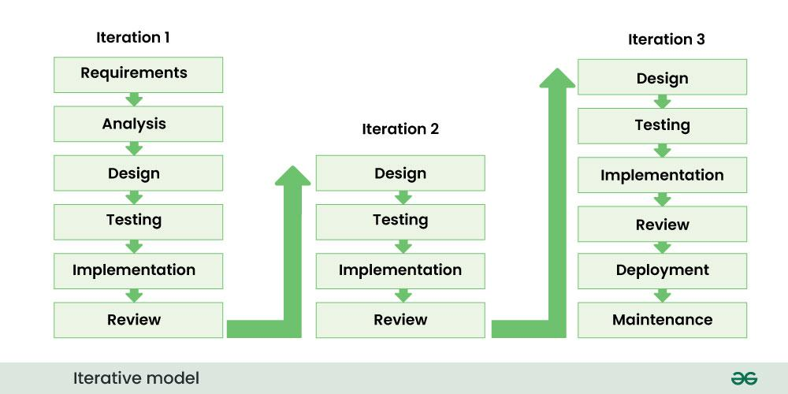
Figure 3. 1 Iterative Model Diagram
Source: https://www.geeksforgeeks.org/software-engineering/top-8-software-development-models-used-in-industry/

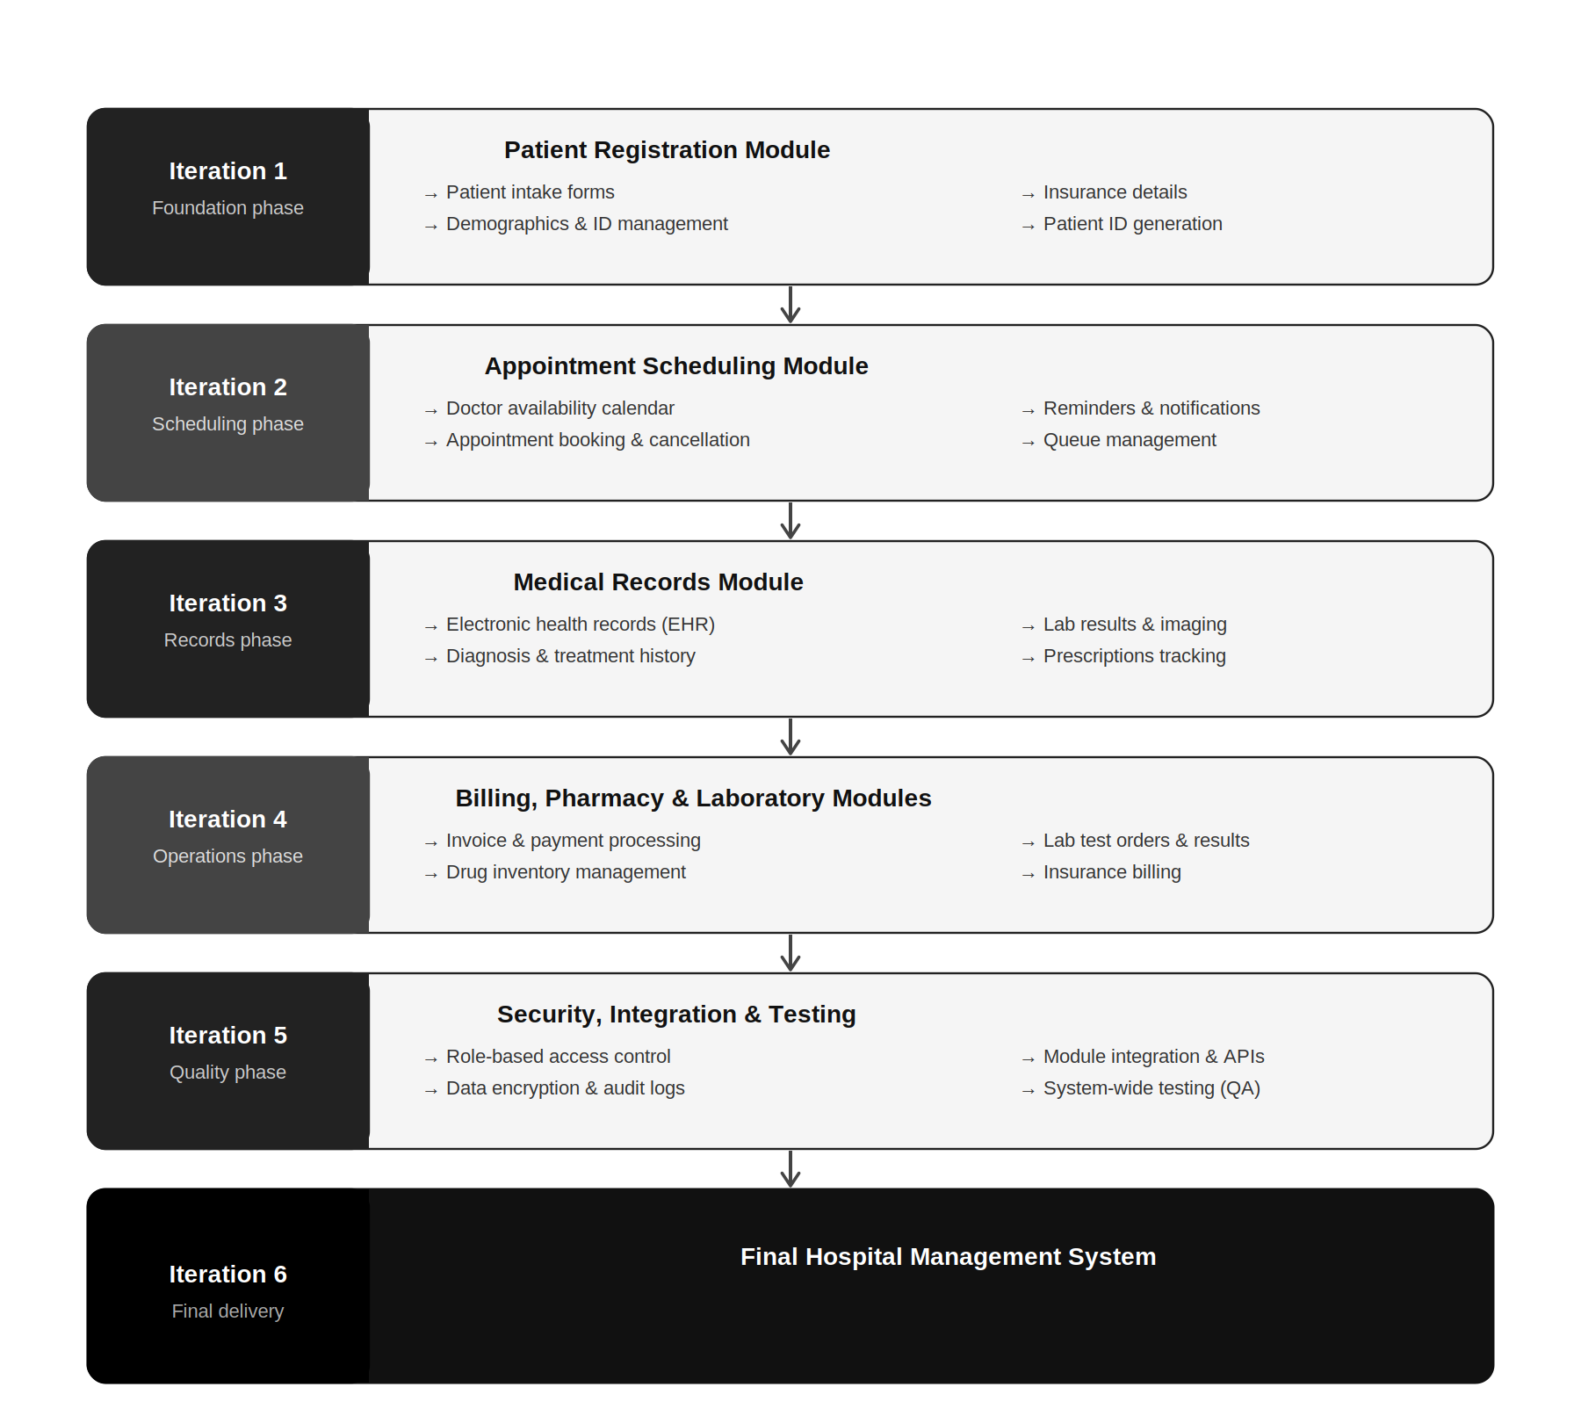
Figure 3. 2 Application to the Proposed System

3.2 System Requirement Specification
The system requirement specification describes the functional and non-functional requirements needed for the successful development of the Hospital Management System. It identifies the major entities, users, processes, and system behaviors required to support hospital operations. The proposed system will be designed to manage patient registration, appointment scheduling, medical records, billing, pharmacy services, laboratory requests, and administrative functions. Additionally, the system will provide a centralized database that allows authorized users to store, retrieve, update, and share hospital records efficiently.
The main entities in the Hospital Management System include patients, doctors, nurses, administrators, pharmacists, laboratory staff, accountants, appointments, bills, prescriptions, medical records, laboratory reports, and payments. Each entity plays an important role in the operation of the system. For example, patients provide personal and medical information during registration, doctors diagnose patients and update medical records, laboratory staff process test requests, pharmacists manage prescriptions, and accountants handle billing and payments. Furthermore, the administrator manages users, system access, roles, and general hospital records.
The main processes of the system include patient registration, appointment booking, consultation, medical record creation, laboratory request processing, prescription management, billing, payment processing, and report generation. When a patient visits the hospital, the registration officer captures the patient’s details and creates a patient record. Subsequently, an appointment may be scheduled with a doctor. After consultation, the doctor updates the patient’s medical record and may request laboratory tests or prescribe medication. Thereafter, the laboratory staff and pharmacist process the request, while the billing unit generates the appropriate bill for services provided.

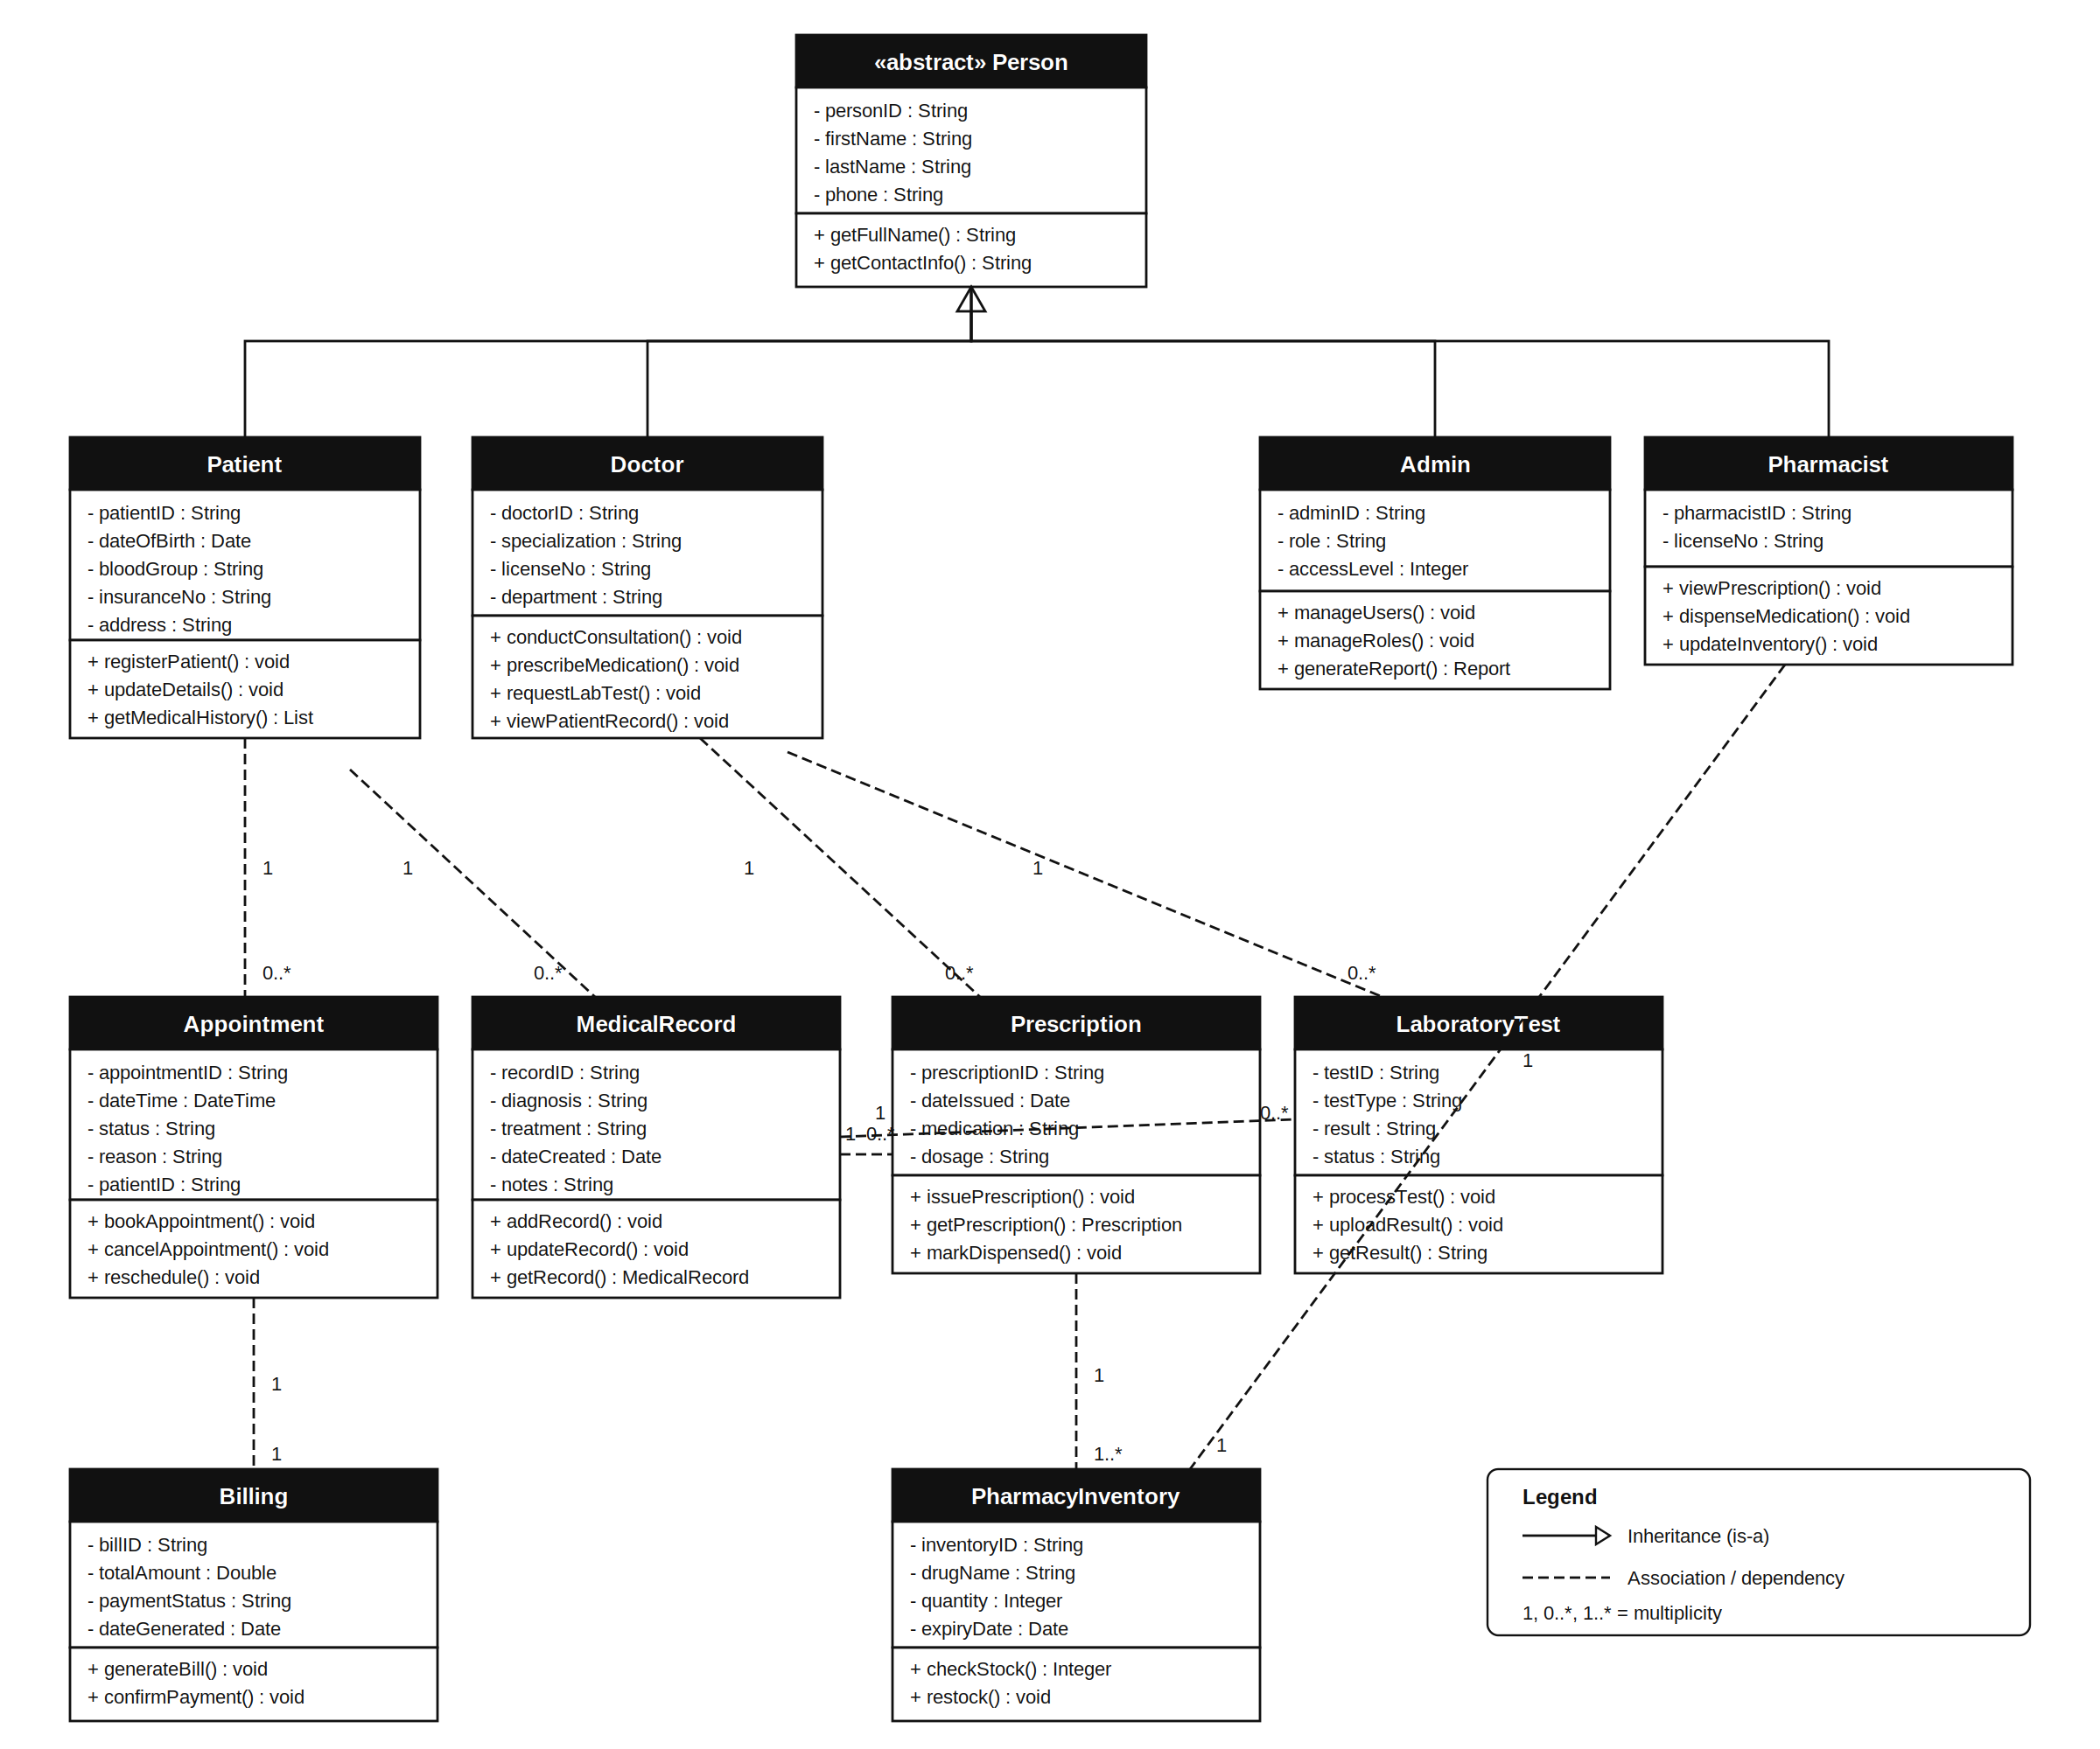
Figure 3. 3 UML Class Diagram

3.2.1 Functional Requirements
Functional requirements describe the specific services, actions, and behaviors that the Hospital Management System must provide to users. These requirements explain how users will interact with the system and what the system must do in response to their inputs. The proposed system will provide different functions for administrators, managers, and end users such as doctors, nurses, pharmacists, laboratory staff, accountants, receptionists, and patients. These functions will help the hospital manage patient information, appointments, medical records, prescriptions, laboratory requests, billing, payments, reports, and user access efficiently.
Admin/Manager Functions
The administrator or manager shall be able to create and manage user accounts for hospital staff. This function will allow the administrator to add new users, update user details, deactivate inactive accounts, and assign roles such as doctor, nurse, pharmacist, laboratory staff, accountant, receptionist, or manager. The system shall also allow the administrator to control user permissions so that each staff member can only access the modules related to their duties. For example, doctors may access patient medical records, while accountants may access billing and payment records.
The system shall allow administrators and managers to manage hospital departments and service information. This includes adding and updating departments such as pharmacy, laboratory, billing, records, and consultation units. Additionally, managers shall be able to define hospital services, consultation fees, laboratory test charges, medication prices, and billing categories. This function will help the hospital maintain accurate service information and ensure that charges are applied correctly during billing.
The system shall provide reporting and monitoring functions for administrators and managers. The administrator shall be able to generate reports on patient registration, appointments, payments, laboratory requests, prescriptions, and staff activities. Furthermore, managers shall be able to monitor system usage, view daily hospital activities, and track service performance. These reports will support decision-making, planning, accountability, and effective management of hospital operations.

End User Functions
The system shall allow receptionists or records officers to register new patients and update existing patient information. During registration, the user shall enter patient details such as name, gender, age, contact information, address, and basic medical information. After registration, the system shall generate a unique patient identification number that can be used to retrieve the patient’s record in future visits. This will reduce duplication of patient records and improve record retrieval.
The system shall allow doctors and nurses to access patient records, conduct consultations, and update medical information. Doctors shall be able to view patient histories, record diagnoses, prescribe medications, and request laboratory tests. Nurses may assist in updating vital signs and treatment notes where permitted. This function will ensure that patient care information is stored electronically and can be accessed by authorized healthcare workers when needed.
The system shall allow laboratory staff to receive laboratory test requests, process them, and upload test results. Once a doctor requests a test, the laboratory staff shall be able to view the request and update the system with the result after testing. The result shall then become available to the doctor for review. This will improve communication between the consultation and laboratory units and reduce delays caused by manual transfer of test reports.
The system shall allow pharmacists to view prescriptions and manage the dispensing of medications. When a doctor prescribes medication, the pharmacist shall be able to access the prescription electronically, confirm drug availability, dispense medication, and update the record. Additionally, the system shall help the pharmacy unit monitor stock levels and identify medicines that need restocking. This function will improve prescription management and reduce errors associated with handwritten prescriptions.
The system shall allow accountants or billing officers to generate bills, record payments, and issue receipts. The billing module shall calculate charges based on services provided, such as consultation, laboratory tests, medication, and other hospital services. After payment, the system shall update the payment status and generate a receipt for the patient. This will improve financial record management, reduce billing errors, and support accountability in hospital revenue collection.

3.2.2 Non-Functional Requirements
Non-functional requirements describe the quality attributes and performance standards that the Hospital Management System must satisfy. Unlike functional requirements, which define what the system should do, non-functional requirements define how well the system should perform its functions. These requirements are important because they determine the effectiveness, reliability, usability, security, and overall performance of the system. The Hospital Management System must provide a secure, reliable, efficient, and user-friendly environment for healthcare workers and patients.
Performance Requirement
The system shall provide fast and efficient processing of user requests. When a user performs an action such as patient registration, appointment booking, record retrieval, or bill generation, the system should respond within a few seconds. The system must be capable of handling multiple users simultaneously without significant delays or performance degradation. This requirement ensures smooth hospital operations and reduces waiting time for patients and staff.
Security Requirement
The system shall protect patient information and hospital records from unauthorized access. Users must authenticate themselves using valid usernames and passwords before accessing the system. Additionally, access rights shall be controlled according to user roles so that users can only access information relevant to their responsibilities. Sensitive data such as patient medical records and billing information must be protected against unauthorized modification, disclosure, or deletion.
Reliability Requirement
The system shall operate consistently and accurately during normal hospital operations. Information entered into the system must be stored correctly and retrieved without loss or corruption. Furthermore, the system should minimize failures and continue functioning effectively even when handling large volumes of data. This requirement is important because healthcare institutions depend on accurate and reliable information for patient care and decision-making.

Availability Requirement
The system shall be available whenever authorized users need to access it. Healthcare services operate continuously, and users may need access to patient records, billing information, prescriptions, or laboratory reports at any time during working hours. Therefore, the system should experience minimal downtime and should recover quickly in the event of hardware or software failures. This ensures uninterrupted hospital operations and continuous access to critical information.
Usability Requirement
The system shall be user-friendly and easy to learn. Users should be able to navigate through menus, enter information, retrieve records, and perform their tasks without difficulty. The interface should provide clear instructions, readable text, consistent layouts, and simple navigation structures. This requirement is important because hospital staff may have different levels of computer literacy and should be able to use the system efficiently with minimal training.
Scalability Requirement
The system shall be capable of accommodating future growth and expansion. As the hospital grows, the number of patients, staff, departments, and records may increase significantly. Therefore, the system should be designed in a way that allows additional modules, users, and database records to be added without affecting performance. This ensures that the system remains useful and effective over a long period.
Maintainability Requirement
The system shall be easy to maintain and update when necessary. System administrators and developers should be able to correct errors, improve functionalities, and install updates without disrupting hospital operations. Proper documentation and modular design should be provided to simplify future maintenance activities. This requirement helps ensure the long-term sustainability and effectiveness of the Hospital Management System.

3.2.3 Software Requirements
The development and operation of the Hospital Management System require various software components to support system functionality, database management, application development, and user interaction. These software requirements provide the platform upon which the system will be designed, implemented, tested, and deployed. The selected software tools were chosen based on their reliability, compatibility, ease of use, and ability to support the objectives of the proposed system.
The operating system required for the development and deployment of the Hospital Management System is Windows 10 or Windows 11. This operating system provides a stable environment for software development, testing, and system administration. Additionally, it supports the development tools and database systems required for the implementation of the project.
The application development environment shall consist of Visual Studio Code (VS Code) as the integrated development environment (IDE). Visual Studio Code provides features such as code editing, debugging, syntax highlighting, extension support, and version control integration. These features improve software development efficiency and simplify the implementation process.
The proposed system shall be developed using PHP Laravel as the server-side programming language. PHP is widely used for developing dynamic web applications and provides strong support for database integration and web-based system development. Furthermore, HTML, CSS, and JavaScript shall be used for designing the user interface and implementing client-side functionalities to improve user interaction and system responsiveness.
The database management system required for the project is MySQL. MySQL will be used to store and manage patient records, appointment details, billing information, laboratory results, prescriptions, and user accounts. The database system provides efficient data storage, retrieval, updating, and security mechanisms required for hospital information management.
The system shall also require a web server such as XAMPP, which includes Apache Server, PHP, and MySQL. XAMPP provides a complete local development environment for testing and running the Hospital Management System before deployment. It simplifies configuration and allows developers to manage both the application and database components efficiently.
For system access, users shall require a modern web browser such as Google Chrome, Mozilla Firefox, Microsoft Edge, or Opera. These browsers support modern web technologies and provide a user-friendly interface for interacting with the Hospital Management System. Additionally, antivirus software and database backup utilities are recommended to enhance system security and ensure data protection.

3.3 System Design
System design describes how the proposed Hospital Management System will be structured and how its different components will work together to achieve the objectives of the study. The design focuses on converting the system requirements into a practical model that can guide development and implementation. The proposed system will be designed as a web-based application that allows authorized users to access hospital services through a browser. It will include modules for patient registration, appointment scheduling, consultation, medical records, laboratory management, pharmacy management, billing, payments, and administration.
The system will follow a centralized design where all hospital records are stored in a single database. This will allow different departments such as registration, pharmacy, laboratory, billing, and administration to access updated information from one platform. For example, when a patient is registered, the patient’s details will be saved in the database and made available to authorized departments. Similarly, when a doctor requests a laboratory test or prescribes medication, the laboratory and pharmacy units will be able to view and process the request electronically. This design will reduce duplication, improve communication, and support faster service delivery.
The design will also include user authentication and role-based access control to protect patient information. Each user will log in with a username and password before accessing the system. Access to modules will depend on the user’s role. For instance, administrators will manage users and reports, doctors will access patient records and consultations, laboratory staff will manage test results, pharmacists will handle prescriptions, and accountants will manage billing and payments. This will help ensure that sensitive information is accessed only by authorized users.
The proposed system design will support easy navigation and user-friendly interaction. The interface will contain clear menus, simple forms, readable text, and consistent buttons to help users perform tasks efficiently. Since hospital staff may have different levels of computer knowledge, the system will be designed to reduce complexity and improve usability. Therefore, the system design will provide a secure, integrated, and user-friendly structure for managing hospital operations effectively.

3.3.1 Use Case Diagram
A use case diagram shows how users interact with the Hospital Management System and the major services the system provides. In this system, the main actors are the Administrator, Receptionist, Doctor, Laboratory Staff, Pharmacist, Accountant, and Patient. Each actor performs specific functions based on their role in the hospital. The diagram helps to show the relationship between users and system functions such as patient registration, appointment scheduling, consultation, laboratory test processing, prescription management, billing, payment, and report generation.
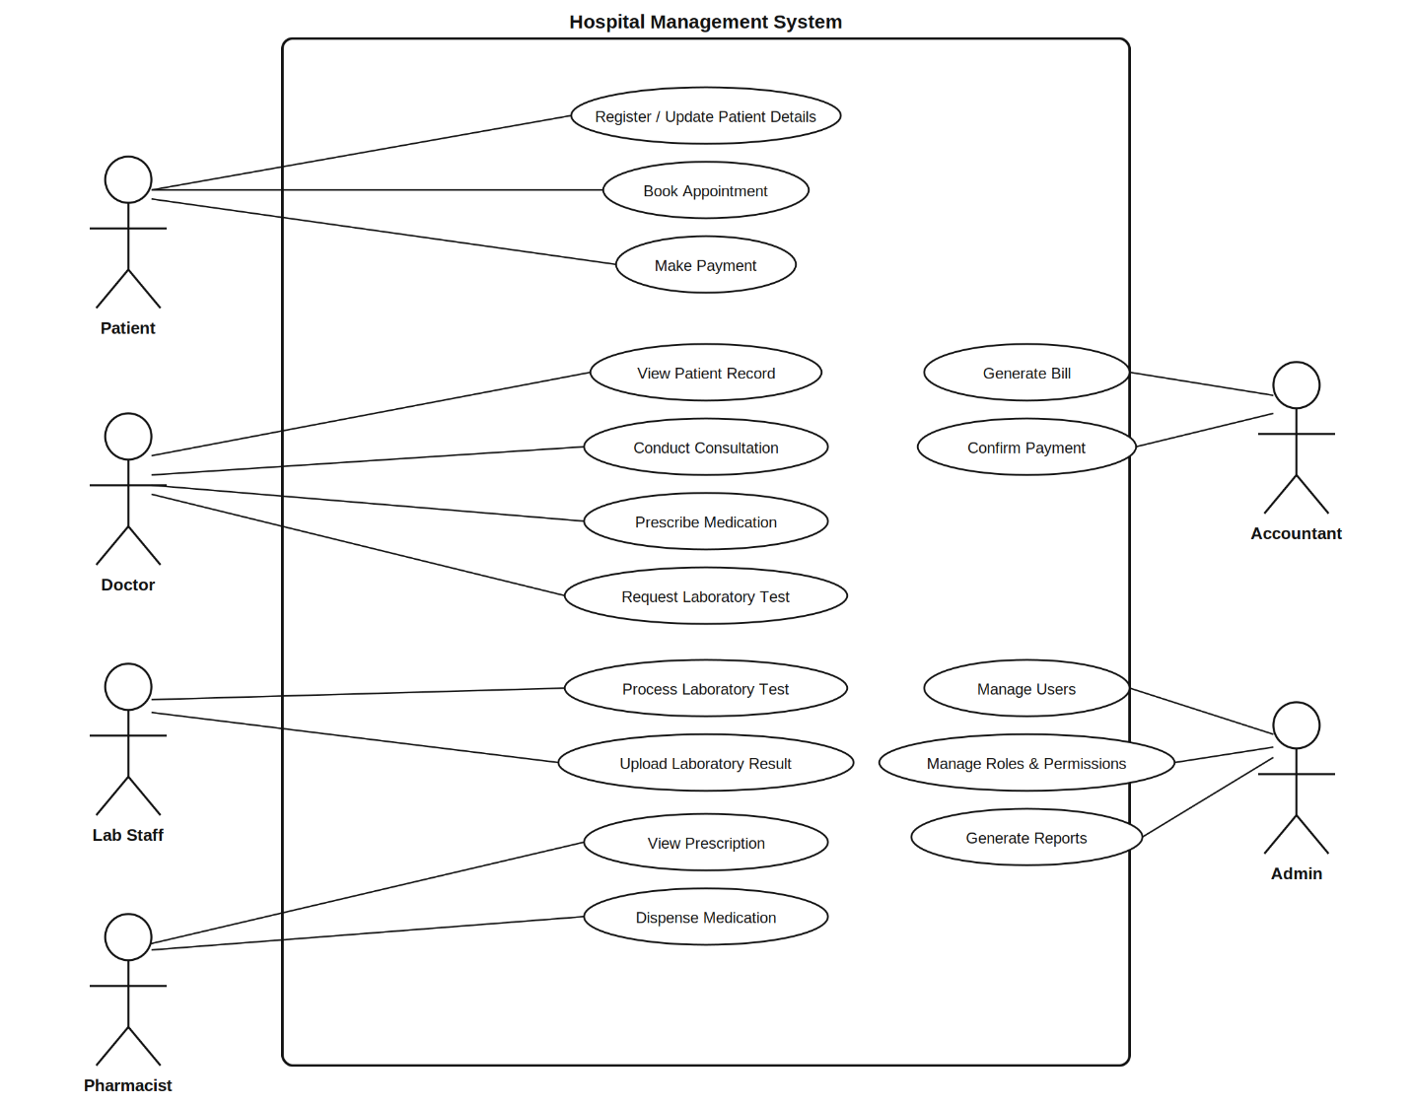
Figure 3. 4 use case diagram

3.3.2 Sequence Diagram
A sequence diagram shows how objects or users interact with the Hospital Management System in a specific order over time. It presents the flow of messages between actors and system components during a particular process. In the proposed Hospital Management System, the sequence diagram explains how a patient moves from registration to consultation, laboratory request, prescription, billing, and payment. This helps to show how different users and modules interact to complete hospital service delivery.
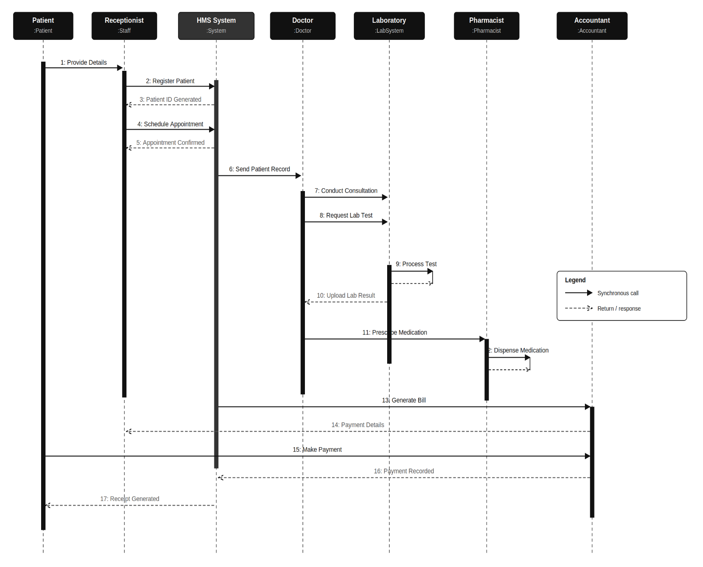
Figure 3. 5 Sequence Diagram

3.3.3 Entity Relationship Diagram
An Entity Relationship Diagram represents the database structure of the Hospital Management System. It shows the main entities in the system, their attributes, and the relationships that exist between them. The proposed system database will include entities such as Patient, User, Role, Appointment, Medical Record, Laboratory Test, Prescription, Bill, Payment, and Department. These entities work together to support patient registration, consultation, laboratory services, pharmacy management, billing, payment, and hospital administration.
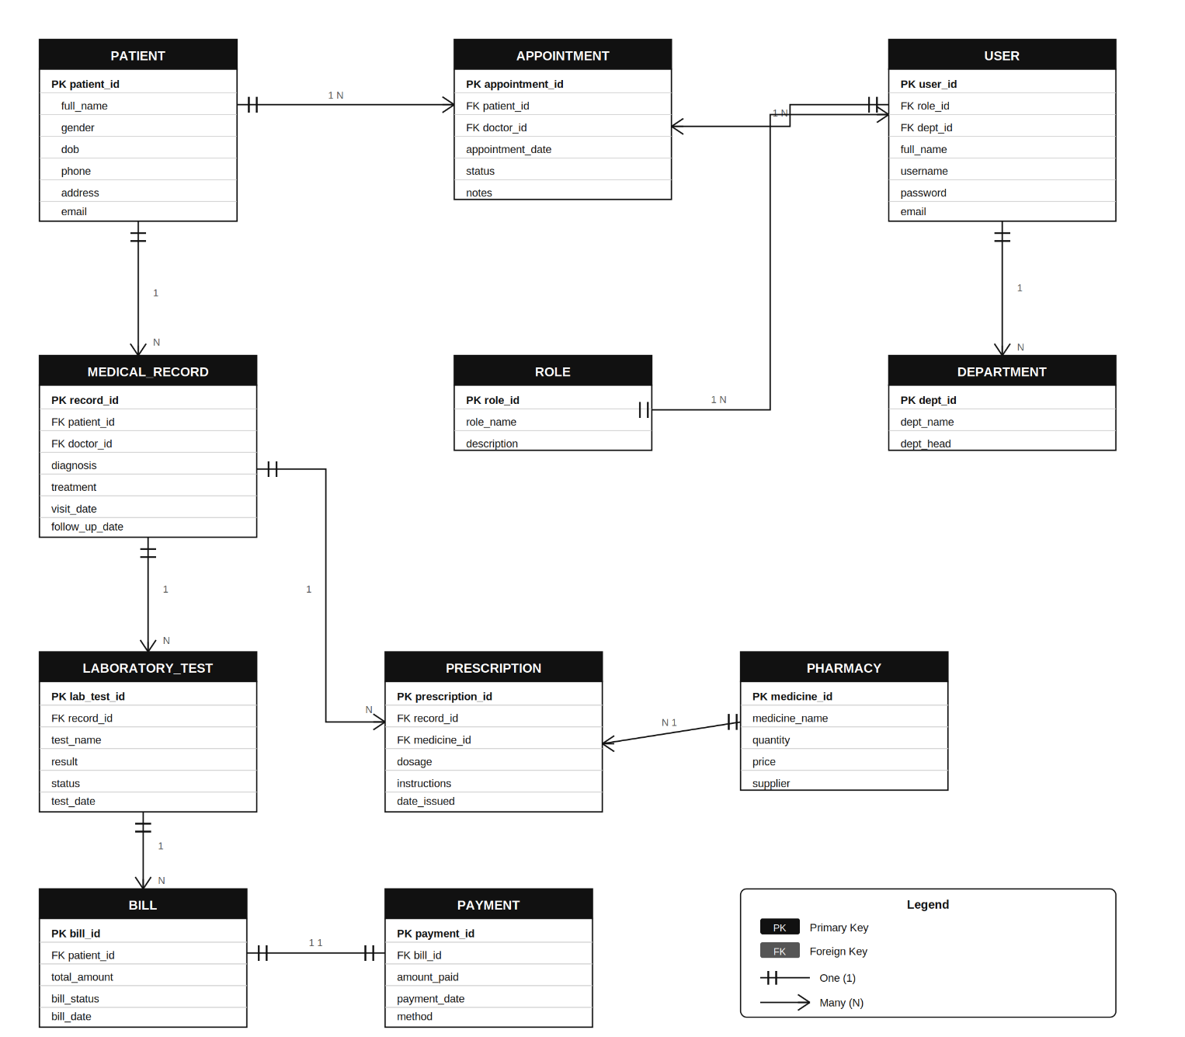
Figure 3. 6 Entity Relationship Diagram

3.3.4 Flow Chart Diagram
A flow chart diagram shows the step-by-step movement of activities within the Hospital Management System. It represents how a patient’s information flows from registration through consultation, laboratory test processing, prescription, billing, payment, and final record update. The flow chart is important because it gives a clear visual understanding of how hospital processes will be handled by the proposed system.
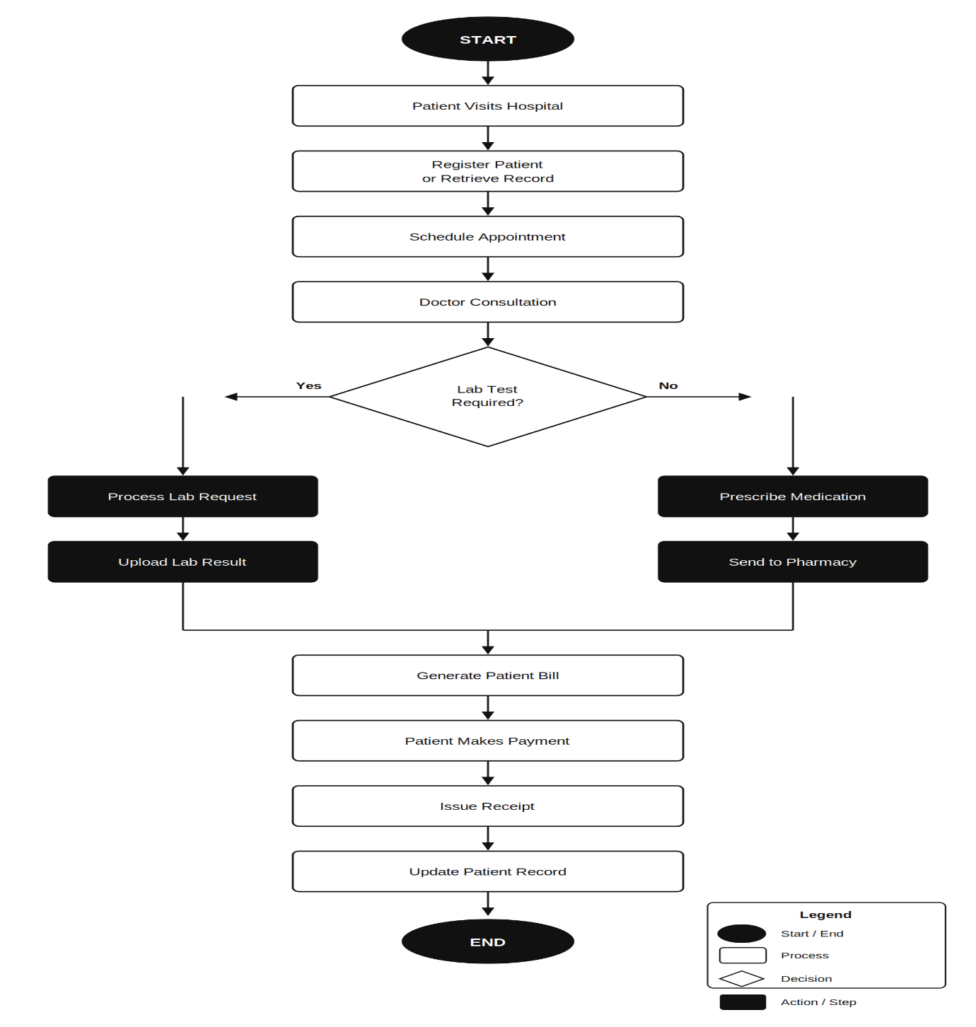
Figure 3. 7 Flowchart Diagram

3.3.5 Data Flow Diagram (DFD)
A Data Flow Diagram (DFD) is a graphical representation that shows how data moves through a system. It illustrates the sources of data, the processes that transform the data, the data stores where information is kept, and the destinations that receive the processed information. Unlike flowcharts, DFDs focus on the movement of data rather than the sequence of activities. In the Hospital Management System, the DFD shows how patient information, appointments, medical records, laboratory results, prescriptions, billing information, and payments flow between users, processes, and databases.
The main external entities in the proposed system include the Patient, Doctor, Laboratory Staff, Pharmacist, Accountant, and Administrator. The major processes include Patient Registration, Appointment Management, Medical Record Management, Laboratory Management, Pharmacy Management, Billing Management, and Report Generation. The primary data stores include the Patient Database, Appointment Database, Medical Records Database, Laboratory Database, Pharmacy Database, Billing Database, and User Database. These components work together to ensure that information is collected, processed, stored, and retrieved efficiently.
Context-Level Data Flow Diagram (Level 0 DFD)
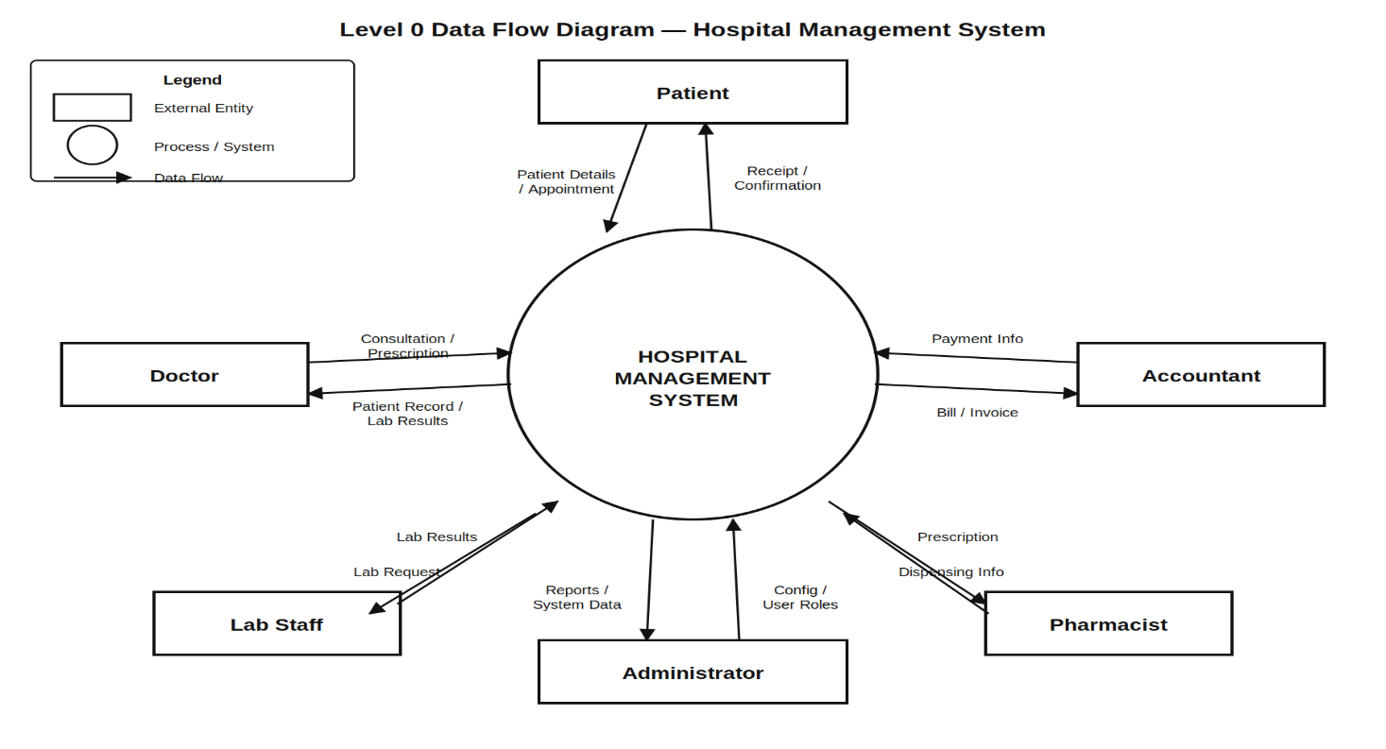
Figure 3. 8 Level 0 Data Flow Diagram
Level 1 Data Flow Diagram
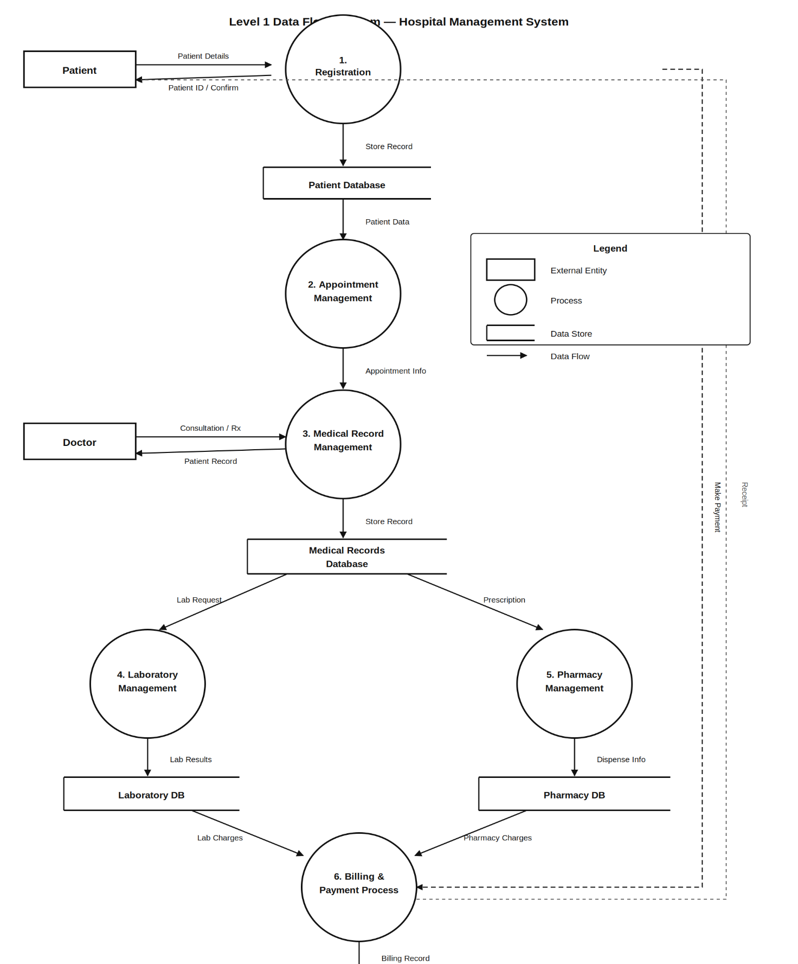
Figure 3. 9 Level 1 Data Flow Diagram

3.4 System Architecture
The proposed Hospital Management System will use a Three-Tier Architecture. This architecture separates the system into three main layers: the presentation layer, the application layer, and the database layer. The presentation layer is the user interface that hospital staff interact with through a web browser. The application layer handles system logic such as registration, appointments, billing, prescriptions, and report processing. The database layer stores all system records, including patient details, medical records, payments, laboratory results, and user accounts.
The Three-Tier Architecture is suitable for this system because it improves organization, security, and maintainability. Additionally, each layer performs a specific role, making the system easier to manage and update. For example, changes can be made to the user interface without directly affecting the database structure. Furthermore, access to the database is controlled through the application layer, which helps protect sensitive patient information from unauthorized access.
This architecture also supports future expansion of the Hospital Management System. As the hospital grows, new modules such as insurance management, staff payroll, or inventory control can be added to the application layer without redesigning the entire system. Therefore, the Three-Tier Architecture is the most appropriate design because it supports security, scalability, flexibility, and efficient management of hospital operations.
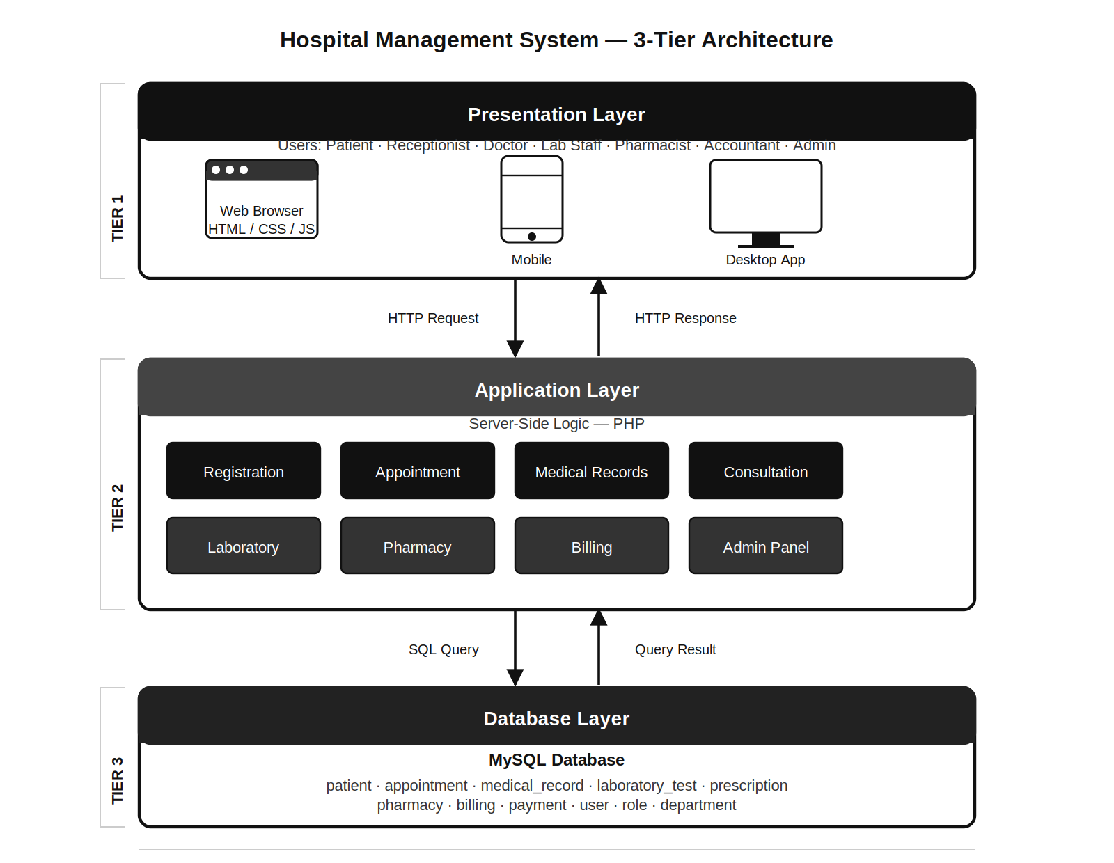
Figure 3. 10 System Architecture Teir 3

3.4.1 Context Diagram
A Context Diagram is a high-level representation of a system that shows the system as a single process and illustrates its interactions with external entities. It defines the boundary between the Hospital Management System and its environment by identifying the users and external entities that exchange information with the system. The context diagram does not show internal processes or data stores; instead, it focuses on the flow of information between the system and external actors.
In the proposed Hospital Management System, the main external entities are the Patient, Receptionist, Doctor, Laboratory Staff, Pharmacist, Accountant, and Administrator. These entities interact with the system by providing inputs and receiving outputs. For example, patients provide registration details and receive appointment information, while doctors submit diagnoses and receive patient records. Similarly, laboratory staff update test results, pharmacists access prescriptions, accountants process payments, and administrators manage users and reports.
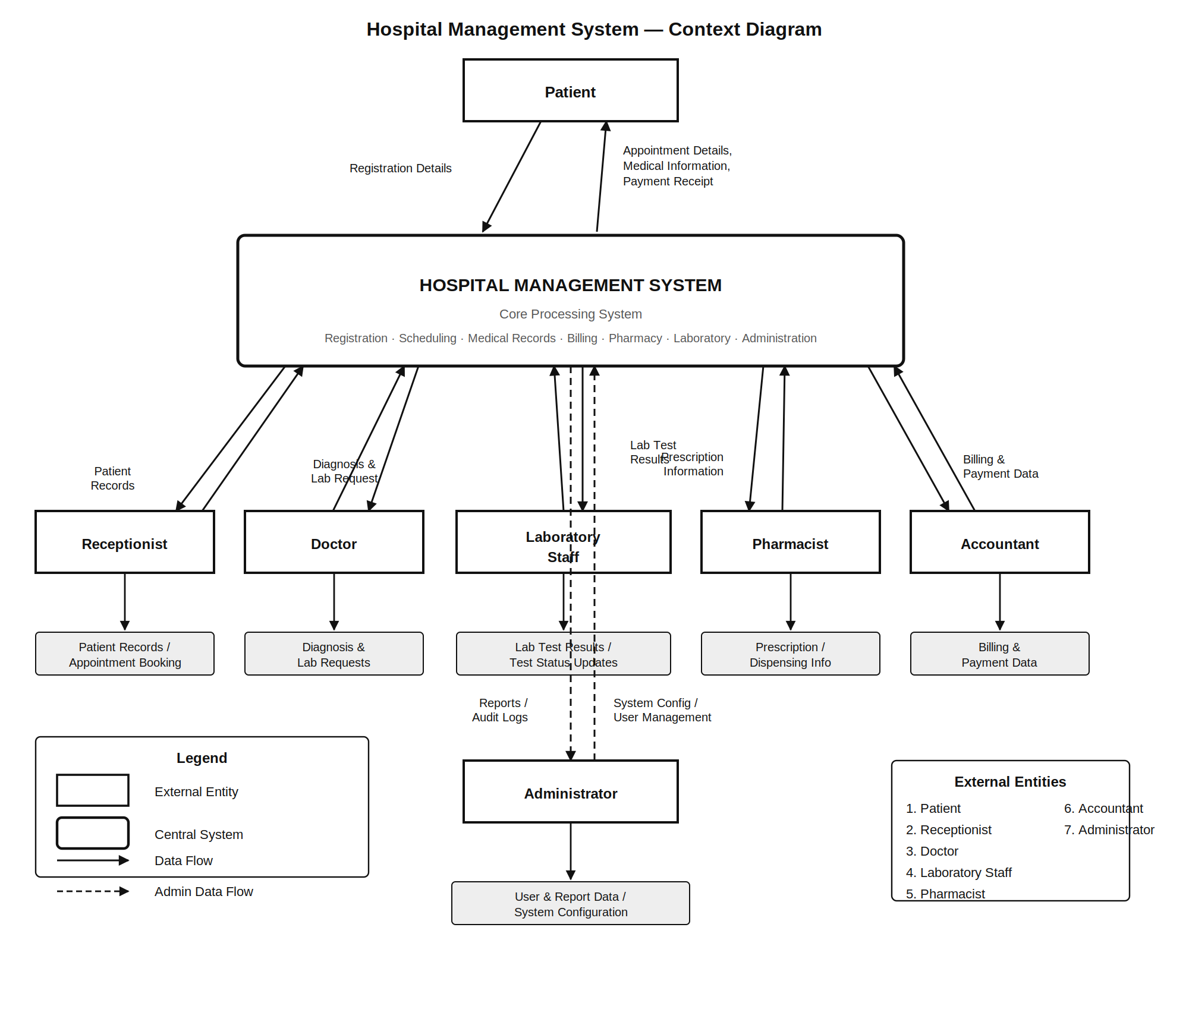
Figure 3. 11 Context Diagram

REFERENCES
Adeniyi, A. et al. (2024) “The impact of electronic health records on patient care and outcomes: A comprehensive review,” World Journal of Advanced Research and Reviews, 21, pp. 1446–1455. Available at: https://doi.org/10.30574/wjarr.2024.21.2.0592.
Ahmad, S. et al. (2025) “BARRIERS TO EFFECTIVE COMMUNICATION TO ENHANCE PATIENT SAFETY,” 03, pp. 23–34. Available at: https://doi.org/10.5281/zenodo.15322131.
Alter, S. (2008) “Alter, S.: Defining information systems as work systems: implications for the IS field. European Journal of Information Systems 17, 448-469,” EJIS, 17, pp. 448–469. Available at: https://doi.org/10.1057/ejis.2008.37.
Aveson, D. and Fitzgerald, G. (2006) “Methodologies for developing information systems: a historical perspective,” IFIP World Computer Congress, TC 8. Springer, pp. 27–38.
Avison, D. and Fitzgerald, G. (2006) “Methodologies for Developing Information Systems: A Historical Perspective,” The Past and Future of Information Systems: 1976-2006 and beyond, pp. 27–38. Available at: https://doi.org/10.1007/978-0-387-34732-5_3.
Benjamin, D.M. (2003) “Reducing medication errors and increasing patient safety: case studies in clinical pharmacology,” The Journal of Clinical Pharmacology, 43(7), pp. 768–783.
Collmann, J. et al. (1997) “Comparing the security risks of paper-based and computerized patient record systems,” Proceedings of SPIE - The International Society for Optical Engineering [Preprint]. Available at: https://doi.org/10.1117/12.274569.
Hamad, H., Altaheri, M. and Shamsi, S. (2025) “The Impact of Information Systems on the Decision-Making Process in Project Management,” International Journal of Entrepreneurship and Project Management, 10, pp. 19–33. Available at: https://doi.org/10.47604/ijepm.3454.
Heeks, R. (2002) “Information systems and developing countries: Failure, success, and local improvisations,” The information society, 18(2), pp. 101–112.
Hopp, W.J. and Lovejoy, W.S. (2012) Hospital operations: Principles of high efficiency health care. FT Press.
Iyanna, S. et al. (2022) “Digital transformation of healthcare sector. What is impeding adoption and continued usage of technology-driven innovations by end-users?,” Journal of Business Research, 153, pp. 150–161. Available at: https://doi.org/10.1016/j.jbusres.2022.08.007.
Kiromah, S. et al. (2024) “An Analysis of the Causes of Delays in the Return of Outpatient Medical Records at Jambesari Public Health Center, Bondowoso,” International Journal of Healthcare and Information Technology, 2, pp. 20–30. Available at: https://doi.org/10.25047/ijhitech.v2i1.6156.
Laudon, K.C. and Laudon, J.P. (2004) Management information systems: Managing the digital firm. Pearson Educación.
Laudon, K.C., Laudon, J.P. and Traver, C.G. (2023) “Essentials of Management Information Systems Fifteenth Edition Global Edition.” Pearson Education Limited.
Li, Q. et al. (2022) “Effects between Information Sharing and Knowledge Formation and Their Impact on Complex Infrastructure Projects’ Performance,” Buildings, 12, p. 1201. Available at: https://doi.org/10.3390/buildings12081201.
Mansell, R. and Wehn, U. (1998) Knowledge societies: Information technology for sustainable development. Oxford University Press.
Mulukuntla, S. and Pamulaparthyvenkata, S. (2020) “DIGITAL TRANSFORMATION IN HEALTHCARE: ASSESSING THE IMPACT ON PATIENT CARE AND SAFETY,” EPH - International Journal of Medical and Health Science, 6, pp. 27–33. Available at: https://doi.org/10.53555/eijmhs.v6i3.201.
O’brien, J.A. and Marakas, G.M. (2011) MANAGEMENT INFORMATION SYSTEMS Tenth Editio. mc griw hill.
SEUN, E. et al. (2023) “Impact of Information Systems on Operational Efficiency: A Comprehensive Analysis,” Indian Journal of Computer Science and Engineering, 14, pp. 661–673. Available at: https://doi.org/10.21817/indjcse/2023/v14i4/231404013.
Sharma, V. (2021) “AI and RPA in Healthcare: Transforming Administrative Operations for Better Outcomes,” International Journal For Multidisciplinary Research, 3, p. 18. Available at: https://doi.org/10.36948/ijfmr.2021.v03i02.36362.
Siau, K. et al. (2021) “Information Systems Analysis and Design: Past Revolutions, Present Challenges, and Future Research Directions,” Communications of the Association for Information Systems, 50. Available at: https://doi.org/10.17705/1CAIS.05037.
Smith-Mitchell, T. (2025) “The Role of Hospital Information Systems (HIS), Electronic Patient or Medical Records (EPR/EMR), Electronic Health Records (EHR), and Telehealth in Enhancing Healthcare Services,” Scientia. Technology, Science and Society, 2, pp. 28–36. Available at: https://doi.org/10.59324/stss.2025.2(8).03.
Stair, R. et al. (2015) Principles of information systems. Cengage Learning Canada Inc.
Sulaiman, N., Abdullah, Z. and Man, N.I. (2023) “The Effects Of Employee Communication And Engagement On Organisational Performance: A Conceptual Study,” pp. 233–251. Available at: https://doi.org/10.55573/IJAFB.084616.
Suman, B. (2025) “Integrated Healthcare Database Systems: A Review of Data Warehousing, Storage, and Integration Strategies,” International Journal of Information Technology and Computer Science Applications, 3, pp. 48–53. Available at: https://doi.org/10.58776/ijitcsa.v3i2.181.
Surchi, A. (2025) “The Role of Management Information Technology in Enhancing Organizational Efficiency: A Multisectoral Analysis,” OTS Canadian Journal, 4, pp. 51–61. Available at: https://doi.org/10.58840/gx6k5803.
Surchi, A.S.S. (2025) “The Role of Management Information Technology in Enhancing Organizational Efficiency: A Multisectoral Analysis,” OTS Canadian Journal, 4(5), pp. 51–61.
Thant, K. and Tin, H.H.K. (2023) “THE IMPACT OF MANUAL AND AUTOMATIC TESTING ON SOFTWARE TESTING EFFICIENCY AND EFFECTIVENESS,” 3, pp. 88–93.
Turban, E., Pollard, C. and Wood, G. (2018) Information technology for management: On-demand strategies for performance, growth and sustainability. John Wiley & Sons.
Warschauer, M. (2002) “A developmental perspective on technology in language education,” TESOL quarterly, 36(3), pp. 453–475.
Yeboah, A. (2023) “Knowledge sharing in organization: A systematic review,” Cogent Business & Management, 10. Available at: https://doi.org/10.1080/23311975.2023.2195027.
Whitten, J.L. and Bentley, L.D. (2007) Systems Analysis and Design Methods. 7th edn. New York: McGraw-Hill/Irwin.
Satzinger, J.W., Jackson, R.B. and Burd, S.D. (2016) Systems Analysis and Design in a Changing World. 7th edn. Boston, MA: Cengage Learning.
Dennis, A., Wixom, B.H. and Roth, R.M. (2015) Systems Analysis and Design. 6th edn. Hoboken, NJ: John Wiley & Sons.
Appari, A. and Johnson, M.E. (2010) ‘Information security and privacy in healthcare: current state of research’, International Journal of Internet and Enterprise Management, 6(4), pp. 279–314.
Kruse, C.S., Smith, B., Vanderlinden, H. and Nealand, A. (2017) ‘Security techniques for the electronic health records’, Journal of Medical Systems, 41(8), pp. 1–9.
Turban, E., Pollard, C. and Wood, G. (2018) Information Technology for Management: On-Demand Strategies for Performance, Growth and Sustainability. 11th edn. Hoboken, NJ: John Wiley & Sons.
Shelly, G.B. and Rosenblatt, H.J. (2012) Systems Analysis and Design. 9th edn. Boston, MA: Cengage Learning.
Kendall, K.E. and Kendall, J.E. (2011) Systems Analysis and Design. 8th edn. Upper Saddle River, NJ: Pearson Education.
Pressman, R.S. and Maxim, B.R. (2020) Software Engineering: A Practitioner’s Approach. 9th edn. New York: McGraw-Hill Education.
Nielsen, J. (2012) Usability Engineering. San Francisco, CA: Morgan Kaufmann.
Sommerville, I. (2016) Software Engineering. 10th edn. Boston, MA: Pearson Education.
Shneiderman, B., Plaisant, C., Cohen, M., Jacobs, S., Elmqvist, N. and Diakopoulos, N. (2016) Designing the User Interface: Strategies for Effective Human-Computer Interaction. 6th edn. Boston, MA: Pearson.
Preece, J., Rogers, Y. and Sharp, H. (2015) Interaction Design: Beyond Human-Computer Interaction. 4th edn. Chichester: John Wiley & Sons.
Dix, A., Finlay, J., Abowd, G.D. and Beale, R. (2004) Human-Computer Interaction. 3rd edn. Harlow: Pearson Education.
Connolly, T. and Begg, C. (2015) Database Systems: A Practical Approach to Design, Implementation, and Management. 6th edn. Harlow: Pearson Education.
Coronel, C. and Morris, S. (2019) Database Systems: Design, Implementation, & Management. 13th edn. Boston, MA: Cengage Learning.
Elmasri, R. and Navathe, S.B. (2016) Fundamentals of Database Systems. 7th edn. Boston, MA: Pearson.
Coronel, C. and Morris, S. (2019) Database Systems: Design, Implementation, & Management. 13th edn. Boston, MA: Cengage Learning.
Date, C.J. (2012) Database Design and Relational Theory: Normal Forms and All That Jazz. Sebastopol, CA: O’Reilly Media.
Silberschatz, A., Korth, H.F. and Sudarshan, S. (2019) Database System Concepts. 7th edn. New York: McGraw-Hill Education.
Buntin, M.B., Burke, M.F., Hoaglin, M.C. and Blumenthal, D. (2011) ‘The benefits of health information technology: a review of the recent literature shows predominantly positive results’, Health Affairs, 30(3), pp. 464–471.
HealthIT.gov (2019) What is an electronic health record (EHR)? Office of the National Coordinator for Health Information Technology. Accessed 15 May 2026.
Kruse, C.S., Smith, B., Vanderlinden, H. and Nealand, A. (2017) ‘Security techniques for the electronic health records’, Journal of Medical Systems, 41(8), pp. 1–9.
Menachemi, N. and Collum, T.H. (2011) ‘Benefits and drawbacks of electronic health record systems’, Risk Management and Healthcare Policy, 4, pp. 47–55
Blobel, B. (2004) ‘Authorisation and access control for electronic health record systems’, International Journal of Medical Informatics, 73(3), pp. 251–257.
Haux, R. (2006) ‘Health information systems: past, present, future’, International Journal of Medical Informatics, 75(3–4), pp. 268–281.
Kumar, S. and Aldrich, K. (2010) ‘Overcoming barriers to electronic medical record adoption in the United States healthcare system’, Health Informatics Journal, 16(4), pp. 306–318.
Winter, A., Haux, R., Ammenwerth, E., Brigl, B., Hellrung, N. and Jahn, F. (2011) Health Information Systems: Architectures and Strategies. 2nd edn. London: Springer.
Braa, J. and Sahay, S. (2012) Integrated Health Information Architecture: Power to the Users. New Delhi: Matrix Publishers.
Braa, J., Hanseth, O., Heywood, A., Mohammed, W. and Shaw, V. (2007) ‘Developing health information systems in developing countries: the flexible standards strategy’, MIS Quarterly, 31(2), pp. 381–402.
Mukama, F. (2005) ‘Health information systems in developing countries: a landscape analysis’, Journal of Health Informatics in Developing Countries, 1(1), pp. 1–12.
Sæbø, J.I., Kossi, E.K., Titlestad, O.H., Tohouri, R.R. and Braa, J. (2011) ‘Comparing strategies to integrate health information systems following a data warehouse approach in four countries’, Information Technology for Development, 17(1), pp. 42–60.
Dennis, A., Wixom, B.H. and Roth, R.M. (2015) Systems Analysis and Design. 6th edn. Hoboken, NJ: John Wiley & Sons.
Pressman, R.S. and Maxim, B.R. (2020) Software Engineering: A Practitioner's Approach. 9th edn. New York: McGraw-Hill Education.
Satzinger, J.W., Jackson, R.B. and Burd, S.D. (2016) Systems Analysis and Design in a Changing World. 7th edn. Boston, MA: Cengage Learning.
Sommerville, I. (2016) Software Engineering. 10th edn. Boston, MA: Pearson Education.

