**MININET TASK**

**Advanced Programming Class in Telecommunication Engineer**

Topology:

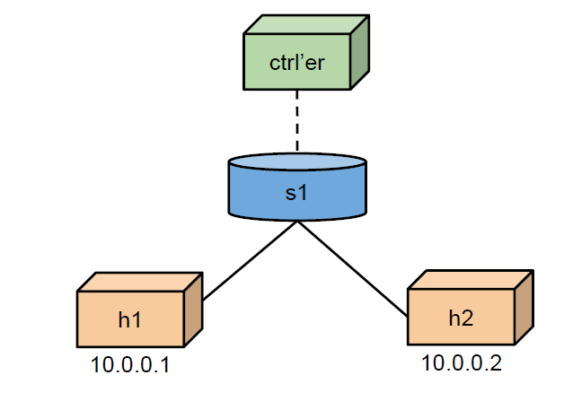

1. Install mininet:

|  |
| --- |
| sudo apt update  sudo apt install mininet |

1. Scripting on Py:

|  |
| --- |
| #!/usr/bin/python  from mininet.topo import Topo  from mininet.net import Mininet  from mininet.node import Controller, RemoteController  from mininet.cli import CLI  from mininet.log import setLogLevel  class SimpleTopo(Topo):  def build(self):  # Add hosts  h1 = self.addHost('h1', ip='10.0.0.1/24')  h2 = self.addHost('h2', ip='10.0.0.2/24')  # Add switch  s1 = self.addSwitch('s1')  # Add links  self.addLink(h1, s1)  self.addLink(h2, s1)  def run():  topo = SimpleTopo()  net = Mininet(topo=topo, controller=Controller)  net.start()  print("**test ping**")  net.pingAll()  CLI(net)  net.stop()  if __name__ == '__main__':  setLogLevel('info')  run() |

1. Ping and show topology

|  |
| --- |
| sudo python3 mininet_task.py  net |