LAB Logbook

Lab 1

**Adm Number: 242243**

**n = 43**

Lab 2

**n= 3**

Lab 3

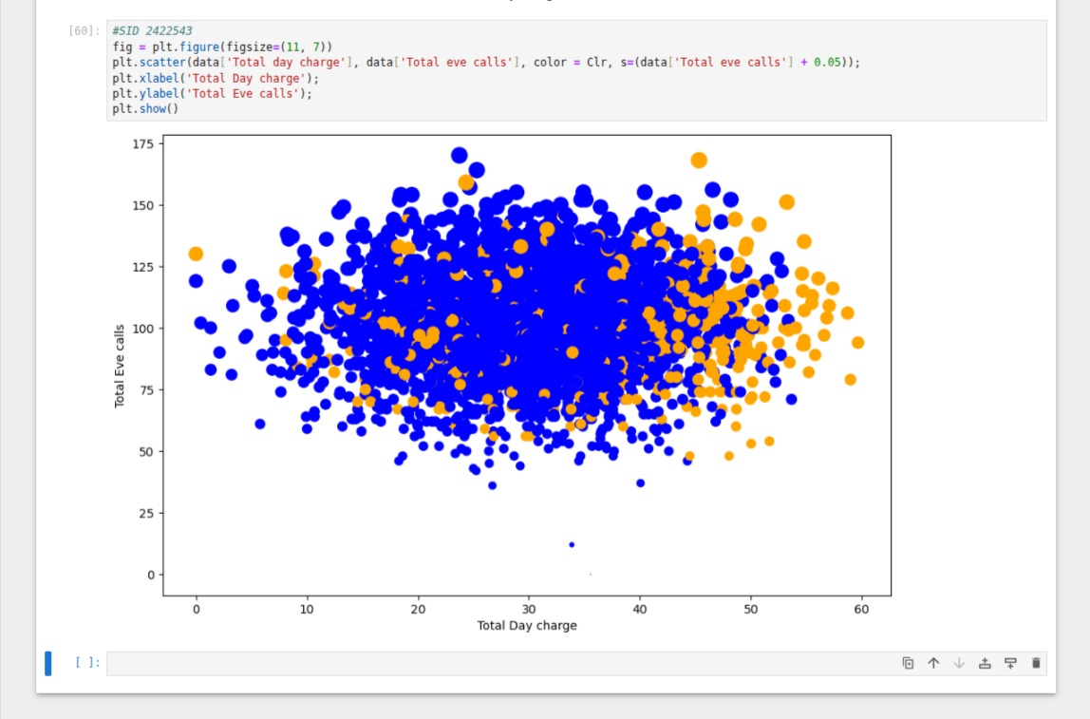

Lab 4

Lab 5

Lab 6

Lab 7

Lab 8

Lab 9

Lab 10

Lab 11

Lab 12