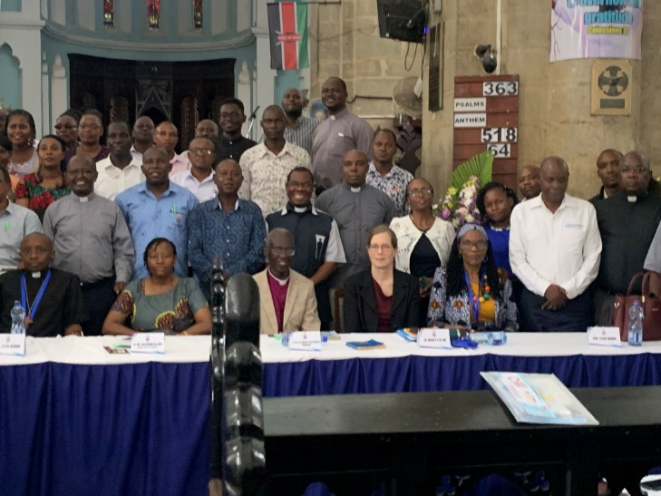

Presenters and attendees at the April 2024 Kenya Christian Biography Conference at the Anglican cathedral in Mombasa.
(Rt. Rev. Dr. Alphonce Baya, DoMRI patron, front row, left edge)

 | Journal of African Christian Biography  Quarterly publication of the Dictionary of African Christian Biography  Sign up for a free subscription at https://dacb.org/journal/ |   DONATE
Journal of  African  Christian  Biography | Vol. 10, No. 3-4 (July-Oct 2025)  Focus: Pioneers and Leaders in Kenya  Proceedings of the DoMRI Kenya Christian Biography Conference 2024
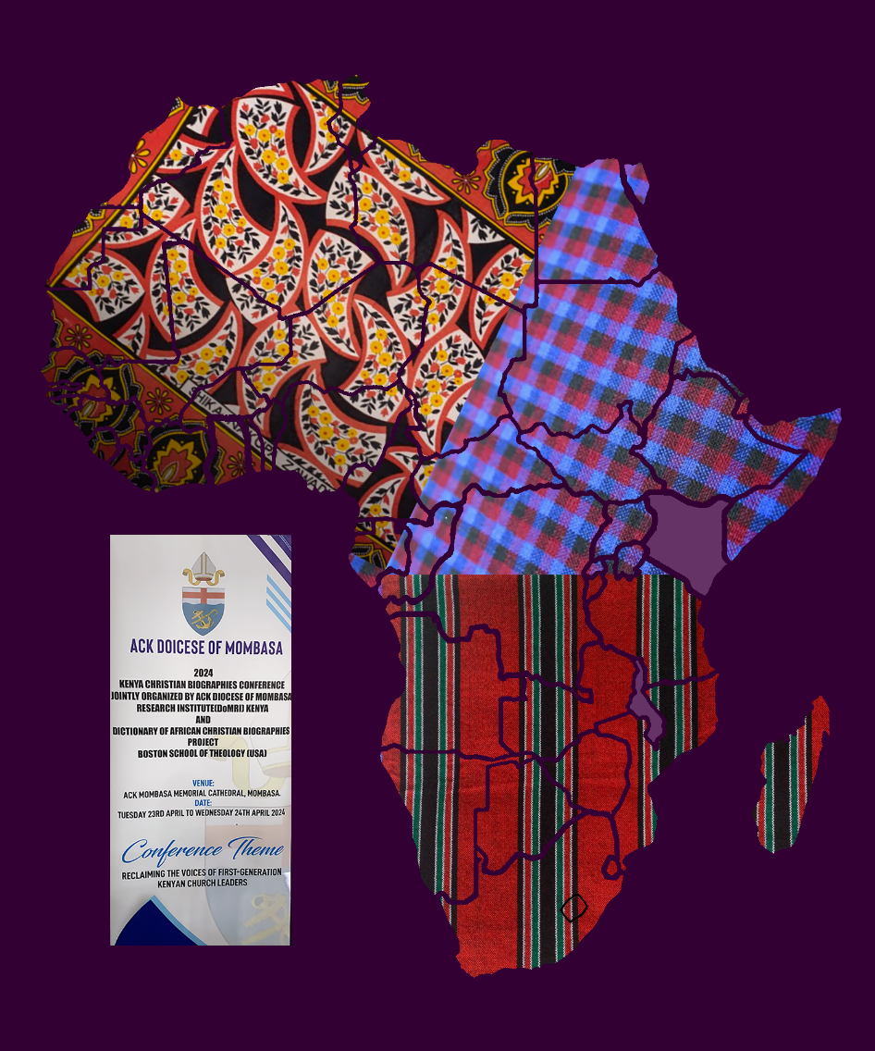
A publication of the Dictionary of African Christian Biography

