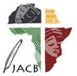 | Journal of African Christian Biography  Quarterly publication of the Dictionary of African Christian Biography  Sign up for a free subscription at https://dacb.org/journal/ |   DONATE
Journal of  African  Christian  Biography | Vol. 10, No. 1 (Jan 2025)  BILINGUAL VERSION*  Focus: Pioneers and Perseverance:  Musa Abdullahi Yousif Sha ed Din (Sudan); *Njoko David (DRC) EN / FR, Prophetess Natholomoa Jehu-Appiah (Hannah Barnes) (Ghana)
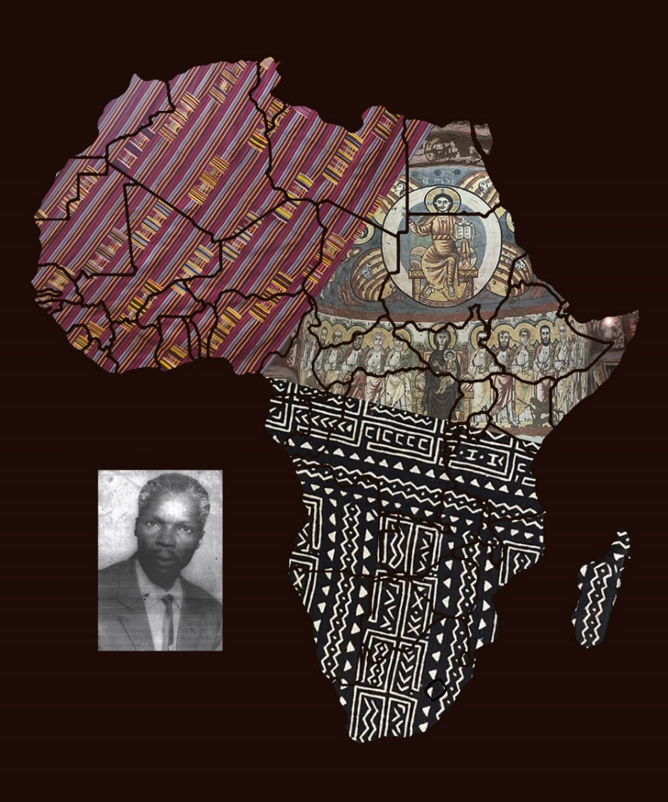
A publication of the Dictionary of African Christian Biography

