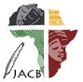 | Journal of African Christian Biography  Quarterly publication of the Dictionary of African Christian Biography  Sign up for a free subscription at https://dacb.org/journal/ |   DONATE
Journal of  African  Christian  Biography | Vol. 10, No. 2 (April 2025)  Focus: Elizabeth Ruhubya (Uganda);  M. O. Madile (Uganda); S. Otu and P. Mohenu (Ghana); Cape Coast History (Ghana)
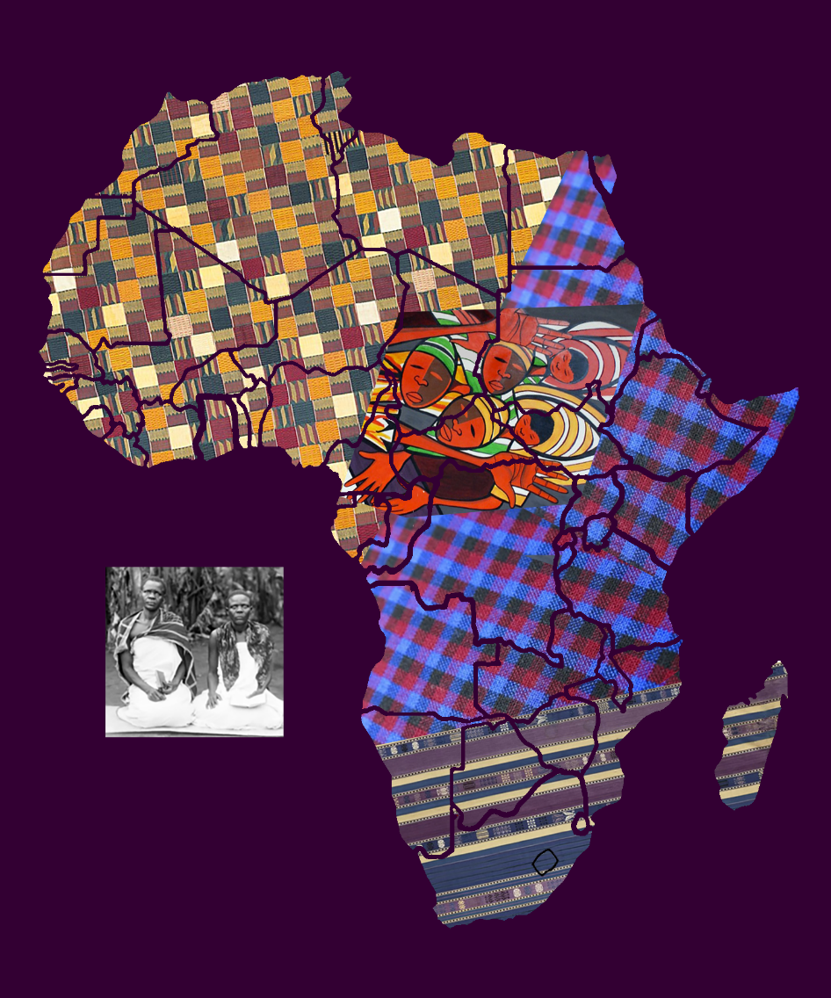
A publication of the Dictionary of African Christian Biography

