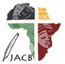 | Journal of African Christian Biography  Quarterly publication of the Dictionary of African Christian Biography  Sign up for a free subscription at https://dacb.org/journal/ |   DONATE
Journal of  African  Christian  Biography | Vol. 11, No. 1 (Jan. 2026)  Focus: Biographies from the Ghana Women’s Stories Workshop; Iris Habib el Masri
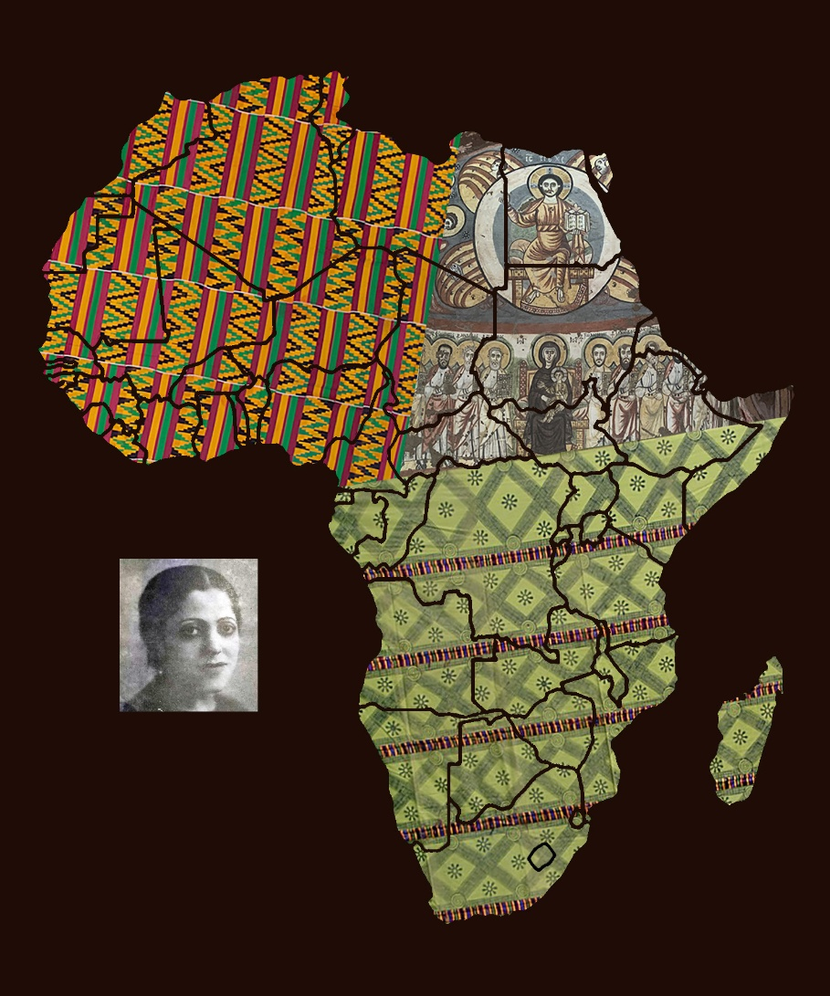
A publication of the Dictionary of African Christian Biography

