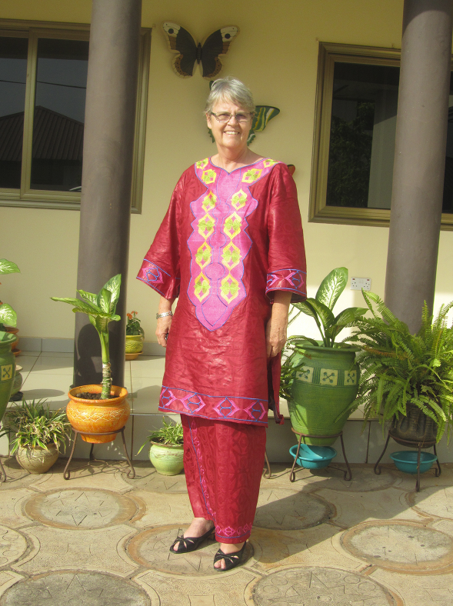

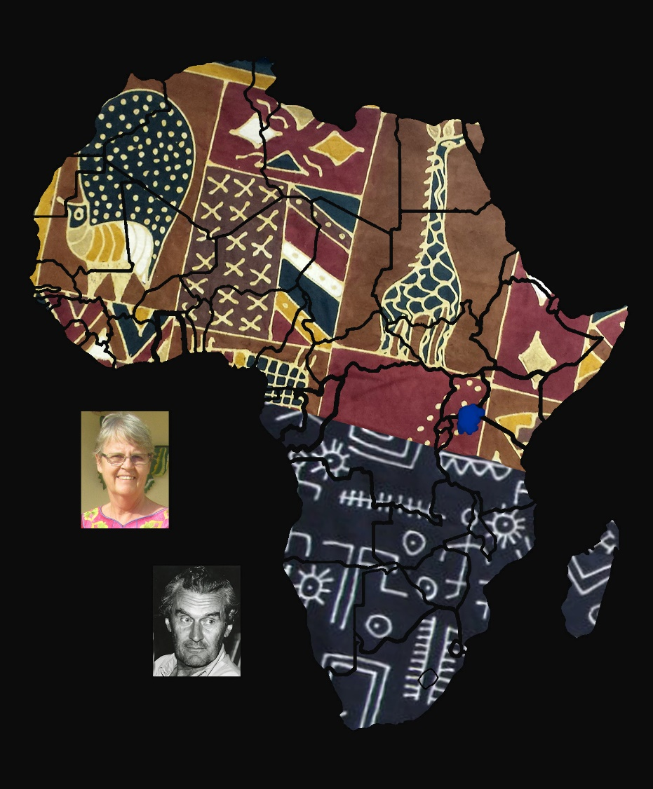

Allison Mary Howell (1951-2023), in front of her home in
Oyarifa, Ghana

 | Journal of African Christian Biography  Quarterly publication of the Dictionary of African Christian Biography  Sign up for a free subscription at https://dacb.org/journal/ |   DONATE
Journal of  African  Christian  Biography | Vol. 9, No. 2-3 (Apr-Jul 2024)  Focus: Tributes to Inus Daneel and Allison Mary Howell; Ludwig Akzaklo (Ghana), Stephen Ndabambi Ndlovu (Zimbabwe), Sengu Mbongu Rebecca (DRC)

A publication of the Dictionary of African Christian Biography

