Marthinus L. “Inus” Daneel (1936-2024)
Zorora murugare. Rest in peace.
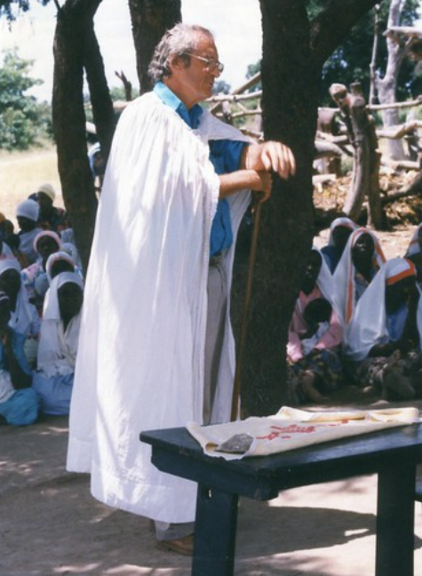
 | Journal of African Christian Biography  Quarterly publication of the Dictionary of African Christian Biography  Sign up for a free subscription at https://dacb.org/journal/ |   DONATE
Journal of  African  Christian  Biography | Vol. 9, No. 4 (Oct. 2024)  Focus: The Pioneering Legacy of Marthinus L. “Inus” Daneel
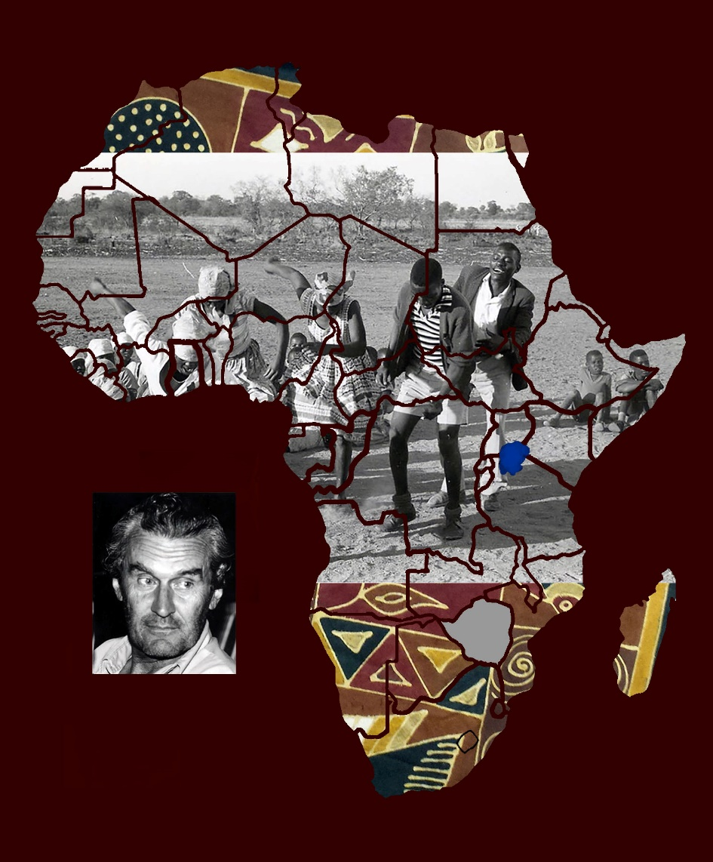
A publication of the Dictionary of African Christian Biography

