|  |
| --- |
|  |

|  |  |
| --- | --- |
| Journal of  African  Christian  Biography | **Vol. 2, No. 3 (July 2017)**  **Focus**:  Agnes Okoh (Nigeria) Kivebulaya, Luwum, Njangali (Uganda)  Lamin Sanneh |

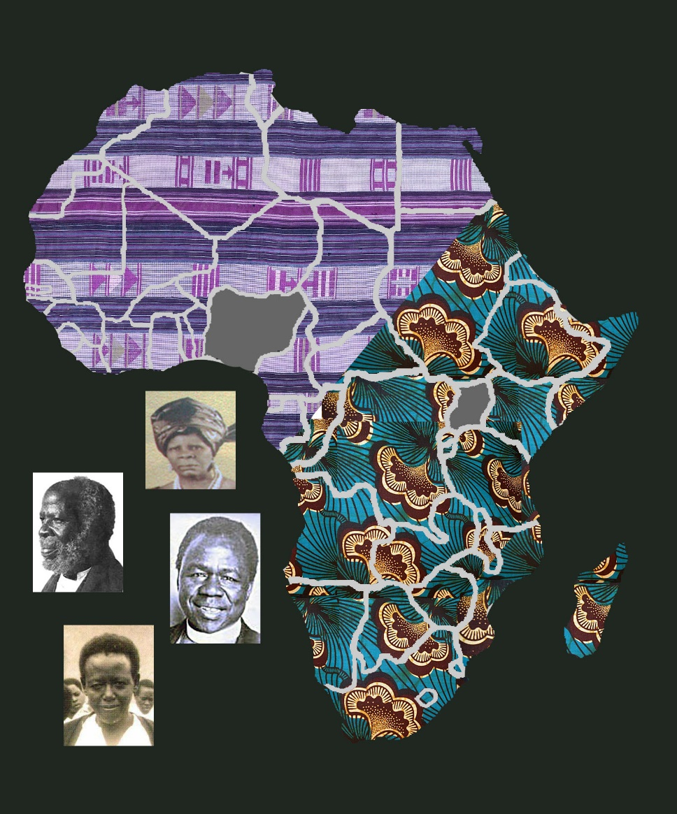

A publication of the *Dictionary of African Christian Biography*