|  |
| --- |
|  |

|  |  |
| --- | --- |
| Journal of  African  Christian  Biography | **Vol. 2, No. 4 (Oct 2017)**  **Focus**:  Bernard Mizeki (Zimbabwe) Manche Masemola & A. Luthuli (S. Africa)  Bethuel Kiplagat |

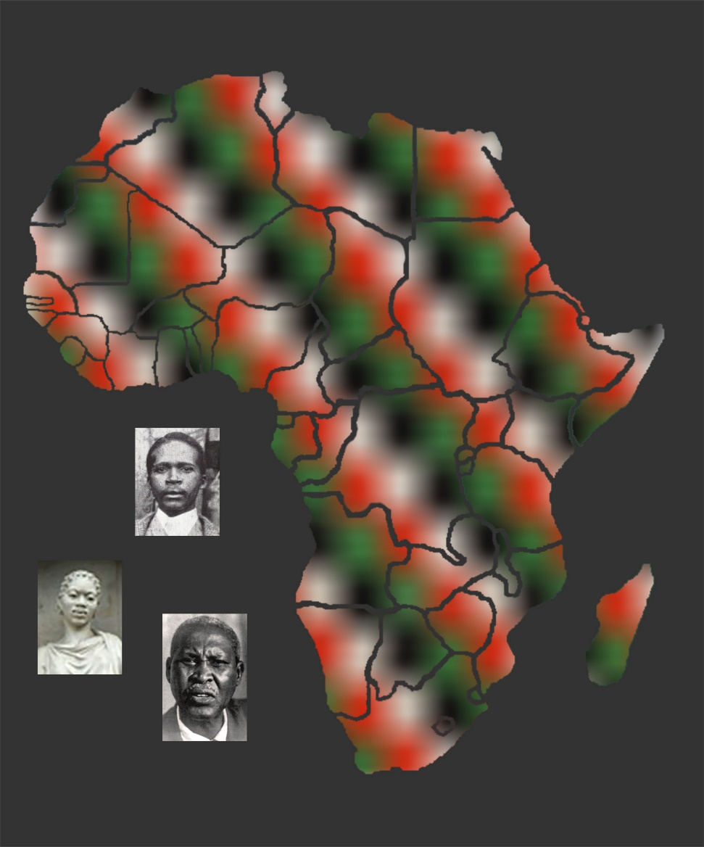

A publication of the *Dictionary of African Christian Biography*