|  |
| --- |
|  |

|  |  |
| --- | --- |
| Journal of  African  Christian  Biography | **Vol. 3, No. 1 (Jan 2018)**  **Focus**:  Horton, Nicol, Maxwell, Richards  (The Gambia) Daniel Williams Alexander (East Africa) |

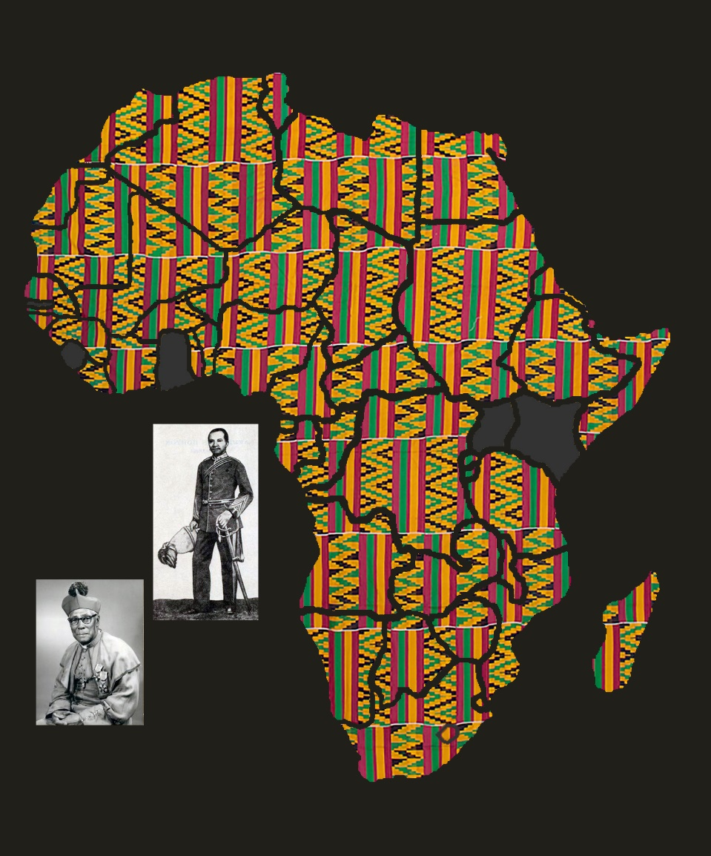

A publication of the *Dictionary of African Christian Biography*

