|  |
| --- |
|  |

|  |  |
| --- | --- |
| Journal of  African  Christian  Biography | **Vol. 3, No. 2 (April 2018)**  **Focus**:  Samuel Mutendi  (Zimbabwe) Paul Nchoji Nkwi (Cameroon) |

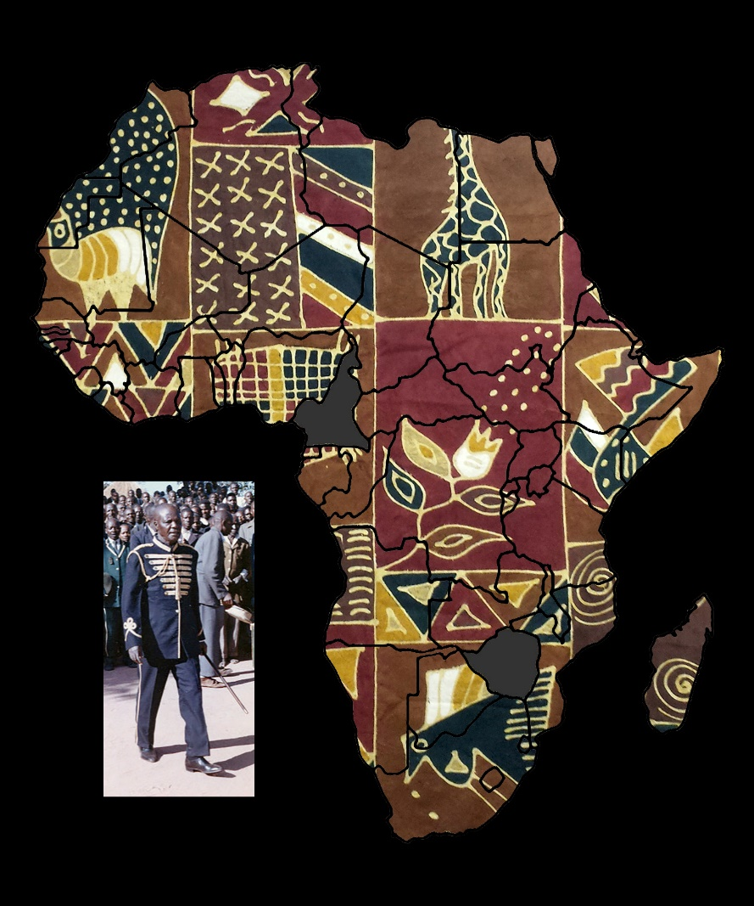

A publication of the *Dictionary of African Christian Biography*