|  |
| --- |
|  |

|  |  |
| --- | --- |
| Journal of  African  Christian  Biography | **Vol. 3, No. 3 (July 2018)**  **Focus**:  Balya, Moshi, and Waliggo (E. Africa)  Wellington Mulwa (Kenya) Interview with Jesse Mugambi (Kenya) |

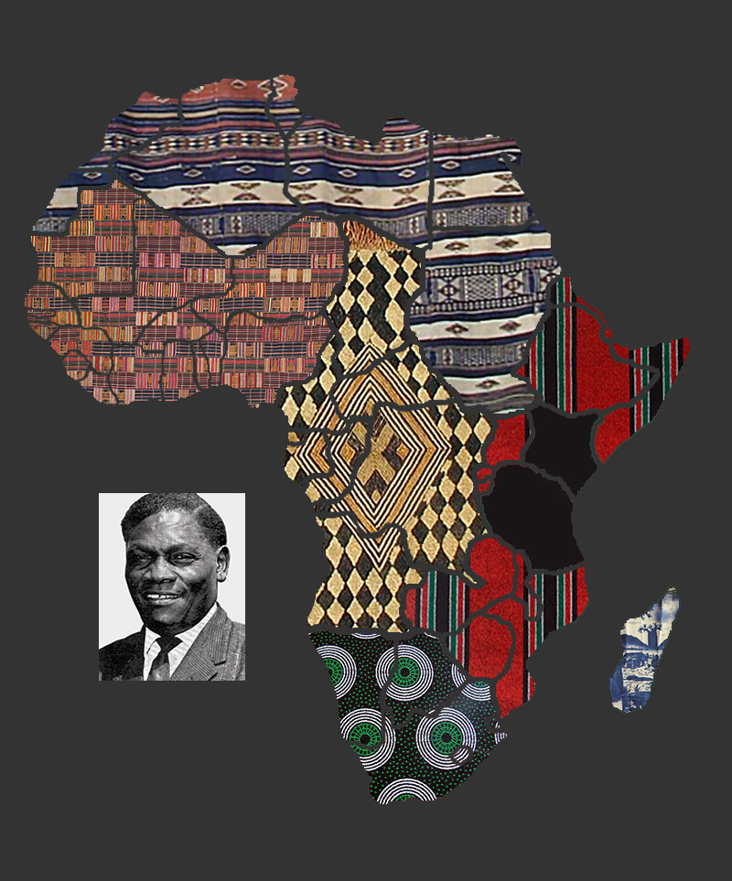

A publication of the *Dictionary of African Christian Biography*