|  |
| --- |
|  |

|  |  |
| --- | --- |
| Journal of  African  Christian  Biography | **Vol. 3, No. 4 (Oct 2018)**  **Focus**: P. D. Zakayo Kivuli (E. Africa)  *Aladura* Trailblazers, Successors (Nigeria) |

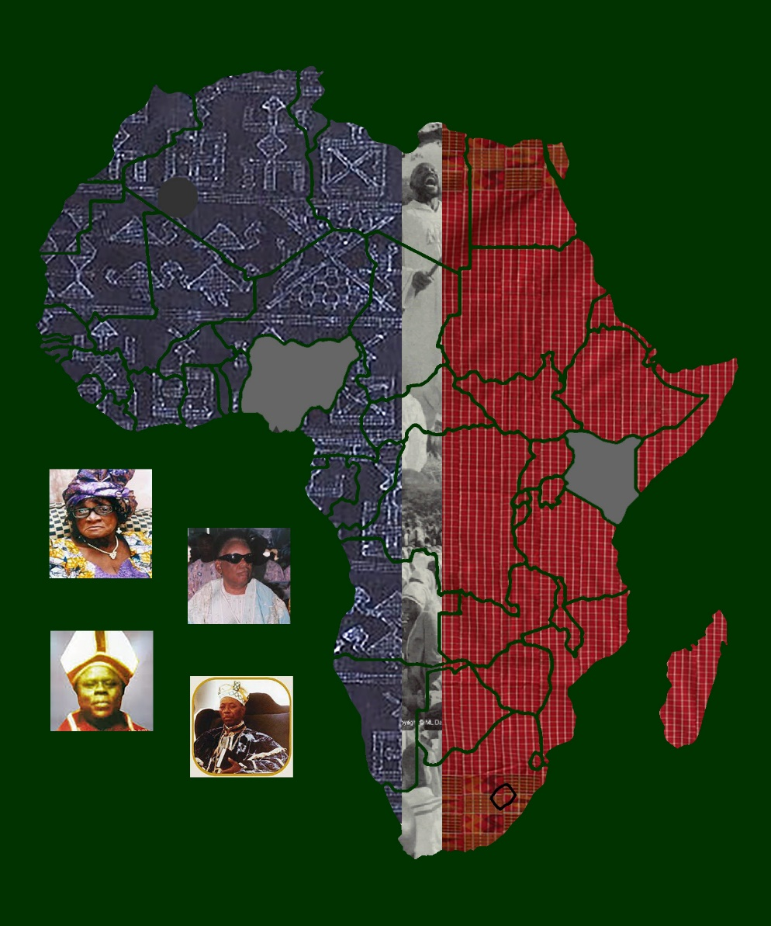

A publication of the *Dictionary of African Christian Biography*