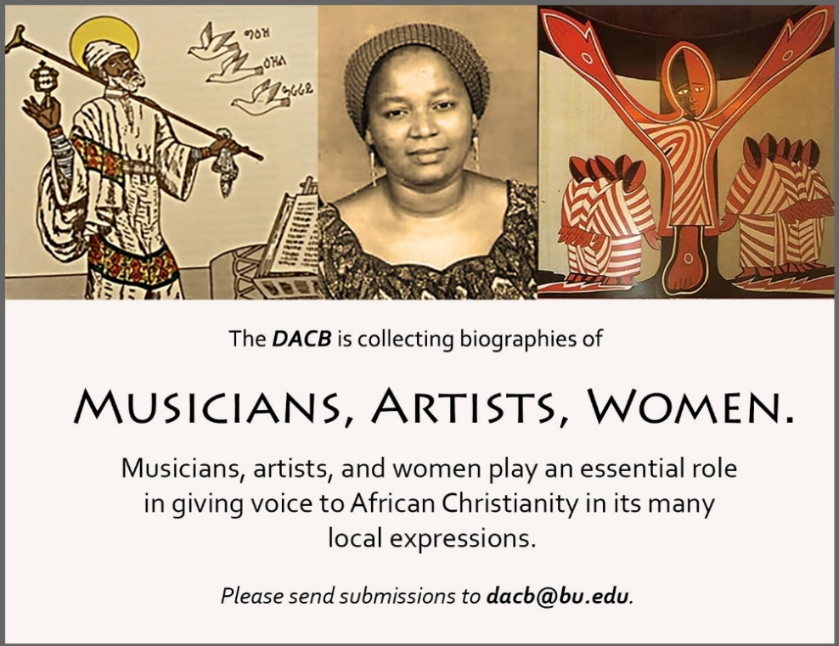

|  |  |
| --- | --- |
|  | **www.DACB.org**  Send biographies of any African men and women, clergy and lay people who served as the founders and builders of Christian communities in Africa to:  Michèle Sigg  Associate Director [dacb@bu.edu](mailto:dacb@bu.edu) |

Subscribe to the *JACB* at **www.dacb.org/news/journal/**

|  |  |
| --- | --- |
| Journal of  African  Christian  Biography | **Vol. 4, No. 1 (Jan. 2019)**  **Focus**: *African Christian Biography*  Musicians and Composers:  Yared, John Knox Bokwe |

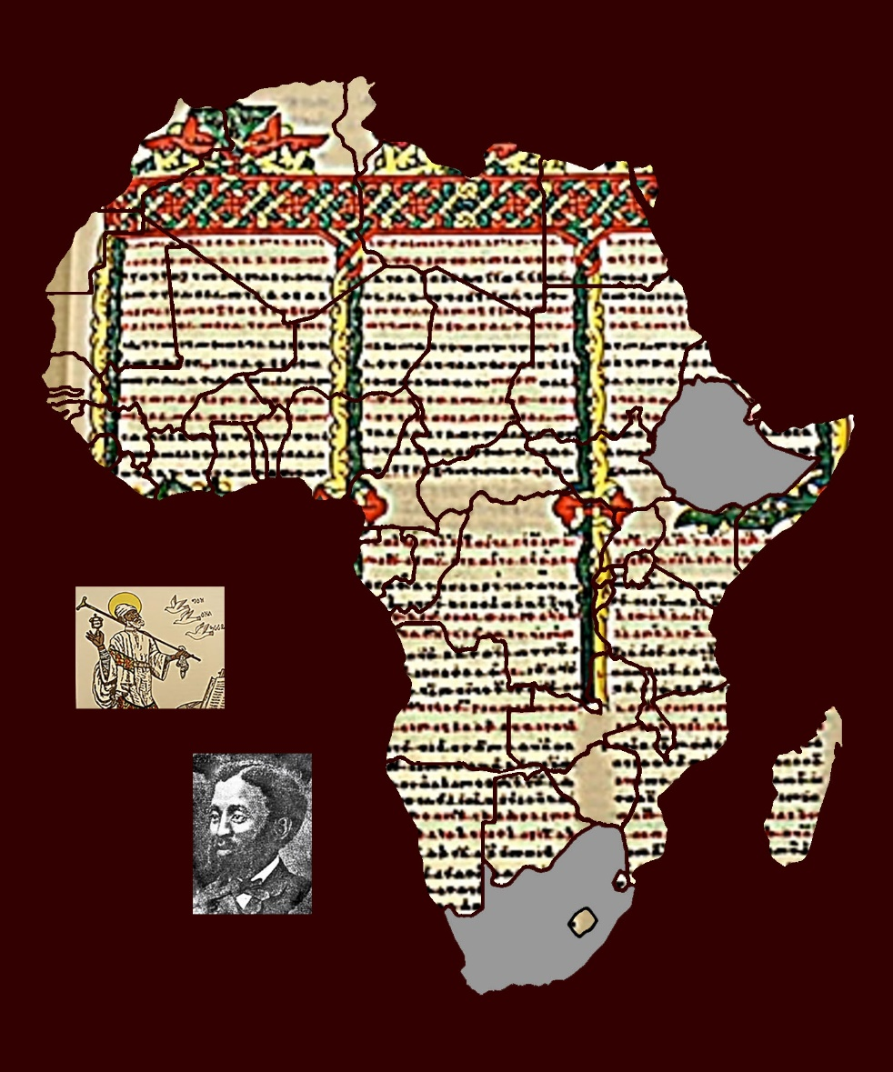

A publication of the *Dictionary of African Christian Biography*