

**Lamin Sanneh (1942-2019)**

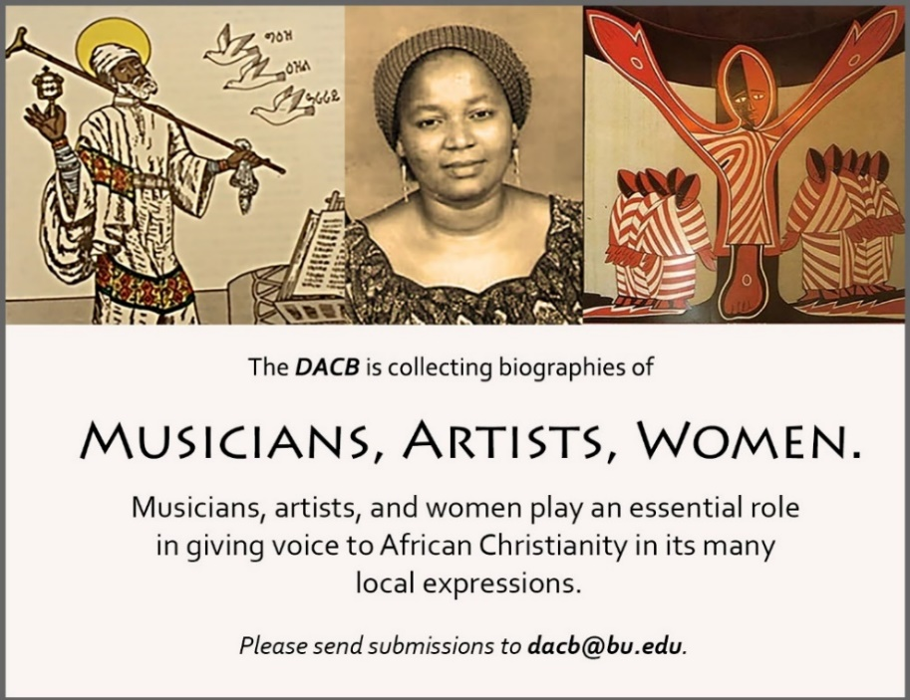

Subscribe to the *JACB* at **www.dacb.org/news/journal/**

|  |  |
| --- | --- |
| Journal of  African  Christian  Biography | **Vol. 4, No. 2 (April 2019)**  **Focus**: The Life and Legacy of Lamin Sanneh  (The Gambia) |

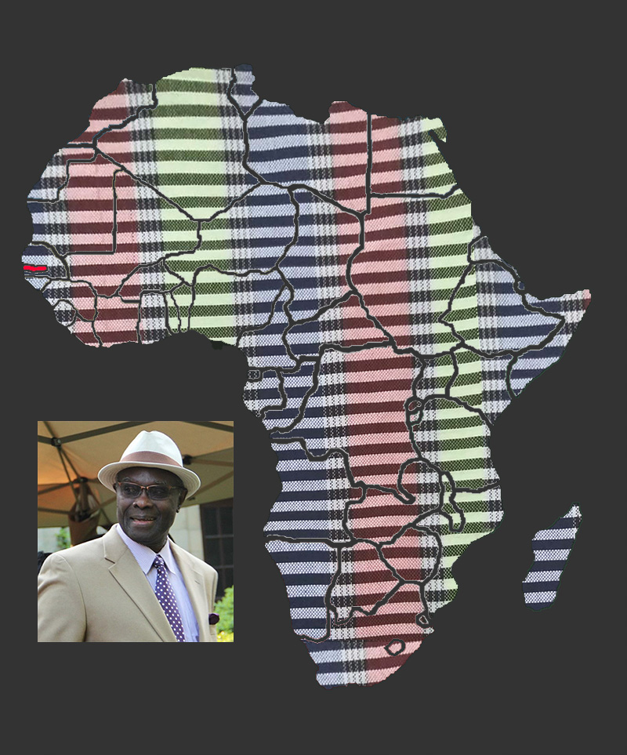

A publication of the *Dictionary of African Christian Biography*