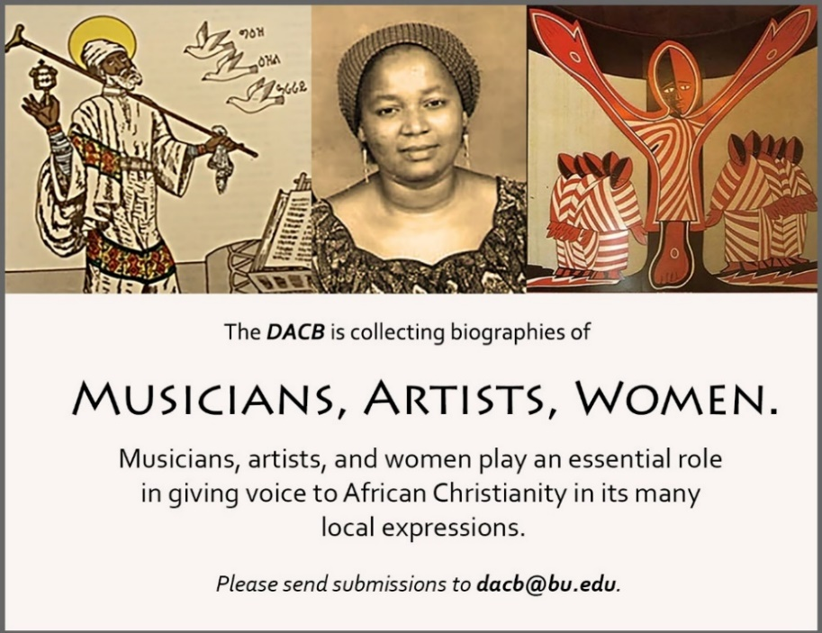

Subscribe to the *JACB* at **www.dacb.org/news/journal/**

|  |  |
| --- | --- |
| Journal of  African  Christian  Biography | **Vol. 4, No. 3 (July 2019)**  **Focus**: I. Ababio and C. Y. Yeboa-Korie (Ghana)  James Cone Tribute  Reviews: *African Christian Biography* and the *Africa Study Bible* |

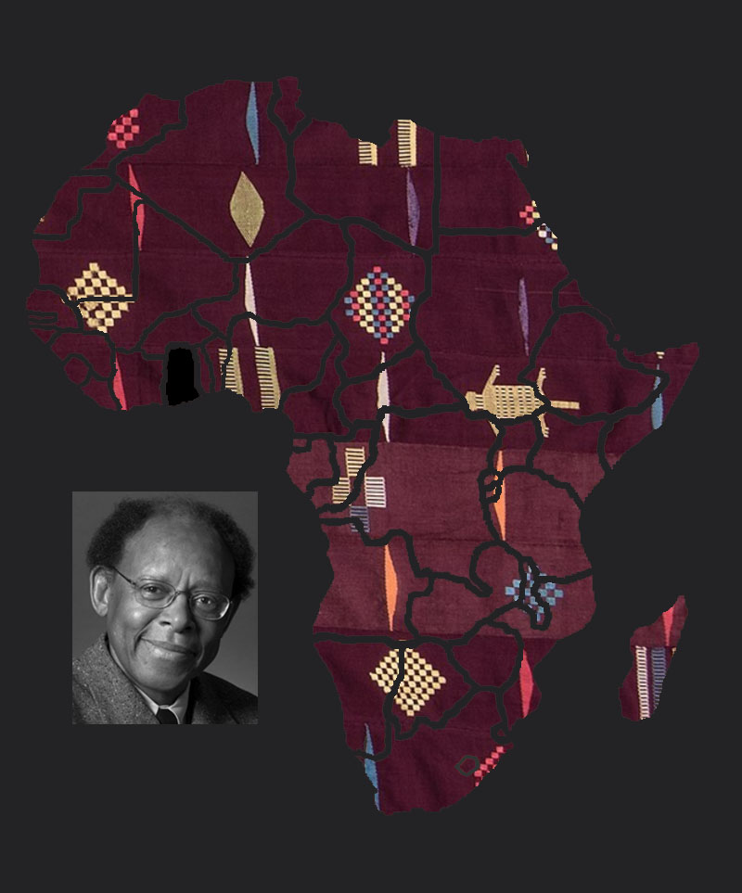

A publication of the *Dictionary of African Christian Biography*