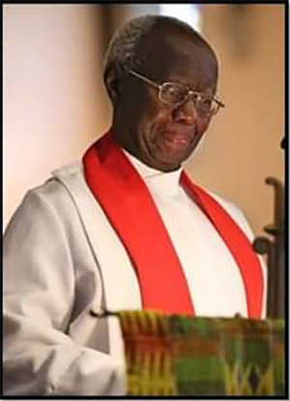

**John S. Mbiti, 1931 - 2019**

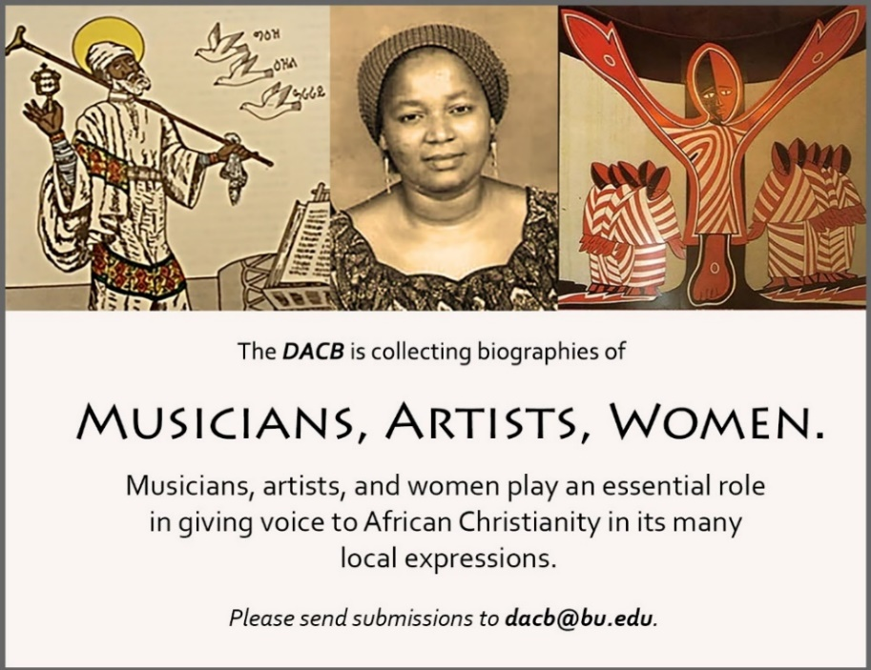

Subscribe to the *JACB* at **www.dacb.org/news/journal/**

|  |  |
| --- | --- |
| Journal of  African  Christian  Biography | **Vol. 4, No. 4 (Oct. 2019)**  **BILINGUAL ISSUE - Focus**: John Mbiti Tribute (Kenya)  Edward Francis Small (The Gambia)  Englebert Mveng (Cameroon) [in French] |

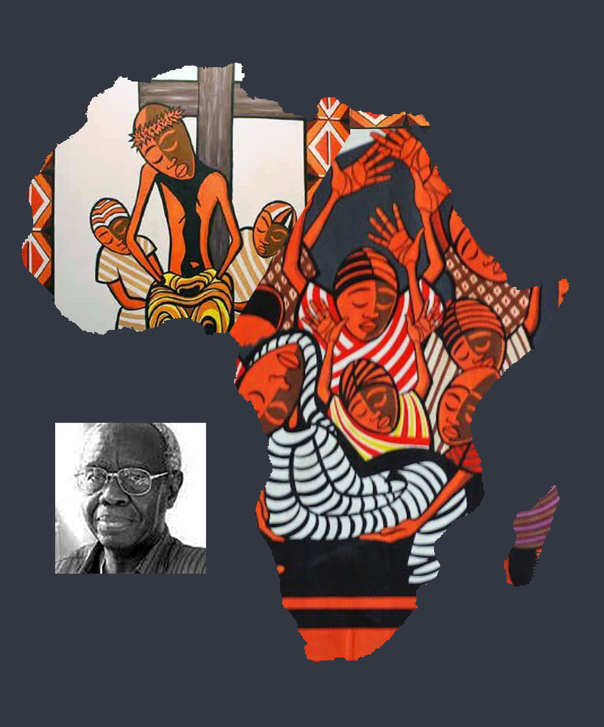  
  
A publication of the *Dictionary of African Christian Biography*