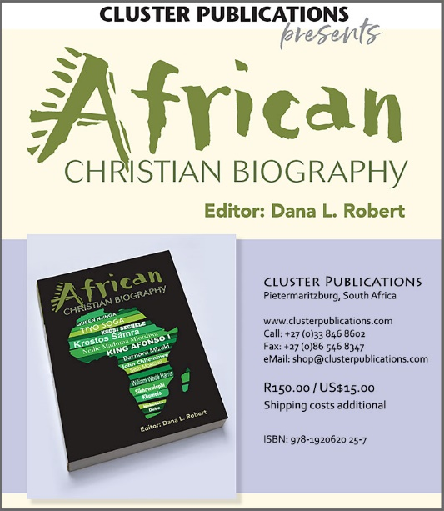

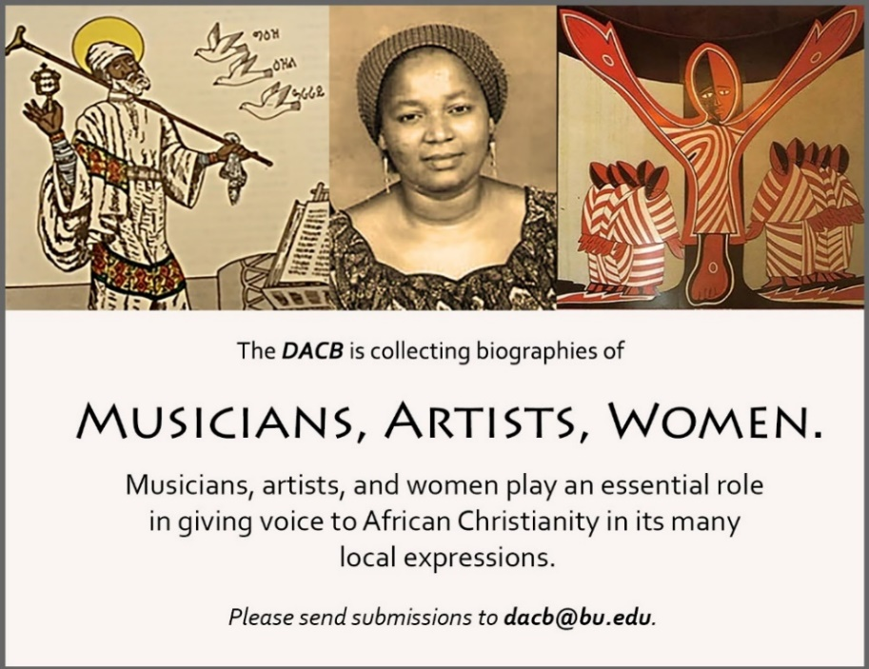

Subscribe to the *JACB* at **www.dacb.org/journal/**

|  |  |
| --- | --- |
| Journal of  African  Christian  Biography | **Vol. 5, No. 1 (Jan. 2020)**  **Focus**: **WOMEN** Kimpa Vita, Queen Njinga (Congo, DRC, Angola), Krəstos Śämra (Ethiopia) |

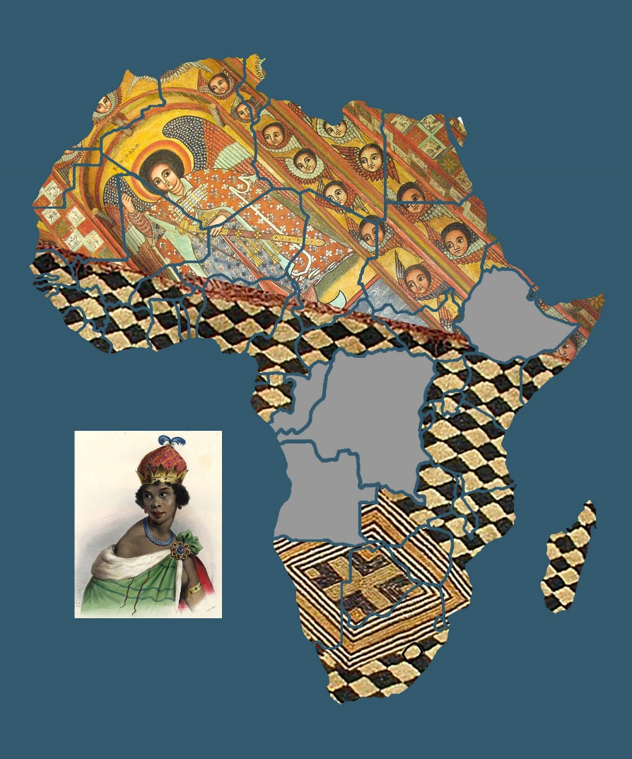  
  
A publication of the *Dictionary of African Christian Biography*