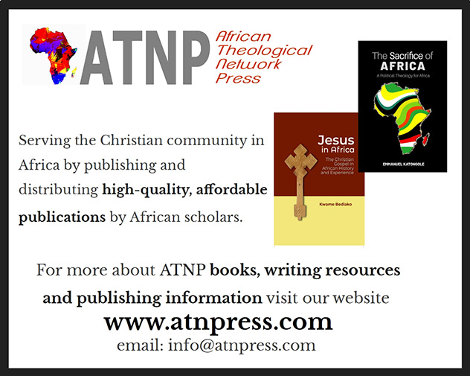

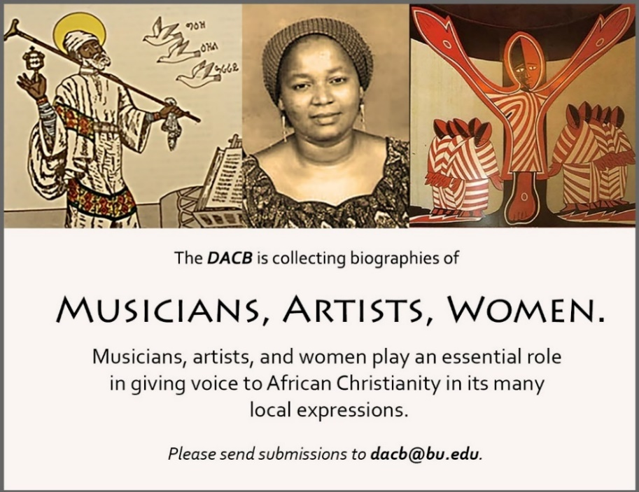

Subscribe to the *JACB* at **www.dacb.org/journal/**

|  |  |
| --- | --- |
| Journal of  African  Christian  Biography | **Vol. 5, No. 2 (April 2020)**  **Focus**: WOMEN / BILINGUAL (FRENCH) Nokutela Dube (S. Africa), Émilienne Moungou-Mouyabi (Congo)  Tribute to John S. Pobee (Ghana) |

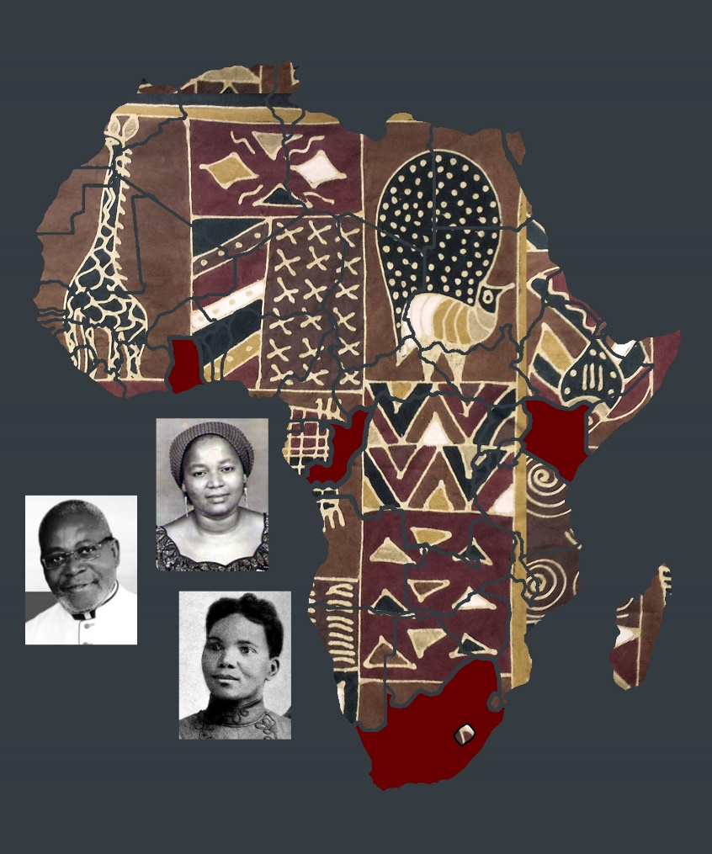

A publication of the *Dictionary of African Christian Biography*