|  |  |  |  |  |  |  |
| --- | --- | --- | --- | --- | --- | --- |
| |  |  | | --- | --- | |  | | | *Afua Kuma.* Watercolor painting (March 2018) by Professor Mark Shaw, Africa International University, Nairobi, Kenya. | | |  | Oral Theologian  Madam Afua Kuma  (1908-1987)  of Ghana  Jesus of the Deep Forest: Prayer and Praises of Afua Kuma | |

|  |  |
| --- | --- |
| Journal of  African  Christian  Biography | **Vol. 5, No. 3 (July 2020)**  **Focus**:  C. Nyamiti (Tanzania), Afua Kuma (Ghana), E. Evans-Afom (Ghana), C. W. Tumi (Cameroon) |

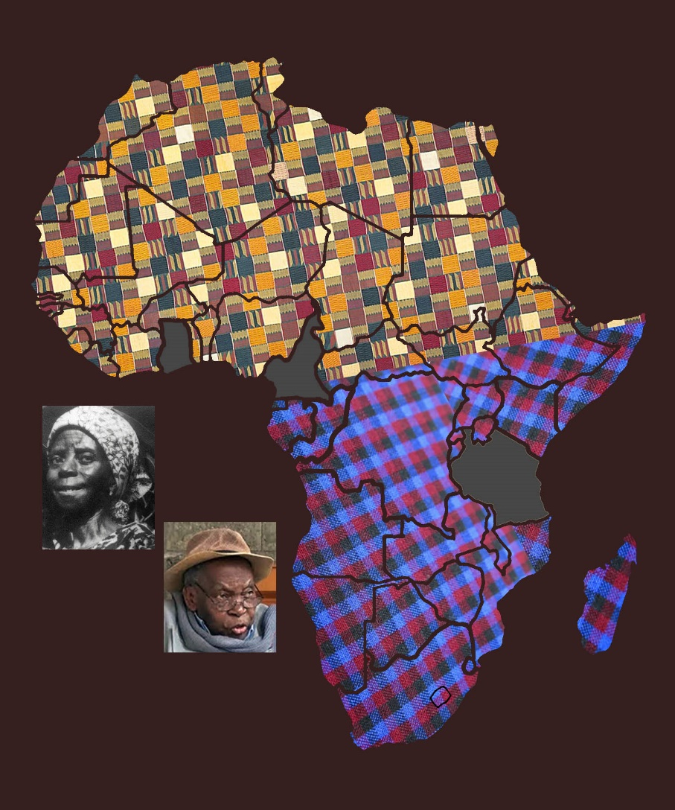

A publication of the *Dictionary of African Christian Biography*