|  |
| --- |
| **Honoring Jonathan Bonk, on his retirement**  **DACB Project Director 1995-2200 and JACB Editor 2016-2020**  A group of people posing for a photo  Description automatically generatedExecutive-Advisory Committee Meeting, Nairobi, Kenya 2016 (From left to right) Madipoane Masenya (Ngwan’a Mphahlele), Michèle Sigg, James Amanze, Edison Kalengyo, Thomas Oduro, Jesse Mugambi, Jonathan Bonk, Deji Ayegboyin, Jean-Claude Loba Mkole, Gabriel Allen, Philomena Mwaura, Evangelos Thiani (missing: Paul Nkwi) |

|  |  |
| --- | --- |
| Journal of  African  Christian  Biography | **Vol. 5, No. 4 (Oct 2020)**  **Focus**:  Special Issue in Honor of  Project Director Jonathan Bonk |

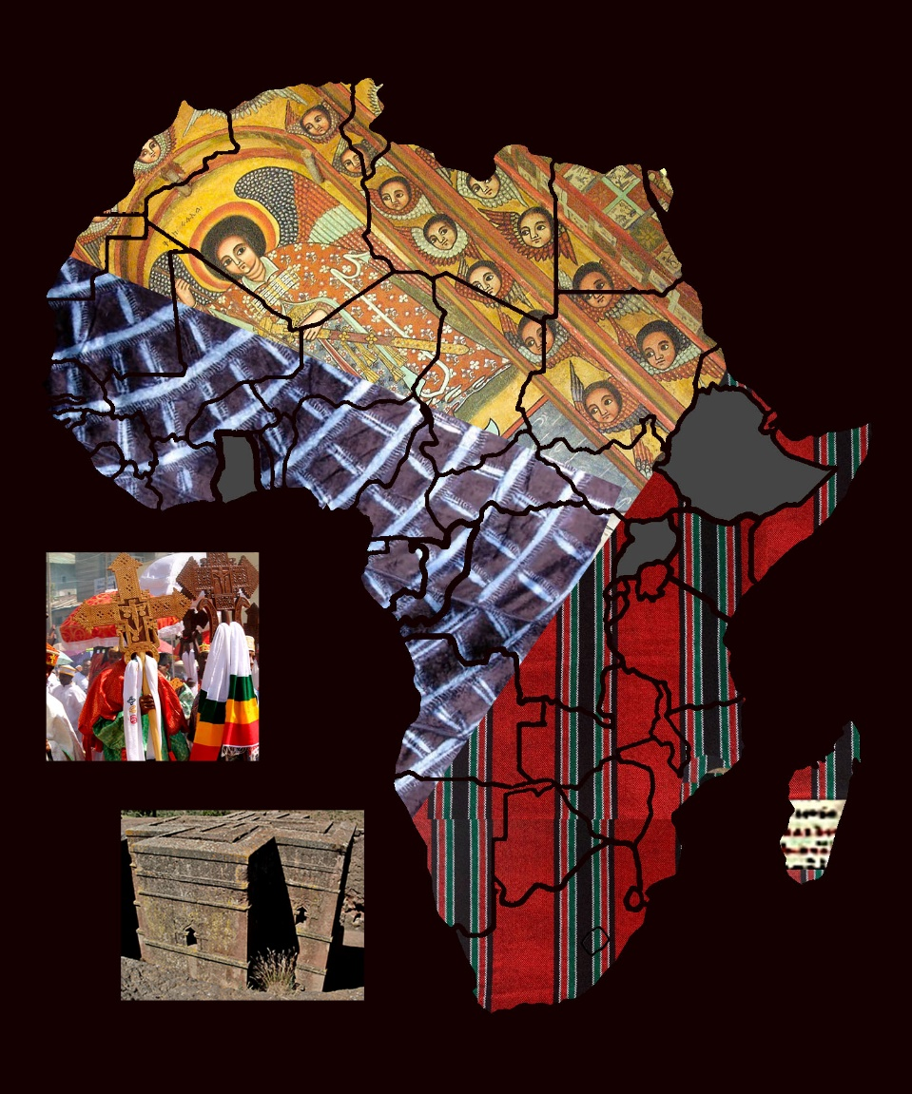

A publication of the *Dictionary of African Christian Biography*