[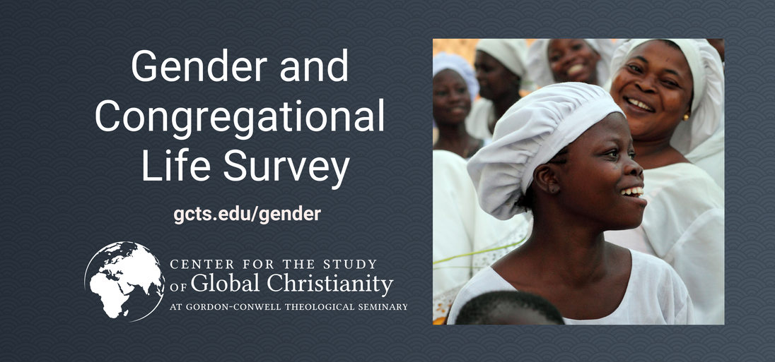](https://centerforglobalchristianity.typeform.com/to/JrHuaUuA)  
  
[Click here to take this survey](https://centerforglobalchristianity.typeform.com/to/JrHuaUuA).

|  |
| --- |
| COVER PHOTO (Credit G. L. Allen): Georgetown Methodist Church, Janjangburay, MacCarthy Island, The Gambia, built and dedicated in 1833, the oldest Wesleyan Methodist Church South of the Sahara Desert in Africa |

|  |  |
| --- | --- |
| Journal of  African  Christian  Biography | **Vol. 6, No. 2 (April 2021)**  **Focus**: **The Gambia:** 200 Years of Wesleyan Methodist Missions; Morgan, Baker, Fox,  Cupidon, Sallah |

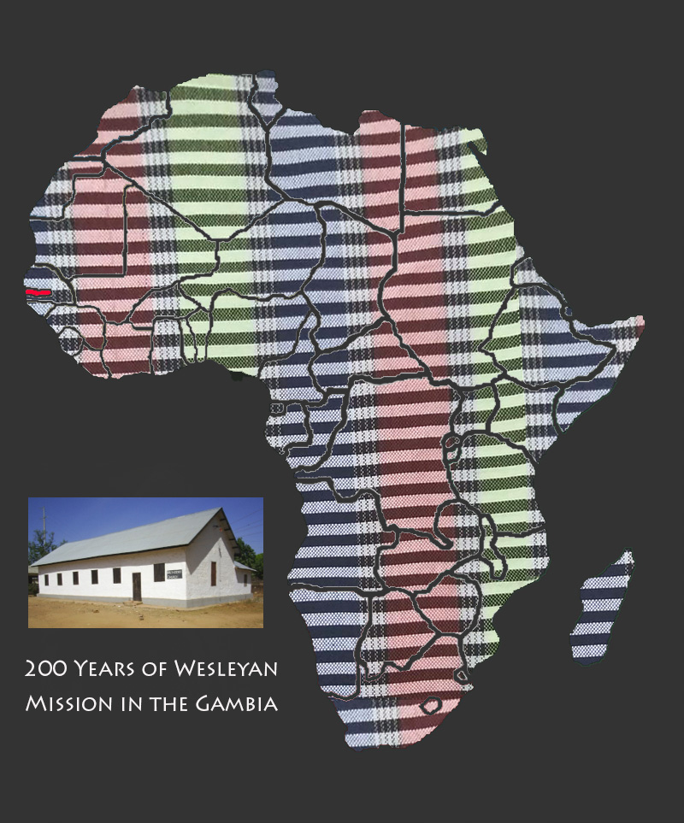  
  
A publication of the *Dictionary of African Christian Biography*