|  |  |  |  |  |  |
| --- | --- | --- | --- | --- | --- |
|  | | |  | | |
|  | | |  | | |
| **Clockwise from top left**: “Xaaji” Maxamed Xuseen Axmed [Haji] (Somalia), Liibaan Ibraahim Xasan (Somalia), Eva and Simeoni Nsimbambi (Uganda), Festo Kivengere (Uganda), Tabitha Maria Magdalena Marwaale [and husband Xasan] (Somalia) | | | | | |
|  | Journal of African Christian Biography  Quarterly publication of the *Dictionary of African Christian Biography*  Sign up for a free subscription at <https://dacb.org/journal/> | |   **DONATE** |



|  |  |
| --- | --- |
| Journal of  African  Christian  Biography | **Vol. 8, No. 1 (Jan 2023)**  **Focus**: East African Revivalists; T. Marwaale, L. Xasan, M. Xaaji (Somalia); BILINGUAL ISSUE: A. Zakariasy (Madagascar) |

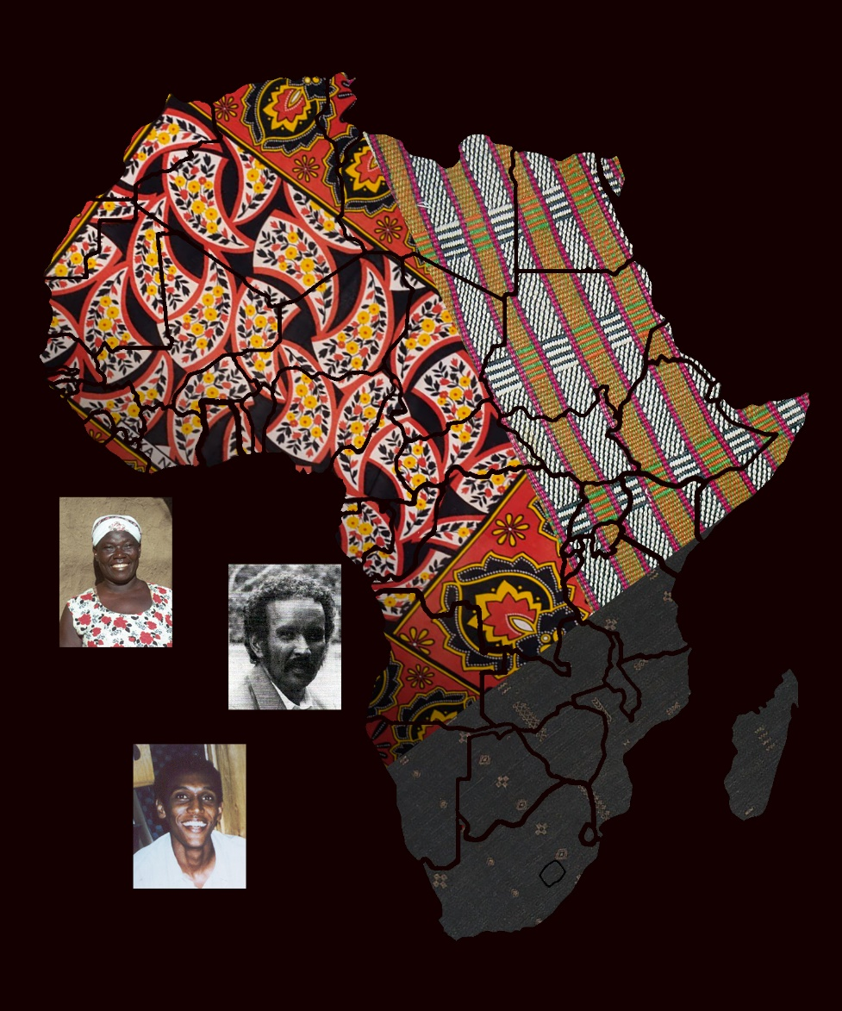

A publication of the *Dictionary of*  *African Christian Biography*