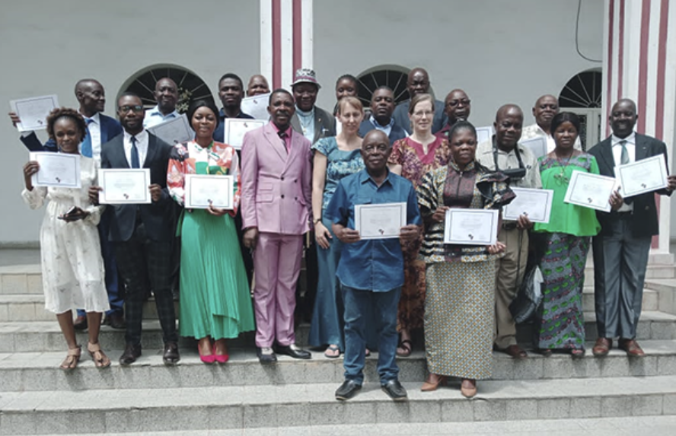

Atelier sur l’Ecriture de l’Histoire de l’Église / Church History Writing Workshop; 20-24 / 03 /2023, Kinshasa, DRC

|  |  |  |
| --- | --- | --- |
|  | Journal of African Christian Biography  Quarterly publication of the *Dictionary of African Christian Biography*  Sign up for a free subscription at <https://dacb.org/journal/> | **Qr code  Description automatically generatedDONATE** |



|  |  |
| --- | --- |
| Journal of  African  Christian  Biography | **Vol. 8, No. 2 (April 2023)**  **Focus**: A. Musopole (uMuntu Theology), I. Phiri, K. Fiedler (Malawi) [BILINGUAL] Workshop report/ Rapport de l’Atelier (DR Congo) |

A publication of the *Dictionary of*  *African Christian Biography*