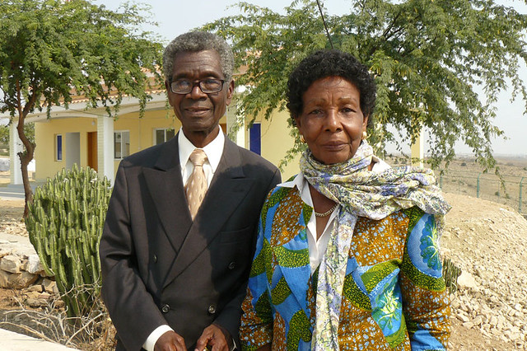

José and Eva Chipenda

|  |  |  |
| --- | --- | --- |
|  | Journal of African Christian Biography  Quarterly publication of the *Dictionary of African Christian Biography*  Sign up for a free subscription at <https://dacb.org/journal/> |   **DONATE** |



|  |  |
| --- | --- |
| Journal of  African  Christian  Biography | **Vol. 8, No. 4 (Oct 2023)**  **Focus**: **Ecumenists** |

A publication of the *Dictionary of*  *African Christian Biography*