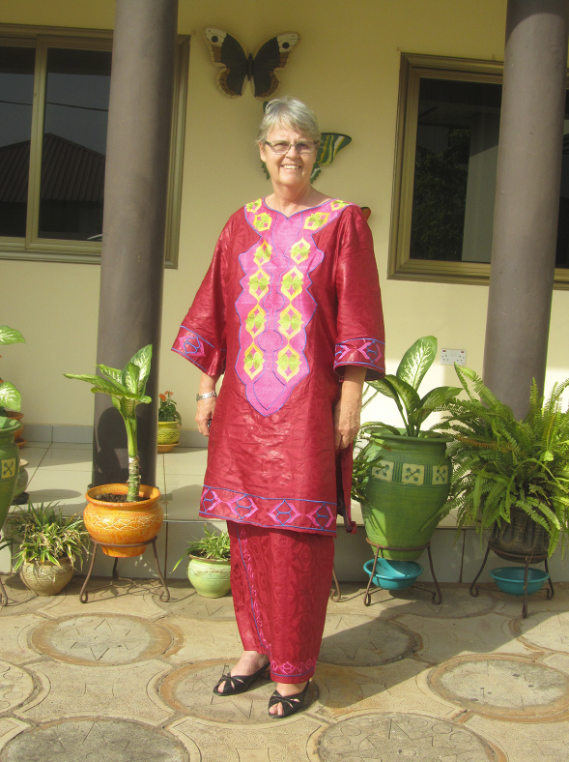

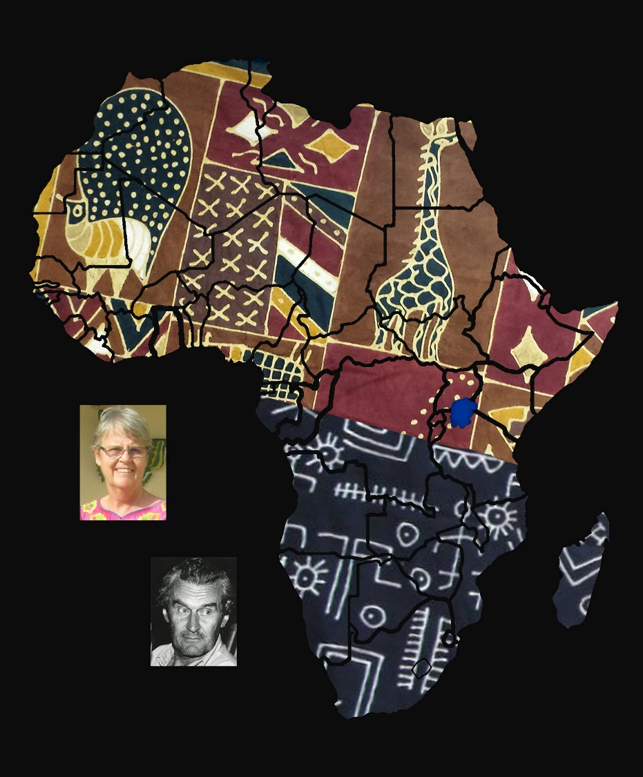

Allison Mary Howell (1951-2023), in front of her home in   
Oyarifa, Ghana

|  |  |  |
| --- | --- | --- |
|  | Journal of African Christian Biography  Quarterly publication of the *Dictionary of African Christian Biography*  Sign up for a free subscription at <https://dacb.org/journal/> |   **DONATE** |



|  |  |
| --- | --- |
| Journal of  African  Christian  Biography | **Vol. 9, No. 2-3 (Apr-Jul 2024)**  **Focus**: Tributes to Inus Daneel and Allison Mary Howell; Ludwig Akzaklo (Ghana), Stephen Ndabambi Ndlovu (Zimbabwe), Sengu Mbongu Rebecca (DRC) |

A publication of the *Dictionary of*  *African Christian Biography*