**Marthinus L. “Inus” Daneel (1936-2024)**  
  
Zorora murugare. Rest in peace.

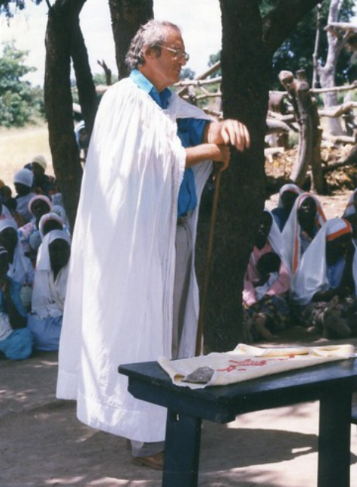

|  |  |  |
| --- | --- | --- |
|  | Journal of African Christian Biography  Quarterly publication of the *Dictionary of African Christian Biography*  Sign up for a free subscription at <https://dacb.org/journal/> |   **DONATE** |



|  |  |
| --- | --- |
| Journal of  African  Christian  Biography | **Vol. 9, No. 4 (Oct. 2024)**  **Focus**: The Pioneering Legacy of Marthinus L. “Inus” Daneel |

A publication of the *Dictionary of* *­African Christian Biography*