COMP4910 Senior Design Project 1, Fall 2025
Advisor: Arman Savran

BPSync
High Level Design
Design Specifications Document

Revision 2.1
05.03.2026

By:
Cem Irer, 22070001077
Kardelen Aldemir, 20070001024
Zeynep Dicle Kartal, 21070001016
Mustafa Göksu Erdoğan, 22070001052

Revision History

Revision | Date | Explanation
1.0 | 19.12.2025 | Initial version of document
1.1 | 28.12.2025 | Added UML Diagrams
2.0 | 31.12.2025 | Supervisor approval version prepared.
2.1 | 04.03.2026 | Latest version of DSD

Table of Contents

Revision History 2
Table of Contents 3
1. Introduction 4
2. BPSync System Design 4
3. BPSync Hardware Subsystem Design 9
3.1. Hardware Subsystem Overview 9
3.2. Hardware Subsystem Components 9
3.3. Interaction and Data Flow 10
3.4. Data Flow Description 12
4. BPSync Software Detailed Design 13
4.1 Wrist Module Firmware 13
4.2. Chest Module Firmware 14
4.4 Backend Ingestion & Session Service (API + Storage) 17
5. References 23

Introduction

The purpose of this project is to develop a smart wearable system that tracks blood pressure trends using Machine Learning (ML). Traditional methods, like Holter monitors or manual arm cuffs, are often uncomfortable or only provide single measurements and not suitable for daily usage. This makes it difficult to see long-term changes in heart health. Therefore this project, BPSync solves this by using a machine learning model to estimate blood pressure trends. It combines data from a chest band (ECG) and a wrist device (PPG) to analyze the user's health continuously .

This system consists of three main components:

- Sensor Hardware: Collects real-time ECG and PPG signals from the user .
- ML Analysis: Uses the sensor data to predict blood pressure trends instead of instant numbers
- Mobile App: Shows simple weekly trends and health alerts (Green/Yellow/Red) to the user .

BPSync System Design

BP-Sync is designed as a modular wearable health monitoring system that integrates multiple sensing devices, a mobile gateway, and a backend analytics platform. The system-level design defines how these components are organized, how they interact, and how data flows across the wearable, mobile, and backend layers.
The design emphasizes clear separation between sensing, communication, data storage, analytics, and reliability mechanisms, enabling scalable operation and iterative system evolution while maintaining robustness under real-world usage conditions.

- System Architecture Overview

BP-Sync is a smart wearable health monitoring system composed of interconnected sensing, analytics, and user interaction layers designed to support blood pressure estimation and long-term trend analysis.

- Sensor Hardware (Wearable Layer):
Collects real-time physiological signals, including ECG and PPG, along with motion and temperature data, forming the sensing layer of the BP-Sync system.
- Backend Analytics (ML & Trend Analysis Layer):
Processes uploaded sensor sessions to estimate blood pressure using ECG–PPG features and XGBoost, with a focus on long-term trend analysis rather than instantaneous measurements.
- Mobile Application (User Interaction Layer):
Acts as a gateway and visualization interface, presenting simplified daily and weekly blood pressure trends and risk-oriented health alerts (e.g., Green / Yellow / Red) to the user.

  - Overall System Architecture Diagram

As shown in Figure 2.1, the BPSync system is organized into wearable, mobile, and backend layers with clearly separated responsibilities.
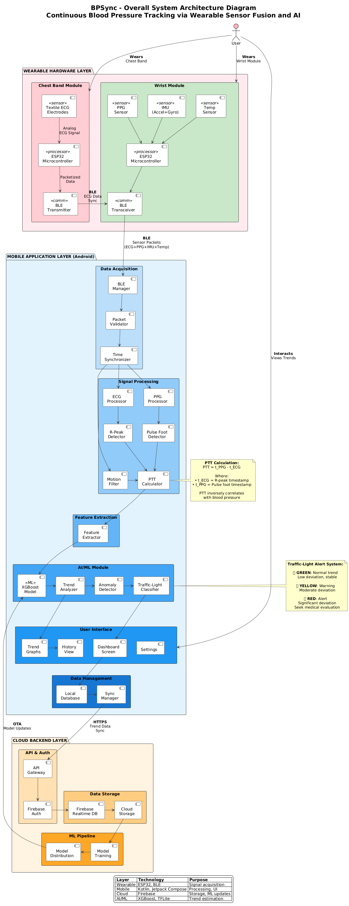
Figure 2.1: Overall System Architecture Diagram
- Component Interaction
Component interaction in BP-Sync is defined by directional data and control flows across the wearable, mobile, and backend layers.
At the wearable level, the wrist module initiates and controls measurement sessions, while the chest module responds by streaming ECG and chest IMU data. Sensor data flows unidirectionally from the chest module to the wrist module, where it is combined with locally acquired wrist signals.
The wrist module forwards merged session data to the mobile application using BLE notifications. The mobile application does not process sensor signals directly; instead, it acts as a transport and storage intermediary, ensuring reliable session collection and delivery.
Interaction between the mobile application and the backend system occurs through RESTful HTTPS interfaces. Session data is uploaded asynchronously, and processed analytics results are retrieved by the mobile application for presentation to the user.

2.2.1 Module Dependency Diagram

Figure 2.2 illustrates the dependency relationships between hardware, mobile, and backend components of the system.
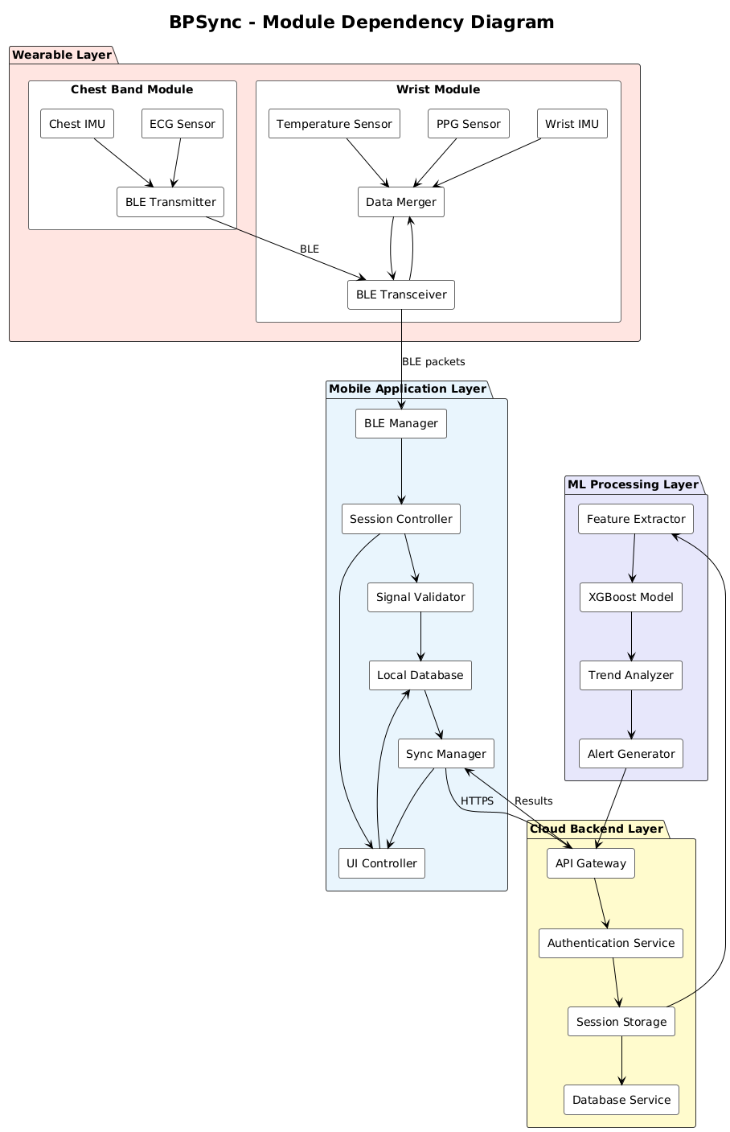
Figure 2.2: Module Dependency Model
- Hardware Inventory (Purchased Electronics)
The BP-Sync system is implemented using commercially available, low-power electronic components selected to support reliable physiological sensing, wireless communication, and wearable prototyping.
Both the Chest Module and the Wrist Module are built around the nRF52840 microcontroller platform. This platform was selected due to its native Bluetooth Low Energy (BLE) support, low power consumption, compact form factor, and compatibility with Arduino-based development tools, making it suitable for wearable system development.
The Chest Module integrates a pulse sensing front-end for cardiac signal acquisition and an inertial measurement unit (IMU) to capture motion data.
During the initial design phase, a MAX30003 ECG front-end was considered. However, due to hardware availability and prototyping simplicity, the system uses the SEN0213 Gravity Analog Pulse Sensor to capture heartbeat signals.
The SEN0213 provides an analog pulse waveform that is sampled by the microcontroller's ADC and used for heart rate and timing analysis within the BP estimation pipeline.The Wrist Module includes an optical PPG sensor (MAX30102) for pulse waveform acquisition, an IMU for motion detection, and a temperature sensor (MCP9808) to provide additional context related to sensor contact and environmental conditions.
Both wearable modules are powered by rechargeable 3.7 V Li-Po batteries and supported by dedicated charging modules to ensure safe and stable operation during measurement sessions.

- Design Principles

The design of the BPSync system is guided by the following core principles:

- Modularity:
The system is decomposed into independent components, including chest firmware, wrist firmware, mobile application, and backend services. This separation enables independent development, testing, and future upgrades without impacting the entire system.
- Reliability:
Session-based data handling, buffering mechanisms, and signal quality indicators are incorporated to ensure robust operation under imperfect connectivity and real-world usage conditions.
- Real-Time Performance:
Bluetooth Low Energy communication and data packet structures are optimized to support continuous data streaming with acceptable latency during active measurement sessions.
- Scalability:
Backend services are designed to support multiple users and devices through asynchronous processing and modular service separation.
- Maintainability:
Clear interfaces and well-defined data contracts between system components simplify debugging, testing, and long-term system maintenance.

- Assumptions and Constraints

Assumptions

- Both nRF52840-based wearable devices can maintain stable Bluetooth Low Energy (BLE) connections in their intended operational roles.
- Users wear the chest module correctly, allowing reliable ECG signal acquisition during measurement sessions.
- An initial dataset sufficient for training and validating the blood pressure estimation model can be collected and curated.
- The mobile application is available during measurement sessions to act as a gateway between wearable devices and the backend system.

Constraints

- Bluetooth Low Energy bandwidth limits the duration and sampling rates of continuous raw waveform streaming.
- Motion artifacts, particularly at the wrist, may reduce PPG signal quality during daily activities.
- Battery capacity constrains sampling frequency, transmission intervals, and overall session duration.
- Model performance and generalization are dependent on dataset diversity and calibration strategies.

BPSync Hardware Subsystem Design

This section describes the software subsystem of the BPSync system, focusing on the components and data flow.

Hardware Subsystem Overview

The software subsystem performs data acquisition (ECG, PPG, IMU, and Temperature), data preprocessing, and transport via BLE and HTTPS protocols. It manages session storage and executes an XGBoost machine learning model to estimate blood pressure trends. The process follows a sequence of collection, processing, prediction, and decision-making.

Hardware Subsystem Components

- Chest Firmware Subsystem

- Function: Acquires ECG and chest IMU data. Controls the system state machine and streams data via BLE.
- Input: Analog pulse signals from the SEN0213 pulse sensor and motion data from the IMU.
- Output: Digital ECG and IMU data packets.

- Wrist Firmware Subsystem

- Function: Acquires PPG, wrist IMU, and temperature data. Merges data from the Chest unit, buffers the combined dataset, and relays it via BLE.
- Input: Optical sensor readings, temperature data, and BLE packets from the Chest Subsystem.
- Output: Combined sensor data stream.

- Mobile Application Subsystem

- Function: Acts as a BLE gateway. Manages local data storage, handles the upload/retry queue, and displays the user interface.
- Input: Sensor data stream via BLE and analysis results from the backend.
- Output: Graphical display for the user and JSON data for the backend.

- Backend Subsystem

- Function: Manages the API and database. Runs the XGBoost model to estimate trends and determines alert levels (Green/Yellow/Red).
- Input: Processed sensor data and session metadata.
- Output: Weekly blood pressure trend values and status alerts.

Interaction and Data Flow

BP-Sync components interact through a sequential, session-based data flow. ECG and chest IMU data are streamed from the Chest Module to the Wrist Module via BLE. The Wrist Module merges incoming chest data with locally acquired PPG, wrist IMU, and temperature data and forwards the merged session to the Mobile Application using BLE notifications. The Mobile Application uploads session data to the Backend API through HTTPS, where blood pressure estimation is performed and results are returned for visualization.

3.3.1 Measurement Session Sequence Diagram

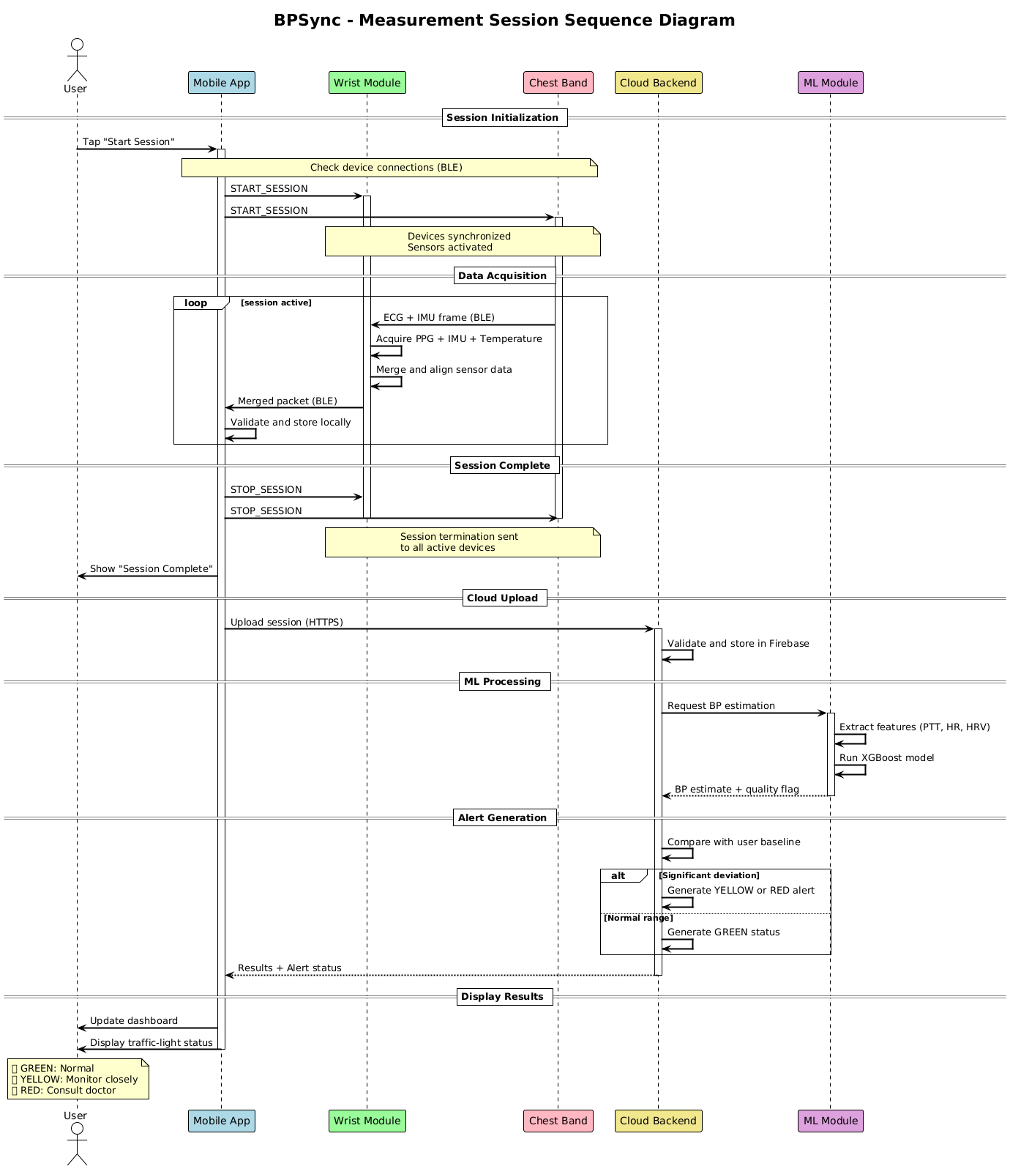
Figure 3.1: Measurement Sequence Diagram

The runtime interaction between system components during a measurement session is illustrated in Figure 3.1.

Data Flow Description

Chest IMU Sensor
ECG Electrods

IMU
R Peak, ECG

Wrist Sensors
Chest Module (ECG + Chest IMU)

(PPG + IMU + Temp)
BLE Stream: ECG + Chest IMU Frames
Time Stamp

Wrist Module

BLE Notifications

Mobile Application
(BLE Gateway + Storage)

HTTPS Upload (Session Data)

Backend API
(Session Storage)

Data Pack
BP Result

XGBoost Inference
(BP Estimation)
Data Pack + BP Result

Mobile Application UI
(Visulization)

  - Design Considerations

- Scalability:
The system is designed to support increasing numbers of users and sessions by decoupling data collection from backend processing.

- Reliability:
Session-based data handling and local storage ensure continued operation under intermittent connectivity or backend unavailability.

- Performance:
Real-time data collection is optimized through BLE communication and efficient packet handling to minimize end-to-end latency.

- Modularity:
Each system component (wearable devices, mobile application, and backend services) is designed as an independent module to simplify maintenance and future updates.

BPSync Software Detailed Design

This section provides a detailed design of the key components in the software subsystem of the BP-Sync system. Each component is described in terms of its responsibilities, inputs, outputs, and key functions.

4.1 Wrist Module Firmware

This module is the central wearable hub. It measures PPG + wrist IMU + temperature, receives ECG + chest IMU from the chest module via BLE, and relays everything to the smartphone over BLE.

Responsibilities

- Acquire PPG (MAX30102), wrist IMU (MPU6050), and temperature (MCP9808) with stable sampling profiles.
- Connect to the chest module over BLE and subscribe to ECG+IMU streams.
- Merge multi-stream data into a unified session timeline and transmit to the phone via BLE.
- Produce signal quality/segment usefulness indicators (SQI + motion-based gating flags).
- Handle buffering and reconnection events without corrupting the session.

Justification

The wrist module acts as the central wearable hub by merging ECG data received from the chest module with locally acquired PPG, IMU, and temperature signals. This design reduces the processing burden on the mobile application and ensures synchronized sensor streams before transmission.

Inputs

- PPG samples from MAX30102
- Wrist IMU samples from MPU6050
- Temperature samples from MCP9808
- Incoming BLE packets from Chest Module:
  - ECG frames
  - Chest IMU frames
- Session control commands from phone (start/stop/config)

Outputs

- BLE stream to smartphone: Merged Session Packets containing
ECG + Chest IMU + PPG + Wrist IMU + Temp (+ metadata)
- Live status to phone (battery, connection state, quality flags)
- Local short-term buffers (ring buffer) for dropouts

Core Functions

- Multi-Sensor Sampling
  - Reads PPG continuously during sessions; supports configurable sampling profiles.
  - Reads wrist IMU at moderate rate to detect motion artifacts.
  - Reads temperature periodically (low rate) for context and contact-change detection.
- Chest Connection & Subscription (BLE Central Role)
  - Scans and connects to chest device.
  - Subscribes to ECG and chest IMU characteristics.
  - Validates sequence numbers and tracks packet loss rate.
- Stream Merging & Timestamp Normalization
  - Maintains a unified time base for multi-stream packets.
  - Tags incoming chest frames with wrist receive time (and optional offset correction).
  - Produces a consistent merged packet structure for backend decoding.
- Quality Gate / Useful Segment Detection
  - Computes motion index from wrist IMU (e.g., accel magnitude variance).
  - Flags windows as HIGH_TRUST / LOW_TRUST based on motion + PPG signal checks.
  - Propagates these flags to phone/backend to avoid using noisy segments for ML.
- BLE Streaming to Phone (Peripheral Role)
  - Advertises WristHub service.
  - Notifies merged packets efficiently (batching to reduce overhead).
  - Provides start/stop control characteristic.
- Buffering & Recovery
  - If phone disconnects, buffers limited data safely (bounded memory).
  - Resumes streaming without breaking packet sequence continuity.

Design Considerations

- BLE throughput is limited; prefer compact binary packets and batched notifications.
- Wrist must support dual BLE roles (Central to chest, Peripheral to phone).
- Low power: duty-cycle sensors when possible; tune BLE connection interval.
- Must preserve session integrity via sequence numbers + timestamps + bounded buffering.

Chest Module Firmware

This module continuously measures ECG and chest IMU, and transmits them to the wrist over BLE.

Responsibilities

- Acquire ECG at fixed sampling rate with stable timing.
- Acquire chest IMU to detect motion/posture affecting ECG quality.
- Package ECG and chest IMU frames with timestamps.
- Stream frames to the wrist module over BLE.

Justification

This module is responsible for acquiring high-quality ECG signals and chest motion data, which are essential for accurate blood pressure trend estimation. Separating ECG acquisition into a dedicated chest module improves signal stability compared to wrist-based measurements and reduces motion-related noise.

Inputs

- Pulse waveform signal from SEN0213 Gravity Analog Pulse Sensor
- Chest IMU samples (MPU6050)
- Start/stop/config commands from wrist (via BLE control)

Outputs

- BLE notifications to wrist:
  - ECG frames
  - Chest IMU frames
  - Battery status
- ECG Acquisition
- Pulse Signal Acquisition
Initializes the SEN0213 analog pulse sensor.
Samples analog pulse waveform using the microcontroller ADC.
Computes heart rate and timing features from the pulse signal.
- Chest IMU Acquisition
  - Reads IMU.
  - Computes motion features based on motion threshold per window.
- Frame Packaging
  - Adds frame_seq, timestamp, fs, and payload length.
- BLE Streaming
  - Advertises ChestSensor service.
  - Sends frames as notifications; supports reconnect without state corruption.
- Safety & Error Handling
  - Detects abnormal conditions (battery low, sensor failure, lead-off).
  - Enters safe state and reports status to wrist.

Design Considerations

- ECG is high-rate data; must use efficient packet sizes and minimal overhead.
- IMU is used for quality gating, not for heavy computation on-device.
- Must remain stable during long sessions with low power consumption.

4.3 Mobile Application (BLE Gateway + UI + Upload Queue)

This component connects to the wrist module, stores sessions locally, uploads to backend, and displays results. The Mobile Application serves as the central software gateway between the wearable devices and the backend infrastructure. It is responsible for managing Bluetooth Low Energy (BLE) communication with the wrist module, storing session data locally, uploading data to the backend services, and presenting blood pressure trends and system feedback to the user.

Responsibilities

- Manage BLE connection lifecycle with the Wrist Module, including pairing, connection, and reconnection.
- Control measurement sessions by initiating and terminating recordings.
- Persist received session data locally using an offline-first strategy.
- Upload recorded sessions to the backend reliably with retry mechanisms.
- Visualize system status, estimation results, and long-term blood pressure trends.
Justification
The mobile application serves as a gateway between the wearable devices and the backend system. Offloading heavy signal processing and machine learning inference to the backend reduces mobile device resource consumption and improves maintainability.

Inputs

- BLE merged packets from wrist module
- User actions (start/stop, view trends, manage device)
- Backend responses (predictions, trends, alerts)

Outputs

- Session files stored locally (raw packet logs + metadata)
- HTTPS requests to backend: session upload + prediction retrieval
- UI screens: measurement status, results, trend charts

Core Functions

- BLE Session Control
  - Sends start/stop commands to wrist.
  - Subscribes to merged stream characteristic.

- Local Session Storage
  - Writes packet stream to session file format (binary/CBOR/JSONL).
  - Stores metadata: device IDs, sampling profile, start/end time.

- Upload Queue Management
  - Implements PENDING → UPLOADING → DONE/FAILED lifecycle.
  - Retries on network failure and supports partial/chunked upload if needed.

- Results Retrieval & UI
  - Fetches inference results and trend summaries.
  - Displays quality flags and recommendations (non-diagnostic wording).

Design Considerations

- Must tolerate BLE jitter and occasional packet loss.
- Must function offline and upload later reliably.
- Data volume can be high; use efficient storage and upload strategies.

4.3.1 User Interaction Flow Diagram
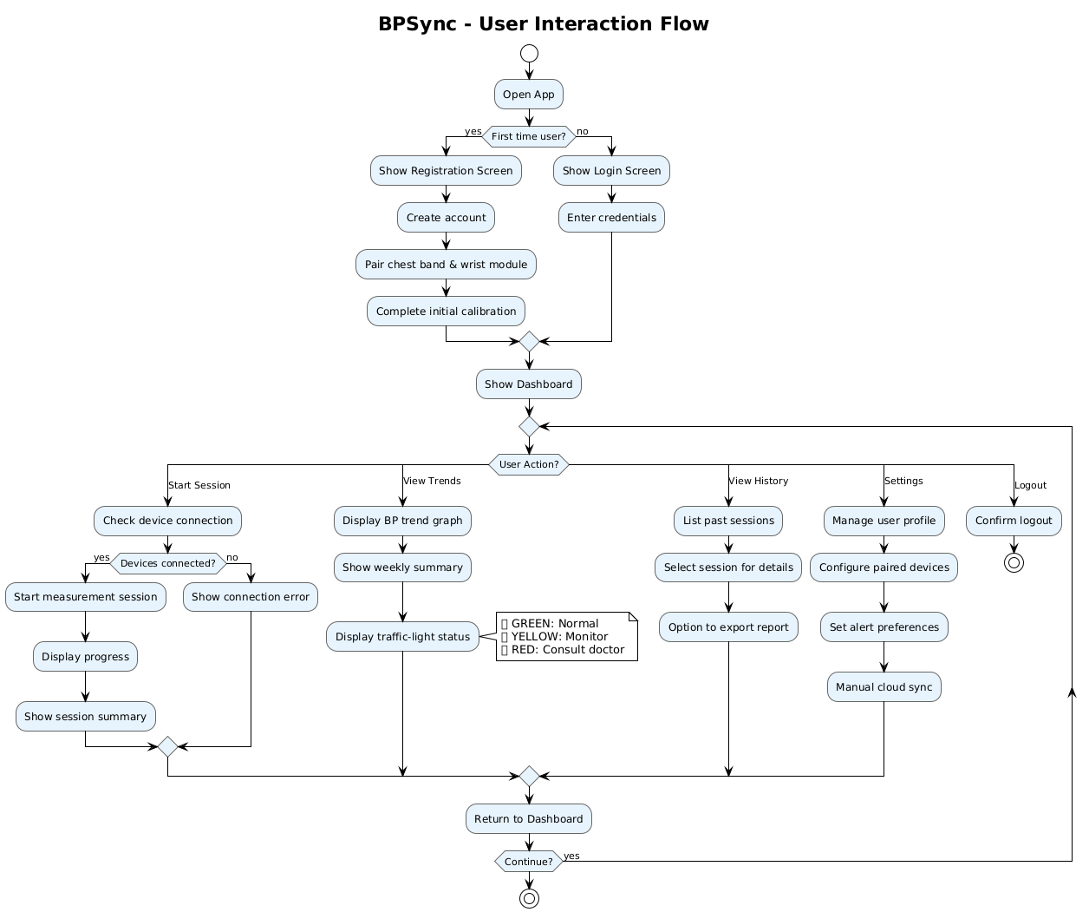
Figure 4.1: User Interaction Flow Diagram

Figure 4.1 presents the main user interaction flow within the mobile application.

4.4 Backend Ingestion & Session Service (API + Storage)

This service receives sessions from mobile, validates them, stores raw data, and triggers processing/inference.

Responsibilities

- Authenticate requests and enforce user/device ownership.
- Validate session schema and packet integrity.
- Store raw session data and metadata.
- Trigger processing pipeline (decode, alignment, features, inference).
- Provide APIs to retrieve sessions, blood pressure results, and trends.

Justification

Centralizing data ingestion and storage in the backend enables scalable session management, secure access control, and reliable long-term data persistence. This architecture supports asynchronous processing and simplifies trend analysis across multiple sessions.

Inputs

- Uploaded session files from mobile app
- Authentication tokens (JWT)
- Device registration data

Outputs

- Stored session records and raw packet blobs
- Processing jobs/events for the pipeline
- API responses: upload status, session summaries, inference outputs

Core Functions

- Session Upload & Validation
  - Checks signature/token, user-device binding, schema correctness.
  - Rejects malformed sessions with clear error codes.
- Storage
  - Saves metadata in relational tables.
  - Stores raw packets as blobs or timeseries tables (implementation choice).
- Job Triggering
  - Enqueues async processing job (recommended).
  - Supports synchronous processing for small sessions (optional).
- Query APIs
  - Provides endpoints for retrieving sessions and predictions.
  - Supports time-range queries for trend analysis.

Design Considerations

- Must scale to large uploads and many sessions.
- Strict validation is critical (health data + ML pipeline stability).
- Separation between ingestion and processing improves reliability.

4.4.1 Cloud Data Model Diagram

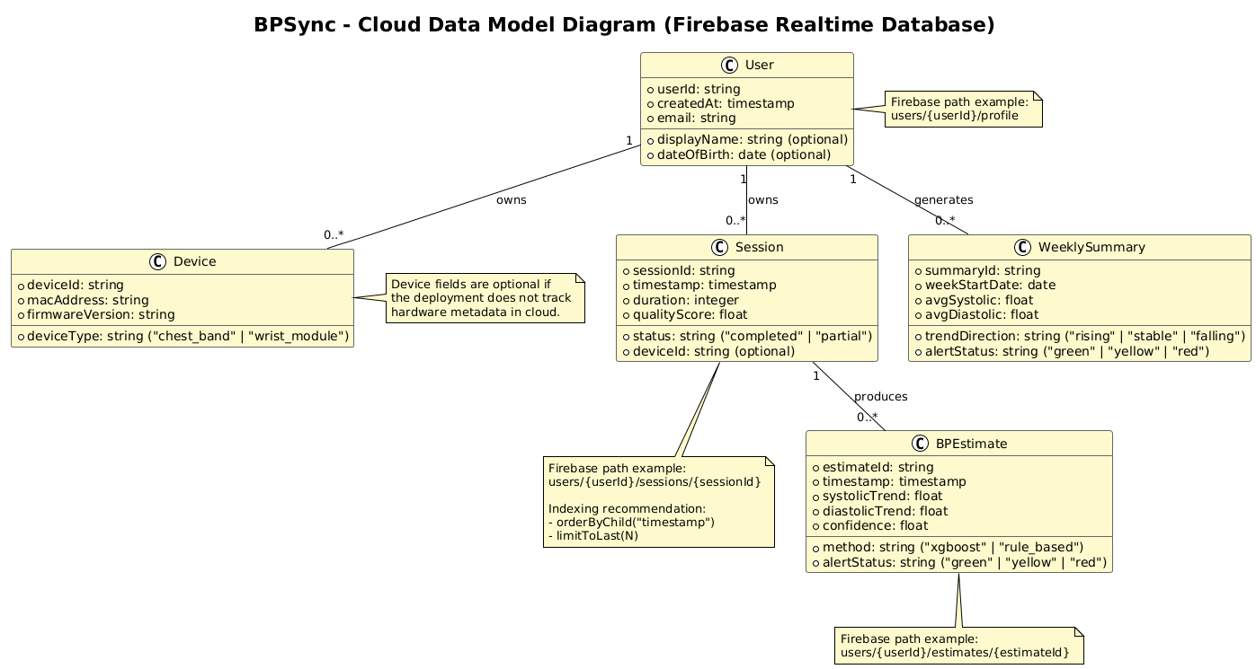
Figure 4.2: Cloud Data Model
The backend data organization and entity relationships are shown in Figure 4.2.

4.5 Signal Processing, Synchronization & Feature Extraction Module

This module reconstructs signals, aligns ECG with PPG, evaluates signal quality, and extracts features for ML.

Responsibilities

- Decode merged packet streams into ECG/PPG/IMU/Temp time series.
- Align ECG and PPG timelines (timestamp normalization).
- Compute signal quality indices (SQI) and select “useful” windows.
- Extract engineered features for XGBoost inference.

Justification

Feature extraction converts raw physiological signals into a structured representation suitable for machine learning inference. This abstraction ensures reproducibility and decouples signal processing logic from the learning model.

Inputs

- Raw packet logs from stored sessions
- Sampling profiles, timestamps, sequence metadata

Outputs

- Cleaned, aligned time series (internal)
- Windowed feature vectors for inference
- Quality reports: motion index, SQI, usable window ratio

Core Functions

- Decoding & Reconstruction
  - Parses merged packet format.
  - Detects missing packets via sequence gaps.
- Time Alignment
  - Synchronizes chest ECG frames with wrist PPG timeline.
  - Applies drift correction or smoothing if required.
- Quality Gate (Useful Segment Detection)
  - Uses chest IMU + wrist IMU motion indices.
  - Uses ECG SQI and PPG SQI thresholds.
  - Labels windows as HIGH_TRUST / LOW_TRUST.
- Feature Extraction
  - ECG: HR, RR intervals, HRV basics, ECG SQI metrics.
  - PPG: pulse features (amplitude, rise time, width), PPG SQI.
  - Fusion: ECG–PPG delay features (PTT-like), HR agreement. (Mukkamala et al., 2015).
  - Context: IMU activity metrics + temperature and temperature slope.

Design Considerations

- Must be robust to missing data and noisy windows.
- Feature schema must be versioned for model compatibility.
- Prefer deterministic, reproducible feature computations.

4.6 Feature Engineering & XGBoost BP Estimation (Backend)

This component converts synchronized ECG + PPG + IMU + Temperature data into a compact feature vector and runs XGBoost regression on the backend to estimate SBP/DBP. Alternative models such as neural networks were considered. However, XGBoost was preferred due to lower computational cost, easier tuning, and better suitability for structured feature-based inference.

Responsibilities

- Build window-based features from ECG/PPG/IMU/Temp.
- Apply basic quality gating (motion + signal quality) to avoid unreliable inference.
- Run XGBoost to estimate SBP (systolic) and DBP (diastolic).
- Return prediction with minimal metadata (quality + model version).

Justification

XGBoost was selected due to its robustness on tabular physiological features, strong performance with limited datasets, and interpretability compared to deep learning alternatives. (Chen & Guestrin, 2016).

Discussion

Feature computation could be partially performed on the mobile device, but backend-based extraction was selected to ensure consistency across sessions and devices.

Inputs

- Aligned sensor windows from a session:
  - ECG (chest), PPG (wrist), IMU (chest+wrist), Temp (wrist)

- Session metadata (sampling rates, timestamps, packet loss info)

Outputs

- Per-window feature vector (tabular row)
- Predicted values:
  - SBP_est, DBP_est
  - quality_flag (OK / LOW_QUALITY)
  - model_version

Core Functions

- Windowing

  - Split session into fixed windows (e.g., 20s) for consistent feature extraction.

- Quality Gate (Deterministic)

  - If motion is high (IMU) or signal quality is poor (basic SQI checks), mark window as LOW_QUALITY.
  - Skip or down-rank low-quality windows.

- Feature Extraction

  - ECG: heart rate / RR-based stability
  - PPG: pulse rate + amplitude/morphology summary
  - ECG–PPG: timing delay feature (PTT/PAT-like)
  - IMU: motion index
  - Temp: mean (and optionally slope)

- XGBoost Inference

  - Run XGBoost regressors to output SBP/DBP.
  - Aggregate window outputs to a single session estimate (e.g., average of OK windows).

Design Considerations

- XGBoost runs only on backend (wearables just stream data).
- Keep features stable and versioned (feature_schema_version) to avoid breaking the model.
- Never show “confident BP” when quality is low; return a clear low-quality flag.

4.7 Trend Analysis & Alerting Module

This module analyzes predicted outputs over time to generate weekly/daily summaries and alerts.

Responsibilities

- Aggregate session-level predictions into daily/weekly statistics.
- Detect trends (upward/downward drift) and instability patterns.
- Generate alerts and user-facing insight messages (non-diagnostic).

Justification

Trend analysis transforms individual session estimates into meaningful long-term indicators. The traffic-light alert mechanism provides users with intuitive, non-diagnostic feedback on potential health risks.

Inputs

- Stored inference results across time
- Quality metrics (usable window ratio, confidence)

Outputs

- Trend summaries (daily/weekly)
- Alerts with severity (Info/Warning/Critical)
- Insight messages for the mobile UI

Core Functions

- Aggregation

  - Mean/min/max/variance by day and week.
  - Handles missing days and uneven sampling.

- Trend Detection

  - Moving average + slope estimation.
  - Change-point detection (optional).
  - Considers quality weights (ignores low-trust results).

- Alert Generation

  - Triggers based on sustained abnormal patterns.
  - Produces recommended action wording (e.g., “Consider consulting a clinician…”).

Design Considerations

- Must avoid false alarms by using quality-weighted logic.
- Alerts must be phrased as guidance, not diagnosis.
- Trend computations should be transparent and explainable.

5. References

- R. Mukkamala et al., “Toward ubiquitous blood pressure monitoring via pulse transit time: Theory and practice,” IEEE Transactions on Biomedical Engineering, vol. 62, no. 8, pp. 1879–1901, Aug. 2015.
- P. Yousefian et al., “Pulse transit time–pulse wave analysis fusion based on wearable wrist BCG for cuff-less blood pressure trend tracking,” IEEE Access, vol. 8, pp. 138077–138087, 2020.
- T. Chen and C. Guestrin, “XGBoost: A scalable tree boosting system,” in Proceedings of the 22nd ACM SIGKDD International Conference on Knowledge Discovery and Data Mining (KDD), San Francisco, CA, USA, 2016, pp. 785–794.
- C. Bentéjac, A. Csörgő, and G. Martínez-Muñoz, “A comparative analysis of XGBoost,” Pattern Recognition, vol. 82, pp. 1–11, Oct. 2018.
- C. Irer, K. Aldemir, Z. D. Kartal, and M. G. Erdoğan, “BPSync: Continuous blood pressure tracking via wearable sensor fusion and AI – Requirements specification document,” Senior Design Project, Yaşar University, İzmir, Türkiye, Rev. 1.0, Nov. 2025..

