Final-Part A

四機三甲 3A511021 朱庭宏

The forward kinematic equations of the robot are as follows:



The inverse kinematic equations of the robot are as follows:







1.

A=[101 21 220]; B=[21 -61 150]; C=[150,30,200];

X=[A;B];

R1=[];

n=size(X,1);

for i=1:n-1

y=linspace3d(X(i,:),X(i+1,:),21);

if (i~=1)

y=y(2:end,:);

end

R1=[R1;y];

end

R1=[R1 zeros(size(R1,1),3)];

x=R1(:,1); y=R1(:,2); z=R1(:,3);

[theta1,theta2,theta3]=inv3arm(x,y,z);

R1(:,4)=theta1; R1(:,5)=theta2(:,1); R1(:,6)=theta3;

%fprintf('R=\n');

%disp(R1);

plot3(x,y,z);

hold on;

Y=[B;C];

R2=[];

n=size(Y,1);

for i=1:n-1

y=linspace3d(Y(i,:),Y(i+1,:),21);

if (i~=1)

y=y(2:end,:);

end

R2=[R2;y];

end

R2=[R2 zeros(size(R2,1),3)];

x=R2(:,1); y=R2(:,2); z=R2(:,3);

[theta1,theta2,theta3]=inv3arm(x,y,z);

R2(:,4)=theta1; R2(:,5)=theta2(:,21); R2(:,6)=theta3;

%fprintf('R2=\n');

%disp(R2);

plot3(x,y,z);

R=[];

R=[R1;R2];

fprintf('R=\n');

disp(R);

xlswrite('testdata.xlsx',R);

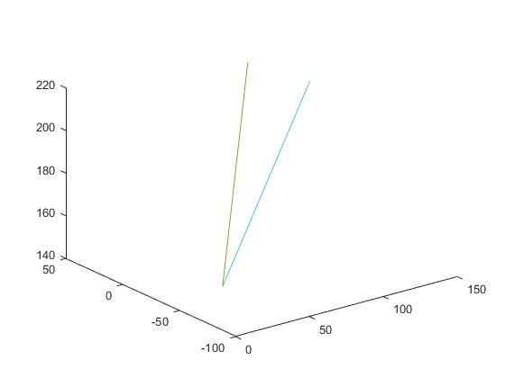

R=

101.0000 21.0000 220.0000 11.7456 -85.1596 67.5021

97.0000 16.9000 216.5000 9.8833 -88.2314 74.2015

93.0000 12.8000 213.0000 7.8366 -90.7673 80.3595

89.0000 8.7000 209.5000 5.5831 -92.8895 86.0848

85.0000 4.6000 206.0000 3.0977 -94.6777 91.4498

81.0000 0.5000 202.5000 0.3537 -96.1868 96.5043

77.0000 -3.6000 199.0000 -2.6768 -97.4566 101.2827

73.0000 -7.7000 195.5000 -6.0213 -98.5180 105.8081

69.0000 -11.8000 192.0000 -9.7045 -99.3963 110.0951

65.0000 -15.9000 188.5000 -13.7455 -100.1145 114.1507

61.0000 -20.0000 185.0000 -18.1527 -100.6952 117.9754

57.0000 -24.1000 181.5000 -22.9190 -101.1622 121.5634

53.0000 -28.2000 178.0000 -28.0163 -101.5427 124.9028

49.0000 -32.3000 174.5000 -33.3922 -101.8681 127.9757

45.0000 -36.4000 171.0000 -38.9690 -102.1753 130.7578

41.0000 -40.5000 167.5000 -44.6485 -102.5069 133.2195

37.0000 -44.6000 164.0000 -50.3210 -102.9102 135.3263

33.0000 -48.7000 160.5000 -55.8777 -103.4354 137.0413

29.0000 -52.8000 157.0000 -61.2225 -104.1314 138.3280

25.0000 -56.9000 153.5000 -66.2809 -105.0409 139.1545

21.0000 -61.0000 150.0000 -71.0033 -106.1947 139.4982

21.0000 -61.0000 150.0000 -71.0033 -98.0927 139.4982

27.4500 -56.4500 152.5000 -64.0677 -97.3577 139.3101

33.9000 -51.9000 155.0000 -56.8483 -96.9355 138.3817

40.3500 -47.3500 157.5000 -49.5635 -96.7903 136.7521

46.8000 -42.8000 160.0000 -42.4438 -96.8663 134.4815

53.2500 -38.2500 162.5000 -35.6901 -97.0971 131.6390

59.7000 -33.7000 165.0000 -29.4443 -97.4150 128.2917

66.1500 -29.1500 167.5000 -23.7814 -97.7563 124.4974

72.6000 -24.6000 170.0000 -18.7186 -98.0643 120.3011

79.0500 -20.0500 172.5000 -14.2322 -98.2891 115.7340

85.5000 -15.5000 175.0000 -10.2754 -98.3865 110.8129

91.9500 -10.9500 177.5000 -6.7912 -98.3156 105.5401

98.4000 -6.4000 180.0000 -3.7213 -98.0350 99.9031

104.8500 -1.8500 182.5000 -1.0108 -97.4988 93.8719

111.3000 2.7000 185.0000 1.3897 -96.6503 87.3945

117.7500 7.2500 187.5000 3.5233 -95.4123 80.3883

124.2000 11.8000 190.0000 5.4273 -93.6697 72.7220

130.6500 16.3500 192.5000 7.1331 -91.2355 64.1783

137.1000 20.9000 195.0000 8.6676 -87.7700 54.3619

143.5500 25.4500 197.5000 10.0535 -82.5428 42.4148

150.0000 30.0000 200.0000 11.3099 -73.2598 25.5213

2.

A=[101 21 220]; B=[21 -61 150];

[theta1i,theta2i,theta3i]=inv3arm(A(1),A(2),A(3));

thetai=[theta1i,theta2i,theta3i];

[theta1f,theta2f,theta3f]=inv3arm(B(1),B(2),B(3));

thetaf=[theta1f,theta2f,theta3f];

ti=0; tf=2; tb=0.5;

w=(thetaf-thetai)/(tf-tb);

t=ti:0.1:tf;

for i=1:length(t)

if (t(i)>=0 & t(i)<=tb)

thetaA(i,:)=thetai+0.5\*w/tb\*t(i)^2;

velA(i,:)=w\*t(i)/tb;

accA(i,:)=w/tb;

elseif (t(i)>tb & t(i)<=tf-tb)

thetaA(i,:)=thetai+0.5\*w\*tb+w\*(t(i)-tb);

velA(i,:)=w;

accA(i,:)=0;

else

thetaA(i,:)=thetaf-0.5\*w\*(tf-t(i))^2;

velA(i,:)=w/tb\*(tf-t(i));

accA(i,:)=-w/tb;

end

end

Px=[]; Py=[]; Pz=[];

for i=1:size(thetaA,1)

[x,y,z]=for3arm(thetaA(i,1),thetaA(i,2),thetaA(i,3));

Px=[Px; x]; Py=[Py; y]; Pz=[Pz; z];

end

subplot(3,3,1),plot(t,thetaA); title('theta A-B'); legend('theta1','theta2','theta3');

subplot(3,3,4),plot(t,velA); title('velocity A-B'); legend('theta1','theta2','theta3');

subplot(3,3,7),plot(t,accA); title('acceleration A-B'); legend('theta1','theta2','theta3');

subplot(3,3,3),plot3(Px,Py,Pz); title('A-B');

B=[21 -61 150]; C=[150 30 200];

[theta1i,theta2i,theta3i]=inv3arm(B(1),B(2),B(3));

thetai=[theta1i,theta2i,theta3i];

[theta1f,theta2f,theta3f]=inv3arm(C(1),C(2),C(3));

thetaf=[theta1f,theta2f,theta3f];

ti=0; tf=2; tb=0.5;

w=(thetaf-thetai)/(tf-tb);

t=ti:0.1:tf;

for i=1:length(t)

if (t(i)>=0 & t(i)<=tb)

thetaB(i,:)=thetai+0.5\*w/tb\*t(i)^2;

velB(i,:)=w\*t(i)/tb;

accB(i,:)=w/tb;

elseif (t(i)>tb & t(i)<=tf-tb)

thetaB(i,:)=thetai+0.5\*w\*tb+w\*(t(i)-tb);

velB(i,:)=w;

accB(i,:)=0;

else

thetaB(i,:)=thetaf-0.5\*w\*(tf-t(i))^2;

velB(i,:)=w/tb\*(tf-t(i));

accB(i,:)=-w/tb;

end

end

Px=[]; Py=[]; Pz=[];

for i=1:size(thetaB,1)

[x,y,z]=for3arm(thetaB(i,1),thetaB(i,2),thetaB(i,3));

Px=[Px; x]; Py=[Py; y]; Pz=[Pz; z];

end

subplot(3,3,2),plot(t,thetaB); title('theta B-C'); legend('theta1','theta2','theta3');

subplot(3,3,5),plot(t,velB); title('velocity B-C'); legend('theta1','theta2','theta3');

subplot(3,3,8),plot(t,accB); title('acceleration B-C'); legend('theta1','theta2','theta3');

subplot(3,3,6),plot3(Px,Py,Pz); title('B-C');

fprintf('thetaA=\n');

disp(thetaA);

fprintf('thetaB=\n');

disp(thetaB);

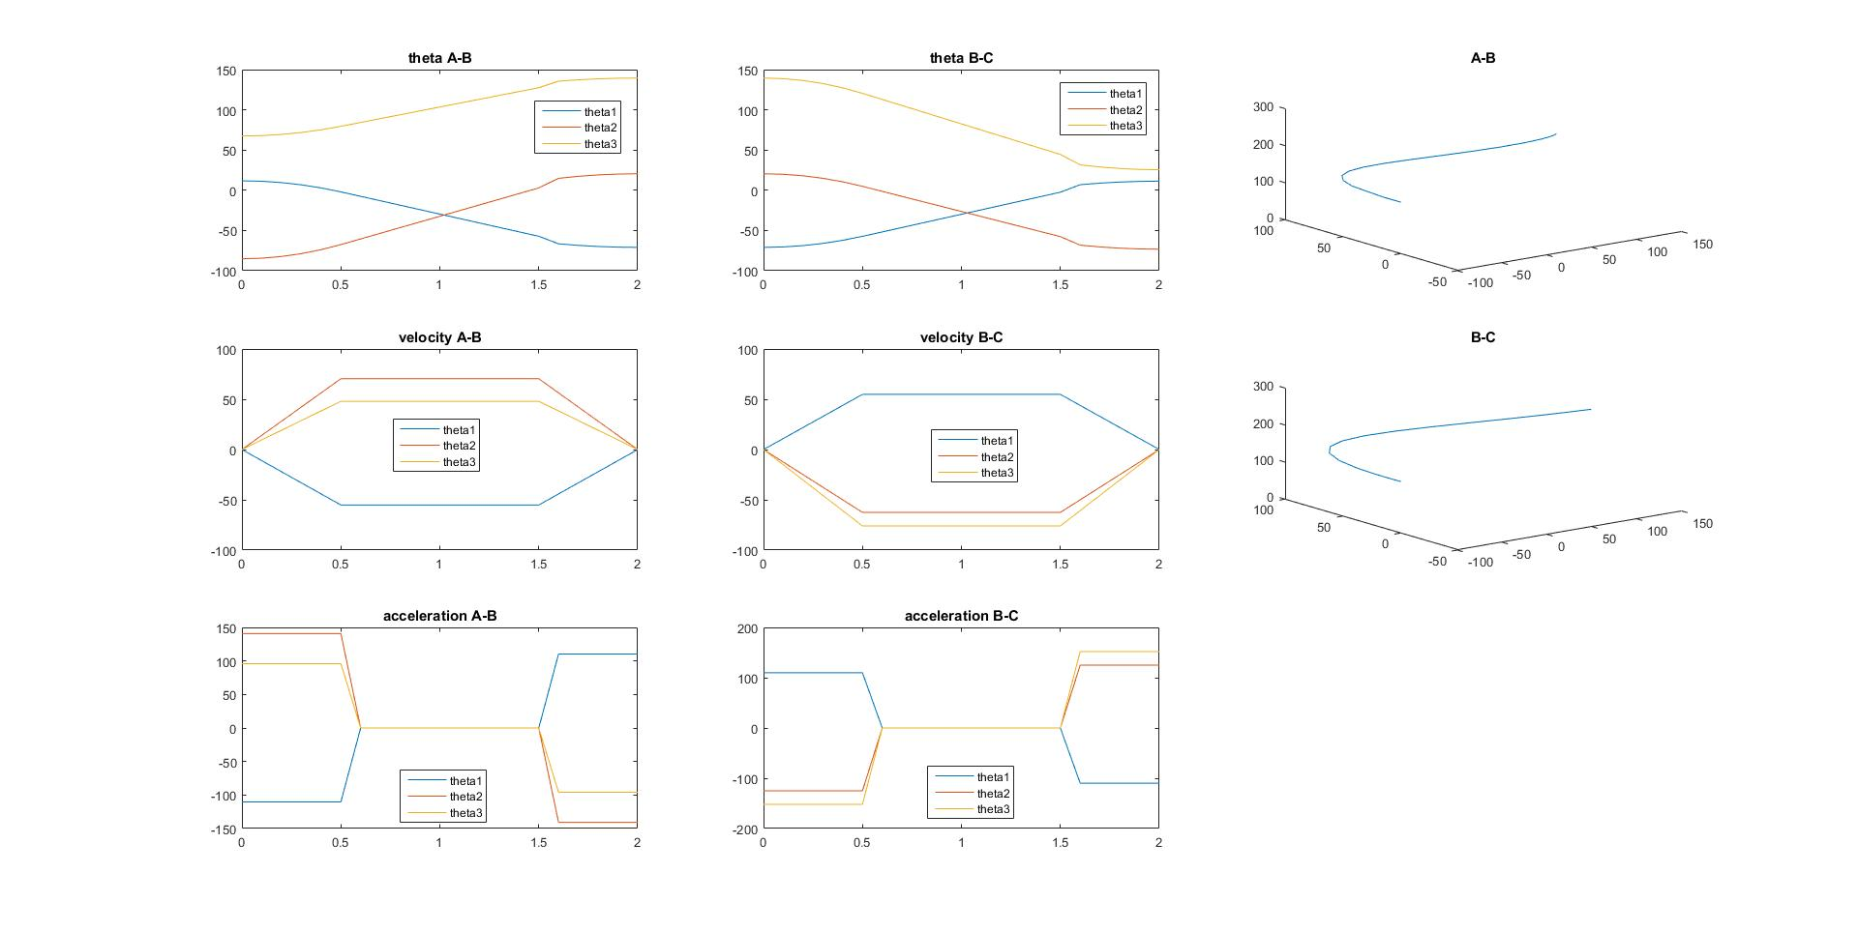



thetaA=

11.7456 -85.1596 67.5021

11.1940 -84.4552 67.9821

9.5390 -82.3421 69.4220

6.7807 -78.8202 71.8219

2.9191 -73.8897 75.1817

-2.0459 -67.5503 79.5015

-7.5625 -60.5066 84.3012

-13.0791 -53.4630 89.1009

-18.5957 -46.4193 93.9007

-24.1123 -39.3756 98.7004

-29.6289 -32.3319 103.5002

-35.1455 -25.2882 108.2999

-40.6621 -18.2445 113.0996

-46.1787 -11.2008 117.8994

-51.6953 -4.1572 122.6991

-57.2118 2.8865 127.4989

-66.5901 14.8608 135.6584

-68.5209 17.3261 137.3383

-69.9000 19.0870 138.5383

-70.7275 20.1436 139.2582

-71.0033 20.4957 139.4982

thetaB=

-71.0033 20.4957 139.4982

-70.4546 19.8707 138.7384

-68.8083 17.9956 136.4588

-66.0645 14.8704 132.6596

-62.2233 10.4952 127.3407

-57.2845 4.8698 120.5020

-51.7969 -1.3805 112.9036

-46.3094 -7.6309 105.3051

-40.8218 -13.8813 97.7067

-35.3343 -20.1317 90.1082

-29.8467 -26.3820 82.5097

-24.3592 -32.6324 74.9113

-18.8716 -38.8828 67.3128

-13.3841 -45.1331 59.7144

-7.8965 -51.3835 52.1159

-2.4089 -57.6339 44.5174

6.9199 -68.2595 31.6000

8.8405 -70.4471 28.9406

10.2124 -72.0097 27.0410

11.0356 -72.9473 25.9012

11.3099 -73.2598 25.5213

>> disp(velA)

0 0 0

-11.0332 14.0874 9.5995

-22.0664 28.1747 19.1990

-33.0996 42.2621 28.7984

-44.1328 56.3495 38.3979

-55.1660 70.4369 47.9974

-55.1660 70.4369 47.9974

-55.1660 70.4369 47.9974

-55.1660 70.4369 47.9974

-55.1660 70.4369 47.9974

-55.1660 70.4369 47.9974

-55.1660 70.4369 47.9974

-55.1660 70.4369 47.9974

-55.1660 70.4369 47.9974

-55.1660 70.4369 47.9974

-55.1660 70.4369 47.9974

-44.1328 56.3495 38.3979

-33.0996 42.2621 28.7984

-22.0664 28.1747 19.1990

-11.0332 14.0874 9.5995

0 0 0

>> disp(velB)

0 0 0

10.9751 -12.5007 -15.1969

21.9502 -25.0015 -30.3938

32.9253 -37.5022 -45.5908

43.9004 -50.0030 -60.7877

54.8755 -62.5037 -75.9846

54.8755 -62.5037 -75.9846

54.8755 -62.5037 -75.9846

54.8755 -62.5037 -75.9846

54.8755 -62.5037 -75.9846

54.8755 -62.5037 -75.9846

54.8755 -62.5037 -75.9846

54.8755 -62.5037 -75.9846

54.8755 -62.5037 -75.9846

54.8755 -62.5037 -75.9846

54.8755 -62.5037 -75.9846

43.9004 -50.0030 -60.7877

32.9253 -37.5022 -45.5908

21.9502 -25.0015 -30.3938

10.9751 -12.5007 -15.1969

0 0 0

>> disp(accA)

-110.3320 140.8737 95.9948

-110.3320 140.8737 95.9948

-110.3320 140.8737 95.9948

-110.3320 140.8737 95.9948

-110.3320 140.8737 95.9948

-110.3320 140.8737 95.9948

0 0 0

0 0 0

0 0 0

0 0 0

0 0 0

0 0 0

0 0 0

0 0 0

0 0 0

0 0 0

110.3320 -140.8737 -95.9948

110.3320 -140.8737 -95.9948

110.3320 -140.8737 -95.9948

110.3320 -140.8737 -95.9948

110.3320 -140.8737 -95.9948

>> disp(accB)

109.7510 -125.0074 -151.9692

109.7510 -125.0074 -151.9692

109.7510 -125.0074 -151.9692

109.7510 -125.0074 -151.9692

109.7510 -125.0074 -151.9692

109.7510 -125.0074 -151.9692

0 0 0

0 0 0

0 0 0

0 0 0

0 0 0

0 0 0

0 0 0

0 0 0

0 0 0

0 0 0

-109.7510 125.0074 151.9692

-109.7510 125.0074 151.9692

-109.7510 125.0074 151.9692

-109.7510 125.0074 151.9692

-109.7510 125.0074 151.9692