Final-Part B

四機三甲 3A511021 朱庭宏

DH Table:

|  |  |  |  |  |
| --- | --- | --- | --- | --- |
| i |  | d | a |  |
| 1 |  | d1=10 | 0 | 90 |
| 2 |  | 0 | a2=6.7 | 0 |
| 3 |  | 0 | a3=12 | 0 |

Hardware:

AX-12 motor

* Weight : 53.5g (AX-12/AX-12+), 54.6g (AX-12A)
* Dimension : 32mm * 50mm * 40mm
* Resolution : 0.29°
* Gear Reduction Ratio :  254 : 1
* Stall Torque : 1.5N.m (at 12.0V, 1.5A)
* No load speed : 59rpm (at 12V)
* Running Degree

§       0° ~ 300°

§       Endless Turn

* Running Temperature : -5℃ ~ +70℃
* Voltage : 9  ~ 12V (Recommended Voltage 11.1V)
* Command Signal : Digital Packet
* Protocol Type : Half duplex Asynchronous Serial Communication (8bit,1stop,No Parity)
* Link (Physical) : TTL Level Multi Drop (daisy chain type Connector)
* ID : 254 ID (0~253)
* Communication Speed : 7343bps ~ 1 Mbps
* Feedback : Position, Temperature, Load, Input Voltage, etc.
* Material : Engineering Plastic

Parameters:

|  |  |  |  |  |  |
| --- | --- | --- | --- | --- | --- |
| **Area** | **Address (Hexadecimal)** | **Name** | **Description** | **Access** | **Initial Value**  **(Hexadecimal)** |
| E  E  P  R  O  M | 0 (0X00) | [Model Number(L)](http://support.robotis.com/en/product/actuator/dynamixel/ax_series/dxl_ax_actuator.htm#Actuator_Address_00) | Lowest byte of model number | R | 12 (0X0C) |
| 1 (0X01) | [Model Number(H)](http://support.robotis.com/en/product/actuator/dynamixel/ax_series/dxl_ax_actuator.htm#Actuator_Address_00) | Highest byte of model number | R | 0 (0X00) |
| 2 (0X02) | [Version of Firmware](http://support.robotis.com/en/product/actuator/dynamixel/ax_series/dxl_ax_actuator.htm#Actuator_Address_02) | Information on the version of firmware | R | - |
| 3 (0X03) | [ID](http://support.robotis.com/en/product/actuator/dynamixel/ax_series/dxl_ax_actuator.htm#Actuator_Address_03) | ID of Dynamixel | RW | 1 (0X01) |
| 4 (0X04) | [Baud Rate](http://support.robotis.com/en/product/actuator/dynamixel/ax_series/dxl_ax_actuator.htm#Actuator_Address_04) | Baud Rate of Dynamixel | RW | 1 (0X01) |
| 5 (0X05) | [Return Delay Time](http://support.robotis.com/en/product/actuator/dynamixel/ax_series/dxl_ax_actuator.htm#Actuator_Address_05) | Return Delay Time | RW | 250 (0XFA) |
| 6 (0X06) | [CW Angle Limit(L)](http://support.robotis.com/en/product/actuator/dynamixel/ax_series/dxl_ax_actuator.htm#Actuator_Address_06) | Lowest byte of clockwise Angle Limit | RW | 0 (0X00) |
| 7 (0X07) | [CW Angle Limit(H)](http://support.robotis.com/en/product/actuator/dynamixel/ax_series/dxl_ax_actuator.htm#Actuator_Address_06) | Highest byte of clockwise Angle Limit | RW | 0 (0X00) |
| 8 (0X08) | [CCW Angle Limit(L)](http://support.robotis.com/en/product/actuator/dynamixel/ax_series/dxl_ax_actuator.htm#Actuator_Address_06) | Lowest byte of counterclockwise Angle Limit | RW | 255 (0XFF) |
| 9 (0X09) | [CCW Angle Limit(H)](http://support.robotis.com/en/product/actuator/dynamixel/ax_series/dxl_ax_actuator.htm#Actuator_Address_06) | Highest byte of counterclockwise Angle Limit | RW | 3 (0X03) |
| 11 (0X0B) | [the Highest Limit Temperature](http://support.robotis.com/en/product/actuator/dynamixel/ax_series/dxl_ax_actuator.htm#Actuator_Address_0B) | Internal Limit Temperature | RW | 70 (0X46) |
| 12 (0X0C) | [the Lowest Limit Voltage](http://support.robotis.com/en/product/actuator/dynamixel/ax_series/dxl_ax_actuator.htm#Actuator_Address_0C) | Lowest Limit Voltage | RW | 60 (0X3C) |
| 13 (0X0D) | [the Highest Limit Voltage](http://support.robotis.com/en/product/actuator/dynamixel/ax_series/dxl_ax_actuator.htm#Actuator_Address_0C) | Highest Limit Voltage | RW | 140 (0XBE) |
| 14 (0X0E) | [Max Torque(L)](http://support.robotis.com/en/product/actuator/dynamixel/ax_series/dxl_ax_actuator.htm#Actuator_Address_0E) | Lowest byte of Max. Torque | RW | 255 (0XFF) |
| 15 (0X0F) | [Max Torque(H)](http://support.robotis.com/en/product/actuator/dynamixel/ax_series/dxl_ax_actuator.htm#Actuator_Address_0E) | Highest byte of Max. Torque | RW | 3 (0X03) |
| 16 (0X10) | [Status Return Level](http://support.robotis.com/en/product/actuator/dynamixel/ax_series/dxl_ax_actuator.htm#Actuator_Address_10) | Status Return Level | RW | 2 (0X02) |
| 17 (0X11) | [Alarm LED](http://support.robotis.com/en/product/actuator/dynamixel/ax_series/dxl_ax_actuator.htm#Actuator_Address_11) | LED for Alarm | RW | 36(0x24) |
| 18 (0X12) | [Alarm Shutdown](http://support.robotis.com/en/product/actuator/dynamixel/ax_series/dxl_ax_actuator.htm#Actuator_Address_12) | Shutdown for Alarm | RW | 36(0x24) |
| R  A  M | 24 (0X18) | [Torque Enable](http://support.robotis.com/en/product/actuator/dynamixel/ax_series/dxl_ax_actuator.htm#Actuator_Address_18) | Torque On/Off | RW | 0 (0X00) |
| 25 (0X19) | [LED](http://support.robotis.com/en/product/actuator/dynamixel/ax_series/dxl_ax_actuator.htm#Actuator_Address_19) | LED On/Off | RW | 0 (0X00) |
| 26 (0X1A) | [CW Compliance Margin](http://support.robotis.com/en/product/actuator/dynamixel/ax_series/dxl_ax_actuator.htm#Actuator_Address_1A) | CW Compliance margin | RW | 1 (0X01) |
| 27 (0X1B) | [CCW Compliance Margin](http://support.robotis.com/en/product/actuator/dynamixel/ax_series/dxl_ax_actuator.htm#Actuator_Address_1A) | CCW Compliance margin | RW | 1 (0X01) |
| 28 (0X1C) | [CW Compliance Slope](http://support.robotis.com/en/product/actuator/dynamixel/ax_series/dxl_ax_actuator.htm#Actuator_Address_1A) | CW Compliance slope | RW | 32 (0X20) |
| 29 (0X1D) | [CCW Compliance Slope](http://support.robotis.com/en/product/actuator/dynamixel/ax_series/dxl_ax_actuator.htm#Actuator_Address_1A) | CCW Compliance slope | RW | 32 (0X20) |
| 30 (0X1E) | [Goal Position(L)](http://support.robotis.com/en/product/actuator/dynamixel/ax_series/dxl_ax_actuator.htm#Actuator_Address_1E) | Lowest byte of Goal Position | RW | - |
| 31 (0X1F) | [Goal Position(H)](http://support.robotis.com/en/product/actuator/dynamixel/ax_series/dxl_ax_actuator.htm#Actuator_Address_1E) | Highest byte of Goal Position | RW | - |
| 32 (0X20) | [Moving Speed(L)](http://support.robotis.com/en/product/actuator/dynamixel/ax_series/dxl_ax_actuator.htm#Actuator_Address_20) | Lowest byte of Moving Speed (Moving Velocity) | RW | - |
| 33 (0X21) | [Moving Speed(H)](http://support.robotis.com/en/product/actuator/dynamixel/ax_series/dxl_ax_actuator.htm#Actuator_Address_20) | Highest byte of Moving Speed (Moving Velocity) | RW | - |
| 34 (0X22) | [Torque Limit(L)](http://support.robotis.com/en/product/actuator/dynamixel/ax_series/dxl_ax_actuator.htm#Actuator_Address_22) | Lowest byte of Torque Limit (Goal Torque) | RW | ADD14 |
| 35 (0X23) | [Torque Limit(H)](http://support.robotis.com/en/product/actuator/dynamixel/ax_series/dxl_ax_actuator.htm#Actuator_Address_22) | Highest byte of Torque Limit (Goal Torque) | RW | ADD15 |
| 36 (0X24) | [Present Position(L)](http://support.robotis.com/en/product/actuator/dynamixel/ax_series/dxl_ax_actuator.htm#Actuator_Address_24) | Lowest byte of Current Position (Present Velocity) | R | - |
| 37 (0X25) | [Present Position(H)](http://support.robotis.com/en/product/actuator/dynamixel/ax_series/dxl_ax_actuator.htm#Actuator_Address_24) | Highest byte of Current Position (Present Velocity) | R | - |
| 38 (0X26) | [Present Speed(L)](http://support.robotis.com/en/product/actuator/dynamixel/ax_series/dxl_ax_actuator.htm#Actuator_Address_26) | Lowest byte of Current Speed | R | - |
| 39 (0X27) | [Present Speed(H)](http://support.robotis.com/en/product/actuator/dynamixel/ax_series/dxl_ax_actuator.htm#Actuator_Address_28) | Highest byte of Current Speed | R | - |
| 40 (0X28) | [Present Load(L)](http://support.robotis.com/en/product/actuator/dynamixel/ax_series/dxl_ax_actuator.htm#Actuator_Address_28) | Lowest byte of Current Load | R | - |
| 41 (0X29) | [Present Load(H)](http://support.robotis.com/en/product/actuator/dynamixel/ax_series/dxl_ax_actuator.htm#Actuator_Address_28) | Highest byte of Current Load | R | - |
| 42 (0X2A) | [Present Voltage](http://support.robotis.com/en/product/actuator/dynamixel/ax_series/dxl_ax_actuator.htm#Actuator_Address_2A) | Current Voltage | R | - |
| 43 (0X2B) | [Present Temperature](http://support.robotis.com/en/product/actuator/dynamixel/ax_series/dxl_ax_actuator.htm#Actuator_Address_2B) | Current Temperature | R | - |
| 44 (0X2C) | [Registered](http://support.robotis.com/en/product/actuator/dynamixel/ax_series/dxl_ax_actuator.htm#Actuator_Address_2C) | Means if Instruction is registered | R | 0 (0X00) |
| 46 (0X2E) | [Moving](http://support.robotis.com/en/product/actuator/dynamixel/ax_series/dxl_ax_actuator.htm#Actuator_Address_2E) | Means if there is any movement | R | 0 (0X00) |
| 47 (0X2F) | [Lock](http://support.robotis.com/en/product/actuator/dynamixel/ax_series/dxl_ax_actuator.htm#Actuator_Address_2F) | Locking EEPROM | RW | 0 (0X00) |
| 48 (0X30) | [Punch(L)](http://support.robotis.com/en/product/actuator/dynamixel/ax_series/dxl_ax_actuator.htm#Actuator_Address_30) | Lowest byte of Punch | RW | 32 (0X20) |
| 49 (0X31) | [Punch(H)](http://support.robotis.com/en/product/actuator/dynamixel/ax_series/dxl_ax_actuator.htm#Actuator_Address_30) | Highest byte of Punch | RW | 0 (0X00) |

DOF:3

Motor Parameters Setup:

* ID:1 to 4
* Baud Rate: 1000000 bps
* GoalPosition(L):512(150) [for center position]

U2D2 Spec:

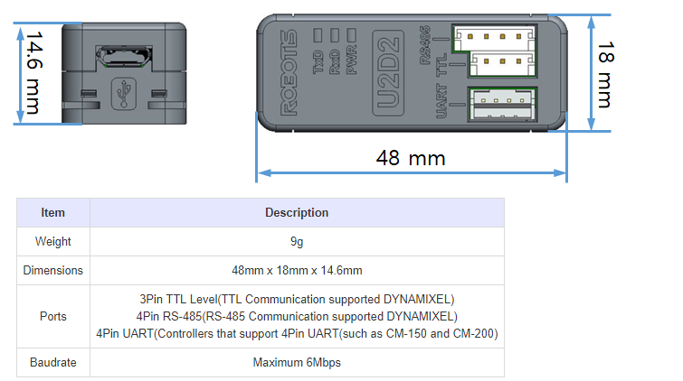

U2D2 Layout:

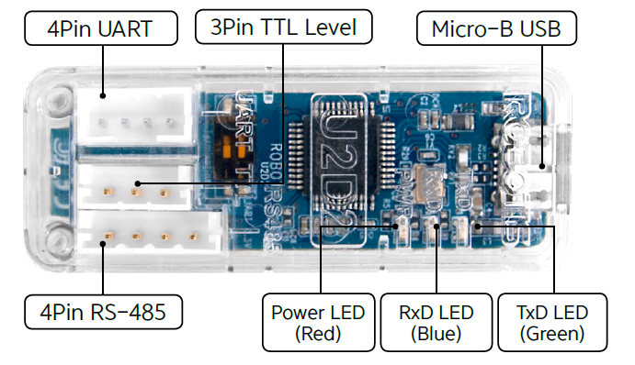

Connect to PC via U2D2:

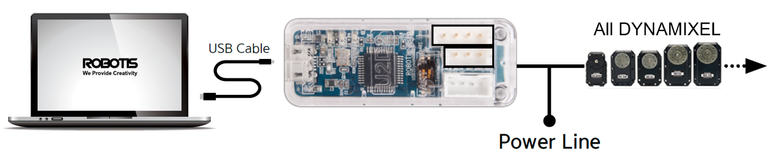

Connection:

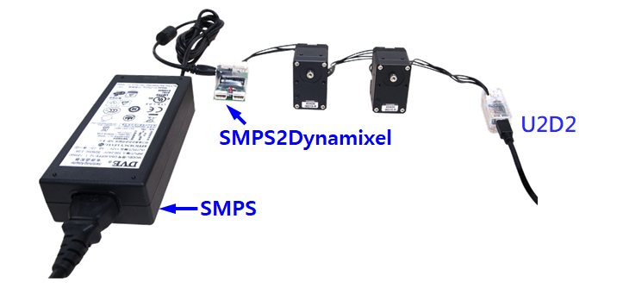

Software:

Roboplus>>Dynamixal Wizard

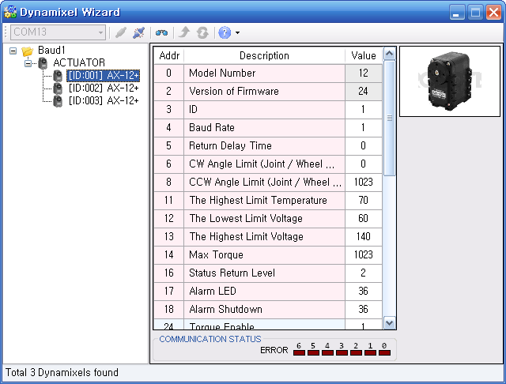

LabVIEW

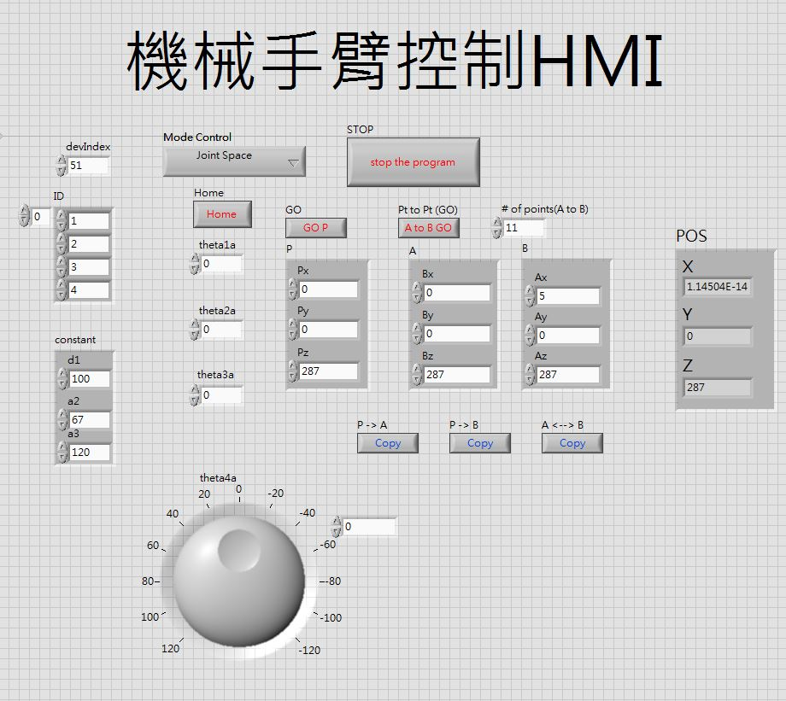

程式

Joint Space

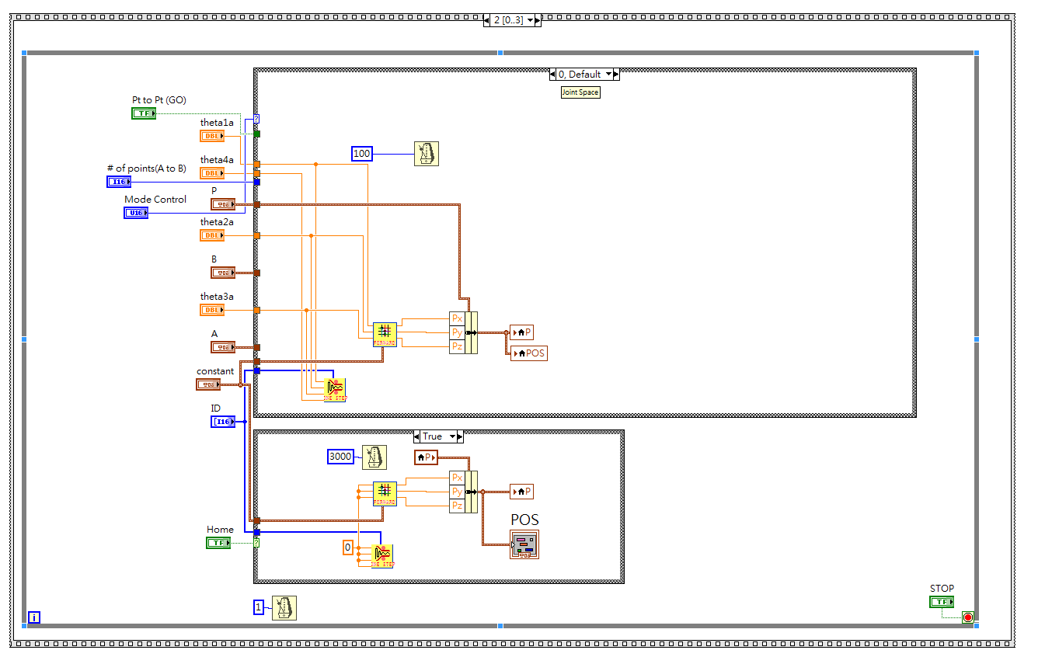

Cartesian Space

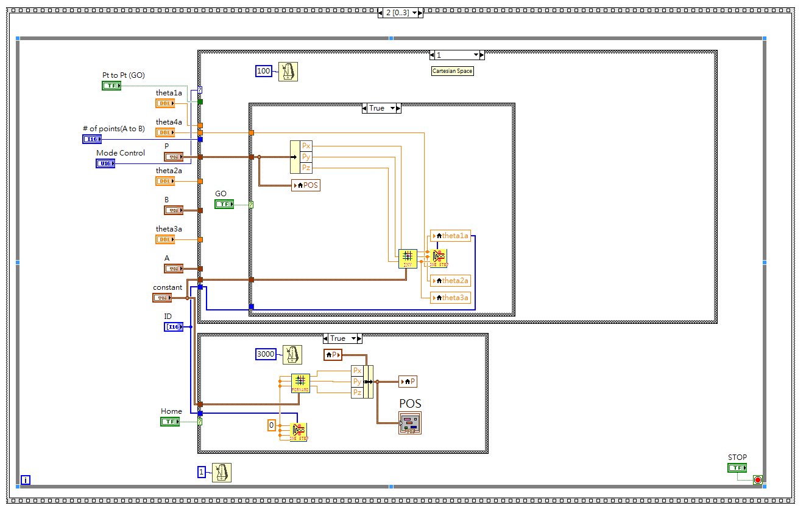

P2P(joint)

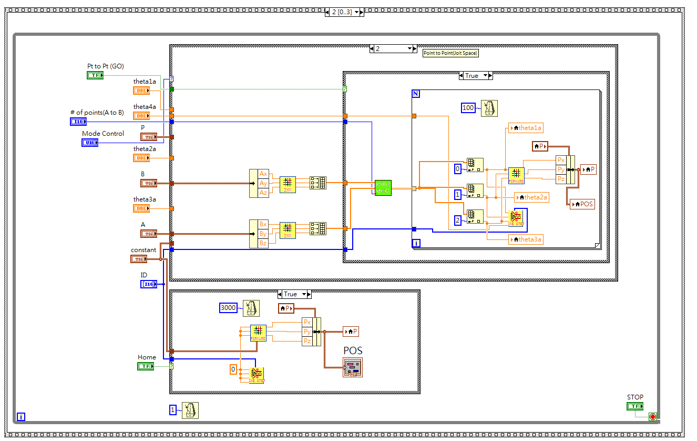

P2P(Cartesian)

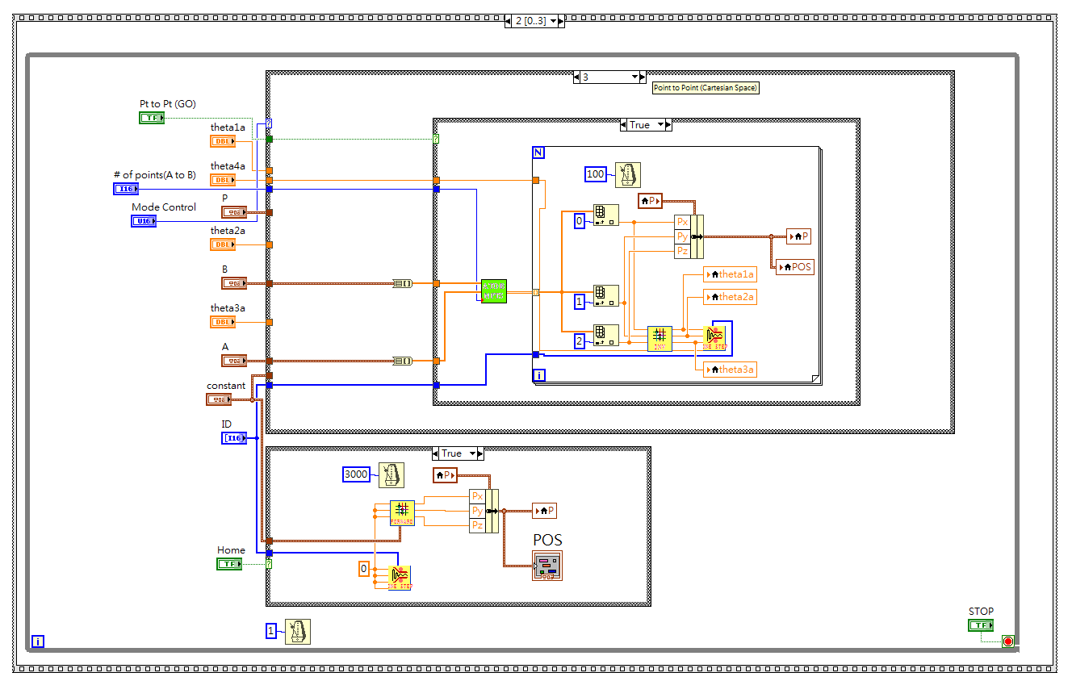

Duplicate

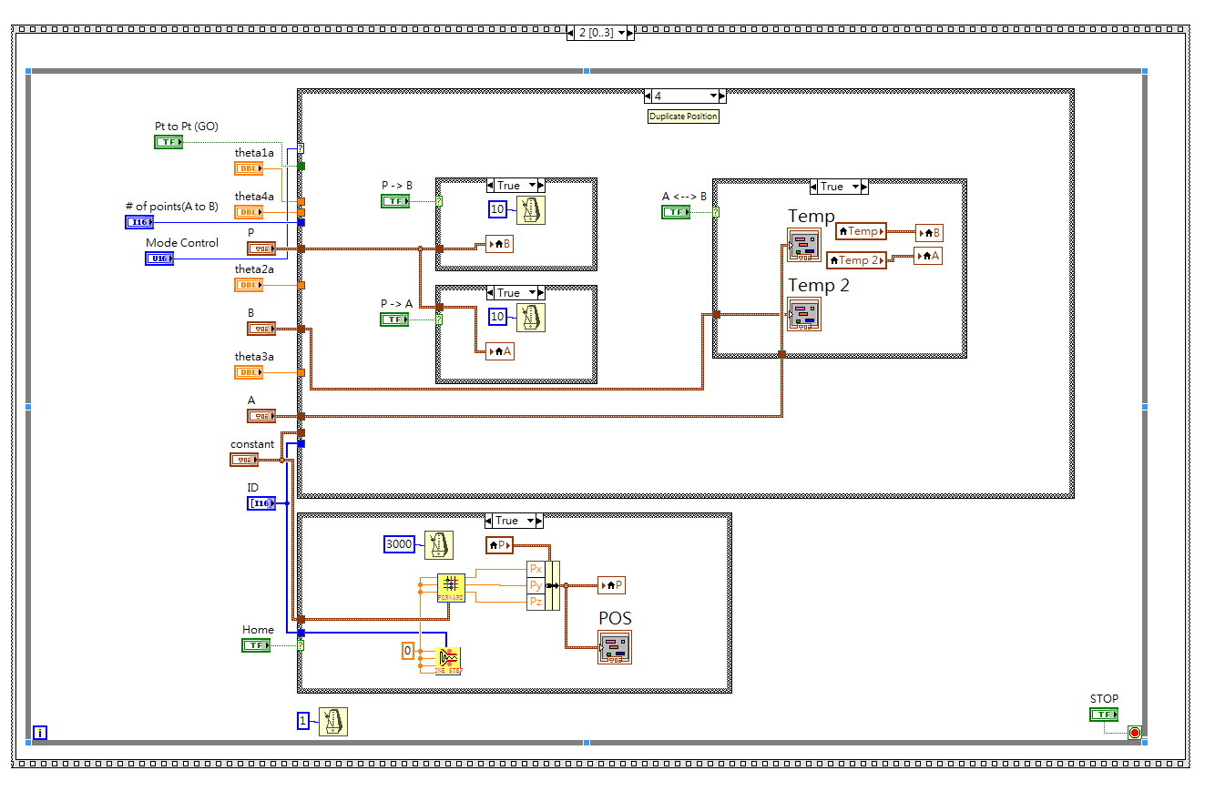

正向運動學

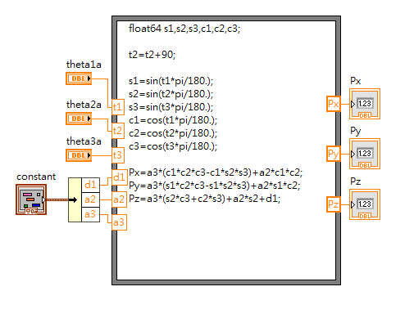

逆向運動學

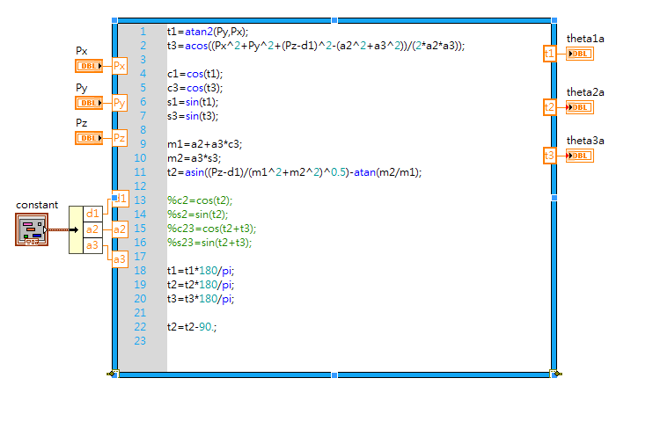

A to B N Points (分點)

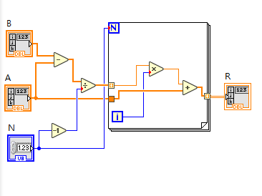

程式改良

1.新增復歸模式

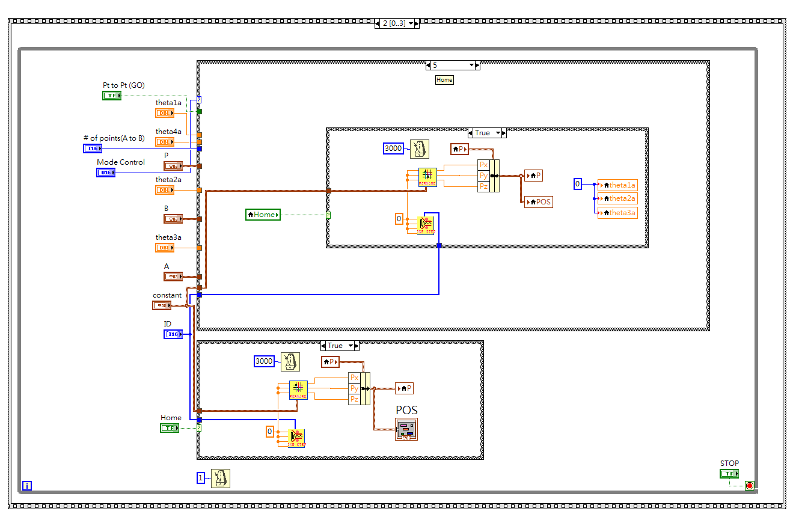

2.複製模式新增AB互換，使其可回到上一點

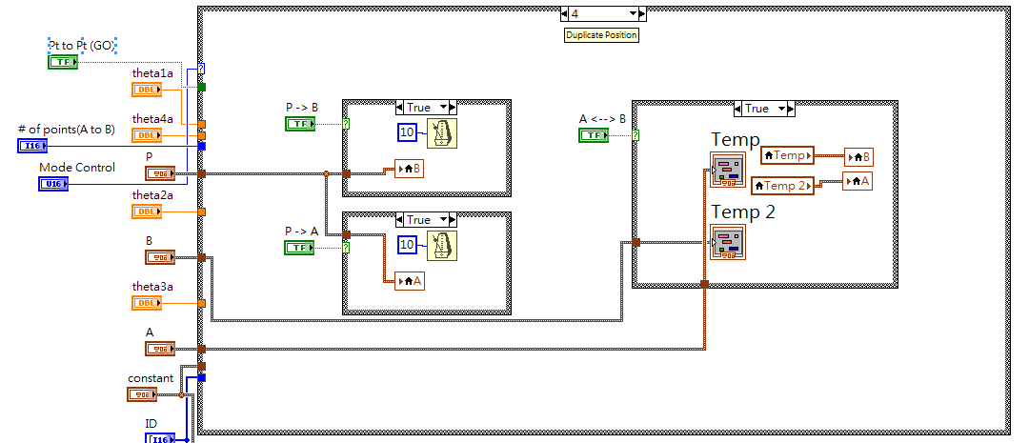

3.於卡式空間須按下GO才會移動到目標點

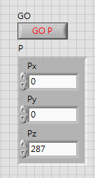

4.顯示當前位置

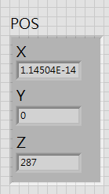

Package

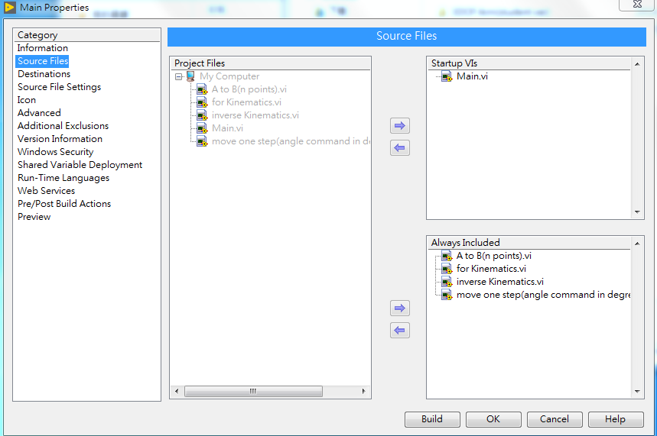

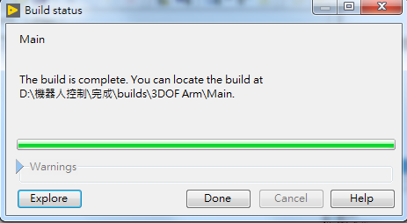

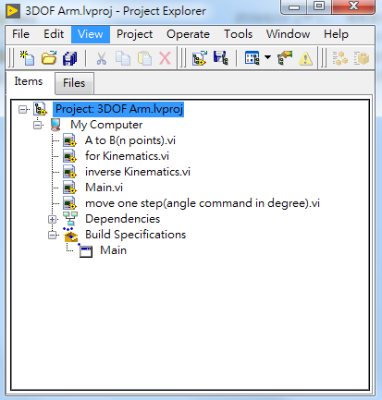

完成圖

