

CSE471 : System Analysis and Design
Lab Assignment on API Postman Collection

Project Title : MedFind BD
Group Number : 02
Backend Framework : Node.js + Express.js (MongoDB Atlas, Mongoose)

Submitted by : Audrija Chowdhury
Student ID : 22299421
Section: 03

Date : 05 November 2026
APIs of Feature - 01: Medicine Catalog Management
Server: Member 1 backend, started with "npm run start:member1" on port 9421 (last four digits of student ID 22299421). Base URL: http://127.0.0.1:9421. Database: MongoDB (Mongoose ODM), connected at server start.
Method | Endpoint - API
1. GET | /api/master-medicines - Search master medicine list
2. GET | /api/owner/catalog - View medicine catalog
3. POST | /api/owner/catalog - Add medicine to catalog
4. GET | /api/owner/catalog/:catalogItemId - View one catalog medicine
5. PATCH | /api/owner/catalog/:catalogItemId - Edit catalog medicine (price & stock)
6. DELETE | /api/owner/catalog/:catalogItemId - Remove medicine from catalog

API 1: Search master medicine list
Purpose | Step 1 of "Add medicine": search the platform master list (brand, generic, manufacturer, strength, dosage form) and see which medicines are already in the catalog.
Endpoint URL | http://127.0.0.1:9421/api/master-medicines
HTTP Method | GET
Headers | Authorization: Bearer <JWT of owner account>
Authentication | JWT required - role: Pharmacy owner
Body / Parameters | Query parameters:  search = ostocal  page = 1  limit = 10
Status code | Expected 200 OK; returned 200 OK in the Postman test below

Example request (cURL):
curl -X GET "http://127.0.0.1:9421/api/master-medicines?search=ostocal&page=1&limit=10" \
-H "Authorization: Bearer <ownerToken>"

Example response (200 OK, recorded from the Postman collection run):
{
"success": true,
"message": "Master medicine list",
"data": {
"medicines": [
{
"id": "7dbbf2400fd851ca9742fcbc",
"brandName": "Ostocal",
"genericName": "Calcium + Vitamin D3",
"manufacturer": "Square Pharmaceuticals",
"strength": "500 mg + 200 IU",
"dosageForm": "Tablet",
"requiresPrescription": false,
"alreadyInCatalog": false
}
],
"pagination": {
"page": 1,
"limit": 10,
"total": 1,
"totalPages": 1
}
}
}

Code snippet (route -> controller -> service):
// src/routes/catalog.routes.js
router.get('/master-medicines', owner, validate(v.masterListQuery, 'query'), ctrl.searchMasterList);

// src/controllers/catalog.controller.js
async function searchMasterList(req, res) {
const q = req.validatedQuery;
const data = await service.searchMasterList(req.pharmacy, { search: q.search, ...getPagination(q, { limit: 10 }) });
ok(res, data, 'Master medicine list');
}

// src/services/catalog.service.js
/** Step 1 of "Add medicine": browse the master list, flagging medicines already in this pharmacy's catalog. */
async function searchMasterList(pharmacy, { search, page, limit, skip }) {
const filter = { isActive: true };
if (search) {
const rx = new RegExp(escapeRegex(search), 'i');
filter.$or = [{ brandName: rx }, { genericName: rx }, { manufacturer: rx }];
}
const [total, docs] = await Promise.all([
MasterMedicine.countDocuments(filter),
MasterMedicine.find(filter).sort({ brandName: 1, strength: 1 }).skip(skip).limit(limit),
]);
const inCatalog = await CatalogItem.find(
{ pharmacy: pharmacy._id, isActive: true, medicine: { $in: docs.map((d) => d._id) } }, 'medicine'
);
const inCatalogSet = new Set(inCatalog.map((c) => String(c.medicine)));
return {
medicines: docs.map((d) => ({
id: d._id, brandName: d.brandName, genericName: d.genericName, manufacturer: d.manufacturer,
strength: d.strength, dosageForm: d.dosageForm, requiresPrescription: d.requiresPrescription,
alreadyInCatalog: inCatalogSet.has(String(d._id)),
})),
pagination: pageMeta(page, limit, total),
};
}

Postman screenshot:
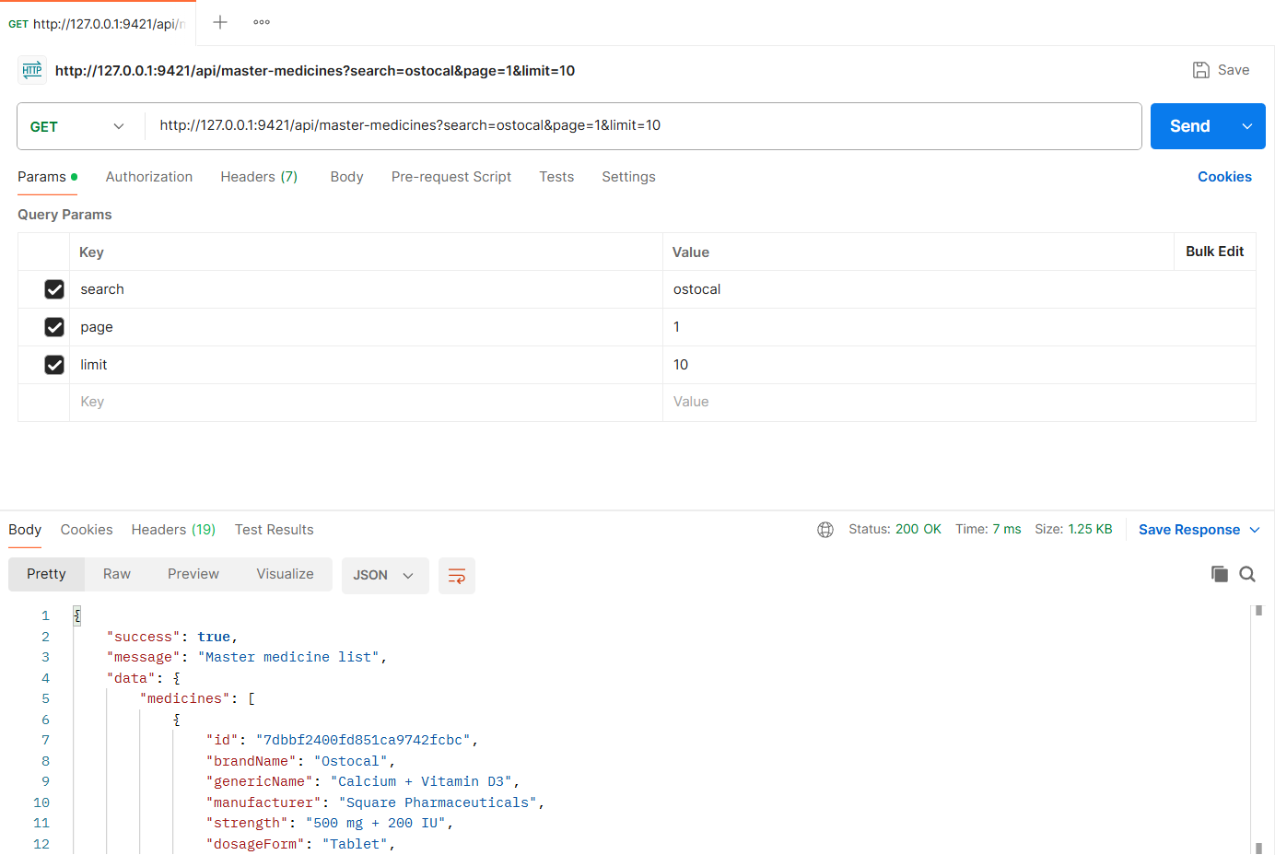
Figure: M1-F1-01 - GET /api/master-medicines tested in Postman (status 200)
API 2: View medicine catalog
Purpose | List the medicines the pharmacy sells with price, stock, stock status, last-updated time and tab counts (All / In stock / Low stock / Out of stock).
Endpoint URL | http://127.0.0.1:9421/api/owner/catalog
HTTP Method | GET
Headers | Authorization: Bearer <JWT of owner account>
Authentication | JWT required - role: Pharmacy owner
Body / Parameters | Query parameters:  status = all  page = 1  limit = 10
Status code | Expected 200 OK; returned 200 OK in the Postman test below

Example request (cURL):
curl -X GET "http://127.0.0.1:9421/api/owner/catalog?status=all&page=1&limit=10" \
-H "Authorization: Bearer <ownerToken>"

Example response (200 OK, recorded from the Postman collection run):
{
"success": true,
"message": "Medicine catalog",
"data": {
"counts": {
"all": 9,
"inStock": 7,
"lowStock": 1,
"outOfStock": 1
},
"items": [
{
"id": "209fc9c7d78228e98d3e949e",
"medicine": {
"id": "3bec8373567f1e169fbef9cb",
"brandName": "Napa",
"genericName": "Paracetamol",
"manufacturer": "Beximco Pharmaceuticals",
"strength": "500 mg",
"dosageForm": "Tablet",
"requiresPrescription": false
},
"price": 1.2,
"stockQuantity": 340,
"minStockLevel": 50,
"stockStatus": "In stock",
"lastUpdatedAt": "2026-11-04T17:55:59.218Z"
},
... (truncated - full response in the Postman screenshot / collection run)

Code snippet (route -> controller -> service):
// src/routes/catalog.routes.js
router.get('/owner/catalog', owner, validate(v.catalogListQuery, 'query'), ctrl.listCatalog);

// src/controllers/catalog.controller.js
async function listCatalog(req, res) {
const q = req.validatedQuery;
const data = await service.listCatalog(req.pharmacy, { search: q.search, status: q.status, ...getPagination(q, { limit: 10 }) });
ok(res, data, 'Medicine catalog');
}

// src/services/catalog.service.js
async function listCatalog(pharmacy, { search, status, page, limit, skip }) {
const base = { pharmacy: pharmacy._id, isActive: true };
if (search) base.medicine = { $in: await masterIdsMatching(search) };
const filter = status && status !== 'all' ? { ...base, ...STATUS_FILTERS[status] } : base;

const [total, items, counts] = await Promise.all([
CatalogItem.countDocuments(filter),
CatalogItem.find(filter).populate('medicine').sort({ lastUpdatedAt: -1 }).skip(skip).limit(limit),
Promise.all([
CatalogItem.countDocuments(base),
CatalogItem.countDocuments({ ...base, ...STATUS_FILTERS.in_stock }),
CatalogItem.countDocuments({ ...base, ...STATUS_FILTERS.low_stock }),
CatalogItem.countDocuments({ ...base, ...STATUS_FILTERS.out_of_stock }),
]),
]);

return {
counts: { all: counts[0], inStock: counts[1], lowStock: counts[2], outOfStock: counts[3] },
items: items.map(formatItem),
pagination: pageMeta(page, limit, total),
};
}

Postman screenshot:
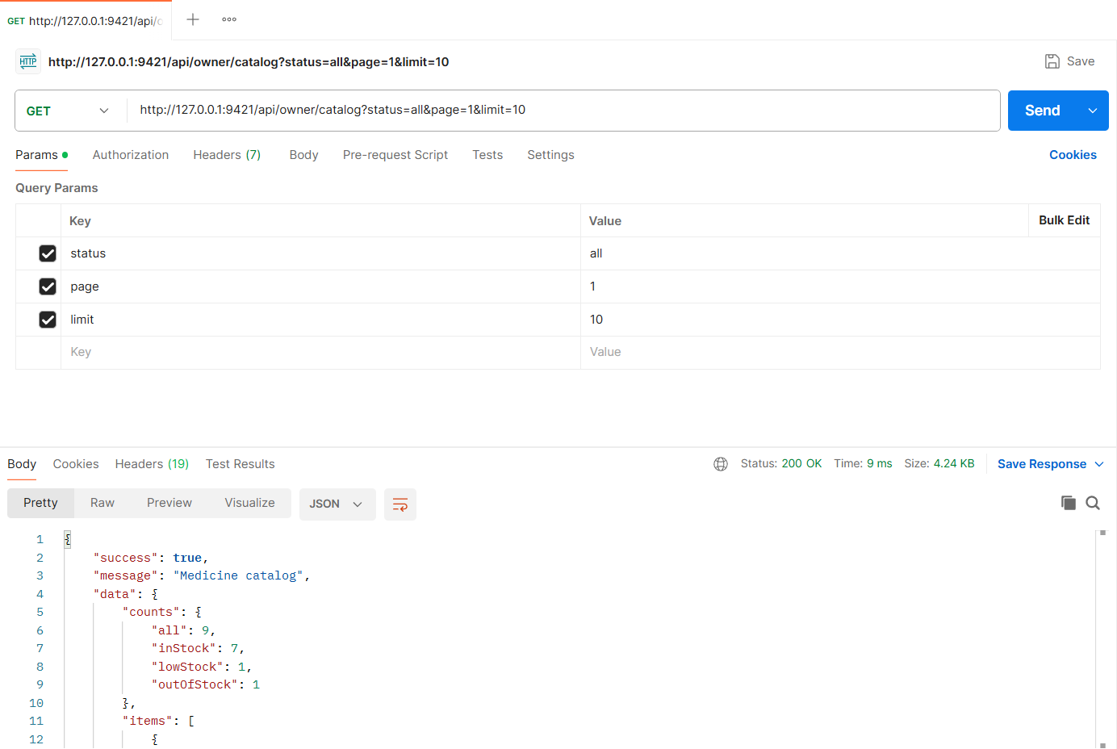
Figure: M1-F1-02 - GET /api/owner/catalog tested in Postman (status 200)
API 3: Add medicine to catalog
Purpose | Add a master-list medicine to the catalog with the pharmacy's own selling price, stock quantity and minimum stock level. Sets "last updated" to now and records the first price in price history.
Endpoint URL | http://127.0.0.1:9421/api/owner/catalog
HTTP Method | POST
Headers | Authorization: Bearer <JWT of owner account>  Content-Type: application/json
Authentication | JWT required - role: Pharmacy owner
Body / Parameters | JSON body:  {  "masterMedicineId": "7dbbf2400fd851ca9742fcbc",  "price": 9.5,  "stockQuantity": 120,  "minStockLevel": 20  }
Status code | Expected 201 Created; returned 201 Created in the Postman test below

Example request (cURL):
curl -X POST "http://127.0.0.1:9421/api/owner/catalog" \
-H "Authorization: Bearer <ownerToken>" \
-H "Content-Type: application/json" \
-d '{"masterMedicineId": "7dbbf2400fd851ca9742fcbc", "price": 9.5, "stockQuantity": 120, "minStockLevel": 20}'

Example response (201 Created, recorded from the Postman collection run):
{
"success": true,
"message": "Medicine added to catalog",
"data": {
"id": "6aeb8dd572dad8d54ca52f64",
"medicine": {
"id": "7dbbf2400fd851ca9742fcbc",
"brandName": "Ostocal",
"genericName": "Calcium + Vitamin D3",
"manufacturer": "Square Pharmaceuticals",
"strength": "500 mg + 200 IU",
"dosageForm": "Tablet",
"requiresPrescription": false
},
"price": 9.5,
"stockQuantity": 120,
"minStockLevel": 20,
"stockStatus": "In stock",
"lastUpdatedAt": "2026-11-04T19:56:05.547Z"
}
}

Code snippet (route -> controller -> service):
// src/routes/catalog.routes.js
router.post('/owner/catalog', owner, validate(v.addCatalogItem), ctrl.addToCatalog);

// src/controllers/catalog.controller.js
async function addToCatalog(req, res) {
created(res, await service.addToCatalog(req.pharmacy, req.user, req.body), 'Medicine added to catalog');
}

// src/services/catalog.service.js
async function addToCatalog(pharmacy, user, { masterMedicineId, price, stockQuantity, minStockLevel }) {
const medicine = await MasterMedicine.findOne({ _id: masterMedicineId, isActive: true });
if (!medicine) throw ApiError.notFound('Medicine not found in the master list');

const existing = await CatalogItem.findOne({ pharmacy: pharmacy._id, medicine: medicine._id });
if (existing && existing.isActive) {
throw ApiError.conflict(`${medicine.brandName} ${medicine.strength} is already in your catalog`);
}

const itemId = await withTransaction(async (session) => {
let item;
if (existing) {
// re-adding a previously removed medicine reactivates the same catalog entry
existing.set({ isActive: true, price, minStockLevel, lastUpdatedAt: new Date() });
item = await existing.save({ session });
} else {
[item] = await CatalogItem.create(
[{ pharmacy: pharmacy._id, medicine: medicine._id, price, minStockLevel, stockQuantity: 0 }],
{ session }
);
}
await inventory.setStockLevel(item, stockQuantity, session);
await PriceHistory.create(
[{ catalogItem: item._id, pharmacy: pharmacy._id, oldPrice: null, newPrice: price, changedBy: user._id, source: 'catalog-add' }],
{ session }
);
return item._id;
});

return getCatalogItem(pharmacy, itemId);
}

Postman screenshot:
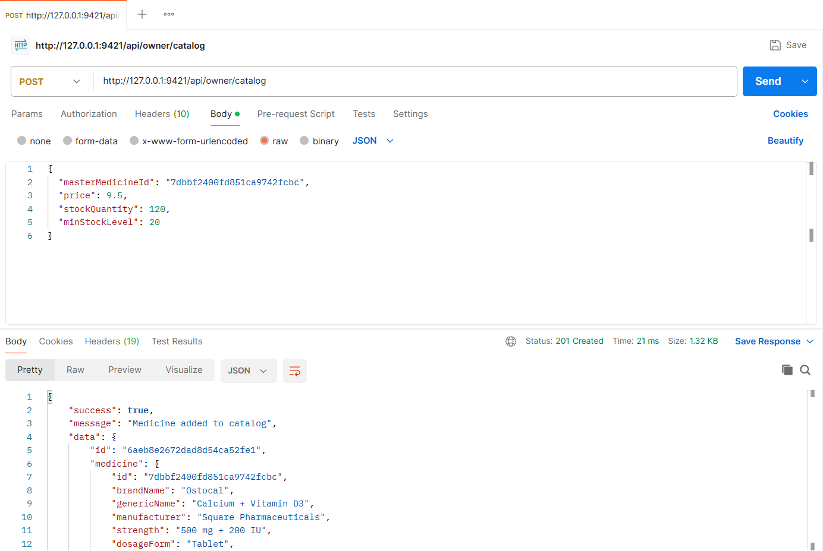
Figure: M1-F1-03 - POST /api/owner/catalog tested in Postman (status 201)
API 4: View one catalog medicine
Purpose | Open a catalog medicine (Edit page data): read-only master-list details plus the pharmacy's price, stock and minimum level.
Endpoint URL | http://127.0.0.1:9421/api/owner/catalog/:catalogItemId
HTTP Method | GET
Headers | Authorization: Bearer <JWT of owner account>
Authentication | JWT required - role: Pharmacy owner
Body / Parameters | Path parameters: catalogItemId (id returned by an earlier request)
Status code | Expected 200 OK; returned 200 OK in the Postman test below

Example request (cURL):
curl -X GET "http://127.0.0.1:9421/api/owner/catalog/<catalogItemId>" \
-H "Authorization: Bearer <ownerToken>"

Example response (200 OK, recorded from the Postman collection run):
{
"success": true,
"message": "Catalog medicine",
"data": {
"id": "6aeb8dd572dad8d54ca52f64",
"medicine": {
"id": "7dbbf2400fd851ca9742fcbc",
"brandName": "Ostocal",
"genericName": "Calcium + Vitamin D3",
"manufacturer": "Square Pharmaceuticals",
"strength": "500 mg + 200 IU",
"dosageForm": "Tablet",
"requiresPrescription": false
},
"price": 9.5,
"stockQuantity": 120,
"minStockLevel": 20,
"stockStatus": "In stock",
"lastUpdatedAt": "2026-11-04T19:56:05.547Z"
}
}

Code snippet (route -> controller -> service):
// src/routes/catalog.routes.js
router.get('/owner/catalog/:itemId', owner, validate(idParam('itemId'), 'params'), ctrl.getCatalogItem);

// src/controllers/catalog.controller.js
async function getCatalogItem(req, res) {
ok(res, await service.getCatalogItem(req.pharmacy, req.params.itemId), 'Catalog medicine');
}

// src/services/catalog.service.js
async function getCatalogItem(pharmacy, itemId) {
return formatItem(await findOwnedItem(pharmacy, itemId));
}

Postman screenshot:
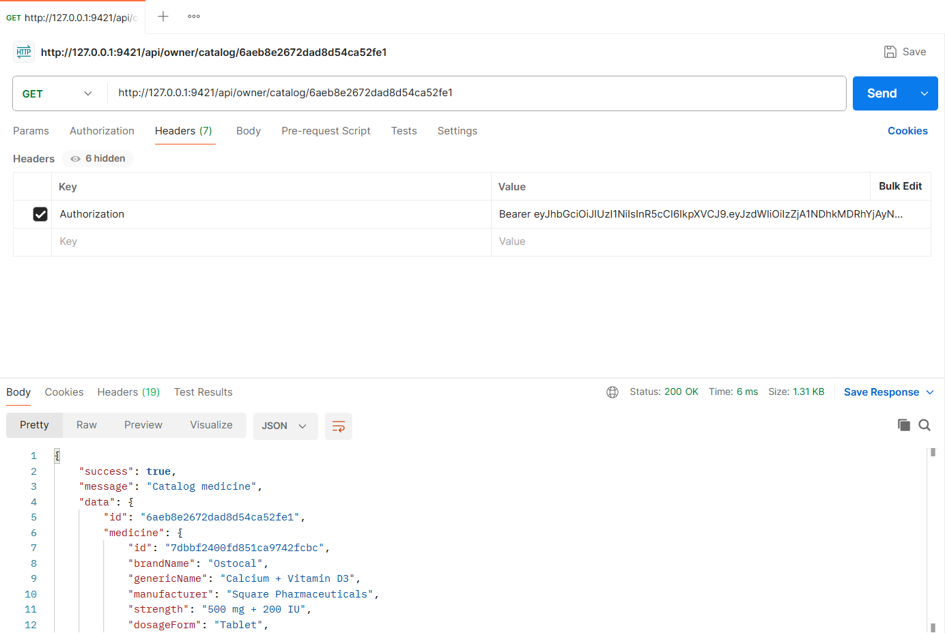
Figure: M1-F1-04 - GET /api/owner/catalog/:catalogItemId tested in Postman (status 200)
API 5: Edit catalog medicine (price & stock)
Purpose | Update selling price and/or stock quantity. A price change is recorded in price history; a stock change is applied through inventory batches; "last updated" is refreshed.
Endpoint URL | http://127.0.0.1:9421/api/owner/catalog/:catalogItemId
HTTP Method | PATCH
Headers | Authorization: Bearer <JWT of owner account>  Content-Type: application/json
Authentication | JWT required - role: Pharmacy owner
Body / Parameters | JSON body:  {  "price": 10,  "stockQuantity": 150,  "minStockLevel": 25  }  Path parameters: catalogItemId (id returned by an earlier request)
Status code | Expected 200 OK; returned 200 OK in the Postman test below

Example request (cURL):
curl -X PATCH "http://127.0.0.1:9421/api/owner/catalog/<catalogItemId>" \
-H "Authorization: Bearer <ownerToken>" \
-H "Content-Type: application/json" \
-d '{"price": 10, "stockQuantity": 150, "minStockLevel": 25}'

Example response (200 OK, recorded from the Postman collection run):
{
"success": true,
"message": "Catalog medicine updated",
"data": {
"id": "6aeb8dd572dad8d54ca52f64",
"medicine": {
"id": "7dbbf2400fd851ca9742fcbc",
"brandName": "Ostocal",
"genericName": "Calcium + Vitamin D3",
"manufacturer": "Square Pharmaceuticals",
"strength": "500 mg + 200 IU",
"dosageForm": "Tablet",
"requiresPrescription": false
},
"price": 10,
"stockQuantity": 150,
"minStockLevel": 25,
"stockStatus": "In stock",
"lastUpdatedAt": "2026-11-04T19:56:05.961Z"
}
}

Code snippet (route -> controller -> service):
// src/routes/catalog.routes.js
router.patch('/owner/catalog/:itemId', owner, validate(idParam('itemId'), 'params'), validate(v.updateCatalogItem), ctrl.updateCatalogItem);

// src/controllers/catalog.controller.js
async function updateCatalogItem(req, res) {
ok(res, await service.updateCatalogItem(req.pharmacy, req.user, req.params.itemId, req.body), 'Catalog medicine updated');
}

// src/services/catalog.service.js
async function updateCatalogItem(pharmacy, user, itemId, { price, stockQuantity, minStockLevel }) {
await withTransaction(async (session) => {
const item = await findOwnedItem(pharmacy, itemId, { session });
if (price !== undefined && price !== item.price) {
await PriceHistory.create(
[{ catalogItem: item._id, pharmacy: pharmacy._id, oldPrice: item.price, newPrice: price, changedBy: user._id, source: 'catalog-edit' }],
{ session }
);
item.price = price;
}
if (minStockLevel !== undefined) item.minStockLevel = minStockLevel;
item.lastUpdatedAt = new Date();
await item.save({ session });
if (stockQuantity !== undefined) await inventory.setStockLevel(item, stockQuantity, session);
});
return getCatalogItem(pharmacy, itemId);
}

Postman screenshot:
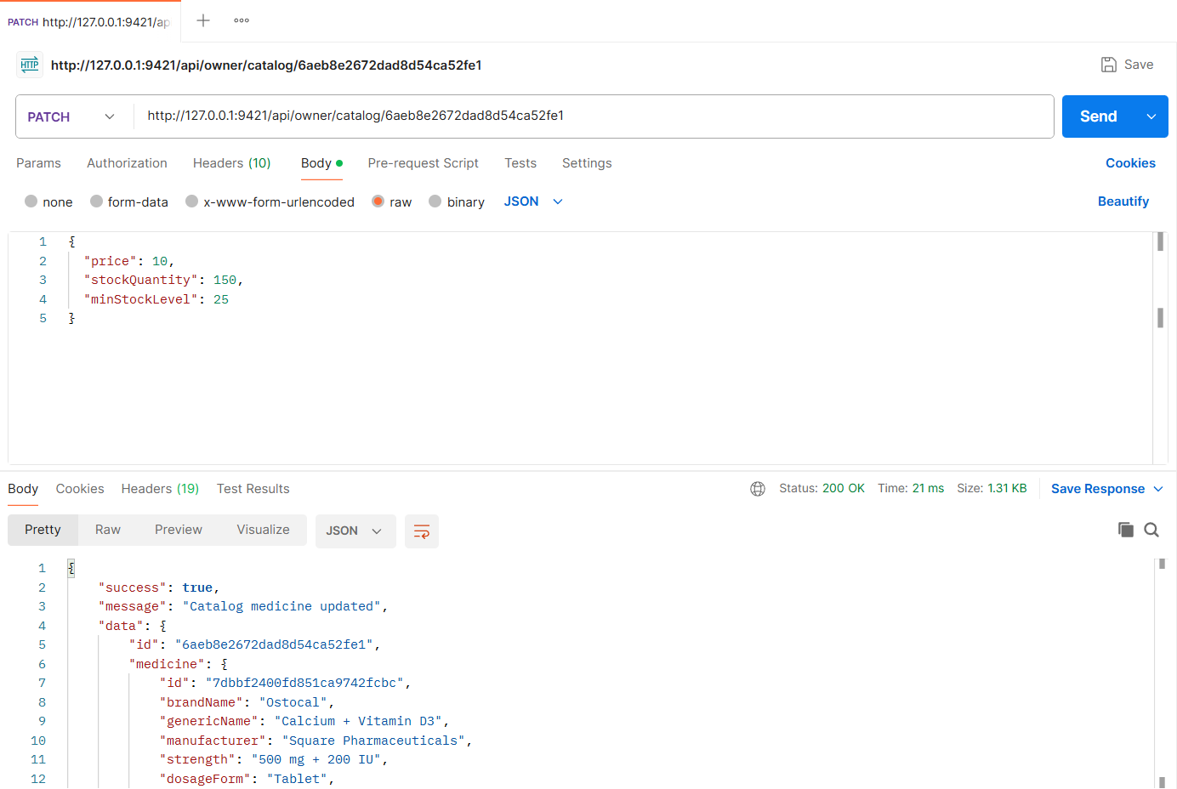
Figure: M1-F1-05 - PATCH /api/owner/catalog/:catalogItemId tested in Postman (status 200)
API 6: Remove medicine from catalog
Purpose | Remove a medicine from the catalog. Customers no longer see it; existing reservations keep their snapshot and are not affected.
Endpoint URL | http://127.0.0.1:9421/api/owner/catalog/:catalogItemId
HTTP Method | DELETE
Headers | Authorization: Bearer <JWT of owner account>
Authentication | JWT required - role: Pharmacy owner
Body / Parameters | Path parameters: catalogItemId (id returned by an earlier request)
Status code | Expected 200 OK; returned 200 OK in the Postman test below

Example request (cURL):
curl -X DELETE "http://127.0.0.1:9421/api/owner/catalog/<catalogItemId>" \
-H "Authorization: Bearer <ownerToken>"

Example response (200 OK, recorded from the Postman collection run):
{
"success": true,
"message": "Medicine removed from catalog",
"data": {
"id": "6aeb8dd572dad8d54ca52f64",
"medicine": "Ostocal 500 mg + 200 IU",
"removed": true
}
}

Code snippet (route -> controller -> service):
// src/routes/catalog.routes.js
router.delete('/owner/catalog/:itemId', owner, validate(idParam('itemId'), 'params'), ctrl.removeCatalogItem);

// src/controllers/catalog.controller.js
async function removeCatalogItem(req, res) {
ok(res, await service.removeCatalogItem(req.pharmacy, req.params.itemId), 'Medicine removed from catalog');
}

// src/services/catalog.service.js
/** Soft delete: customers stop seeing it; existing reservations keep their snapshot and are not affected. */
async function removeCatalogItem(pharmacy, itemId) {
const item = await findOwnedItem(pharmacy, itemId);
item.isActive = false;
item.lastUpdatedAt = new Date();
await item.save();
return { id: item._id, medicine: `${item.medicine.brandName} ${item.medicine.strength}`, removed: true };
}

Postman screenshot:
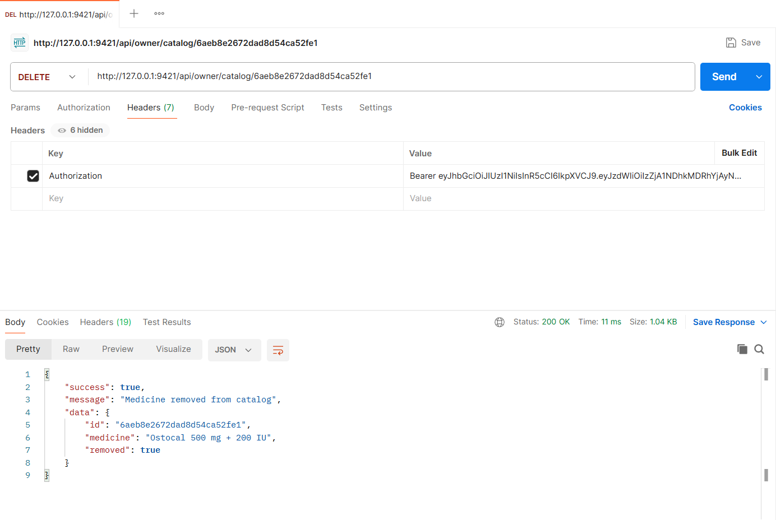
Figure: M1-F1-06 - DELETE /api/owner/catalog/:catalogItemId tested in Postman (status 200)
Validation and error-handling tests (Feature 01)
The same APIs were also tested with invalid input, wrong roles and invalid state changes. Each request below was sent from Postman to the running server.
Missing token (401)
Request | GET http://127.0.0.1:9421/api/owner/catalog
Scenario | Requests without a JWT are rejected.
Body / Parameters | None
Result | Expected 401 Unauthorized; returned 401 Unauthorized

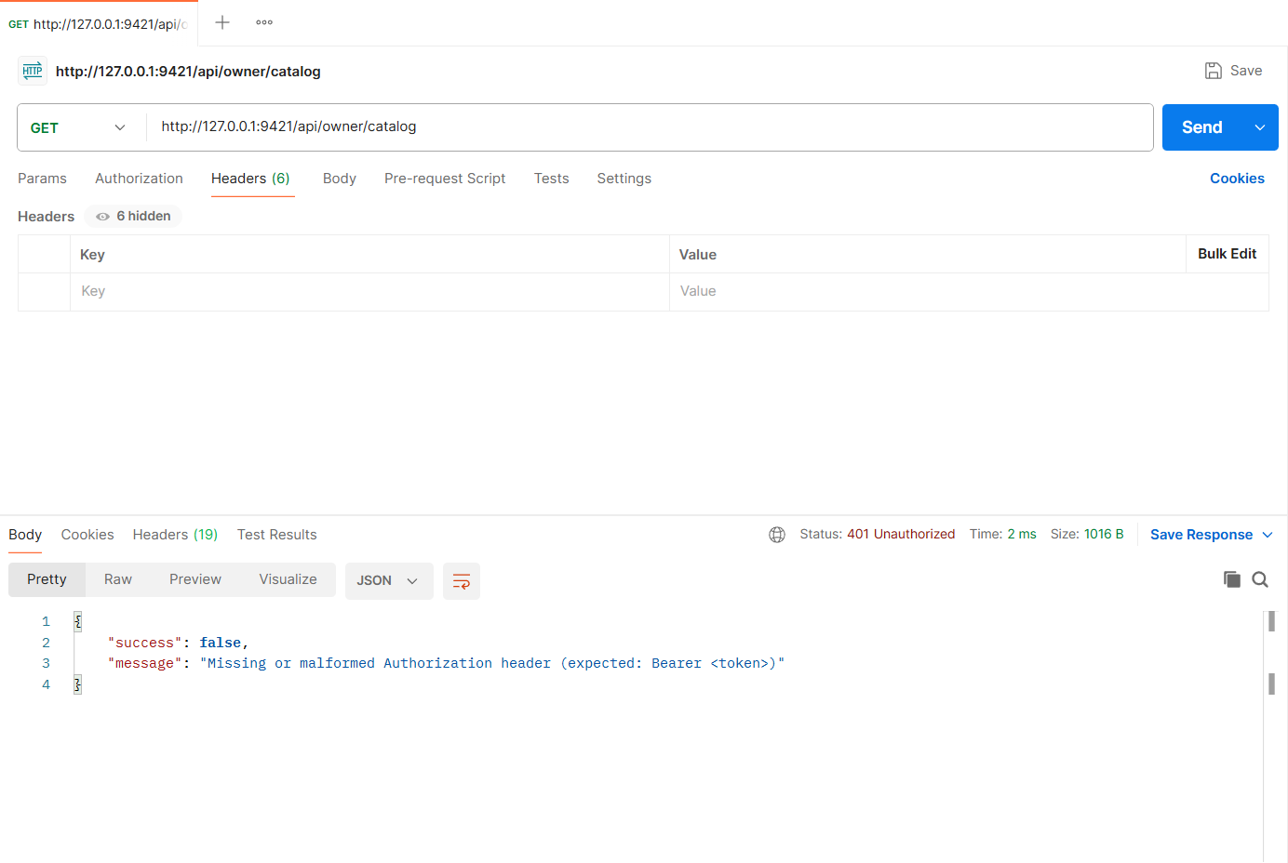
Figure: M1-F1-N4 - Missing token (401)
Patient cannot manage a catalog (403)
Request | GET http://127.0.0.1:9421/api/owner/catalog
Scenario | Role-based access: only pharmacy owners can use catalog APIs.
Body / Parameters | None
Result | Expected 403 Forbidden; returned 403 Forbidden

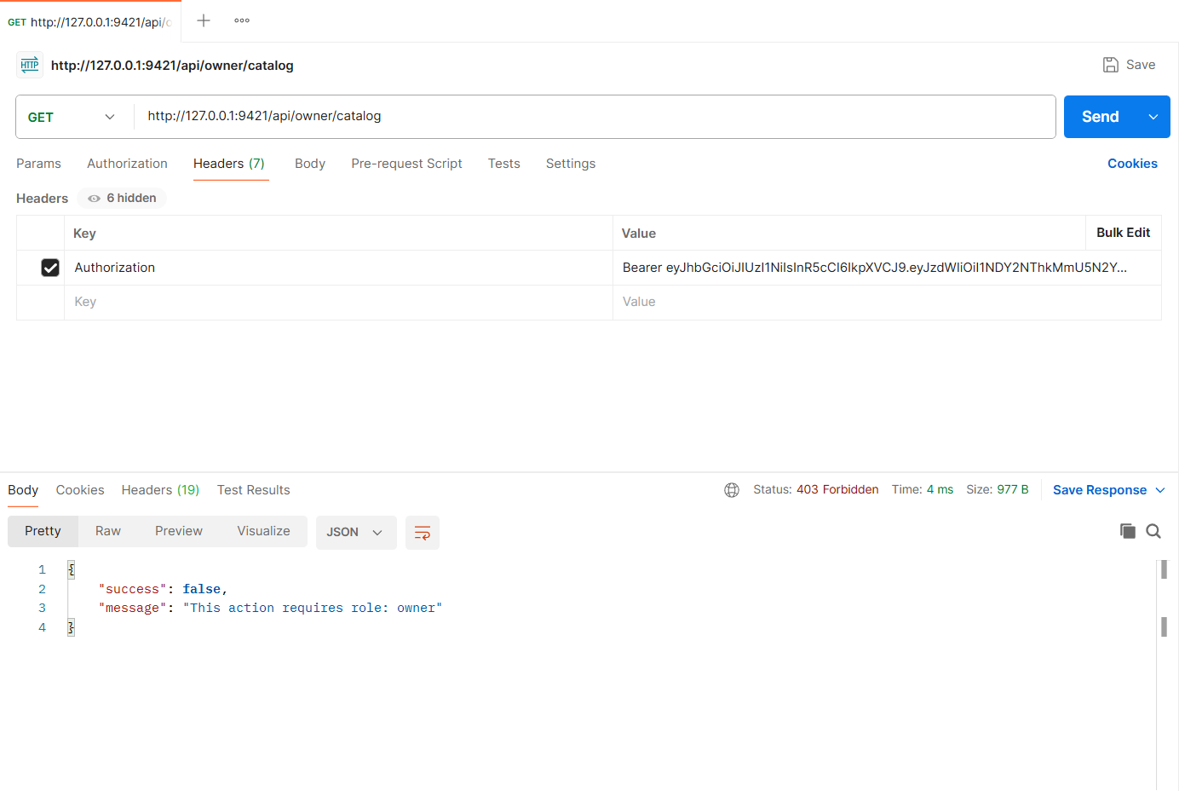
Figure: M1-F1-N3 - Patient cannot manage a catalog (403)
Add duplicate medicine (409)
Request | POST http://127.0.0.1:9421/api/owner/catalog
Scenario | Adding a medicine that is already in the catalog is rejected.
Body / Parameters | JSON body:  {  "masterMedicineId": "3bec8373567f1e169fbef9cb",  "price": 1.2,  "stockQuantity": 10  }
Result | Expected 409 Conflict; returned 409 Conflict

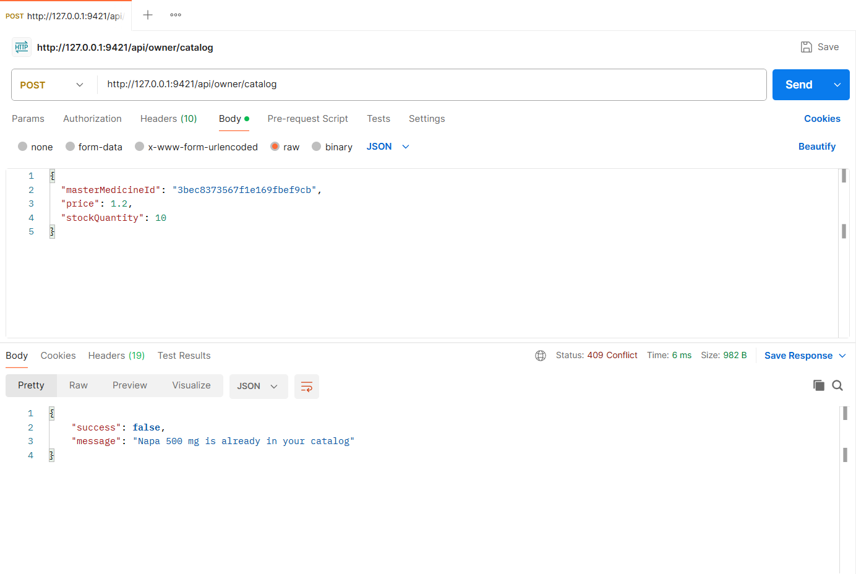
Figure: M1-F1-N1 - Add duplicate medicine (409)
Invalid medicine data (400)
Request | POST http://127.0.0.1:9421/api/owner/catalog
Scenario | Invalid id, negative price and missing stock quantity are rejected with field errors.
Body / Parameters | JSON body:  {  "masterMedicineId": "abc",  "price": -5  }
Result | Expected 400 Bad Request; returned 400 Bad Request

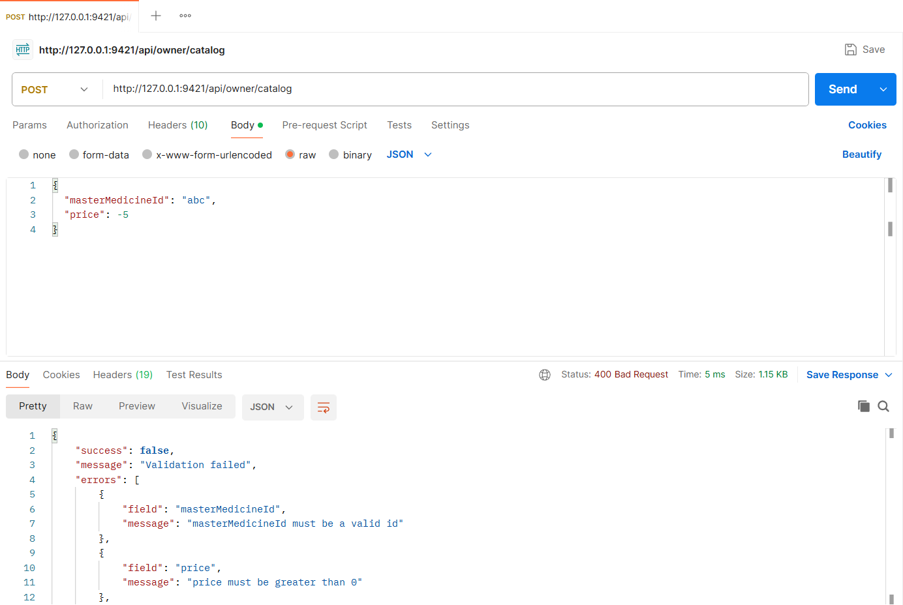
Figure: M1-F1-N2 - Invalid medicine data (400)
APIs of Feature - 02: Stock & Expiry Tracking
Server: Member 1 backend, started with "npm run start:member1" on port 9421 (last four digits of student ID 22299421). Base URL: http://127.0.0.1:9421. Database: MongoDB (Mongoose ODM), connected at server start.
Method | Endpoint - API
1. GET | /api/owner/stock/overview - Stock overview
2. POST | /api/owner/stock/batches - Add stock batch
3. GET | /api/owner/stock/items/209fc9c7d78228e98d3e949e/batches - View medicine batches (FEFO order)
4. PATCH | /api/owner/stock/batches/:batchId - Edit stock batch
5. GET | /api/owner/stock/expiry - Expiry inventory (30 / 60 / 90 days)
6. POST | /api/owner/stock/items/209fc9c7d78228e98d3e949e/dispense - Dispense stock (earliest-expiring batch first)
7. DELETE | /api/owner/stock/batches/:batchId - Remove stock batch

API 1: Stock overview
Purpose | Summary cards (medicines tracked, available units, batches expiring in 30 days, expired batches) and one row per medicine with available stock (non-expired batches only), batch count and earliest expiry.
Endpoint URL | http://127.0.0.1:9421/api/owner/stock/overview
HTTP Method | GET
Headers | Authorization: Bearer <JWT of owner account>
Authentication | JWT required - role: Pharmacy owner
Body / Parameters | None
Status code | Expected 200 OK; returned 200 OK in the Postman test below

Example request (cURL):
curl -X GET "http://127.0.0.1:9421/api/owner/stock/overview" \
-H "Authorization: Bearer <ownerToken>"

Example response (200 OK, recorded from the Postman collection run):
{
"success": true,
"message": "Stock overview",
"data": {
"summary": {
"medicinesTracked": 9,
"availableUnits": 1273,
"expiringIn30Days": 2,
"expiredBatches": 2
},
"items": [
{
"catalogItemId": "209fc9c7d78228e98d3e949e",
"medicine": {
"id": "3bec8373567f1e169fbef9cb",
"brandName": "Napa",
"genericName": "Paracetamol",
"strength": "500 mg",
"dosageForm": "Tablet"
},
"availableStock": 340,
"batches": 4,
"expiredBatches": 1,
"earliestExpiry": "2026-12-11T19:55:59.218Z",
"minStockLevel": 50,
"status": "In stock"
},
{
... (truncated - full response in the Postman screenshot / collection run)

Code snippet (route -> controller -> service):
// src/routes/stock.routes.js
router.get('/owner/stock/overview', owner, validate(v.stockOverviewQuery, 'query'), ctrl.overview);

// src/controllers/stock.controller.js
async function overview(req, res) {
ok(res, await service.overview(req.pharmacy, req.validatedQuery), 'Stock overview');
}

// src/services/stock.service.js
/** Stock overview page: summary cards + one row per catalog medicine. */
async function overview(pharmacy, { search } = {}) {
const now = new Date();
const itemFilter = { pharmacy: pharmacy._id, isActive: true };
if (search) {
const rx = new RegExp(escapeRegex(search), 'i');
const ids = await MasterMedicine.find({ $or: [{ brandName: rx }, { genericName: rx }] }, '_id');
itemFilter.medicine = { $in: ids.map((d) => d._id) };
}
const items = await CatalogItem.find(itemFilter).populate('medicine').sort({ lastUpdatedAt: -1 });
const batches = await InventoryBatch.find({ catalogItem: { $in: items.map((i) => i._id) }, quantity: { $gt: 0 } });

const byItem = new Map();
for (const b of batches) {
const key = String(b.catalogItem);
if (!byItem.has(key)) byItem.set(key, []);
byItem.get(key).push(b);
}

const in30 = addDays(now, 30);
const summary = { medicinesTracked: items.length, availableUnits: 0, expiringIn30Days: 0, expiredBatches: 0 };
const rows = items.map((item) => {
const list = byItem.get(String(item._id)) || [];
const live = list.filter((b) => !b.expiryDate || b.expiryDate > now);
const expired = list.filter((b) => b.expiryDate && b.expiryDate <= now);
const available = live.reduce((s, b) => s + b.quantity, 0);
const dated = live.filter((b) => b.expiryDate).sort(inventory.fefoSort);

summary.availableUnits += available;
summary.expiringIn30Days += dated.filter((b) => b.expiryDate <= in30).length;
summary.expiredBatches += expired.length;

let status = item.stockStatus;
if (available === 0 && expired.length > 0) status = 'Expired';
return {
catalogItemId: item._id,
medicine: medicineLabel(item.medicine),
availableStock: available,
batches: list.length,
expiredBatches: expired.length,
earliestExpiry: dated[0] ? dated[0].expiryDate : null,
minStockLevel: item.minStockLevel,
status,
};
});

return { summary, items: rows };
}

Postman screenshot:
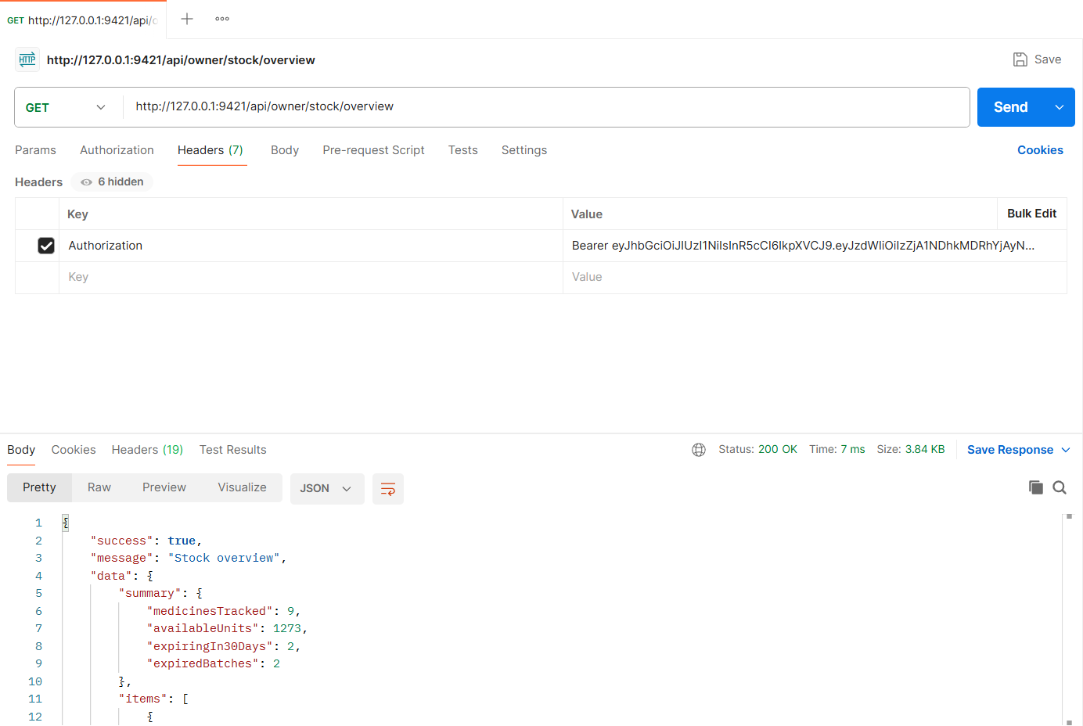
Figure: M1-F2-01 - GET /api/owner/stock/overview tested in Postman (status 200)
API 2: Add stock batch
Purpose | Record a delivery as a batch with batch number, quantity, manufacturing date, expiry date and purchase price. Available stock is recalculated from non-expired batches.
Endpoint URL | http://127.0.0.1:9421/api/owner/stock/batches
HTTP Method | POST
Headers | Authorization: Bearer <JWT of owner account>  Content-Type: application/json
Authentication | JWT required - role: Pharmacy owner
Body / Parameters | JSON body:  {  "catalogItemId": "209fc9c7d78228e98d3e949e",  "batchNumber": "NP-2501",  "quantity": 200,  "manufacturingDate": "2026-06-10",  "expiryDate": "2028-06-10",  "purchasePrice": 0.85  }
Status code | Expected 201 Created; returned 201 Created in the Postman test below

Example request (cURL):
curl -X POST "http://127.0.0.1:9421/api/owner/stock/batches" \
-H "Authorization: Bearer <ownerToken>" \
-H "Content-Type: application/json" \
-d '{"catalogItemId": "209fc9c7d78228e98d3e949e", "batchNumber": "NP-2501", "quantity": 200, "manufacturingDate": "2026-06-10", "expiryDate": "2028-06-10", "purchasePrice": 0.85}'

Example response (201 Created, recorded from the Postman collection run):
{
"success": true,
"message": "Stock batch added",
"data": {
"medicine": {
"id": "3bec8373567f1e169fbef9cb",
"brandName": "Napa",
"genericName": "Paracetamol",
"strength": "500 mg",
"dosageForm": "Tablet"
},
"batch": {
"id": "6aeb8dd672dad8d54ca52f96",
"batchNumber": "NP-2501",
"quantity": 200,
"initialQuantity": 200,
"manufacturingDate": "2026-06-10T00:00:00.000Z",
"expiryDate": "2028-06-10T00:00:00.000Z",
"purchasePrice": 0.85,
"source": "delivery",
"timeLeft": "1 year",
"daysLeft": 584,
"status": "Good"
},
"availableStock": 540
}
}

Code snippet (route -> controller -> service):
// src/routes/stock.routes.js
router.post('/owner/stock/batches', owner, validate(v.addBatch), ctrl.addBatch);

// src/controllers/stock.controller.js
async function addBatch(req, res) {
created(res, await service.addBatch(req.pharmacy, req.body), 'Stock batch added');
}

// src/services/stock.service.js
async function addBatch(pharmacy, { catalogItemId, batchNumber, quantity, manufacturingDate, expiryDate, purchasePrice }) {
const item = await findOwnedItem(pharmacy, catalogItemId);
if (expiryDate <= startOfLocalDay()) throw ApiError.badRequest('Expiry date must be in the future; expired stock cannot be added');
if (manufacturingDate && manufacturingDate >= expiryDate) throw ApiError.badRequest('Manufacturing date must be before the expiry date');
if (manufacturingDate && manufacturingDate > new Date()) throw ApiError.badRequest('Manufacturing date cannot be in the future');

const duplicate = await InventoryBatch.exists({ catalogItem: item._id, batchNumber: batchNumber.toUpperCase() });
if (duplicate) throw ApiError.conflict(`Batch ${batchNumber.toUpperCase()} already exists for this medicine`);

const result = await withTransaction(async (session) => {
const [batch] = await InventoryBatch.create(
[{ pharmacy: pharmacy._id, catalogItem: item._id, batchNumber, quantity, initialQuantity: quantity, manufacturingDate, expiryDate, purchasePrice, source: 'delivery' }],
{ session }
);
const availableStock = await inventory.recalculateStock(item._id, { session });
return { batch, availableStock };
});

return {
medicine: medicineLabel(item.medicine),
batch: formatBatch(result.batch),
availableStock: result.availableStock,
};
}

Postman screenshot:
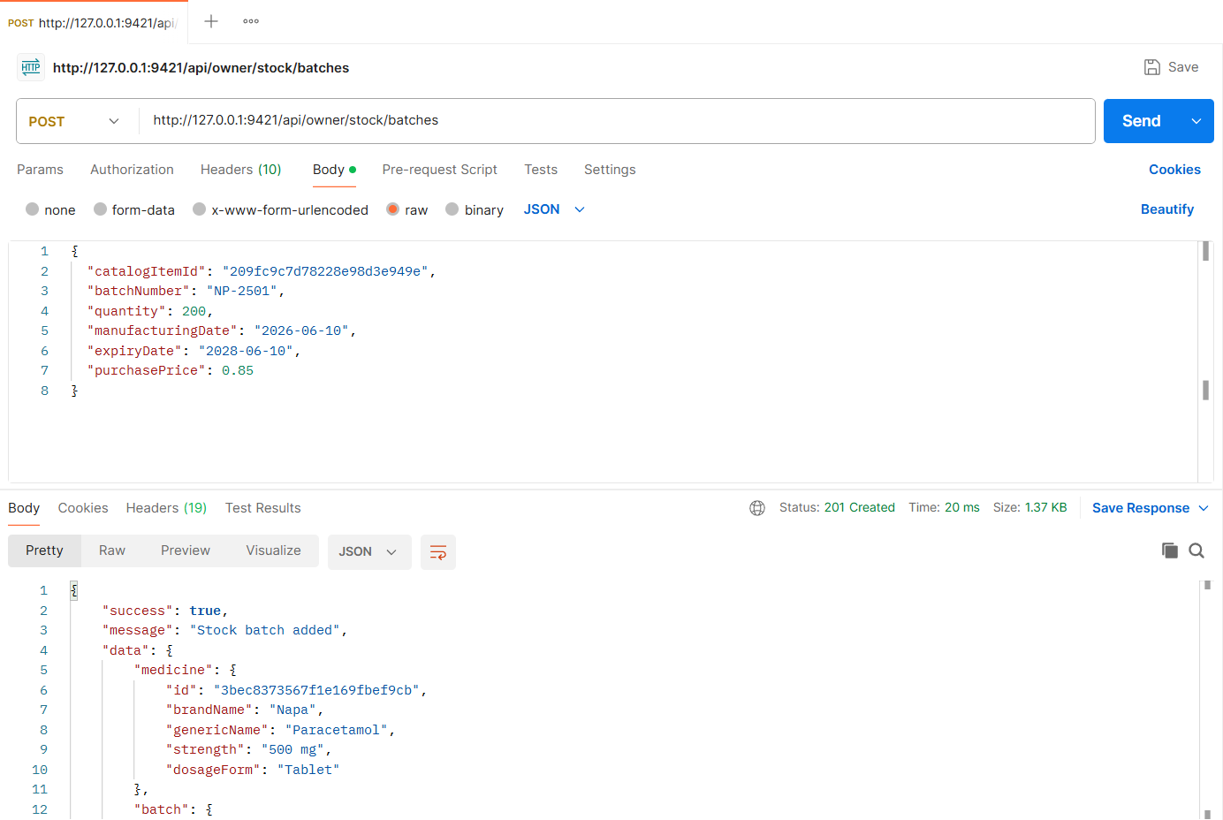
Figure: M1-F2-02 - POST /api/owner/stock/batches tested in Postman (status 201)
API 3: View medicine batches (FEFO order)
Purpose | All batches of one medicine in the order they will be used (earliest expiry first), with time left, status, available vs expired units and the next batch to use.
Endpoint URL | http://127.0.0.1:9421/api/owner/stock/items/209fc9c7d78228e98d3e949e/batches
HTTP Method | GET
Headers | Authorization: Bearer <JWT of owner account>
Authentication | JWT required - role: Pharmacy owner
Body / Parameters | None
Status code | Expected 200 OK; returned 200 OK in the Postman test below

Example request (cURL):
curl -X GET "http://127.0.0.1:9421/api/owner/stock/items/209fc9c7d78228e98d3e949e/batches" \
-H "Authorization: Bearer <ownerToken>"

Example response (200 OK, recorded from the Postman collection run):
{
"success": true,
"message": "Medicine batches",
"data": {
"medicine": {
"id": "3bec8373567f1e169fbef9cb",
"brandName": "Napa",
"genericName": "Paracetamol",
"strength": "500 mg",
"dosageForm": "Tablet"
},
"availableStock": 540,
"expiredUnits": 60,
"nextBatchToUse": {
"id": "6aeb8dd09f44bd620e171e4e",
"batchNumber": "NP-2411",
"expiryDate": "2026-12-11T19:55:59.218Z"
},
"batches": [
{
"id": "6aeb8dd09f44bd620e171e54",
"batchNumber": "NP-2301",
"quantity": 60,
"initialQuantity": 60,
"manufacturingDate": "2024-12-04T19:55:59.218Z",
"expiryDate": "2026-09-30T19:55:59.218Z",
"purchasePrice": 0.9,
"source": "delivery",
... (truncated - full response in the Postman screenshot / collection run)

Code snippet (route -> controller -> service):
// src/routes/stock.routes.js
router.get('/owner/stock/items/:itemId/batches', owner, validate(idParam('itemId'), 'params'), validate(v.batchListQuery, 'query'), ctrl.listBatches);

// src/controllers/stock.controller.js
async function listBatches(req, res) {
ok(res, await service.listBatches(req.pharmacy, req.params.itemId, req.validatedQuery), 'Medicine batches');
}

// src/services/stock.service.js
/** All batches of one medicine, in the order they will be used (FEFO). */
async function listBatches(pharmacy, itemId, { includeDepleted = false } = {}) {
const now = new Date();
const item = await findOwnedItem(pharmacy, itemId);
const filter = { catalogItem: item._id, ...(includeDepleted ? {} : { quantity: { $gt: 0 } }) };
const batches = (await InventoryBatch.find(filter)).sort(inventory.fefoSort);

const live = batches.filter((b) => b.quantity > 0 && (!b.expiryDate || b.expiryDate > now));
const expired = batches.filter((b) => b.quantity > 0 && b.expiryDate && b.expiryDate <= now);
const next = live[0];

return {
medicine: medicineLabel(item.medicine),
availableStock: live.reduce((s, b) => s + b.quantity, 0),
expiredUnits: expired.reduce((s, b) => s + b.quantity, 0),
nextBatchToUse: next ? { id: next._id, batchNumber: next.batchNumber, expiryDate: next.expiryDate } : null,
batches: batches.map((b) => formatBatch(b, now)),
};
}

// src/services/inventory.service.js
/** Earliest expiry first; undated batches last (oldest first). */
function fefoSort(a, b) {
if (a.expiryDate && b.expiryDate) return a.expiryDate - b.expiryDate;
if (a.expiryDate) return -1;
if (b.expiryDate) return 1;
return a.createdAt - b.createdAt;
}

Postman screenshot:
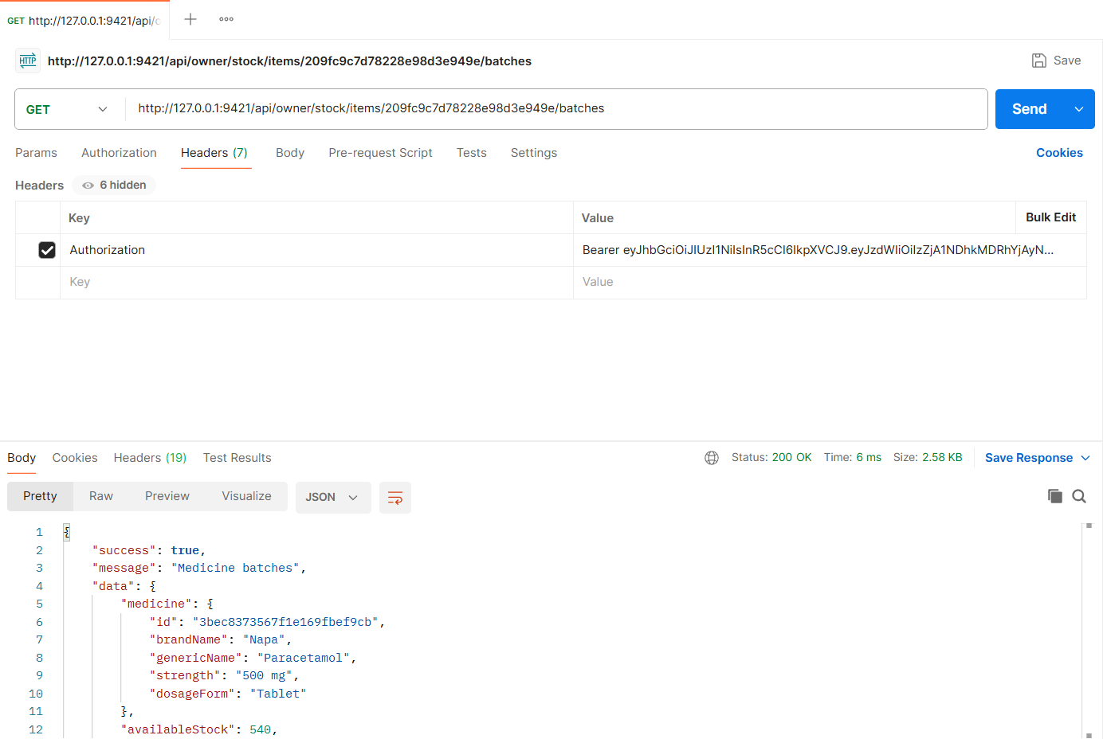
Figure: M1-F2-03 - GET /api/owner/stock/items/209fc9c7d78228e98d3e949e/batches tested in Postman (status 200)
API 4: Edit stock batch
Purpose | Correct a batch (quantity, dates, purchase price). Stock is recalculated.
Endpoint URL | http://127.0.0.1:9421/api/owner/stock/batches/:batchId
HTTP Method | PATCH
Headers | Authorization: Bearer <JWT of owner account>  Content-Type: application/json
Authentication | JWT required - role: Pharmacy owner
Body / Parameters | JSON body:  {  "quantity": 180  }  Path parameters: batchId (id returned by an earlier request)
Status code | Expected 200 OK; returned 200 OK in the Postman test below

Example request (cURL):
curl -X PATCH "http://127.0.0.1:9421/api/owner/stock/batches/<batchId>" \
-H "Authorization: Bearer <ownerToken>" \
-H "Content-Type: application/json" \
-d '{"quantity": 180}'

Example response (200 OK, recorded from the Postman collection run):
{
"success": true,
"message": "Batch updated",
"data": {
"batch": {
"id": "6aeb8dd672dad8d54ca52f96",
"batchNumber": "NP-2501",
"quantity": 180,
"initialQuantity": 200,
"manufacturingDate": "2026-06-10T00:00:00.000Z",
"expiryDate": "2028-06-10T00:00:00.000Z",
"purchasePrice": 0.85,
"source": "delivery",
"timeLeft": "1 year",
"daysLeft": 584,
"status": "Good"
},
"availableStock": 520
}
}

Code snippet (route -> controller -> service):
// src/routes/stock.routes.js
router.patch('/owner/stock/batches/:batchId', owner, validate(idParam('batchId'), 'params'), validate(v.updateBatch), ctrl.updateBatch);

// src/controllers/stock.controller.js
async function updateBatch(req, res) {
ok(res, await service.updateBatch(req.pharmacy, req.params.batchId, req.body), 'Batch updated');
}

// src/services/stock.service.js
async function updateBatch(pharmacy, batchId, changes) {
const batch = await findOwnedBatch(pharmacy, batchId);
if (batch.source === 'adjustment' && (changes.expiryDate || changes.batchNumber)) {
throw ApiError.badRequest('The stock adjustment batch only supports quantity changes');
}

const nextMfg = changes.manufacturingDate ?? batch.manufacturingDate;
const nextExp = changes.expiryDate ?? batch.expiryDate;
if (nextMfg && nextExp && nextMfg >= nextExp) throw ApiError.badRequest('Manufacturing date must be before the expiry date');

if (changes.batchNumber && changes.batchNumber.toUpperCase() !== batch.batchNumber) {
const dup = await InventoryBatch.exists({ catalogItem: batch.catalogItem, batchNumber: changes.batchNumber.toUpperCase() });
if (dup) throw ApiError.conflict(`Batch ${changes.batchNumber.toUpperCase()} already exists for this medicine`);
}

if (changes.quantity !== undefined) {
// keep initialQuantity >= quantity so "received" never looks smaller than "remaining"
batch.initialQuantity = Math.max(batch.initialQuantity, changes.quantity);
}
batch.set(changes);

const availableStock = await withTransaction(async (session) => {
await batch.save({ session });
return inventory.recalculateStock(batch.catalogItem, { session });
});
return { batch: formatBatch(batch), availableStock };
}

Postman screenshot:
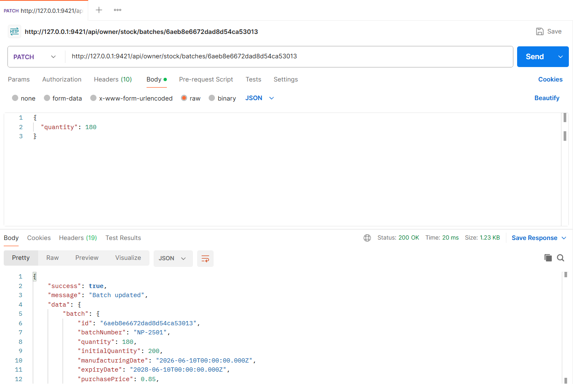
Figure: M1-F2-04 - PATCH /api/owner/stock/batches/:batchId tested in Postman (status 200)
API 5: Expiry inventory (30 / 60 / 90 days)
Purpose | Batches expiring within the selected window (30, 60 or 90 days) or already expired, with counts for every window.
Endpoint URL | http://127.0.0.1:9421/api/owner/stock/expiry
HTTP Method | GET
Headers | Authorization: Bearer <JWT of owner account>
Authentication | JWT required - role: Pharmacy owner
Body / Parameters | Query parameters:  window = 30
Status code | Expected 200 OK; returned 200 OK in the Postman test below

Example request (cURL):
curl -X GET "http://127.0.0.1:9421/api/owner/stock/expiry?window=30" \
-H "Authorization: Bearer <ownerToken>"

Example response (200 OK, recorded from the Postman collection run):
{
"success": true,
"message": "Expiry inventory",
"data": {
"window": "30 days",
"counts": {
"within30Days": 2,
"within60Days": 4,
"within90Days": 6,
"expired": 2
},
"batches": [
{
"catalogItemId": "74b69d848a77075e3a3f381f",
"medicine": {
"id": "f0d40c262d508a24feeb4563",
"brandName": "Seclo 20",
"genericName": "Omeprazole",
"strength": "20 mg",
"dosageForm": "Capsule"
},
"id": "6aeb8dd09f44bd620e171e5b",
"batchNumber": "SC-2208",
"quantity": 18,
"initialQuantity": 18,
"manufacturingDate": "2026-05-08T19:55:59.218Z",
"expiryDate": "2026-11-24T19:55:59.218Z",
"purchasePrice": 4.5,
... (truncated - full response in the Postman screenshot / collection run)

Code snippet (route -> controller -> service):
// src/routes/stock.routes.js
router.get('/owner/stock/expiry', owner, validate(v.expiryQuery, 'query'), ctrl.expiryInventory);

// src/controllers/stock.controller.js
async function expiryInventory(req, res) {
ok(res, await service.expiryInventory(req.pharmacy, req.validatedQuery), 'Expiry inventory');
}

// src/services/stock.service.js
/** Expiry inventory: batches expiring within 30/60/90 days, or already expired. */
async function expiryInventory(pharmacy, { window }) {
const now = new Date();
const base = { pharmacy: pharmacy._id, quantity: { $gt: 0 }, expiryDate: { $ne: null } };
const within = (days) => ({ ...base, expiryDate: { $gt: now, $lte: addDays(now, days) } });
const expiredFilter = { ...base, expiryDate: { $ne: null, $lte: now } };

const [c30, c60, c90, cExpired] = await Promise.all([
InventoryBatch.countDocuments(within(30)),
InventoryBatch.countDocuments(within(60)),
InventoryBatch.countDocuments(within(90)),
InventoryBatch.countDocuments(expiredFilter),
]);

const filter = window === 'expired' ? expiredFilter : within(Number(window));
const batches = await InventoryBatch.find(filter)
.populate({ path: 'catalogItem', populate: { path: 'medicine' } })
.sort({ expiryDate: 1 });

return {
window: window === 'expired' ? 'expired' : `${window} days`,
counts: { within30Days: c30, within60Days: c60, within90Days: c90, expired: cExpired },
batches: batches
.filter((b) => b.catalogItem && b.catalogItem.isActive)
.map((b) => ({
catalogItemId: b.catalogItem._id,
medicine: medicineLabel(b.catalogItem.medicine),
...formatBatch(b, now),
warning: batchStatus(b, now) === 'Expired' ? 'Expired - remove from shelf' : `Expires in ${timeLeftLabel(b.expiryDate, now)}`,
})),
};
}

Postman screenshot:
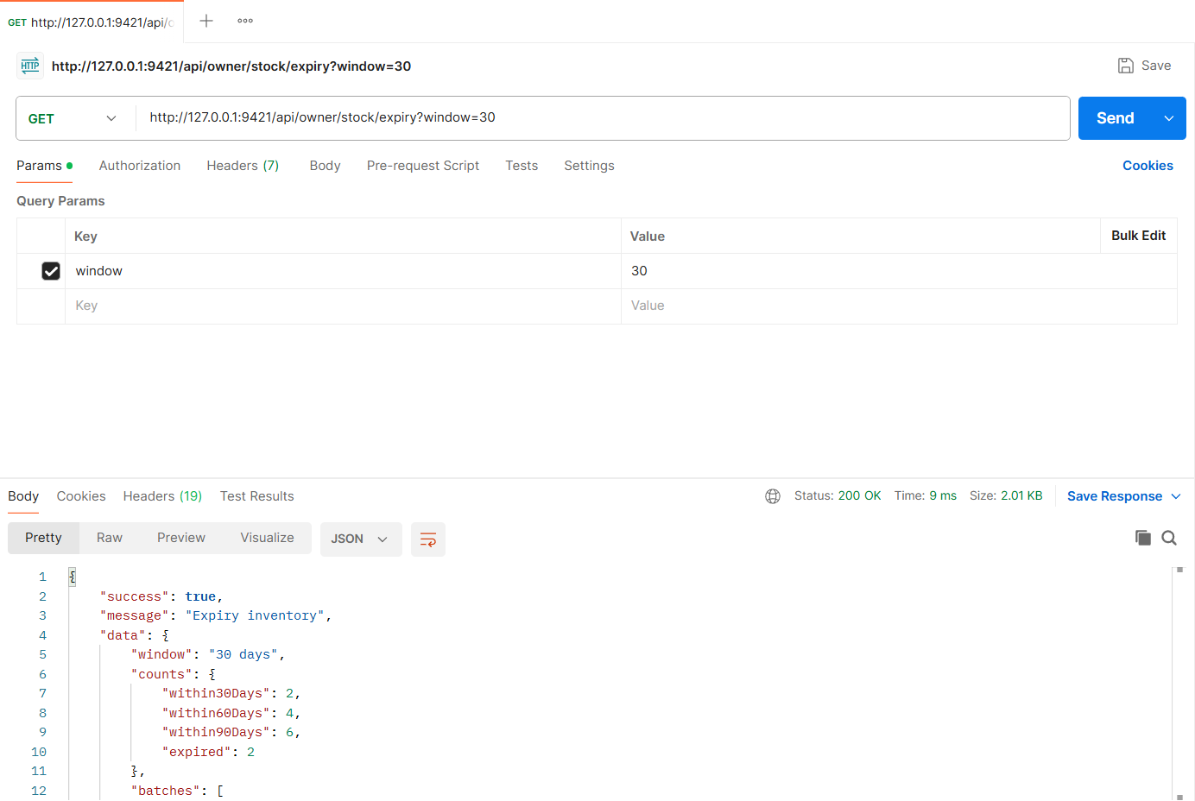
Figure: M1-F2-05 - GET /api/owner/stock/expiry tested in Postman (status 200)
API 6: Dispense stock (earliest-expiring batch first)
Purpose | Counter sale: removes units using the earliest-expiring non-expired batch first (the same engine used when a reservation is collected). Expired batches are never used.
Endpoint URL | http://127.0.0.1:9421/api/owner/stock/items/209fc9c7d78228e98d3e949e/dispense
HTTP Method | POST
Headers | Authorization: Bearer <JWT of owner account>  Content-Type: application/json
Authentication | JWT required - role: Pharmacy owner
Body / Parameters | JSON body:  {  "quantity": 130,  "note": "Walk-in sale"  }
Status code | Expected 200 OK; returned 200 OK in the Postman test below

Example request (cURL):
curl -X POST "http://127.0.0.1:9421/api/owner/stock/items/209fc9c7d78228e98d3e949e/dispense" \
-H "Authorization: Bearer <ownerToken>" \
-H "Content-Type: application/json" \
-d '{"quantity": 130, "note": "Walk-in sale"}'

Example response (200 OK, recorded from the Postman collection run):
{
"success": true,
"message": "Stock dispensed (earliest expiry first)",
"data": {
"medicine": {
"id": "3bec8373567f1e169fbef9cb",
"brandName": "Napa",
"genericName": "Paracetamol",
"strength": "500 mg",
"dosageForm": "Tablet"
},
"dispensed": 130,
"note": "Walk-in sale",
"consumedBatches": [
{
"batch": "6aeb8dd09f44bd620e171e4e",
"batchNumber": "NP-2411",
"quantity": 120
},
{
"batch": "6aeb8dd09f44bd620e171e52",
"batchNumber": "NP-2409",
"quantity": 10
}
],
"availableStock": 390
}
}

Code snippet (route -> controller -> service):
// src/routes/stock.routes.js
router.post('/owner/stock/items/:itemId/dispense', owner, validate(idParam('itemId'), 'params'), validate(v.dispense), ctrl.dispense);

// src/controllers/stock.controller.js
async function dispense(req, res) {
ok(res, await service.dispense(req.pharmacy, req.params.itemId, req.body), 'Stock dispensed (earliest expiry first)');
}

// src/services/stock.service.js
/** Counter sale / dispense: removes stock using earliest-expiring batch first. */
async function dispense(pharmacy, itemId, { quantity, note }) {
const item = await findOwnedItem(pharmacy, itemId);
const consumed = await withTransaction((session) => inventory.consumeFEFO(item._id, quantity, session));
const fresh = await CatalogItem.findById(item._id);
return { medicine: medicineLabel(item.medicine), dispensed: quantity, note, consumedBatches: consumed, availableStock: fresh.stockQuantity };
}

// src/services/inventory.service.js
/**
* Removes `quantity` units using FEFO. Returns [{ batch, batchNumber, quantity }].
* Throws 409 when non-expired stock is insufficient.
*/
async function consumeFEFO(catalogItemId, quantity, session) {
const batches = await availableBatches(catalogItemId, session);
const available = batches.reduce((sum, b) => sum + b.quantity, 0);
if (available < quantity) {
throw ApiError.conflict(`Insufficient non-expired stock: requested ${quantity}, available ${available}`);
}

const consumed = [];
let remaining = quantity;
for (const batch of batches) {
if (remaining === 0) break;
const take = Math.min(batch.quantity, remaining);
// conditional update guards against concurrent consumption of the same batch
const res = await InventoryBatch.updateOne(
{ _id: batch._id, quantity: { $gte: take } },
{ $inc: { quantity: -take } },
{ session }
);
if (res.modifiedCount !== 1) throw ApiError.conflict('Stock changed while processing, please retry');
consumed.push({ batch: batch._id, batchNumber: batch.batchNumber, quantity: take });
remaining -= take;
}
await recalculateStock(catalogItemId, { session });
return consumed;
}

Postman screenshot:
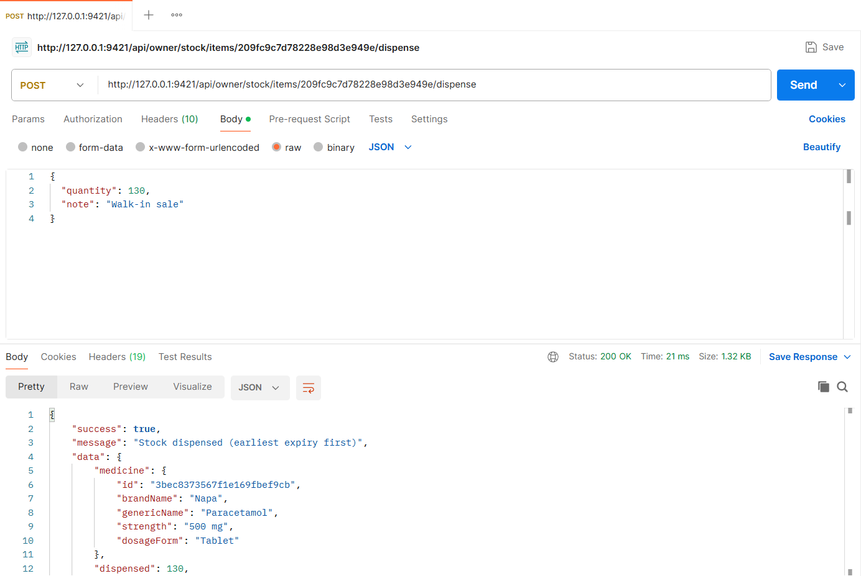
Figure: M1-F2-06 - POST /api/owner/stock/items/209fc9c7d78228e98d3e949e/dispense tested in Postman (status 200)
API 7: Remove stock batch
Purpose | Delete a wrongly entered batch; available stock is recalculated.
Endpoint URL | http://127.0.0.1:9421/api/owner/stock/batches/:batchId
HTTP Method | DELETE
Headers | Authorization: Bearer <JWT of owner account>
Authentication | JWT required - role: Pharmacy owner
Body / Parameters | Path parameters: batchId (id returned by an earlier request)
Status code | Expected 200 OK; returned 200 OK in the Postman test below

Example request (cURL):
curl -X DELETE "http://127.0.0.1:9421/api/owner/stock/batches/<batchId>" \
-H "Authorization: Bearer <ownerToken>"

Example response (200 OK, recorded from the Postman collection run):
{
"success": true,
"message": "Batch removed",
"data": {
"deletedBatch": "NP-2501",
"availableStock": 210
}
}

Code snippet (route -> controller -> service):
// src/routes/stock.routes.js
router.delete('/owner/stock/batches/:batchId', owner, validate(idParam('batchId'), 'params'), ctrl.deleteBatch);

// src/controllers/stock.controller.js
async function deleteBatch(req, res) {
ok(res, await service.deleteBatch(req.pharmacy, req.params.batchId), 'Batch removed');
}

// src/services/stock.service.js
async function deleteBatch(pharmacy, batchId) {
const batch = await findOwnedBatch(pharmacy, batchId);
const availableStock = await withTransaction(async (session) => {
await InventoryBatch.deleteOne({ _id: batch._id }, { session });
return inventory.recalculateStock(batch.catalogItem, { session });
});
return { deletedBatch: batch.batchNumber, availableStock };
}

Postman screenshot:
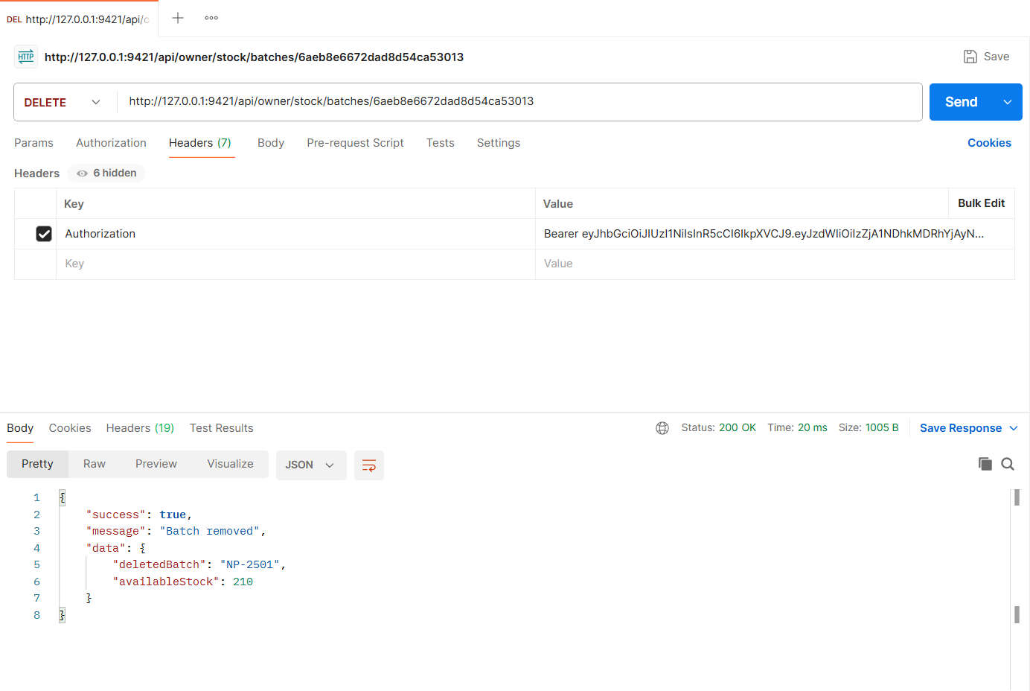
Figure: M1-F2-07 - DELETE /api/owner/stock/batches/:batchId tested in Postman (status 200)
Validation and error-handling tests (Feature 02)
The same APIs were also tested with invalid input, wrong roles and invalid state changes. Each request below was sent from Postman to the running server.
Duplicate batch number (409)
Request | POST http://127.0.0.1:9421/api/owner/stock/batches
Scenario | Batch numbers are unique per medicine.
Body / Parameters | JSON body:  {  "catalogItemId": "209fc9c7d78228e98d3e949e",  "batchNumber": "NP-2412",  "quantity": 10,  "expiryDate": "2028-01-01"  }
Result | Expected 409 Conflict; returned 409 Conflict

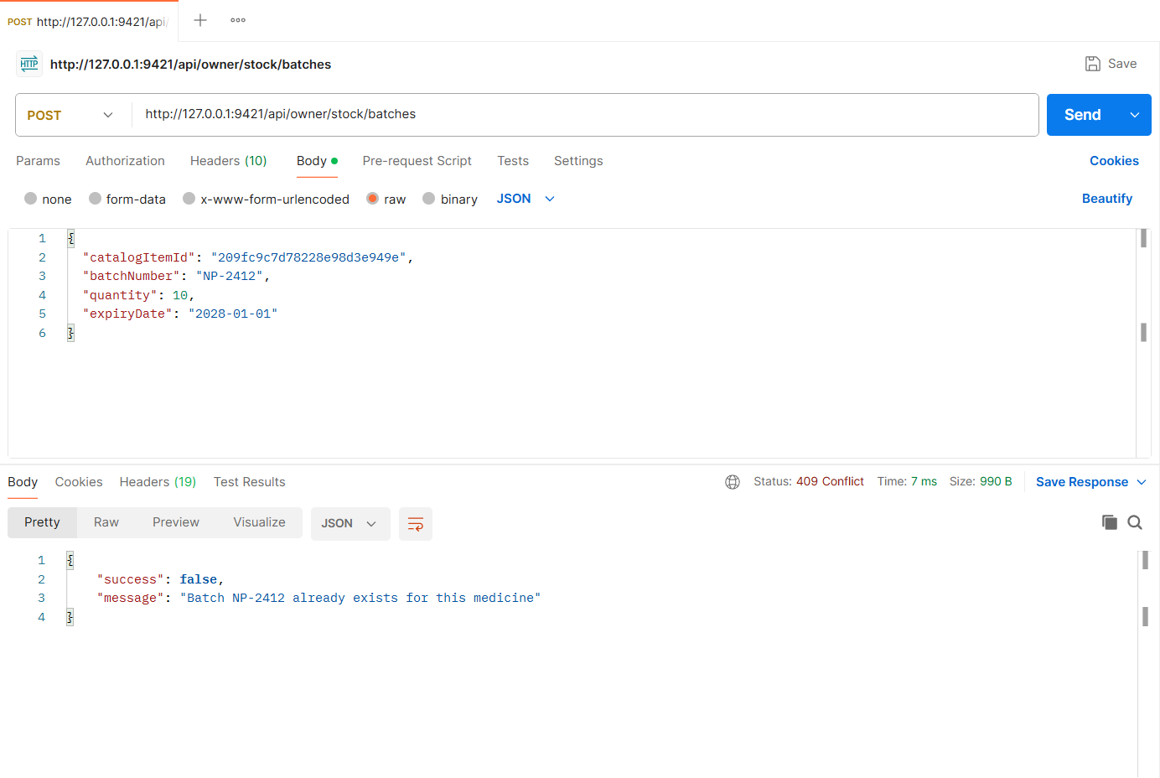
Figure: M1-F2-N2 - Duplicate batch number (409)
Expired batch rejected (400)
Request | POST http://127.0.0.1:9421/api/owner/stock/batches
Scenario | A batch whose expiry date has already passed cannot be added as stock.
Body / Parameters | JSON body:  {  "catalogItemId": "209fc9c7d78228e98d3e949e",  "batchNumber": "NP-OLD1",  "quantity": 50,  "expiryDate": "2025-12-31"  }
Result | Expected 400 Bad Request; returned 400 Bad Request

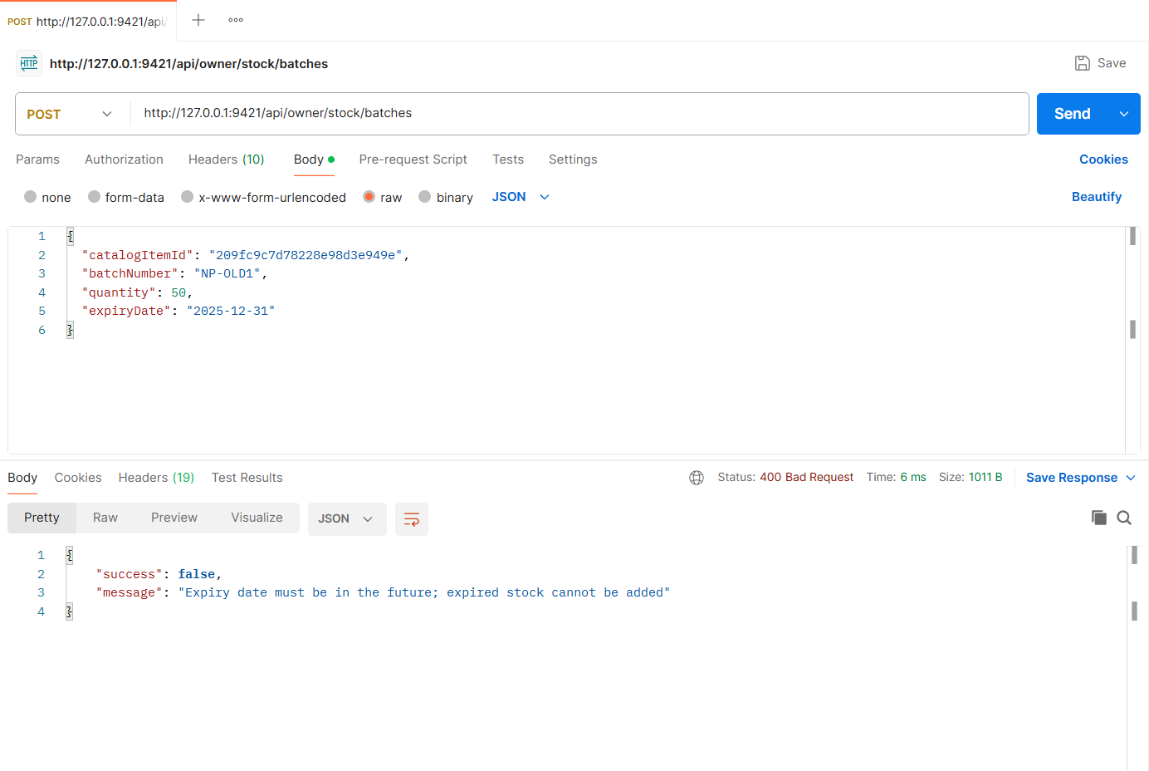
Figure: M1-F2-N1 - Expired batch rejected (400)
Insufficient non-expired stock (409)
Request | POST http://127.0.0.1:9421/api/owner/stock/items/209fc9c7d78228e98d3e949e/dispense
Scenario | Dispensing more than the non-expired stock is rejected.
Body / Parameters | JSON body:  {  "quantity": 5000  }
Result | Expected 409 Conflict; returned 409 Conflict

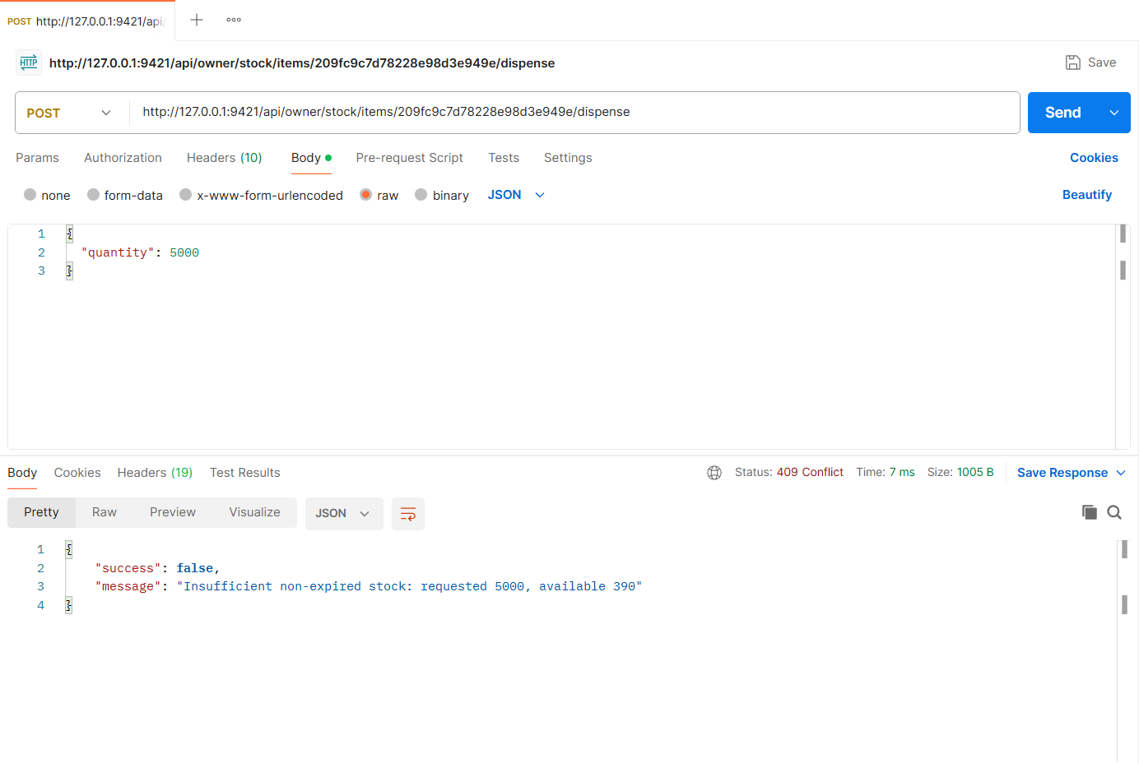
Figure: M1-F2-N3 - Insufficient non-expired stock (409)
Implementation Notes
Project | MedFind BD - medicine availability and reservation platform (CSE471, Group 02, Section 03)
Tech stack | Node.js, Express.js 5, MongoDB (MongoDB Atlas in deployment, local replica set in development), Mongoose 8, JWT + bcrypt, Multer + Cloudinary (local-disk fallback), node-cron, zod validation
My server | cd backend  npm install  npm run seed  npm run start:member1  -> http://127.0.0.1:9421/api/health
Environment | backend/.env (copy of .env.example): MONGODB_URI, JWT_SECRET, PORT_MEMBER1..4, CLOUDINARY_*, SENDGRID_API_KEY, business-rule settings
Postman | Import postman/Member1/Member1_22299421.postman_collection.json, run the "00 Setup" login requests (if present), then run each feature folder top to bottom. File fields use postman/assets/*.
Architecture | routes (URL + middleware) -> controllers (HTTP in/out) -> services (business logic) -> Mongoose models. Central error handler returns { success, message, errors }.

Database connection (src/config/db.js):
const mongoose = require('mongoose');
const env = require('./env');

mongoose.set('strictQuery', true);

async function connectDB(uri = env.mongoUri) {
await mongoose.connect(uri, { serverSelectionTimeoutMS: 10000 });
const { host, name } = mongoose.connection;
console.log(`[db] connected to MongoDB ${host}/${name}`);
return mongoose.connection;
}

async function disconnectDB() {
await mongoose.disconnect();
}

module.exports = { connectDB, disconnectDB };

