

CSE471 : System Analysis and Design
Lab Assignment on API Postman Collection

Project Title : MedFind BD
Group Number : 02
Backend Framework : Node.js + Express.js (MongoDB Atlas, Mongoose)

Submitted by : Abdullah Al Zahur Rafi
Student ID : 22299050
Section: 03

Date : 05 November 2026
APIs of Feature - 01: Medicine Details & Reservation Request
Server: Member 2 backend, started with "npm run start:member2" on port 9050 (last four digits of student ID 22299050). Base URL: http://127.0.0.1:9050. Database: MongoDB (Mongoose ODM), connected at server start.
Method | Endpoint - API
1. GET | /api/medicines/3bec8373567f1e169fbef9cb - Medicine details with pharmacy availability
2. GET | /api/medicines/3bec8373567f1e169fbef9cb/pharmacies/0367672641e1463cf4ee98cd/availability - Pharmacy availability & reservation summary
3. POST | /api/reservations - Send reservation request
4. PUT | /api/reservations/:reservationId/prescription - Upload prescription image

API 1: Medicine details with pharmacy availability
Purpose | Medicine details page: medicine information, prescription requirement, price range and every verified pharmacy that lists it with price, reported stock, rating and last-updated time.
Endpoint URL | http://127.0.0.1:9050/api/medicines/3bec8373567f1e169fbef9cb
HTTP Method | GET
Headers | None
Authentication | Public (no login required)
Body / Parameters | Query parameters:  sort = price
Status code | Expected 200 OK; returned 200 OK in the Postman test below

Example request (cURL):
curl -X GET "http://127.0.0.1:9050/api/medicines/3bec8373567f1e169fbef9cb?sort=price"

Example response (200 OK, recorded from the Postman collection run):
{
"success": true,
"message": "Medicine details",
"data": {
"medicine": {
"id": "3bec8373567f1e169fbef9cb",
"brandName": "Napa",
"genericName": "Paracetamol",
"manufacturer": "Beximco Pharmaceuticals",
"strength": "500 mg",
"dosageForm": "Tablet",
"unit": "pc",
"requiresPrescription": false
},
"prescription": "Prescription: not required",
"disclaimer": "Used for general medicine information only. Ask your pharmacist or doctor for medical advice.",
"priceRange": {
"min": 1,
"max": 1.5,
"unit": "pc"
},
"pharmacyCount": 5,
"pharmacies": [
{
"catalogItemId": "edbb2441e262aa3e846986b0",
"pharmacy": {
"id": "762db1f8dd93e1a8c9999f02",
"name": "Tamanna Pharmacy",
... (truncated - full response in the Postman screenshot / collection run)

Code snippet (route -> controller -> service):
// src/routes/reservationRequest.routes.js
router.get('/medicines/:medicineId', validate(idParam('medicineId'), 'params'), validate(v.detailsQuery, 'query'), ctrl.medicineDetails);

// src/controllers/reservationRequest.controller.js
async function medicineDetails(req, res) {
ok(res, await service.getMedicineDetails(req.params.medicineId, req.validatedQuery), 'Medicine details');
}

// src/services/reservationRequest.service.js
/** Medicine details page: which verified pharmacies list it, at what price, with what stock and when updated. */
async function getMedicineDetails(medicineId, { sort = 'price', inStockOnly = false } = {}) {
const medicine = await findPublicMedicine(medicineId);
const items = await CatalogItem.find({ medicine: medicine._id, isActive: true })
.populate({ path: 'pharmacy', match: Pharmacy.publicFilter() });

let listings = items
.filter((i) => i.pharmacy)
.map((i) => ({
catalogItemId: i._id,
pharmacy: pharmacyInfo(i.pharmacy),
price: i.price,
reportedStock: i.stockQuantity,
stockStatus: i.stockStatus,
lastUpdatedAt: i.lastUpdatedAt,
canReserve: i.stockQuantity > 0,
}));
if (inStockOnly) listings = listings.filter((l) => l.reportedStock > 0);

const sorters = {
price: (a, b) => a.price - b.price,
rating: (a, b) => b.pharmacy.rating - a.pharmacy.rating,
updated: (a, b) => b.lastUpdatedAt - a.lastUpdatedAt,
stock: (a, b) => b.reportedStock - a.reportedStock,
};
listings.sort(sorters[sort] || sorters.price);

const prices = listings.map((l) => l.price);
return {
medicine: medicineInfo(medicine),
prescription: medicine.requiresPrescription ? 'Prescription required' : 'Prescription: not required',
disclaimer: DISCLAIMER,
priceRange: prices.length ? { min: Math.min(...prices), max: Math.max(...prices), unit: medicine.unit } : null,
pharmacyCount: listings.length,
pharmacies: listings,
note: 'Prices and stock are reported by pharmacies. Pharmacies must confirm availability before you travel.',
};
}

Postman screenshot:
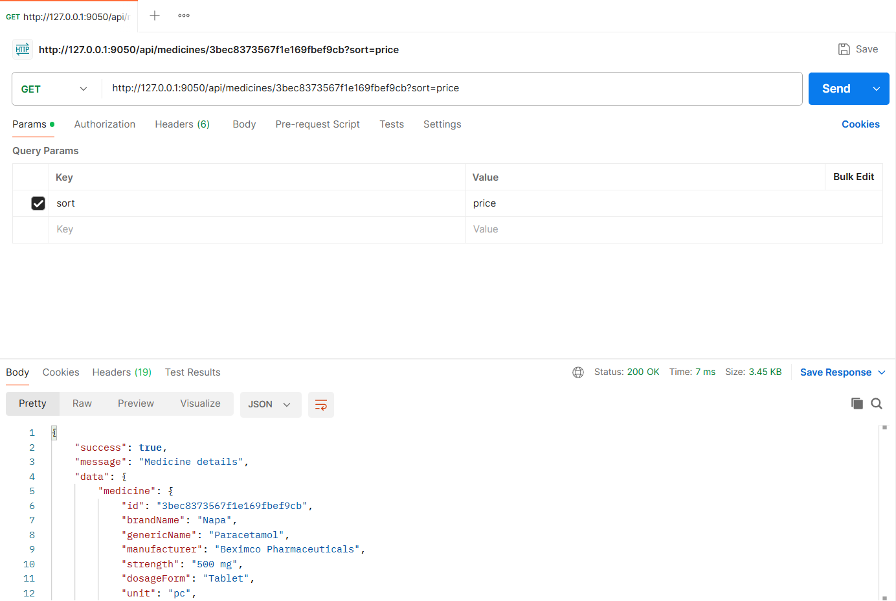
Figure: M2-F1-01 - GET /api/medicines/3bec8373567f1e169fbef9cb tested in Postman (status 200)
API 2: Pharmacy availability & reservation summary
Purpose | Reservation form summary for one pharmacy: price per unit, reported stock, units that can still be reserved, estimated total, prescription requirement and pickup rules.
Endpoint URL | http://127.0.0.1:9050/api/medicines/3bec8373567f1e169fbef9cb/pharmacies/0367672641e1463cf4ee98cd/availability
HTTP Method | GET
Headers | None
Authentication | Public (no login required)
Body / Parameters | Query parameters:  quantity = 10
Status code | Expected 200 OK; returned 200 OK in the Postman test below

Example request (cURL):
curl -X GET "http://127.0.0.1:9050/api/medicines/3bec8373567f1e169fbef9cb/pharmacies/0367672641e1463cf4ee98cd/availability?quantity=10"

Example response (200 OK, recorded from the Postman collection run):
{
"success": true,
"message": "Pharmacy availability",
"data": {
"medicine": {
"id": "3bec8373567f1e169fbef9cb",
"brandName": "Napa",
"genericName": "Paracetamol",
"manufacturer": "Beximco Pharmaceuticals",
"strength": "500 mg",
"dosageForm": "Tablet",
"unit": "pc",
"requiresPrescription": false
},
"pharmacy": {
"id": "0367672641e1463cf4ee98cd",
"name": "Lazz Pharma",
"area": "Mirpur 10",
"address": "House 12, Road 3, Mirpur 10, Dhaka",
"verified": true,
"rating": 4.8,
"ratingCount": 5,
"openNow": false,
"openingHours": "Daily 9:00 AM - 10:00 PM"
},
"catalogItemId": "209fc9c7d78228e98d3e949e",
"pricePerUnit": 1.2,
"reportedStock": 340,
... (truncated - full response in the Postman screenshot / collection run)

Code snippet (route -> controller -> service):
// src/routes/reservationRequest.routes.js
router.get('/medicines/:medicineId/pharmacies/:pharmacyId/availability', validate(listingParams, 'params'), validate(v.availabilityQuery, 'query'), ctrl.availability);

// src/controllers/reservationRequest.controller.js
async function availability(req, res) {
const { medicineId, pharmacyId } = req.params;
ok(res, await service.getAvailability(medicineId, pharmacyId, req.validatedQuery.quantity), 'Pharmacy availability');
}

// src/services/reservationRequest.service.js
/** Reservation form summary: price, reported stock, how many units can still be reserved, estimated total. */
async function getAvailability(medicineId, pharmacyId, quantity = 1) {
const { medicine, pharmacy, item } = await findListing(medicineId, pharmacyId);
const reservable = await inventory.reservableQuantity(item);
return {
medicine: medicineInfo(medicine),
pharmacy: pharmacyInfo(pharmacy),
catalogItemId: item._id,
pricePerUnit: item.price,
reportedStock: item.stockQuantity,
lastUpdatedAt: item.lastUpdatedAt,
reservableQuantity: reservable,
quantity,
estimatedTotal: Number((item.price * quantity).toFixed(2)),
canReserve: reservable >= quantity,
prescriptionRequired: medicine.requiresPrescription,
pickupRules: {
minLeadMinutes: env.reservation.minLeadMinutes,
maxDaysAhead: env.reservation.maxDaysAhead,
openingHours: pharmacy.openingHoursText,
},
note: 'Final price is confirmed by the pharmacy.',
};
}

Postman screenshot:
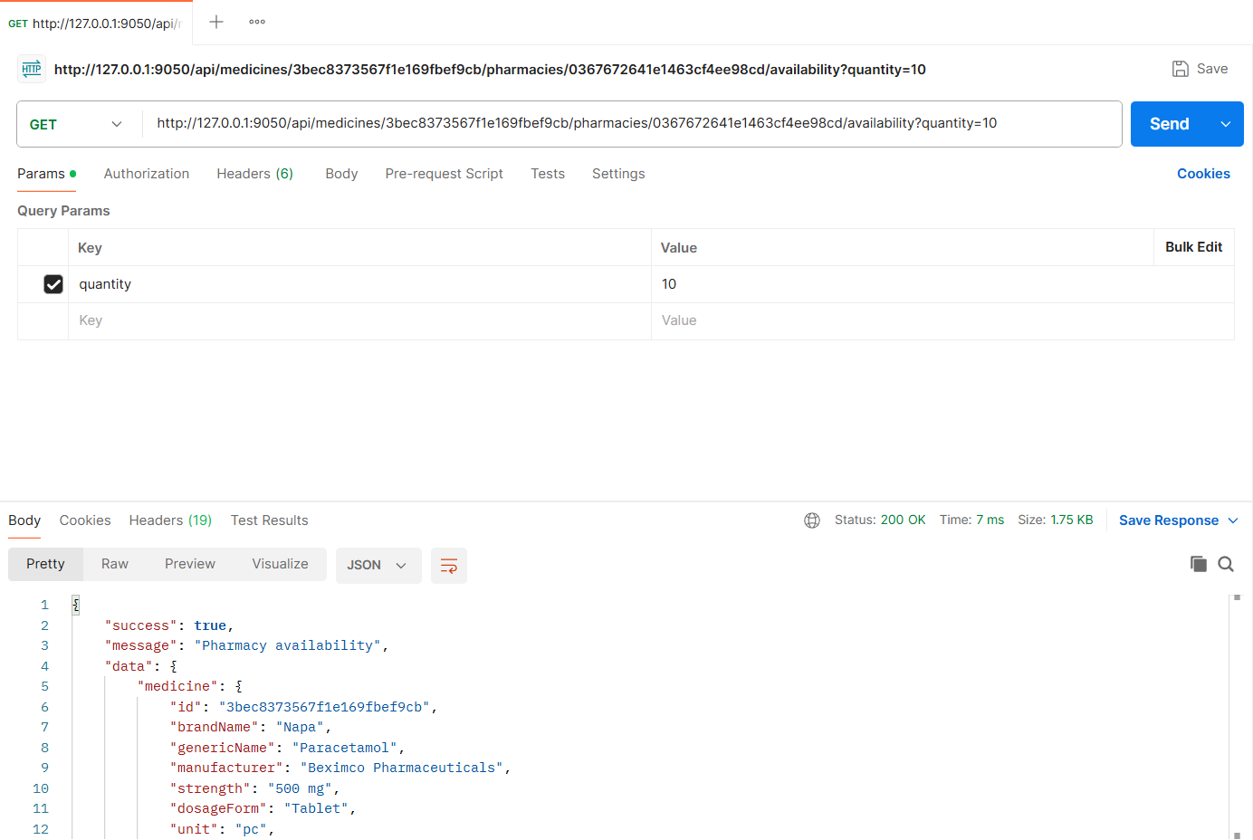
Figure: M2-F1-02 - GET /api/medicines/3bec8373567f1e169fbef9cb/pharmacies/0367672641e1463cf4ee98cd/availability tested in Postman (status 200)
API 3: Send reservation request
Purpose | Patient reserves a medicine: quantity, preferred pickup date and time, optional note and optional prescription image (required for prescription-only medicines). The request is created as "Pending" and the owner is notified.
Endpoint URL | http://127.0.0.1:9050/api/reservations
HTTP Method | POST
Headers | Authorization: Bearer <JWT of patient2 account>  Content-Type: multipart/form-data (set automatically by Postman)
Authentication | JWT required - role: Patient
Body / Parameters | form-data:  medicineId = 3bec8373567f1e169fbef9cb  pharmacyId = 0367672641e1463cf4ee98cd  quantity = 10  pickupDate = {{pickupDate}}  pickupTime = 18:00  note = I need the 500 mg strip only
Status code | Expected 201 Created; returned 201 Created in the Postman test below

Example request (cURL):
curl -X POST "http://127.0.0.1:9050/api/reservations" \
-H "Authorization: Bearer <patient2Token>" \
-F "medicineId=3bec8373567f1e169fbef9cb" \
-F "pharmacyId=0367672641e1463cf4ee98cd" \
-F "quantity=10" \
-F "pickupDate={{pickupDate}}" \
-F "pickupTime=18:00" \
-F "note=I need the 500 mg strip only"

Example response (201 Created, recorded from the Postman collection run):
{
"success": true,
"message": "Reservation request sent",
"data": {
"reservation": {
"id": "6aeb8dde98cb47d48631c371",
"code": "R-1019",
"status": "Pending",
"statusLabel": "Pending",
"medicine": "Napa 500 mg x 10",
"pharmacy": "Lazz Pharma, Mirpur 10",
"quantity": 10,
"unitPrice": 1.2,
"estimatedTotal": 12,
"pickupAt": "2026-11-06T12:00:00.000Z",
"pickupDeadline": "2026-11-06T14:00:00.000Z",
"prescriptionUrl": null
},
"message": "Lazz Pharma will confirm your reservation soon."
}
}

Code snippet (route -> controller -> service):
// src/routes/reservationRequest.routes.js
router.post('/reservations', patient, imageUpload.single('prescription'), validate(v.createReservation), ctrl.createReservation);

// src/controllers/reservationRequest.controller.js
async function createReservation(req, res) {
const data = await service.createReservation(req.user, req.body, req.file);
created(res, data, 'Reservation request sent');
}

// src/services/reservationRequest.service.js
async function createReservation(patient, { medicineId, pharmacyId, quantity, pickupDate, pickupTime, note }, prescriptionFile) {
const { medicine, pharmacy, item } = await findListing(medicineId, pharmacyId);

if (medicine.requiresPrescription && !prescriptionFile) {
throw ApiError.badRequest(`${medicine.brandName} is a prescription-only medicine. Please upload a prescription image.`);
}

const pickupAt = validatePickup(pharmacy, pickupDate, pickupTime);

const duplicate = await Reservation.exists({
patient: patient._id, catalogItem: item._id, status: { $in: Reservation.ACTIVE_STATUSES },
});
if (duplicate) throw ApiError.conflict('You already have an active reservation for this medicine at this pharmacy');

const reservable = await inventory.reservableQuantity(item);
if (quantity > reservable) {
throw ApiError.conflict(`Only ${reservable} unit(s) can be reserved at this pharmacy right now`);
}

const prescription = prescriptionFile ? await storage.saveImage(prescriptionFile, 'prescriptions') : undefined;
const seq = await Counter.next('reservation', 1000);

const reservation = await Reservation.create({
code: `R-${seq}`,
patient: patient._id,
pharmacy: pharmacy._id,
catalogItem: item._id,
medicine: medicine._id,
medicineSnapshot: {
brandName: medicine.brandName, genericName: medicine.genericName, strength: medicine.strength,
dosageForm: medicine.dosageForm, manufacturer: medicine.manufacturer, requiresPrescription: medicine.requiresPrescription,
},
pharmacySnapshot: { name: pharmacy.name, area: pharmacy.address.area },
quantity,
unitPrice: item.price,
totalPrice: Number((item.price * quantity).toFixed(2)),
pickupAt,
pickupDeadline: new Date(pickupAt.getTime() + env.reservation.graceMinutes * 60000),
note,
prescription,
status: 'Pending',
statusHistory: [{ status: 'Pending', by: patient._id, note: 'Request sent' }],
});

notify(pharmacy.owner, {
type: 'new_reservation',
title: `New reservation ${reservation.code}`,
message: `${patient.name} requested ${medicine.brandName} ${medicine.strength} x ${quantity} for pickup at ${pickupAt.toISOString()}.`,
data: { reservationId: reservation._id },
});

return {
reservation: {
id: reservation._id,
code: reservation.code,
status: reservation.status,
statusLabel: reservation.statusLabel,
medicine: `${medicine.brandName} ${medicine.strength} x ${quantity}`,
pharmacy: `${pharmacy.name}, ${pharmacy.address.area}`,
quantity,
unitPrice: reservation.unitPrice,
estimatedTotal: reservation.totalPrice,
pickupAt: reservation.pickupAt,
pickupDeadline: reservation.pickupDeadline,
prescriptionUrl: prescription ? prescription.url : null,
},
message: `${pharmacy.name} will confirm your reservation soon.`,
};
}

// src/services/reservationRequest.service.js
function validatePickup(pharmacy, pickupDate, pickupTime) {
const pickupAt = localDateTime(pickupDate, pickupTime);
if (!pickupAt) throw ApiError.badRequest('Invalid pickup date or time');
const now = new Date();
const earliest = new Date(now.getTime() + env.reservation.minLeadMinutes * 60000);
if (pickupAt < earliest) {
throw ApiError.badRequest(`Pickup time must be at least ${env.reservation.minLeadMinutes} minutes from now`);
}
if (pickupAt > addDays(now, env.reservation.maxDaysAhead)) {
throw ApiError.badRequest(`Pickup must be within ${env.reservation.maxDaysAhead} days`);
}
if (pharmacy.openingHours.length && !isOpenAt(pharmacy.openingHours, pickupAt)) {
throw ApiError.badRequest(`The pharmacy is closed at the selected pickup time (${pharmacy.openingHoursText || 'see opening hours'})`);
}
return pickupAt;
}

Postman screenshot:
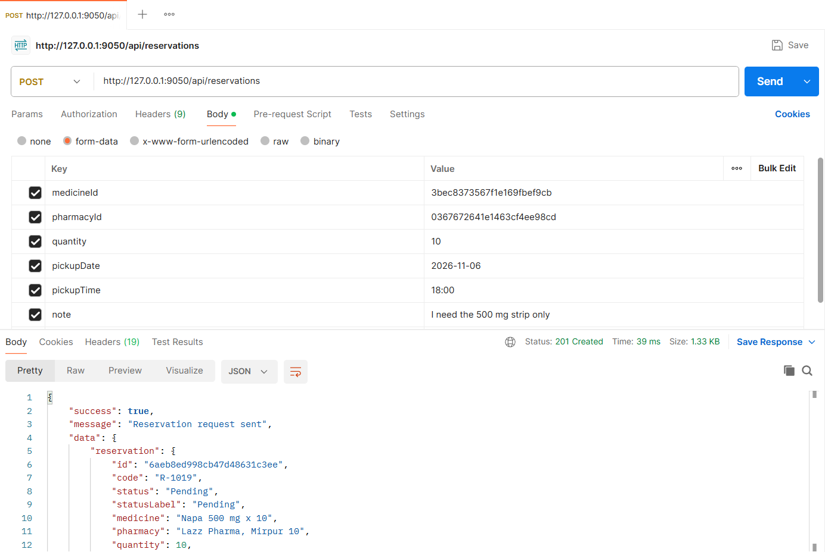
Figure: M2-F1-03 - POST /api/reservations tested in Postman (status 201)
API 4: Upload prescription image
Purpose | Attach or replace the prescription image while the reservation is still Pending (PNG/JPG up to 5 MB).
Endpoint URL | http://127.0.0.1:9050/api/reservations/:reservationId/prescription
HTTP Method | PUT
Headers | Authorization: Bearer <JWT of patient2 account>  Content-Type: multipart/form-data (set automatically by Postman)
Authentication | JWT required - role: Patient
Body / Parameters | form-data:  prescription = (file) sample-prescription.png  Path parameters: reservationId (id returned by an earlier request)
Status code | Expected 200 OK; returned 200 OK in the Postman test below

Example request (cURL):
curl -X PUT "http://127.0.0.1:9050/api/reservations/<reservationId>/prescription" \
-H "Authorization: Bearer <patient2Token>" \
-F "prescription=@sample-prescription.png"

Example response (200 OK, recorded from the Postman collection run):
{
"success": true,
"message": "Prescription uploaded",
"data": {
"id": "6aeb8dde98cb47d48631c371",
"code": "R-1019",
"prescriptionUrl": "/uploads/prescriptions/1793822174218-7f214214af6e.png"
}
}

Code snippet (route -> controller -> service):
// src/routes/reservationRequest.routes.js
router.put('/reservations/:id/prescription', patient, validate(idParam(), 'params'), imageUpload.single('prescription'), ctrl.uploadPrescription);

// src/controllers/reservationRequest.controller.js
async function uploadPrescription(req, res) {
ok(res, await service.uploadPrescription(req.user, req.params.id, req.file), 'Prescription uploaded');
}

// src/services/reservationRequest.service.js
/** Attach or replace the prescription image while the request is still Pending. */
async function uploadPrescription(patient, reservationId, file) {
if (!file) throw ApiError.badRequest('Prescription image is required (form-data field "prescription")');
const reservation = await Reservation.findById(reservationId);
if (!reservation) throw ApiError.notFound('Reservation not found');
if (!reservation.patient.equals(patient._id)) throw ApiError.forbidden('This reservation does not belong to you');
if (reservation.status !== 'Pending') {
throw ApiError.conflict(`Prescription can only be changed while the reservation is Pending (current: ${reservation.statusLabel})`);
}
reservation.prescription = await storage.saveImage(file, 'prescriptions');
reservation.statusHistory.push({ status: 'Pending', by: patient._id, note: 'Prescription uploaded' });
await reservation.save();
return { id: reservation._id, code: reservation.code, prescriptionUrl: reservation.prescription.url };
}

Postman screenshot:
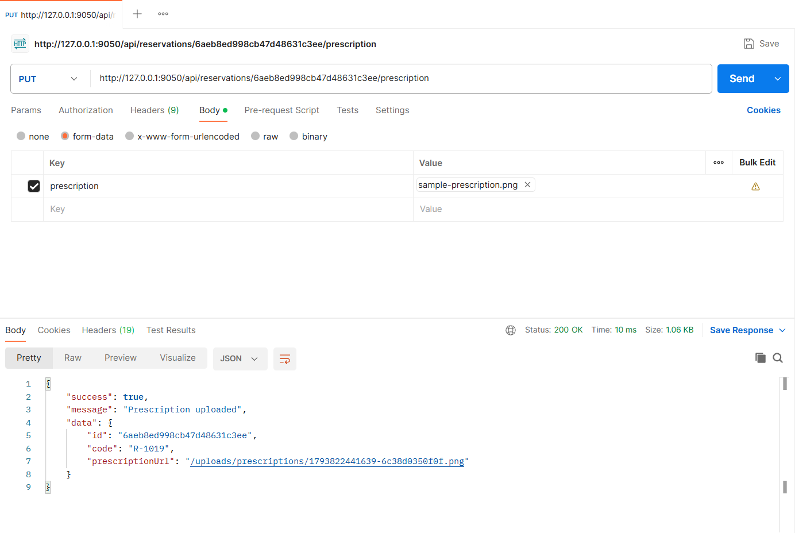
Figure: M2-F1-04 - PUT /api/reservations/:reservationId/prescription tested in Postman (status 200)
Validation and error-handling tests (Feature 01)
The same APIs were also tested with invalid input, wrong roles and invalid state changes. Each request below was sent from Postman to the running server.
Unverified pharmacy (404)
Request | GET http://127.0.0.1:9050/api/medicines/3bec8373567f1e169fbef9cb/pharmacies/24157e5f946b95812b4b9b3d/availability
Scenario | Pharmacies that are not verified cannot be reserved from.
Body / Parameters | None
Result | Expected 404 Not Found; returned 404 Not Found

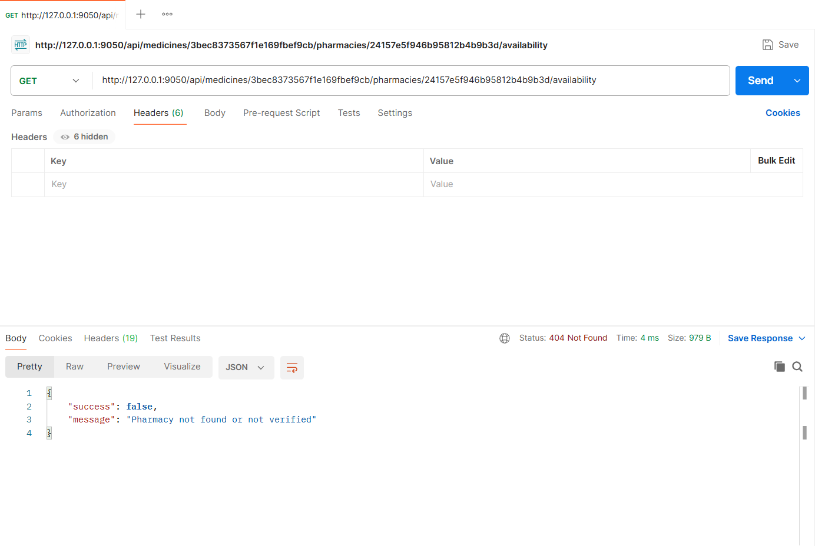
Figure: M2-F1-N4 - Unverified pharmacy (404)
Prescription-only medicine without prescription (400)
Request | POST http://127.0.0.1:9050/api/reservations
Scenario | Zimax 500 (azithromycin) requires a prescription image.
Body / Parameters | JSON body:  {  "medicineId": "1033d6bfeec8147b31105b9f",  "pharmacyId": "0367672641e1463cf4ee98cd",  "quantity": 3,  "pickupDate": "{{pickupDate}}",  "pickupTime": "18:00"  }
Result | Expected 400 Bad Request; returned 400 Bad Request

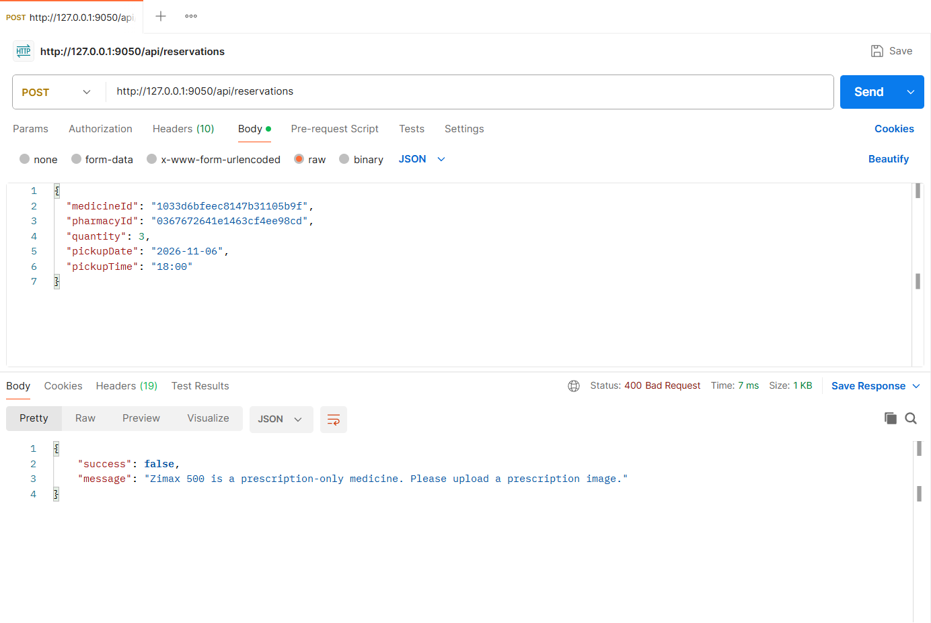
Figure: M2-F1-N1 - Prescription-only medicine without prescription (400)
Quantity exceeds available stock (409)
Request | POST http://127.0.0.1:9050/api/reservations
Scenario | Reservations cannot exceed the stock that can still be promised.
Body / Parameters | JSON body:  {  "medicineId": "3bec8373567f1e169fbef9cb",  "pharmacyId": "762db1f8dd93e1a8c9999f02",  "quantity": 200,  "pickupDate": "{{pickupDate}}",  "pickupTime": "18:00"  }
Result | Expected 409 Conflict; returned 409 Conflict

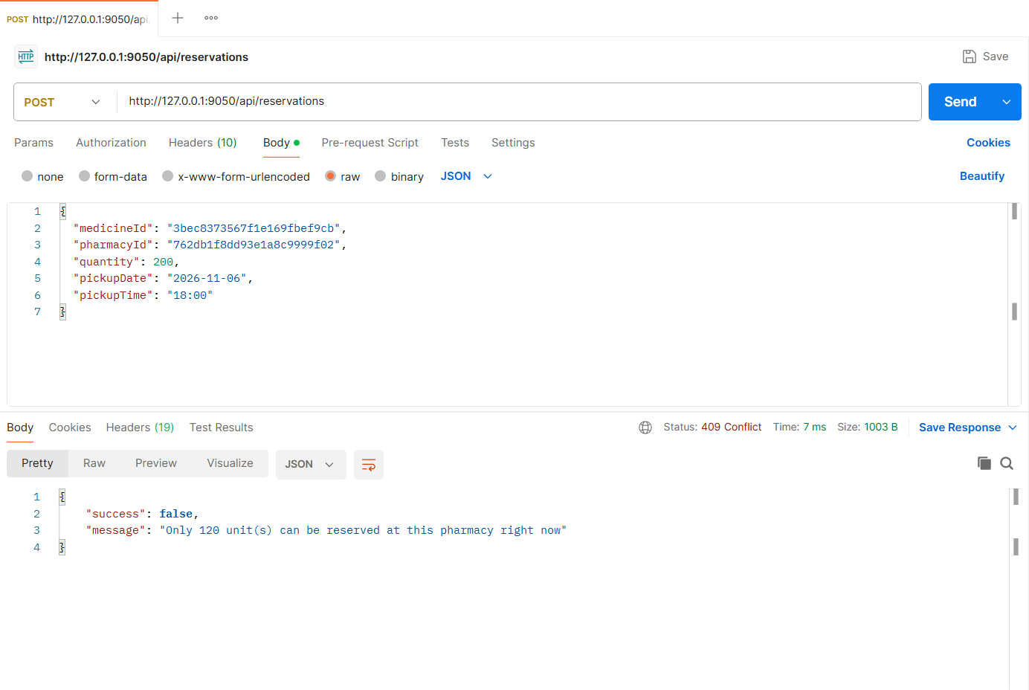
Figure: M2-F1-N2 - Quantity exceeds available stock (409)
Pickup time outside opening hours (400)
Request | POST http://127.0.0.1:9050/api/reservations
Scenario | Lazz Pharma closes at 10:00 PM.
Body / Parameters | JSON body:  {  "medicineId": "f0d40c262d508a24feeb4563",  "pharmacyId": "0367672641e1463cf4ee98cd",  "quantity": 2,  "pickupDate": "{{pickupDate}}",  "pickupTime": "23:30"  }
Result | Expected 400 Bad Request; returned 400 Bad Request

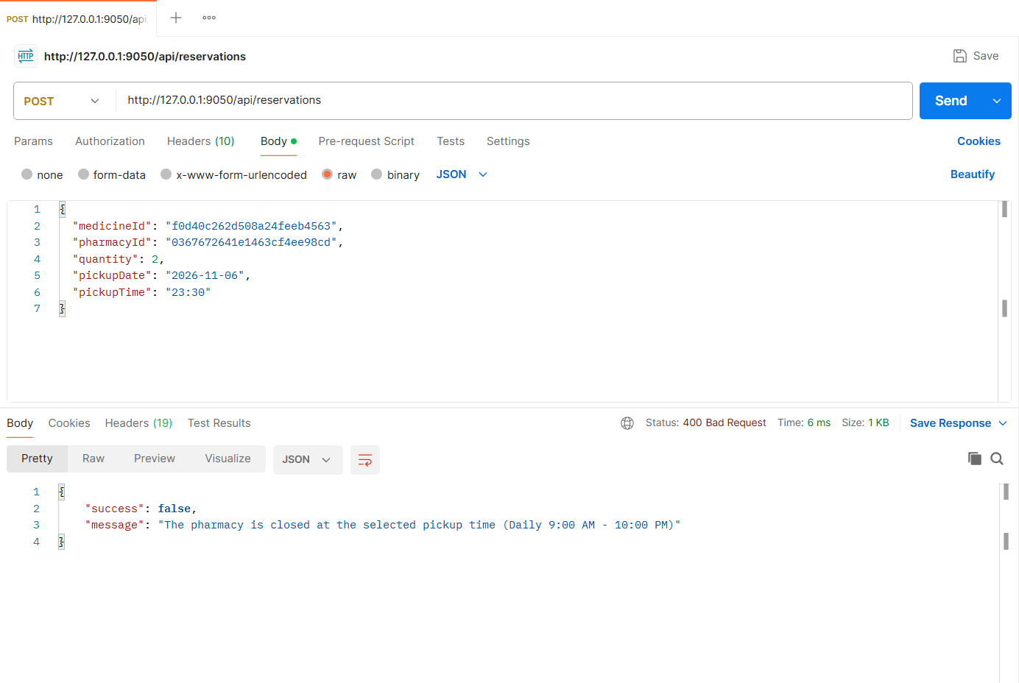
Figure: M2-F1-N3 - Pickup time outside opening hours (400)
APIs of Feature - 02: Reservation Status Tracking
Server: Member 2 backend, started with "npm run start:member2" on port 9050 (last four digits of student ID 22299050). Base URL: http://127.0.0.1:9050. Database: MongoDB (Mongoose ODM), connected at server start.
Method | Endpoint - API
1. GET | /api/reservations/my - My reservations
2. GET | /api/owner/reservations - Owner reservation inbox
3. PATCH | /api/owner/reservations/:reservationId/status - Confirm availability (Pending -> Confirmed)
4. PATCH | /api/owner/reservations/:reservationId/status - Mark ready for pickup (Confirmed -> Ready for pickup)
5. PATCH | /api/owner/reservations/:reservationId/status - Mark collected (stock reduces automatically)
6. GET | /api/reservations/:reservationId - Reservation status timeline
7. PATCH | /api/owner/reservations/:rejectReservationId/reject - Reject reservation with reason
8. PATCH | /api/reservations/:cancelReservationId/cancel - Patient cancels reservation
9. POST | /api/admin/reservations/expire-overdue - Expire overdue reservations (scheduled job trigger)

API 1: My reservations
Purpose | Patient's reservations with tab counts (All / Active / Completed / Cancelled), status and pickup time.
Endpoint URL | http://127.0.0.1:9050/api/reservations/my
HTTP Method | GET
Headers | Authorization: Bearer <JWT of patient2 account>
Authentication | JWT required - role: Patient
Body / Parameters | Query parameters:  tab = all
Status code | Expected 200 OK; returned 200 OK in the Postman test below

Example request (cURL):
curl -X GET "http://127.0.0.1:9050/api/reservations/my?tab=all" \
-H "Authorization: Bearer <patient2Token>"

Example response (200 OK, recorded from the Postman collection run):
{
"success": true,
"message": "My reservations",
"data": {
"counts": {
"all": 7,
"active": 3,
"completed": 4,
"cancelled": 0
},
"reservations": [
{
"id": "6aeb8dde98cb47d48631c371",
"code": "R-1019",
"medicine": "Napa 500 mg x 10",
"pharmacy": "Lazz Pharma",
"quantity": 10,
"totalPrice": 12,
"pickupAt": "2026-11-06T12:00:00.000Z",
"status": "Pending",
"statusLabel": "Pending"
},
{
"id": "6aeb8ddbd346b37c89b2a27c",
"code": "R-1018",
"medicine": "Fexo 120 120 mg x 5",
"pharmacy": "Tamanna Pharmacy",
"quantity": 5,
... (truncated - full response in the Postman screenshot / collection run)

Code snippet (route -> controller -> service):
// src/routes/reservationStatus.routes.js
router.get('/reservations/my', patient, validate(v.myReservationsQuery, 'query'), ctrl.myReservations);

// src/controllers/reservationStatus.controller.js
async function myReservations(req, res) {
const q = req.validatedQuery;
ok(res, await service.myReservations(req.user, { tab: q.tab, ...getPagination(q) }), 'My reservations');
}

// src/services/reservationStatus.service.js
async function myReservations(patient, { tab = 'all', page, limit, skip }) {
const base = { patient: patient._id };
const filter = { ...base, ...PATIENT_TABS[tab] };
const [total, list, counts] = await Promise.all([
Reservation.countDocuments(filter),
Reservation.find(filter).sort({ createdAt: -1 }).skip(skip).limit(limit),
Promise.all(Object.values(PATIENT_TABS).map((f) => Reservation.countDocuments({ ...base, ...f }))),
]);
return {
counts: { all: counts[0], active: counts[1], completed: counts[2], cancelled: counts[3] },
reservations: list.map(summary),
pagination: pageMeta(page, limit, total),
};
}

Postman screenshot:
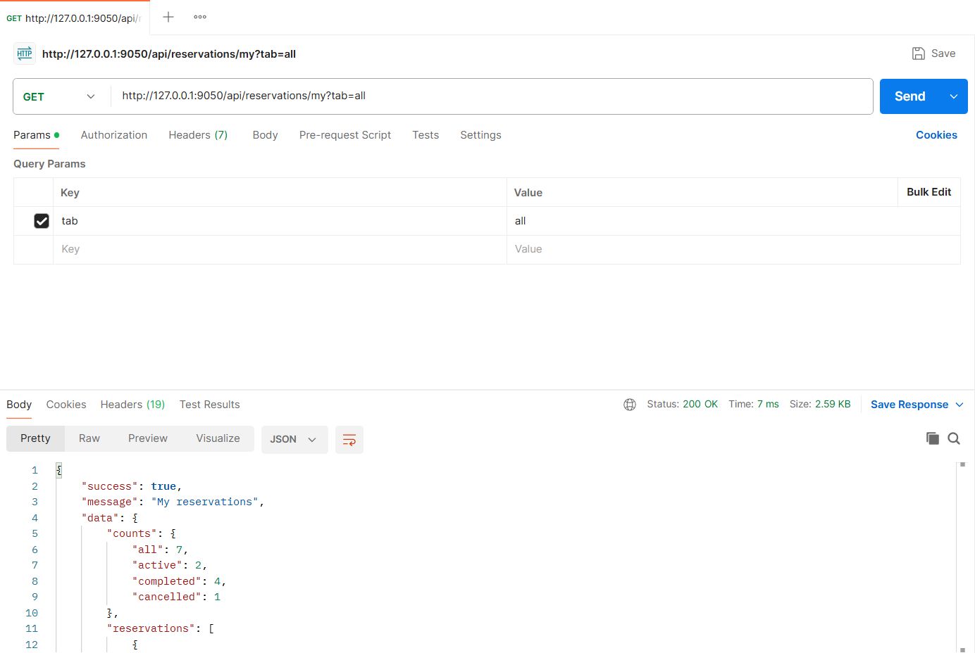
Figure: M2-F2-01 - GET /api/reservations/my tested in Postman (status 200)
API 2: Owner reservation inbox
Purpose | Pharmacy owner inbox with counts (Pending, Confirmed, Ready for pickup, Collected today) and requests including patient name and phone.
Endpoint URL | http://127.0.0.1:9050/api/owner/reservations
HTTP Method | GET
Headers | Authorization: Bearer <JWT of owner account>
Authentication | JWT required - role: Pharmacy owner
Body / Parameters | Query parameters:  status = Pending
Status code | Expected 200 OK; returned 200 OK in the Postman test below

Example request (cURL):
curl -X GET "http://127.0.0.1:9050/api/owner/reservations?status=Pending" \
-H "Authorization: Bearer <ownerToken>"

Example response (200 OK, recorded from the Postman collection run):
{
"success": true,
"message": "Reservation requests",
"data": {
"counts": {
"pending": 4,
"confirmed": 0,
"readyForPickup": 0,
"collectedToday": 0
},
"reservations": [
{
"id": "6aeb8ddad346b37c89b2a26a",
"code": "R-1012",
"medicine": "Seclo 20 20 mg x 4",
"pharmacy": "Lazz Pharma",
"quantity": 4,
"totalPrice": 24,
"pickupAt": "2026-11-06T11:00:00.000Z",
"status": "Pending",
"statusLabel": "Pending",
"patient": {
"name": "Imran Hossain",
"phone": "01819222333"
}
},
{
"id": "6aeb8ddad346b37c89b2a267",
... (truncated - full response in the Postman screenshot / collection run)

Code snippet (route -> controller -> service):
// src/routes/reservationStatus.routes.js
router.get('/owner/reservations', owner, validate(v.inboxQuery, 'query'), ctrl.ownerInbox);

// src/controllers/reservationStatus.controller.js
async function ownerInbox(req, res) {
const q = req.validatedQuery;
ok(res, await service.ownerInbox(req.pharmacy, { status: q.status, ...getPagination(q) }), 'Reservation requests');
}

// src/services/reservationStatus.service.js
async function ownerInbox(pharmacy, { status, page, limit, skip }) {
const base = { pharmacy: pharmacy._id };
const filter = status ? { ...base, status } : { ...base, status: { $in: ACTIVE_STATUSES } };
const [total, list, pending, confirmed, ready, collectedToday] = await Promise.all([
Reservation.countDocuments(filter),
Reservation.find(filter).populate('patient', 'name phone').sort({ pickupAt: 1 }).skip(skip).limit(limit),
Reservation.countDocuments({ ...base, status: 'Pending' }),
Reservation.countDocuments({ ...base, status: 'Confirmed' }),
Reservation.countDocuments({ ...base, status: 'ReadyForPickup' }),
Reservation.countDocuments({ ...base, status: 'Collected', collectedAt: { $gte: startOfLocalDay() } }),
]);
return {
counts: { pending, confirmed, readyForPickup: ready, collectedToday },
reservations: list.map((r) => ({ ...summary(r), patient: { name: r.patient.name, phone: r.patient.phone } })),
pagination: pageMeta(page, limit, total),
};
}

Postman screenshot:
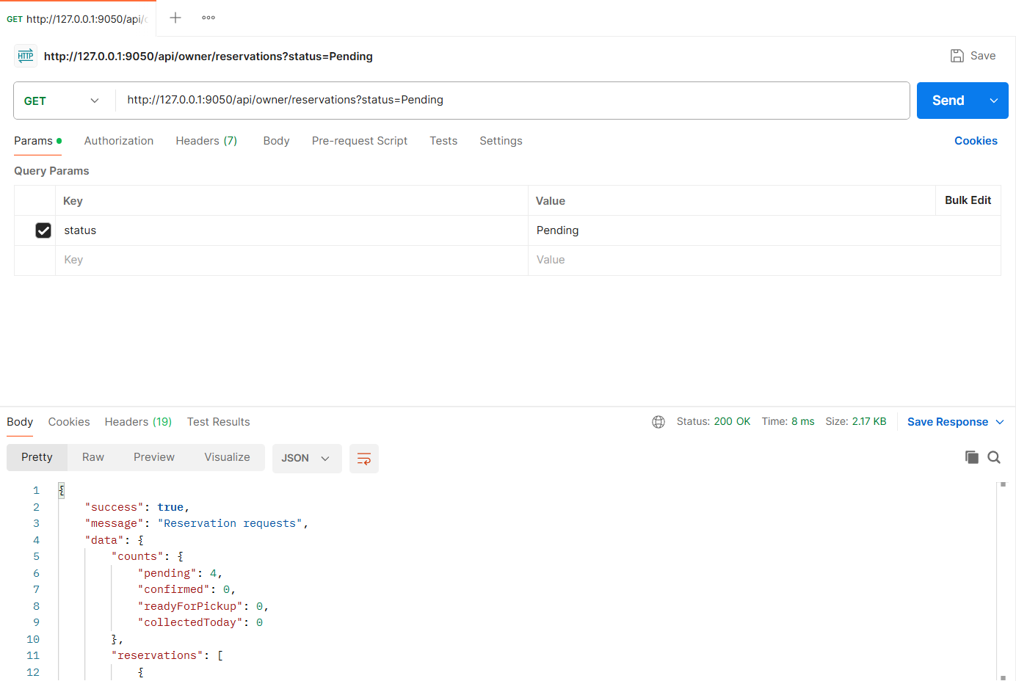
Figure: M2-F2-02 - GET /api/owner/reservations tested in Postman (status 200)
API 3: Confirm availability (Pending -> Confirmed)
Purpose | Owner moves the reservation one step forward. Stock that can be promised is re-checked before confirming.
Endpoint URL | http://127.0.0.1:9050/api/owner/reservations/:reservationId/status
HTTP Method | PATCH
Headers | Authorization: Bearer <JWT of owner account>  Content-Type: application/json
Authentication | JWT required - role: Pharmacy owner
Body / Parameters | JSON body:  {  "status": "Confirmed",  "note": "Availability confirmed"  }  Path parameters: reservationId (id returned by an earlier request)
Status code | Expected 200 OK; returned 200 OK in the Postman test below

Example request (cURL):
curl -X PATCH "http://127.0.0.1:9050/api/owner/reservations/<reservationId>/status" \
-H "Authorization: Bearer <ownerToken>" \
-H "Content-Type: application/json" \
-d '{"status": "Confirmed", "note": "Availability confirmed"}'

Example response (200 OK, recorded from the Postman collection run):
{
"success": true,
"message": "Reservation status updated",
"data": {
"id": "6aeb8dde98cb47d48631c371",
"code": "R-1019",
"medicine": "Napa 500 mg x 10",
"pharmacy": "Lazz Pharma",
"quantity": 10,
"totalPrice": 12,
"pickupAt": "2026-11-06T12:00:00.000Z",
"status": "Confirmed",
"statusLabel": "Confirmed",
"remainingStock": 340,
"nextStatus": "ReadyForPickup"
}
}

Code snippet (route -> controller -> service):
// src/routes/reservationStatus.routes.js
router.patch('/owner/reservations/:id/status', owner, validate(idParam(), 'params'), validate(v.advanceStatus), ctrl.advanceStatus);

// src/controllers/reservationStatus.controller.js
async function advanceStatus(req, res) {
ok(res, await service.advanceStatus(req.user, req.pharmacy, req.params.id, req.body), 'Reservation status updated');
}

// src/services/reservationStatus.service.js
/** Owner moves a reservation one step forward: Pending -> Confirmed -> ReadyForPickup -> Collected. */
async function advanceStatus(owner, pharmacy, id, { status: requested, note }) {
const r = await loadOwnedReservation(pharmacy, id);
const expected = OWNER_TRANSITIONS[r.status];
if (!expected) throw ApiError.conflict(`Reservation is ${STATUS_LABELS[r.status]}; no further status changes are allowed`);
if (requested !== expected) {
throw ApiError.conflict(`Invalid status transition ${STATUS_LABELS[r.status]} -> ${STATUS_LABELS[requested]}. Next allowed: ${STATUS_LABELS[expected]}`);
}
if (r.pickupDeadline < new Date()) {
await markExpired(r);
throw ApiError.conflict(`Reservation ${r.code} has expired (pickup deadline passed)`);
}

if (requested === 'Confirmed') {
const item = await CatalogItem.findById(r.catalogItem);
if (!item || !item.isActive) throw ApiError.conflict('This medicine is no longer in your catalog');
const reservable = await inventory.reservableQuantity(item, { excludeReservationId: r._id });
if (r.quantity > reservable) throw ApiError.conflict(`Insufficient stock to confirm: ${r.quantity} requested, ${reservable} reservable`);
}

await withTransaction(async (session) => {
if (requested === 'Collected') {
// stock reduces automatically on collection, earliest-expiring batch first
r.consumedBatches = await inventory.consumeFEFO(r.catalogItem, r.quantity, session);
r.collectedAt = new Date();
}
r.status = requested;
r.statusHistory.push({ status: requested, by: owner._id, note: note || defaultNote(requested) });
await r.save({ session });
});

notify(r.patient, {
type: 'reservation_status',
title: `Reservation ${r.code} is ${STATUS_LABELS[requested]}`,
message: `Your reservation ${r.code} at ${r.pharmacySnapshot.name} is now ${STATUS_LABELS[requested]}.`,
data: { reservationId: r._id },
});

const item = await CatalogItem.findById(r.catalogItem);
return { ...summary(r), consumedBatches: requested === 'Collected' ? r.consumedBatches : undefined, remainingStock: item ? item.stockQuantity : undefined, nextStatus: OWNER_TRANSITIONS[r.status] || null };
}

Postman screenshot:
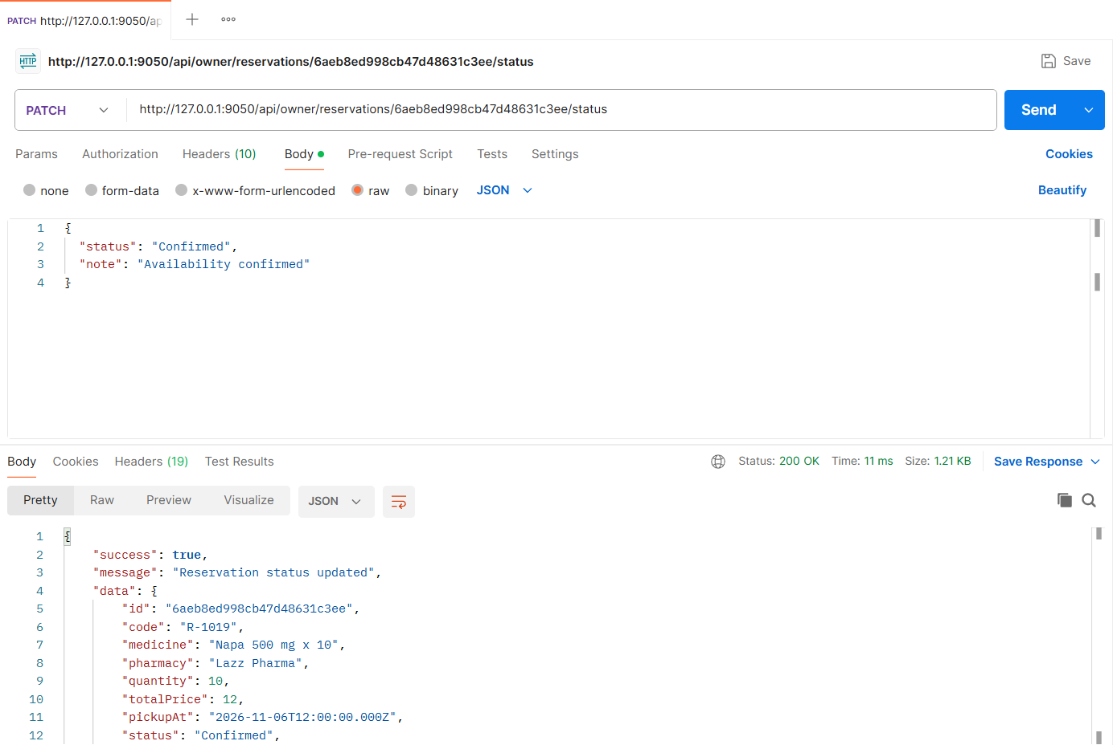
Figure: M2-F2-03 - PATCH /api/owner/reservations/:reservationId/status tested in Postman (status 200)
API 4: Mark ready for pickup (Confirmed -> Ready for pickup)
Purpose | Second step of the workflow.
Endpoint URL | http://127.0.0.1:9050/api/owner/reservations/:reservationId/status
HTTP Method | PATCH
Headers | Authorization: Bearer <JWT of owner account>  Content-Type: application/json
Authentication | JWT required - role: Pharmacy owner
Body / Parameters | JSON body:  {  "status": "ReadyForPickup"  }  Path parameters: reservationId (id returned by an earlier request)
Status code | Expected 200 OK; returned 200 OK in the Postman test below

Example request (cURL):
curl -X PATCH "http://127.0.0.1:9050/api/owner/reservations/<reservationId>/status" \
-H "Authorization: Bearer <ownerToken>" \
-H "Content-Type: application/json" \
-d '{"status": "ReadyForPickup"}'

Example response (200 OK, recorded from the Postman collection run):
{
"success": true,
"message": "Reservation status updated",
"data": {
"id": "6aeb8dde98cb47d48631c371",
"code": "R-1019",
"medicine": "Napa 500 mg x 10",
"pharmacy": "Lazz Pharma",
"quantity": 10,
"totalPrice": 12,
"pickupAt": "2026-11-06T12:00:00.000Z",
"status": "ReadyForPickup",
"statusLabel": "Ready for pickup",
"remainingStock": 340,
"nextStatus": "Collected"
}
}

Code snippet (route -> controller -> service):
// src/routes/reservationStatus.routes.js
router.patch('/owner/reservations/:id/status', owner, validate(idParam(), 'params'), validate(v.advanceStatus), ctrl.advanceStatus);

// src/controllers/reservationStatus.controller.js
async function advanceStatus(req, res) {
ok(res, await service.advanceStatus(req.user, req.pharmacy, req.params.id, req.body), 'Reservation status updated');
}

Postman screenshot:
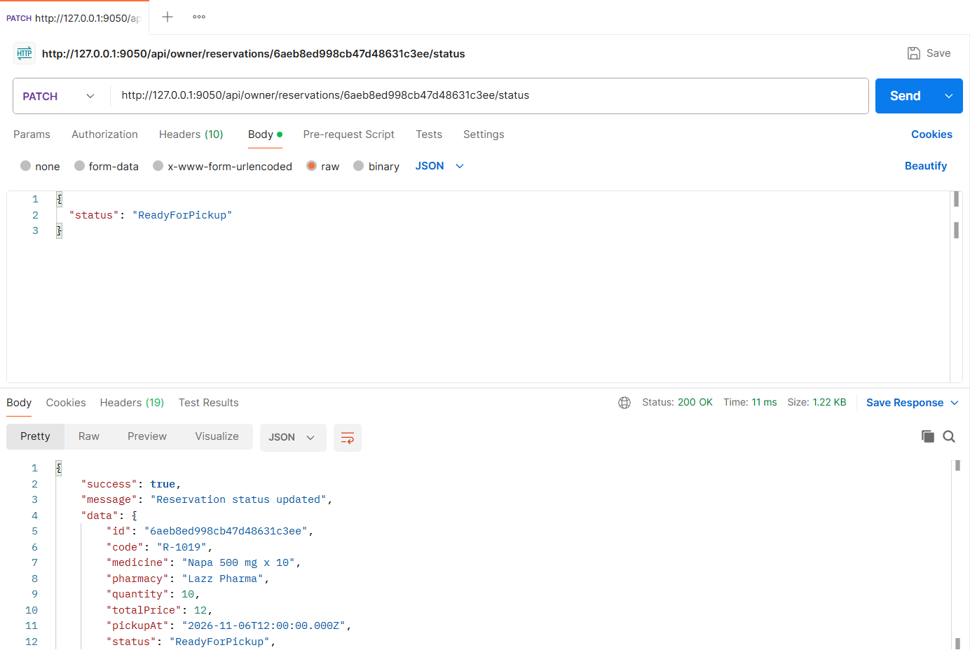
Figure: M2-F2-04 - PATCH /api/owner/reservations/:reservationId/status tested in Postman (status 200)
API 5: Mark collected (stock reduces automatically)
Purpose | Final step. In one transaction the status becomes Collected and stock is reduced using the earliest-expiring batch first.
Endpoint URL | http://127.0.0.1:9050/api/owner/reservations/:reservationId/status
HTTP Method | PATCH
Headers | Authorization: Bearer <JWT of owner account>  Content-Type: application/json
Authentication | JWT required - role: Pharmacy owner
Body / Parameters | JSON body:  {  "status": "Collected"  }  Path parameters: reservationId (id returned by an earlier request)
Status code | Expected 200 OK; returned 200 OK in the Postman test below

Example request (cURL):
curl -X PATCH "http://127.0.0.1:9050/api/owner/reservations/<reservationId>/status" \
-H "Authorization: Bearer <ownerToken>" \
-H "Content-Type: application/json" \
-d '{"status": "Collected"}'

Example response (200 OK, recorded from the Postman collection run):
{
"success": true,
"message": "Reservation status updated",
"data": {
"id": "6aeb8dde98cb47d48631c371",
"code": "R-1019",
"medicine": "Napa 500 mg x 10",
"pharmacy": "Lazz Pharma",
"quantity": 10,
"totalPrice": 12,
"pickupAt": "2026-11-06T12:00:00.000Z",
"status": "Collected",
"statusLabel": "Collected",
"consumedBatches": [
{
"batch": "6aeb8dd8d346b37c89b2a16e",
"batchNumber": "NP-2411",
"quantity": 10
}
],
"remainingStock": 330,
"nextStatus": null
}
}

Code snippet (route -> controller -> service):
// src/routes/reservationStatus.routes.js
router.patch('/owner/reservations/:id/status', owner, validate(idParam(), 'params'), validate(v.advanceStatus), ctrl.advanceStatus);

// src/controllers/reservationStatus.controller.js
async function advanceStatus(req, res) {
ok(res, await service.advanceStatus(req.user, req.pharmacy, req.params.id, req.body), 'Reservation status updated');
}

Postman screenshot:
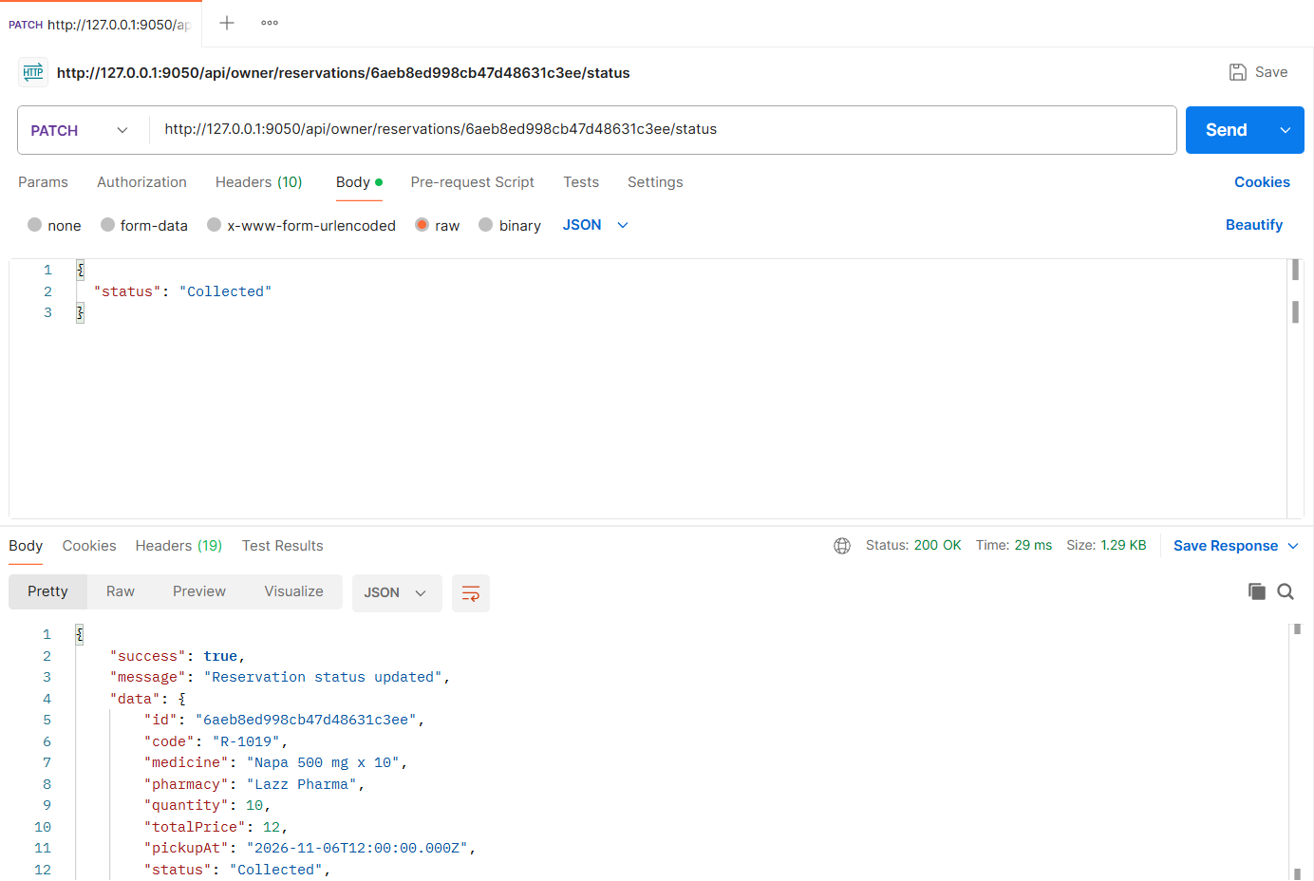
Figure: M2-F2-05 - PATCH /api/owner/reservations/:reservationId/status tested in Postman (status 200)
API 6: Reservation status timeline
Purpose | Reservation detail with the 4-step timeline (Pending, Confirmed, Ready for pickup, Collected), full status history, pickup deadline and whether it can be cancelled.
Endpoint URL | http://127.0.0.1:9050/api/reservations/:reservationId
HTTP Method | GET
Headers | Authorization: Bearer <JWT of patient2 account>
Authentication | JWT required - role: Patient
Body / Parameters | Path parameters: reservationId (id returned by an earlier request)
Status code | Expected 200 OK; returned 200 OK in the Postman test below

Example request (cURL):
curl -X GET "http://127.0.0.1:9050/api/reservations/<reservationId>" \
-H "Authorization: Bearer <patient2Token>"

Example response (200 OK, recorded from the Postman collection run):
{
"success": true,
"message": "Reservation details",
"data": {
"id": "6aeb8dde98cb47d48631c371",
"code": "R-1019",
"medicine": "Napa 500 mg x 10",
"pharmacy": "Lazz Pharma",
"quantity": 10,
"totalPrice": 12,
"pickupAt": "2026-11-06T12:00:00.000Z",
"status": "Collected",
"statusLabel": "Collected",
"medicineDetails": {
"brandName": "Napa",
"genericName": "Paracetamol",
"strength": "500 mg",
"dosageForm": "Tablet",
"manufacturer": "Beximco Pharmaceuticals",
"requiresPrescription": false
},
"unitPrice": 1.2,
"pickupDeadline": "2026-11-06T14:00:00.000Z",
"note": "I need the 500 mg strip only",
"prescriptionUrl": "/uploads/prescriptions/1793822174218-7f214214af6e.png",
"prescriptionRequired": false,
"timeline": {
"steps": [
... (truncated - full response in the Postman screenshot / collection run)

Code snippet (route -> controller -> service):
// src/routes/reservationStatus.routes.js
router.get('/reservations/:id', authenticate, validate(idParam(), 'params'), ctrl.getReservation);

// src/controllers/reservationStatus.controller.js
async function getReservation(req, res) {
ok(res, await service.getReservation(req.user, req.params.id), 'Reservation details');
}

// src/services/reservationStatus.service.js
async function getReservation(user, id) {
const { r, isOwner } = await loadForUser(user, id);
const data = {
...summary(r),
medicineDetails: r.medicineSnapshot,
unitPrice: r.unitPrice,
pickupDeadline: r.pickupDeadline,
note: r.note || null,
prescriptionUrl: r.prescription && r.prescription.url ? r.prescription.url : null,
prescriptionRequired: Boolean(r.medicineSnapshot.requiresPrescription),
rejection: r.status === 'Rejected' ? r.rejection : undefined,
timeline: buildTimeline(r),
history: r.statusHistory.map((h) => ({ status: h.status, label: STATUS_LABELS[h.status], at: h.at, note: h.note })),
canCancel: CANCELLABLE.includes(r.status),
pharmacyDetails: { name: r.pharmacy.name, address: `${r.pharmacy.address.line}, ${r.pharmacy.address.area}`, phone: r.pharmacy.phone },
};
if (isOwner || user.role === 'admin') {
const item = await CatalogItem.findById(r.catalogItem);
data.patient = { name: r.patient.name, phone: r.patient.phone };
data.yourStock = item ? item.stockQuantity : 0;
data.nextStatus = OWNER_TRANSITIONS[r.status] || null;
}
return data;
}

// src/services/reservationStatus.service.js
/** Builds the 4-step timeline shown on the status page, plus any terminal state. */
function buildTimeline(r) {
const reachedAt = {};
for (const ev of r.statusHistory) if (!reachedAt[ev.status]) reachedAt[ev.status] = ev;
const steps = FLOW.map((status) => ({
status,
label: STATUS_LABELS[status],
done: Boolean(reachedAt[status]),
at: reachedAt[status] ? reachedAt[status].at : null,
note: reachedAt[status] ? reachedAt[status].note : null,
}));
const terminal = ['Rejected', 'Cancelled', 'Expired'].includes(r.status)
? { status: r.status, label: STATUS_LABELS[r.status], at: reachedAt[r.status] && reachedAt[r.status].at }
: null;
return { steps, terminal };
}

Postman screenshot:
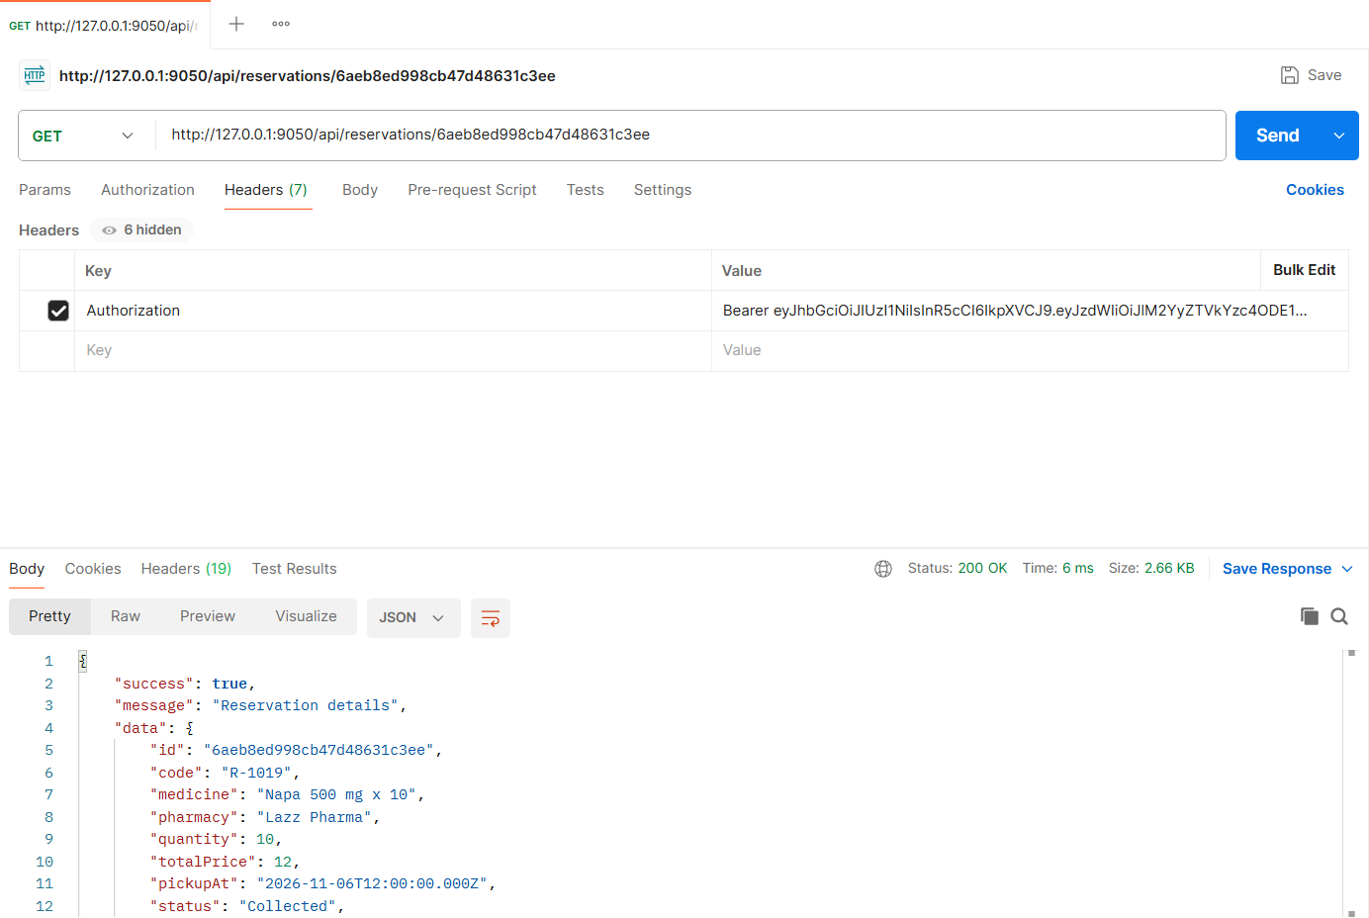
Figure: M2-F2-06 - GET /api/reservations/:reservationId tested in Postman (status 200)
API 7: Reject reservation with reason
Purpose | Owner rejects a Pending/Confirmed request with a reason and optional message; the patient is notified by email and in the app.
Endpoint URL | http://127.0.0.1:9050/api/owner/reservations/:rejectReservationId/reject
HTTP Method | PATCH
Headers | Authorization: Bearer <JWT of owner account>  Content-Type: application/json
Authentication | JWT required - role: Pharmacy owner
Body / Parameters | JSON body:  {  "reason": "Out of stock",  "message": "Sorry, this batch is sold out. New stock arrives on Thursday."  }  Path parameters: rejectReservationId (id returned by an earlier request)
Status code | Expected 200 OK; returned 200 OK in the Postman test below

Example request (cURL):
curl -X PATCH "http://127.0.0.1:9050/api/owner/reservations/<rejectReservationId>/reject" \
-H "Authorization: Bearer <ownerToken>" \
-H "Content-Type: application/json" \
-d '{"reason": "Out of stock", "message": "Sorry, this batch is sold out. New stock arrives on Thursday."}'

Example response (200 OK, recorded from the Postman collection run):
{
"success": true,
"message": "Reservation rejected",
"data": {
"id": "6aeb8ddad346b37c89b2a26a",
"code": "R-1012",
"medicine": "Seclo 20 20 mg x 4",
"pharmacy": "Lazz Pharma",
"quantity": 4,
"totalPrice": 24,
"pickupAt": "2026-11-06T11:00:00.000Z",
"status": "Rejected",
"statusLabel": "Rejected",
"rejection": {
"reason": "Out of stock",
"message": "Sorry, this batch is sold out. New stock arrives on Thursday."
}
}
}

Code snippet (route -> controller -> service):
// src/routes/reservationStatus.routes.js
router.patch('/owner/reservations/:id/reject', owner, validate(idParam(), 'params'), validate(v.reject), ctrl.rejectReservation);

// src/controllers/reservationStatus.controller.js
async function rejectReservation(req, res) {
ok(res, await service.rejectReservation(req.user, req.pharmacy, req.params.id, req.body), 'Reservation rejected');
}

// src/services/reservationStatus.service.js
async function rejectReservation(owner, pharmacy, id, { reason, message }) {
const r = await loadOwnedReservation(pharmacy, id);
if (!['Pending', 'Confirmed'].includes(r.status)) {
throw ApiError.conflict(`Only Pending or Confirmed reservations can be rejected (current: ${STATUS_LABELS[r.status]})`);
}
r.status = 'Rejected';
r.rejection = { reason, message };
r.statusHistory.push({ status: 'Rejected', by: owner._id, note: message ? `${reason}: ${message}` : reason });
await r.save();
notify(r.patient, {
type: 'reservation_status',
title: `Reservation ${r.code} rejected`,
message: `${r.pharmacySnapshot.name} rejected reservation ${r.code}. Reason: ${reason}.${message ? ` ${message}` : ''}`,
data: { reservationId: r._id },
});
return { ...summary(r), rejection: r.rejection };
}

Postman screenshot:
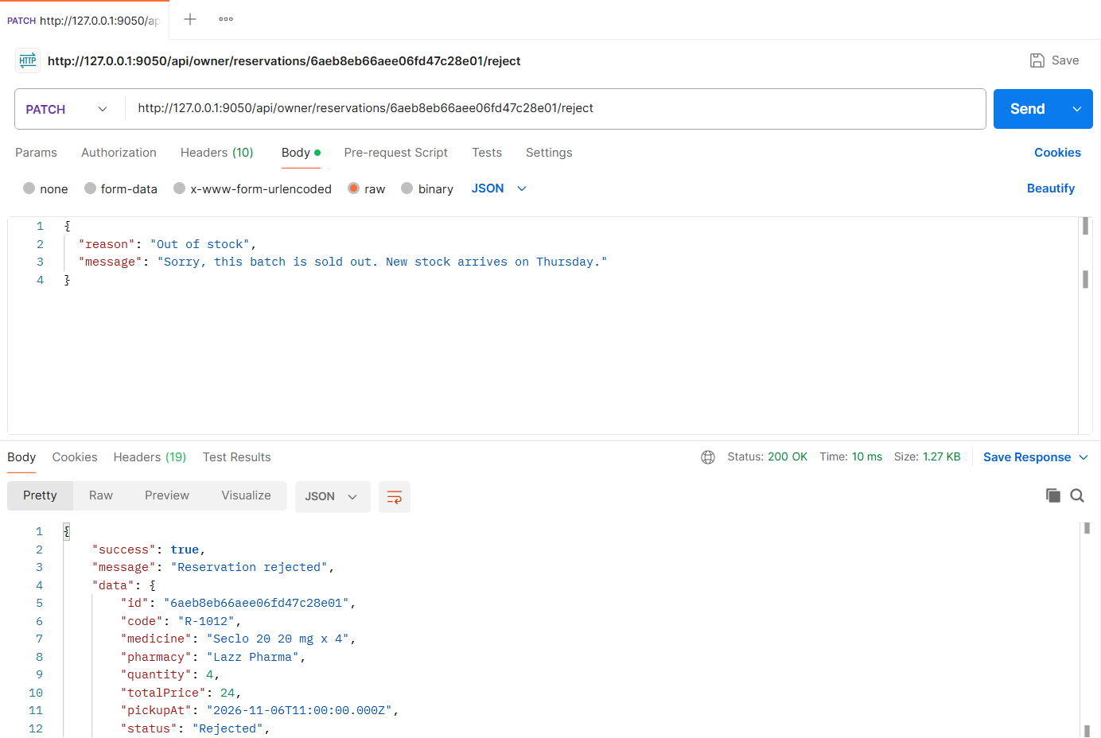
Figure: M2-F2-07 - PATCH /api/owner/reservations/:rejectReservationId/reject tested in Postman (status 200)
API 8: Patient cancels reservation
Purpose | Patients can cancel any time before the reservation is Ready for pickup.
Endpoint URL | http://127.0.0.1:9050/api/reservations/:cancelReservationId/cancel
HTTP Method | PATCH
Headers | Authorization: Bearer <JWT of patient account>  Content-Type: application/json
Authentication | JWT required - role: Patient
Body / Parameters | JSON body:  {  "reason": "Bought it elsewhere"  }  Path parameters: cancelReservationId (id returned by an earlier request)
Status code | Expected 200 OK; returned 200 OK in the Postman test below

Example request (cURL):
curl -X PATCH "http://127.0.0.1:9050/api/reservations/<cancelReservationId>/cancel" \
-H "Authorization: Bearer <patientToken>" \
-H "Content-Type: application/json" \
-d '{"reason": "Bought it elsewhere"}'

Example response (200 OK, recorded from the Postman collection run):
{
"success": true,
"message": "Reservation cancelled",
"data": {
"id": "6aeb8ddad346b37c89b2a267",
"code": "R-1011",
"medicine": "Napa 500 mg x 10",
"pharmacy": "Lazz Pharma",
"quantity": 10,
"totalPrice": 12,
"pickupAt": "2026-11-06T12:00:00.000Z",
"status": "Cancelled",
"statusLabel": "Cancelled"
}
}

Code snippet (route -> controller -> service):
// src/routes/reservationStatus.routes.js
router.patch('/reservations/:id/cancel', patient, validate(idParam(), 'params'), validate(v.cancel), ctrl.cancelReservation);

// src/controllers/reservationStatus.controller.js
async function cancelReservation(req, res) {
ok(res, await service.cancelReservation(req.user, req.params.id, req.body.reason), 'Reservation cancelled');
}

// src/services/reservationStatus.service.js
async function cancelReservation(patient, id, reason) {
const r = await Reservation.findById(id);
if (!r) throw ApiError.notFound('Reservation not found');
if (!r.patient.equals(patient._id)) throw ApiError.forbidden('This reservation does not belong to you');
if (!CANCELLABLE.includes(r.status)) {
throw ApiError.conflict(`Cannot cancel a reservation that is ${STATUS_LABELS[r.status]}. Cancellation is allowed only before Ready for pickup.`);
}
r.status = 'Cancelled';
r.statusHistory.push({ status: 'Cancelled', by: patient._id, note: reason || 'Cancelled by patient' });
await r.save();
const pharmacy = await Pharmacy.findById(r.pharmacy, 'owner');
notify(pharmacy.owner, { type: 'reservation_status', title: `Reservation ${r.code} cancelled`, message: `${patient.name} cancelled reservation ${r.code}.`, data: { reservationId: r._id } });
return summary(r);
}

Postman screenshot:
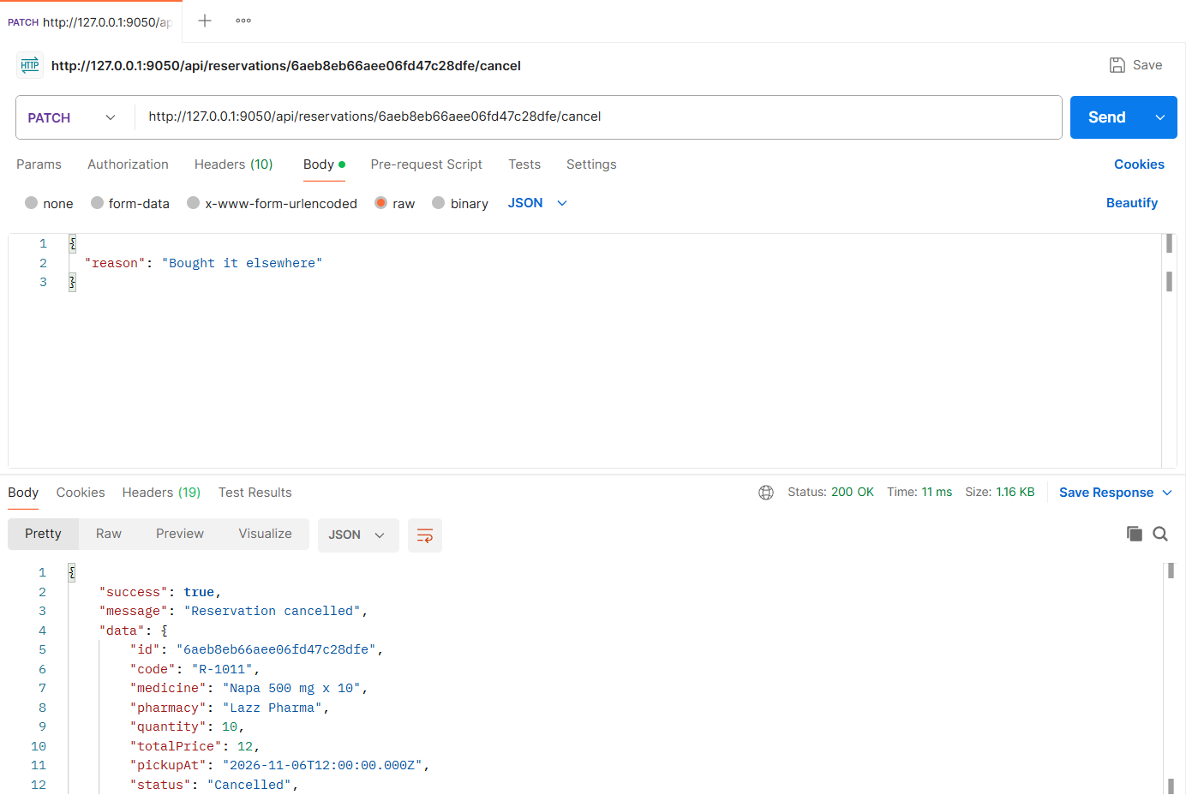
Figure: M2-F2-08 - PATCH /api/reservations/:cancelReservationId/cancel tested in Postman (status 200)
API 9: Expire overdue reservations (scheduled job trigger)
Purpose | Runs the same logic as the node-cron job (every 5 minutes): active reservations whose pickup deadline has passed become Expired and patients are notified.
Endpoint URL | http://127.0.0.1:9050/api/admin/reservations/expire-overdue
HTTP Method | POST
Headers | Authorization: Bearer <JWT of admin account>
Authentication | JWT required - role: Admin
Body / Parameters | None
Status code | Expected 200 OK; returned 200 OK in the Postman test below

Example request (cURL):
curl -X POST "http://127.0.0.1:9050/api/admin/reservations/expire-overdue" \
-H "Authorization: Bearer <adminToken>"

Example response (200 OK, recorded from the Postman collection run):
{
"success": true,
"message": "Overdue reservations expired",
"data": {
"expiredCount": 1,
"codes": [
"R-1018"
]
}
}

Code snippet (route -> controller -> service):
// src/routes/reservationStatus.routes.js
router.post('/admin/reservations/expire-overdue', authenticate, authorize('admin'), ctrl.expireOverdue);

// src/controllers/reservationStatus.controller.js
async function expireOverdue(_req, res) {
ok(res, await service.expireOverdueReservations(), 'Overdue reservations expired');
}

// src/services/reservationStatus.service.js
/** Scheduled job (node-cron) and admin trigger: expire active reservations whose pickup deadline has passed. */
async function expireOverdueReservations() {
const overdue = await Reservation.find({ status: { $in: ACTIVE_STATUSES }, pickupDeadline: { $lt: new Date() } });
for (const r of overdue) await markExpired(r);
return { expiredCount: overdue.length, codes: overdue.map((r) => r.code) };
}

Postman screenshot:
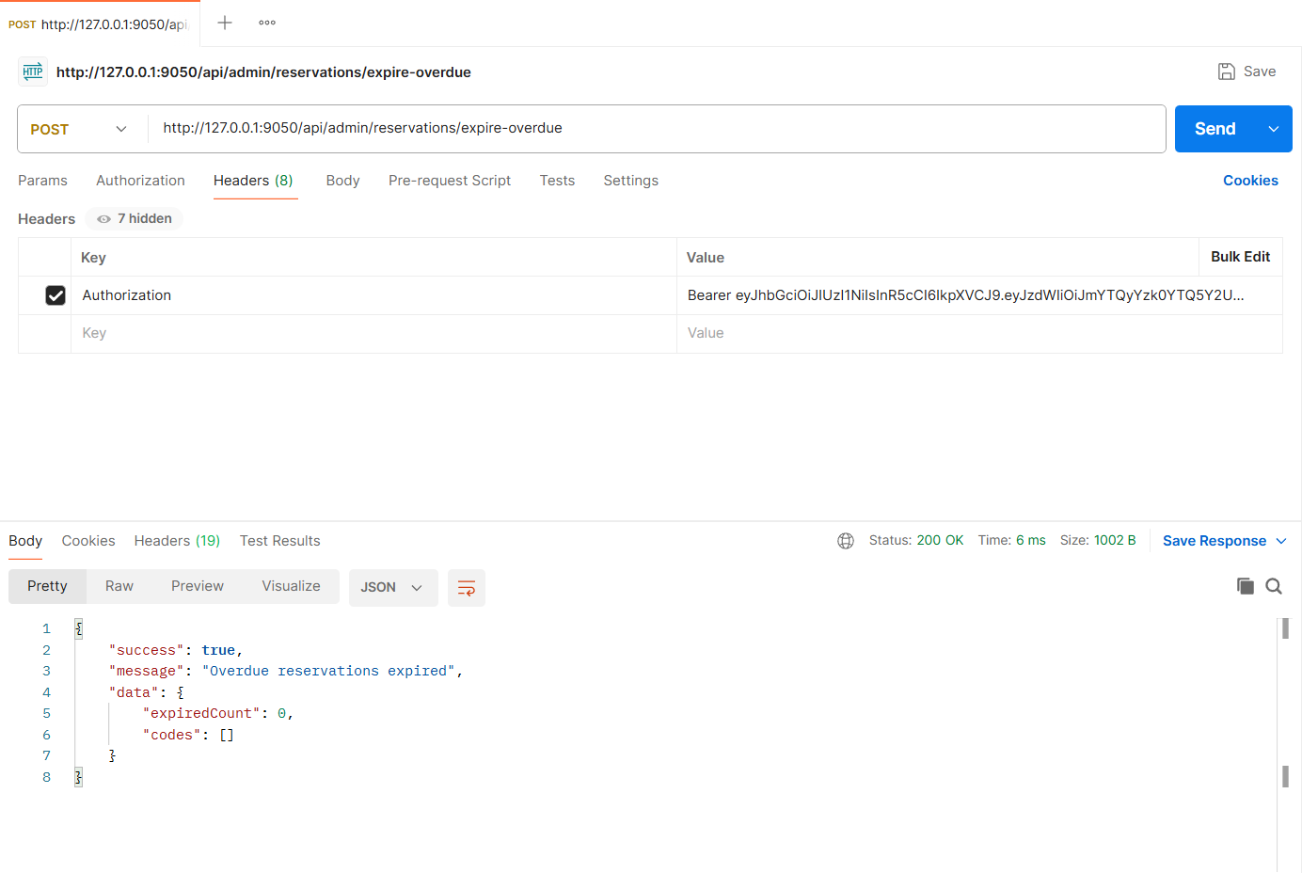
Figure: M2-F2-09 - POST /api/admin/reservations/expire-overdue tested in Postman (status 200)
Validation and error-handling tests (Feature 02)
The same APIs were also tested with invalid input, wrong roles and invalid state changes. Each request below was sent from Postman to the running server.
Invalid status transition (409)
Request | PATCH http://127.0.0.1:9050/api/owner/reservations/:reservationId/status
Scenario | A Collected reservation cannot move back to Confirmed.
Body / Parameters | JSON body:  {  "status": "Confirmed"  }  Path parameters: reservationId (id returned by an earlier request)
Result | Expected 409 Conflict; returned 409 Conflict

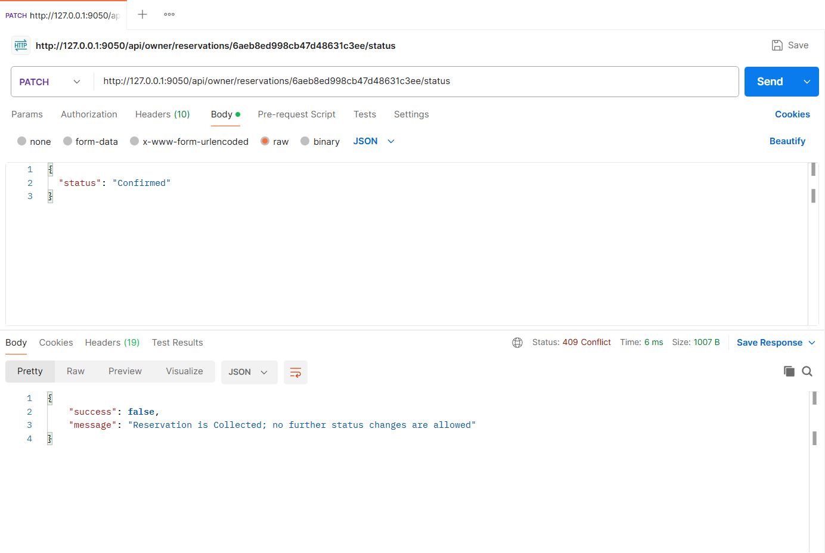
Figure: M2-F2-N1 - Invalid status transition (409)
Cancel after Ready for pickup / collected (409)
Request | PATCH http://127.0.0.1:9050/api/reservations/:reservationId/cancel
Scenario | Cancellation is only allowed before Ready for pickup.
Body / Parameters | JSON body:  {}  Path parameters: reservationId (id returned by an earlier request)
Result | Expected 409 Conflict; returned 409 Conflict

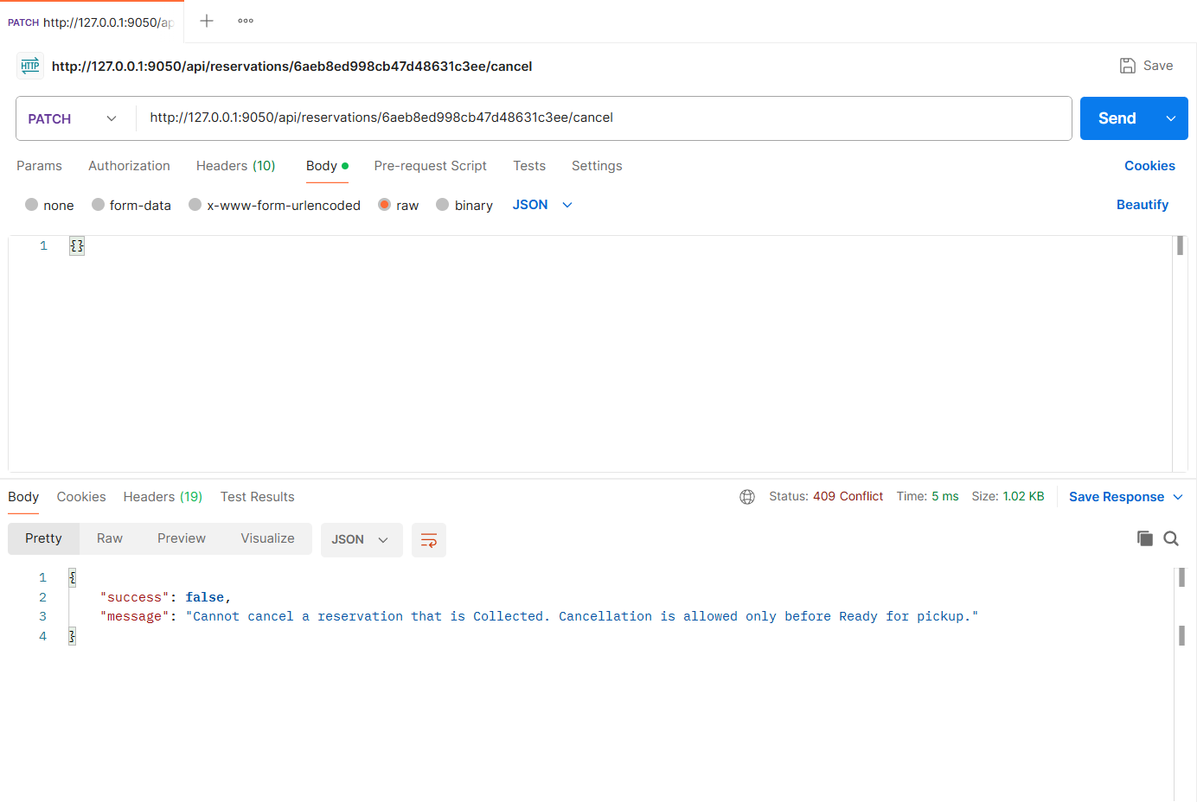
Figure: M2-F2-N2 - Cancel after Ready for pickup / collected (409)
Another patient cannot view the reservation (403)
Request | GET http://127.0.0.1:9050/api/reservations/:reservationId
Scenario | Reservation details are visible only to the patient, the pharmacy owner and admins.
Body / Parameters | Path parameters: reservationId (id returned by an earlier request)
Result | Expected 403 Forbidden; returned 403 Forbidden

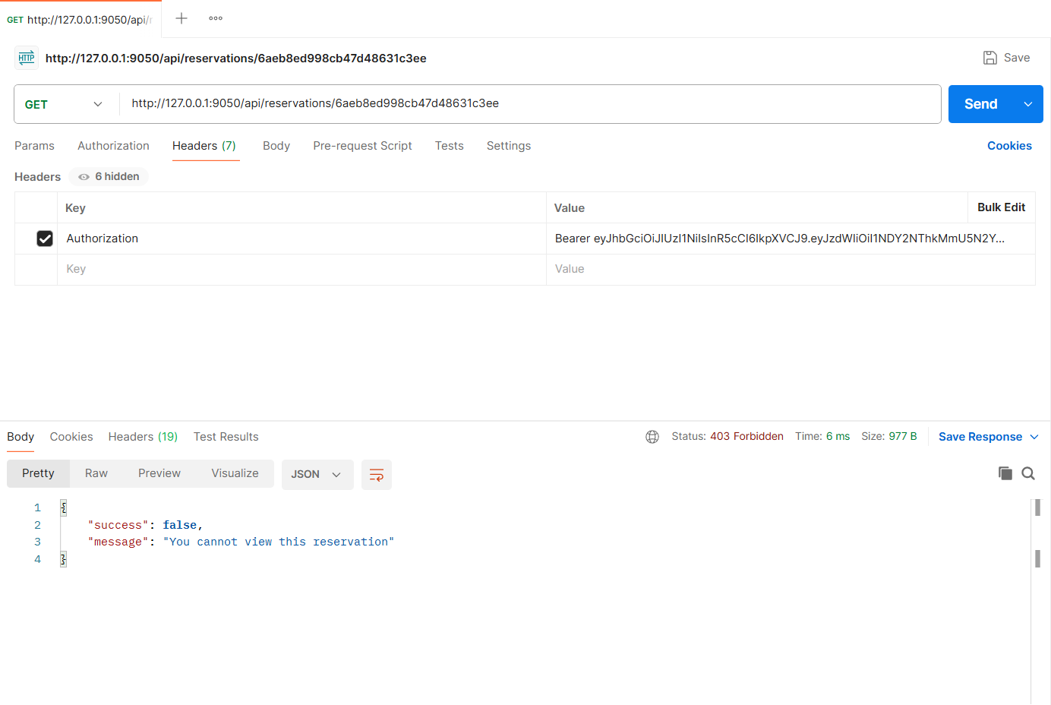
Figure: M2-F2-N3 - Another patient cannot view the reservation (403)
Non-admin cannot run the expiry job (403)
Request | POST http://127.0.0.1:9050/api/admin/reservations/expire-overdue
Scenario | Admin-only action.
Body / Parameters | None
Result | Expected 403 Forbidden; returned 403 Forbidden

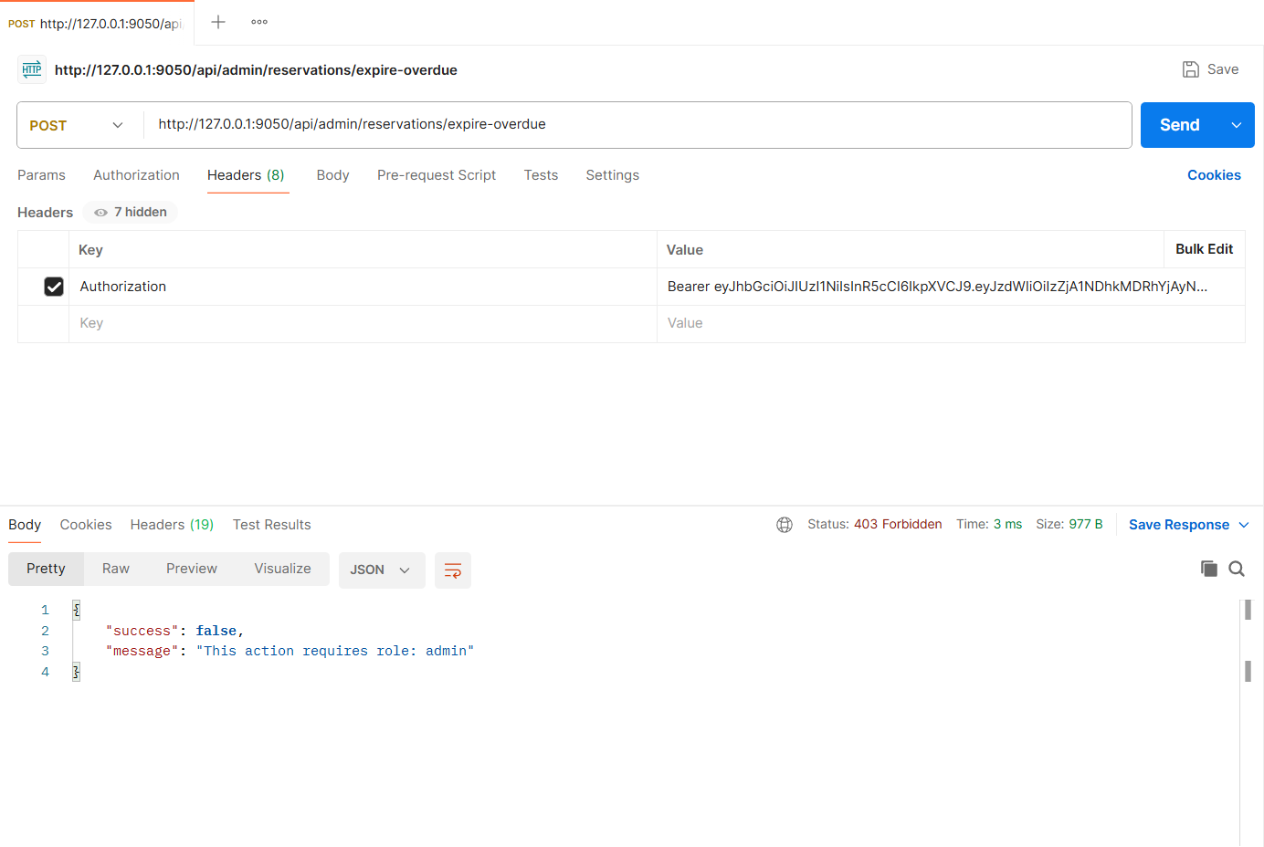
Figure: M2-F2-N4 - Non-admin cannot run the expiry job (403)
Implementation Notes
Project | MedFind BD - medicine availability and reservation platform (CSE471, Group 02, Section 03)
Tech stack | Node.js, Express.js 5, MongoDB (MongoDB Atlas in deployment, local replica set in development), Mongoose 8, JWT + bcrypt, Multer + Cloudinary (local-disk fallback), node-cron, zod validation
My server | cd backend  npm install  npm run seed  npm run start:member2  -> http://127.0.0.1:9050/api/health
Environment | backend/.env (copy of .env.example): MONGODB_URI, JWT_SECRET, PORT_MEMBER1..4, CLOUDINARY_*, SENDGRID_API_KEY, business-rule settings
Postman | Import postman/Member2/Member2_22299050.postman_collection.json, run the "00 Setup" login requests (if present), then run each feature folder top to bottom. File fields use postman/assets/*.
Architecture | routes (URL + middleware) -> controllers (HTTP in/out) -> services (business logic) -> Mongoose models. Central error handler returns { success, message, errors }.

Database connection (src/config/db.js):
const mongoose = require('mongoose');
const env = require('./env');

mongoose.set('strictQuery', true);

async function connectDB(uri = env.mongoUri) {
await mongoose.connect(uri, { serverSelectionTimeoutMS: 10000 });
const { host, name } = mongoose.connection;
console.log(`[db] connected to MongoDB ${host}/${name}`);
return mongoose.connection;
}

async function disconnectDB() {
await mongoose.disconnect();
}

module.exports = { connectDB, disconnectDB };

